
UNIVERSITY OF ZIMBABWE
FACULTY OF ENGINEERING AND BUILT ENVIRONMENT

A FINAL-YEAR RESEARCH PROJECT PROPOSAL
ON
THE USE OF AI BY USING ADVANCED SIX SIGMA METHODOLOGY TO IMPROVE TOTAL QUALITY CONTROL IN BEVERAGES COMPANIES.

PRESENTED TO
THE DEPARTMENT OF INDUSTRIAL AND MECHATRONICS
FACULTY OF ENGINEERING AND THE BUILT ENVIRONMENT
BY
IAN T CHIGOMERE (R214155E)

PROJECT SUPERVISOR: ENG MUGWINDIRI

INTRODUCTION
The history of quality is the history of human efforts to make things perfect in an imperfect world (Coskun, 2010).The primary objective of the quality procedures is to minimize errors and enhance customer satisfaction. Errors and mistakes are part of human nature, but so is the ability to create solutions and better alternatives. By using modern quality management tools we can shift the balance from errors towards solutions and better alternatives (Coskun, 2010).
(Yang, 2003) Defines quality as the totality of characteristics of an entity that bear on its ability to satisfy stated and implied needs. Six Sigma is a comprehensive organizational strategy aimed at achieving zero defects and reducing variability in manufacturing and process industries. This initiative encourages organizations to reassess their processes, identify and eliminate bottlenecks, and ensure the delivery of consistent quality. Through ongoing evaluation and optimization of existing business processes, the Six Sigma methodology enhances overall performance (Mittal, 2023).
Product defects can arise from various sources, including inadequate design, faulty materials, and substandard production processes (Ballen, 2023). One of the primary challenges these companies face is the rejection of their products by customers, often due to defects and low quality. This issue not only impacts immediate sales but can also have long-term repercussions on customer safety, loyalty and market position.
Product defects can arise from various sources, including inadequate design, faulty materials, and substandard production processes. The application of the six sigma methodology in manufacturing processes allows for the identification of problems, the collection of relevant data, the identification of possible causes, and the development of remedies (Mittal, 2023).

BACKGROUND
According to (Statista, 2024) Revenue in the Beverages Market is projected to reach US$90.54m in 2024. Revenue is expected to show an annual growth rate (CAGR 2024-2029) of 13.81%, resulting in a projected market volume of US$172.90m by 2029.
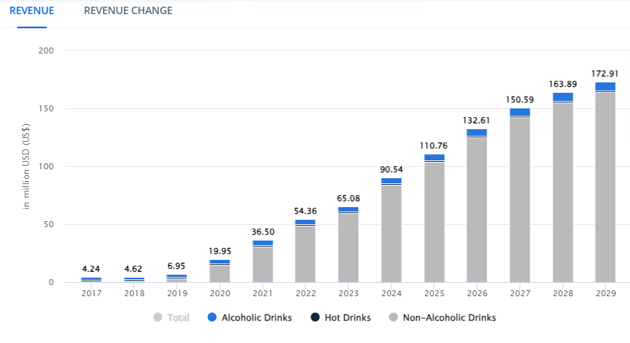
Figure 1: Revenue growth from year 2017-2029

As revenue in the beverage market grows, manufacturers face increased pressure to optimize their operations since consumers expect higher quality and consistency in beverages. Six Sigma focuses on identifying and eliminating inefficiencies and minimize defects and variations in product quality, which can lead to significant cost reductions, customer satisfaction and loyalty, which in turn drives repeat purchases and increases overall revenue.. By streamlining manufacturing processes, companies can produce more products at a lower cost, directly contributing to improved profit margins.

Table below indicates the top ten companies in the Beverages Industry in Zimbabwe based on annual revenues

Table 1. Top ten beverage companies in Zimbabwe based on annual revenues
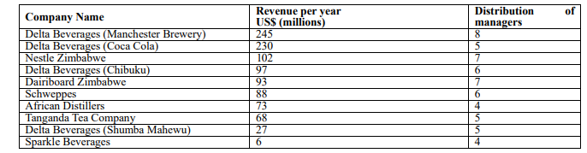
Figure 2: Top ten beverage companies in Zimbabwe
With increasing revenue, beverage companies often look to expand their production capabilities. Six Sigma supports this growth by establishing standardized processes that can be replicated across different facilities. This scalability ensures that as companies ramp up production to meet higher demand, they maintain quality and efficiency, preventing potential revenue losses due to inconsistencies or defects (Dutta, 2020).
The main goal of any manufacturing process is to reduce waste, cost and manufacture products that will satisfy their customer while increasing their position in the world market. This common goal among manufacturing industries in accompanied by constraints or drawbacks such as poor product quality control, inefficient manufacturing processes and rejection rates from customers. Application of the six sigma methodology to the manufacturing processes acts as a framework in identifying the root causes of poor quality and rejection rates among customer, analyzing the data and creating a solution in the route to having almost 0% defects and maintaining customer loyalty and brand reputation.

JUSTIFICATION
Reducing Contamination Risks
To minimize the likelihood of contamination from glass breakages and foreign objects in beverage products, it is essential to conduct proper inspections of bottle integrity before usage. This proactive approach helps ensure that only safe, high-quality bottles are utilized in the manufacturing process.
Enhancing Consumer Satisfaction
Producing defect-free products that meet or exceed customer expectations is crucial for improving consumer satisfaction. By delivering high-quality beverages, companies can foster trust and loyalty among their customers, leading to long-term relationships and repeat business.
Addressing Product Rejection
Implementing Six Sigma methodologies helps address product rejection, which not only improves overall quality but also results in significant cost savings. By systematically identifying and eliminating defects, organizations can reduce expenses related to returns, repairs, and replacements.
Gaining Competitive Advantage
Six Sigma can greatly enhance a company's competitive advantage. By improving quality, reducing costs, and accelerating processes, businesses can position themselves more favorably in the market. The focus on data-driven decision-making and employee engagement further strengthens this advantage.
Increasing Operational Efficiency
Streamlining processes and eliminating waste through Six Sigma practices leads to increased operational efficiency. This improvement results in lower production costs, enabling organizations to allocate resources more effectively and drive profitability.

PROBLEM STATEMENT
The existing manufacturing processes face significant challenges related to product rejection due to defects and low quality, which adversely affect customer satisfaction, brand reputation, and financial performance of a company despite existing quality control measures that are in place.

AIM
Integration of artificial intelligence and Six Sigma methodology through the use of an automated quality control prediction model to reduce the defect and product rejection rate in manufacturing processes, thereby improving product quality and minimizing customer rejection.

OBJECTIVES
1) Achieving a minimum reduction of atleast 2% in the defect rate compared to the current baseline by systematically identifying and addressing the root causes of defects within the manufacturing process
2) To achieve a reduction in the product rejection rate by 5% thus enhancing overall quality assurance processes and minimize waste within the manufacturing framework
3) To improve customer satisfaction score by 5% regarding product quality.
4) Conduct a financial analysis to ensure the solution is a profitable investment for the business, delivering high returns on implementation

METHODOLOGY

Literature review
- The researchers will visit libraries and Google to review literature on manufacturing processes that have already been implemented including their advantages and challenges faced by the workforce in implementing such practices.

Data collection
Data containing key metrics will be collected, such as defect rates, types of defects, production cycle times, and customer satisfaction scores. There will also be collection of historical data to understand current performance levels before implementing improvements. Quantitative data will include production logs and quality control checks. Qualitative data will include customer feedback and even employee input on current processes.
Automation System Design
Designing of an automated quality control prediction model based on historical and real data.
System Integration
The system will be integrated with the six sigma methodology so as to achieve a high precision of defect detection before the product is released into the market.
Data analysis
Data collected will be analysed through descriptive statistics, inferential statistics, root cause analysis and the visualisation tools. Tools used are Minitab during the design of experiments, chi-square test and statistical analysis tools (IBM SPSS).
Automation System Design
Designing of an automated quality control prediction model based on historical and real data.
System Integration
The system will be integrated with the six sigma methodology so as to achieve a high precision of defect detection before the product is released into the market.

The proposed project aims to achieve the following:
-Improved Quality control by identifying and eliminating defects, companies can deliver higher-quality products or services, leading to increased customer satisfaction.
-Increased cost reduction by streamlining processes to reduce waste and operational costs, allowing companies to allocate resources more effectively.
-Enhanced Decision-Making through the emphasis of statistical analysis, allowing companies to make informed decisions based on real data rather than assumptions.
-Strategic Alignment by focusing on customer needs through the alignment of processes with customer requirements, companies can enhance their value propositions.

SCHEDULE OF ACTIVITIES
This sub-section highlights the steps involved in carrying out the whole project from the onset of the proposal to the final document submission. The distribution and allocation of tasks are not fixed; they can be deliberated with as per rising need according to the progress of the project.

References
Ballen, K. 2., 2023. Strategies for Minimizing Defects in Outsourced Products. (Doctoral dissertation, Walden University), p. 10.
Coskun, A. e., 2010. Quality management and six sigma. SCIYO BoD–Books on Demand., p. 1.
Dutta, S. a. J. S., 2020. Reducing packaging material defects in beverage production line using Six sigma methodology. International Journal of Six Sigma and Competitive Advantage, 12(1), p. 59.
Mittal, A. G. P. K. V. A. O. A. M. S. a. S. S., 2023. The performance improvement analysis using Six Sigma DMAIC methodology: A case study on Indian manufacturing company.. Heliyon, 9(3), p. 1.
Statista, 2024. Alcoholic Drinks - Zimbabwe: Statista Market Forecast. [Online]
Available at: https://www.statista.com/outlook/cmo/alcoholic-drinks/zimbabwe
[Accessed 15 September 2024].
Yang, K. B. S. a. E.-H. B., 2003. Design for six sigma. New York: McGraw-Hill., p. 1.

