Advanced Customization via the NIMBLE MCMC Engine

Introduction
 Note on Model Scope
To keep the example simpler for this tutorial, we assume an independent skills model (i.e., there does not exist any dependencies between the different skills).

If you are new to the package, we highly recommend starting with the Beginner Tutorial. There, we introduce the run_pgdcm_auto() function, which was purposefully designed to offer a quick, automated, and streamlined approach to estimation.
While automated wrappers are fantastic for rapid prototyping and standard applications, advanced researchers and psychometric practitioners often demand finer control over their inferential engine. You may need to modify the underlying Bayesian network priors, explicitly configure internal MCMC sampling blocks, customize the diagnostic plotting routines, or manually inspect step-by-step predictive simulations.
This advanced tutorial is tailored specifically for users who need that deeper level of control. In the following sections, we will conceptually deconstruct the automated pipeline. We will guide you through explicitly defining the Bayesian network architecture, executing the core nimbleMCMC sampling engine, and leveraging the granular configuration options available in both pgdcm and nimbleMCMC.

1. Environment and Data Setup
First, we will load the requisite packages and structural data. We will utilize the basic DTMR dataset and its corresponding Q-Matrix to demonstrate the manual estimation workflow.
library(nimble)
library(pgdcm)
library(dcmdata)
library(MCMCvis)
# Load data and Q-Matrix
X <- dtmr_data
Q <- dtmr_qmatrix
# Build the graphical structure
g <- QMatrix2iGraph(Q)
# Generate Nimble configurations
config <- build_model_config(g, X)
The build_model_config() is a critical foundational setup function:
- Arguments: Accepts an igraph object representing the Q-Matrix dependencies (g), the observational item response matrix (X), and optionally a character specifying the framework (compute, e.g., “dina”, “dino”, “dinm”).
- Returns: A list (which we saved to config) containing structural validation, prior constants (config$constants), isolated data matrix (config$data), initial values for MCMC (config$inits), and the name of the dynamically generated model code file (config$code_file).

2. Extracting the NIMBLE Model Code
The pgdcm package dynamically writes Bayesian mathematical syntax (BUGS/NIMBLE language) to a temporary file based on your Q-Matrix topology. To manually run nimble, we need to load this raw code into our R session.
# The config object specifies the location of the generated code inside your library
source(config$code_file)
# We extract the actual code object into memory
model_code <- get(config$model_object)
 Customizing Models
For advanced users looking to build custom model types, you can simply point the model_code variable above to your own customized NIMBLE model definition. The rest of this manual estimation workflow will continue to function properly provided you adhere to the parameter naming conventions we have utilized throughout the package’s DCM and SEM foundational logitmodel code.

3. Prior Predictive Checking
Before launching a computationally expensive MCMC sampler, rigorous Bayesian workflows conduct a Prior Predictive Check (PPC). This step simulates dataset outcomes strictly from the prior distributions without conditioning on any observed data. It acts as a generative plausibility check, ensuring that our specified model parameter priors produce theoretically sound distributions of observable test scores before empirical training even begins.
We do this using run_predictive_check().
prior_ppc_results <- run_predictive_check(
config = config,
obs_X = config$data$X,
posterior_samples = NULL, # Enforces PRIOR checking
n_sim = 50,
prefix = NULL, # Forces the plot to render inline instead of drawing to a PDF
title = "PriorCheck"
)
- Arguments:
  - config: Our configuration list.
  - obs_X: The observed response data matrix to compare against.
  - posterior_samples: MCMC samples. We set this to NULL to let the function know that this is a prior predictive check and not a posterior predictive check.
  - n_sim: The number of predictive datasets to simulate.
  - prefix and title: Strings used to name the output report.
- Returns: A quantitative list of simulated summary metrics (simMeans, simRowMeans, simColMeans, etc.) and automatically generates a diagnostic PDF plot in your working directory.
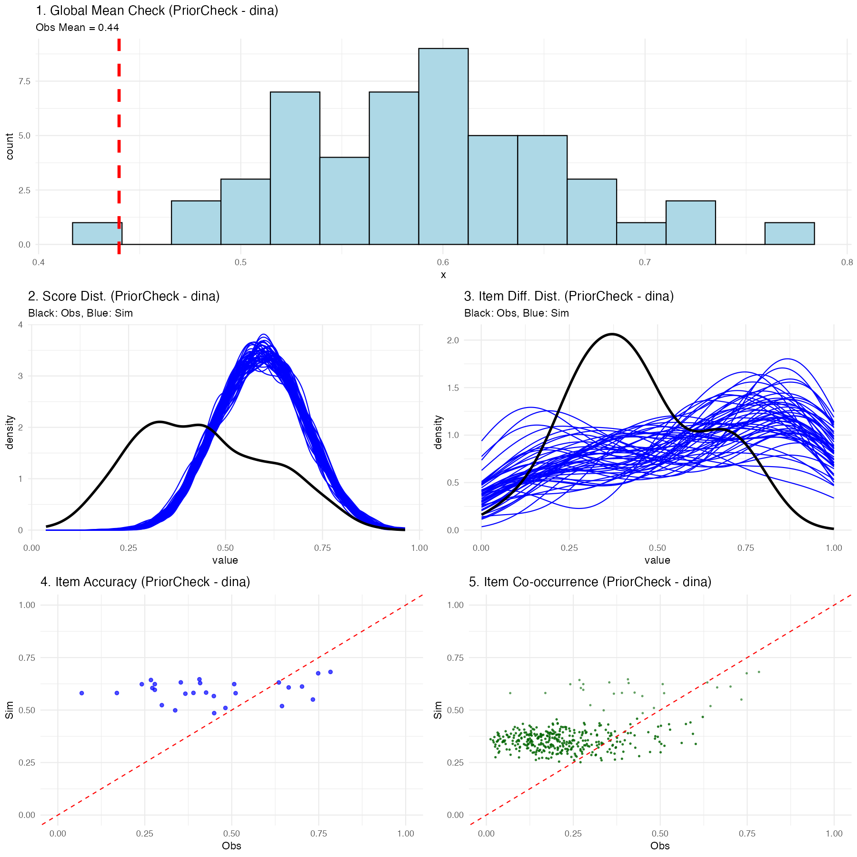
Prior Predictive Check Diagnostics

Explaining the Prior Predictive Plots
Executing this function generates a multifaceted diagnostic visualization showing exactly what the naive, untrained model believes a classroom of students would score:
- Global Mean Check: A histogram showing the average overall test score expected by the model. The vertical red line shows your real observed data mean. In a prior check, this distribution should be incredibly wide (uninformed).
- Score Distribution: Density plots showing expected participant-level scores (blue) vs the actual observed spread (black).
- Item Percentage Correct Distribution: Density plots showing the expected distribution of the percentage correct for items across the assessment vs the observed distribution.
- Item Accuracy: A scatter plot comparing the empirically observed percentage correct for a given item against the simulated percentage correct for that exact same item.
- Item Co-occurrence: A scatter plot comparing the observed versus simulated second-order moments, revealing how accurately the model captured the frequency with which pairs of items were answered correctly together.
(Note: Because we used uninformed priors internally in the package, you should expect these prior predictive checks to look very dispersed and potentially mismatched from the black actual data lines—this is normal before training!)

4. Manual MCMC Execution
Now, we will execute the NIMBLE engine manually. By doing this explicitly, you have the freedom to intercept the configuration object and apply custom block samplers or change hyperparameters before calling nimbleMCMC().
 Note
For the sake of testing/tutorial, the code below defaults to a fast compilation format. In a rigorous real-world analysis, you migh have to run over 10,000 iterations across 2-3 chains!

mcmc_raw <- nimbleMCMC(
code = model_code, # The NIMBLE code we extracted earlier
constants = config$constants, # Fixed constants mapped from the Q-Matrix
data = config$data, # The isolated observational vectors
inits = config$inits, # Starter values for the Markov chain
monitors = config$monitors, # Variables we want NIMBLE to track
nchains = 2,
niter = 2000,
nburnin = 500,
summary = TRUE,
samplesAsCodaMCMC = TRUE, # Force output to a list format compatible with CODA
WAIC = TRUE # Calculate the Watanabe-Akaike Information Criterion
)
Understanding the Execution Output
Because we enabled the summary and WAIC flags in the function call above, nimbleMCMC() will conclude its sampling process and return a composite list to the mcmc_raw object containing three primary elements:
- samples: An mcmc.list containing the raw, point-by-point posterior draws for every tracked parameter across all chains.
- summary: A pre-calculated matrix providing the mean, median, standard deviation, and key credible intervals for every estimated parameter.
- WAIC: A standalone list of predictive accuracy metrics. Specifically:
  - WAIC (Watanabe-Akaike Information Criterion): An estimator of out-of-sample predictive accuracy. Lower WAIC values indicate a better-fitting model, which is highly useful when comparing competing Q-Matrices or network architectures.
  - pWAIC: The estimated “effective number of parameters.” In complex hierarchical Bayesian networks like cognitive modeling, this penalty term describes the structural complexity and shrinkage of your model, penalizing overly parameterized networks that risk overfitting.

5. Post-Processing and Convergence
Once the sampler has finished executing, we isolate our posterior samples.
When mapping complex hierarchical graphical networks recursively, mathematically unconnected structural placeholders are marked with NA to preserve the parent Q-Matrix dimensions. We filter these empty pathways out natively before validating model convergence to guarantee pure mathematical comparisons.
# Convert raw samples to an MCMC list format
res_mcmc <- mcmc.list(mcmc_raw$samples)
# Clean structural MCMC artifacts
res_clean <- filter_structural_nas(res_mcmc)
- filter_structural_nas() accepts an mcmc.list and returns a cleanly formatted mcmc.list with unused topology nodes stripped out so that parameter arrays correctly match the structural dimensions required for diagnostic math.
We can now cleanly verify if our MCMC chains have successfully traversed the distribution and converged:
convergence_diag <- check_mcmc_convergence(
chainlist = res_clean,
blocksize = 50,
burninperiod = 100
)
print(paste("Algorithm fully converged:", convergence_diag$converged))
- check_mcmc_convergence() accepts an mcmc.list, a block size to average across, and a burn-in iteration count. It conceptually evaluates chain stability by calculating moving block averages across the specified intervals. It returns a list of resulting stability metrics, including a strict boolean converged parameter indicating if the relative errors of all parameter blocks have successfully stabilized beneath a 10% tolerance threshold (< 0.1).

6. Posterior Predictive Checking
Finally, the cornerstone of an advanced Bayesian workflow is the Posterior Predictive Check (PPC). We run the exact same run_predictive_check() function from Step 3, but this time we provide it with our posterior predictice samples we got from the estimation procedure (res_clean).
post_ppc_results <- run_predictive_check(
config = config,
obs_X = config$data$X,
posterior_samples = res_clean, # Uses trained inference
n_sim = 50,
prefix = NULL, # Renders plot inline in Quarto
title = "PosteriorCheck"
)
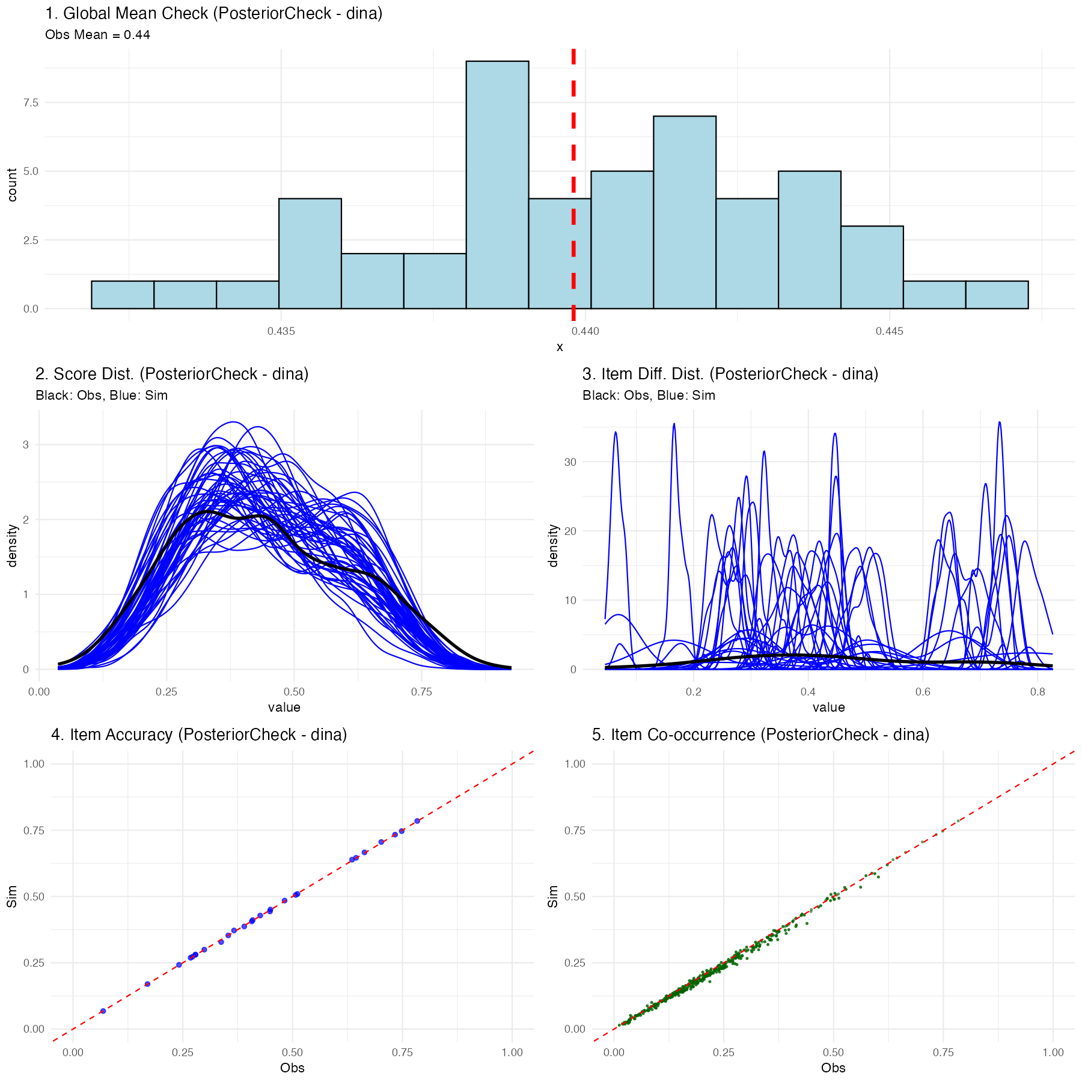
Posterior Predictive Check Diagnostics

Understanding the Posterior Predictive Checking Results
If the chosen Diagnostic Classification Model (in this case, DINA) successfully maps the psychometric properties of your test to the students, you will see a much tighter relationship in the plots:
- Global Mean: The simulated blue histogram should tightly cluster around your red observed mean line.
- Score & Item Distributions: The fluctuating blue simulation lines should overlay effectively perfectly onto the thick black observed data lines.
- Scatter Plots: The blue nodes (item accuracy and co-occurrence representations) should hug tightly to the diagonal red equivalence line.
If the posterior predictive plots show significant deviations (for instance, the distributions don’t align, or scatter nodes sit far off the red line), this is diagnostic proof that your chosen psychological framework (like DINA) is structurally misspecified for this dataset, and you should likely attempt a different network framework like DINO or DINM.

7. Generating Summary Tables and Assessing Accuracy
While the beginner-friendly run_pgdcm_auto() function automatically generates and saves mapped_parameters.csv, skill_profiles.csv, and item_parameters.csv directly to your working directory, advanced users executing manual MCMC chains must extract and build these tables themselves to maintain full control.
# 1. Generate the raw summary matrix
mcmc_summ <- MCMCvis::MCMCsummary(object = res_clean)
# 2. Extract original participant IDs for correct row mapping
student_ids <- rownames(config$data$X)
# 3. Map Nimble parameters to human-readable names
mapped_results <- map_pgdcm_parameters(
summary_mx = mcmc_summ,
config_obj = config,
student_names = student_ids
)
# 4. Generate the final clean tables (Skill Profiles, Item Parameters)
summary_tables <- generate_summary_tables(
mapped_results = mapped_results,
config_obj = config,
student_names = student_ids,
return_groups = TRUE # Enable this to explicitly extract skill profile clusters
)
# Extract the skill profiles specifically
skill_profiles <- summary_tables$skill_profiles
group_patterns <- summary_tables$group_patterns
If you set return_groups = TRUE, the function will additionally map all observed skill profiles to their exhaustive $2^{K}$ latent class grouping combinations, allowing you to easily extract and visualize group-level membership arrays (summary_tables$group_patterns).

Assessing Classification Performance
Once you have your skill_profiles matrix (either manually generated from the procedure above, or simply loaded from the skill_profiles.csv file automatically saved during the run_pgdcm_auto() workflow), you can quantitatively evaluate how well your model classified the students if you happen to possess a “ground truth” dataset.
We can accomplish this using the assess_classification_accuracy() function.
# Assess classification accuracy against known true profiles
accuracy_results <- assess_classification_accuracy(
skill_profiles = skill_profiles,
true_data = dtmr_true_profiles,
mapping_list = list(
"referent_units" = "referent_units",
"partitioning_iterating" = "partitioning_iterating",
"appropriateness" = "appropriateness",
"multiplicative_comparison" = "multiplicative_comparison"
)
)
# View the individual skill accuracies, Cohen's Kappa, and overall profile match rate
print(accuracy_results$metrics)
print(paste("Profile Correct Classification Rate:", accuracy_results$profile_accuracy))
This final validation step computes both the isolated accuracy rate for every individual skill and the overarching, strict multi-dimensional profile match rate!

8. Using pgdcm as a Scoring Model
A frequent use case in psychometrics is scoring. After successfully estimating and calibrating your structural and item parameters on a large sample, you may want to apply those fixed parameters to score subsequent (often smaller) datasets without recalculating the item difficulties.
In a Bayesian framework, you “fix” a parameter by supplying it with a highly informative prior (a point distribution). By leveraging the priors argument in build_model_config(), we can supply our calibrated posterior means, and lock them in place using an extremely small standard deviation (e.g., 1e-4).
# 1. Assume you have tables of calibrated means from a previous study:
# calibrated_theta_means (Dimensions: K x 2 matrix)
# calibrated_lambda_means (Dimensions: J x 2 matrix)
# 2. Build your highly informative scoring priors
scoring_priors <- list(
# Keep the root attribute priors somewhat diffuse to allow new students to be scored
beta_mean = c(0),
beta_std = c(2),
# "Lock in" your previously calibrated structural parameters (K x 2 matrix)
theta_mean = calibrated_theta_means,
theta_std = matrix(0.0001, nrow = nrow(calibrated_theta_means), ncol = 2),
# "Lock in" your previously calibrated item parameters (J x 2 matrix)
lambda_mean = calibrated_lambda_means,
lambda_std = matrix(0.0001, nrow = nrow(calibrated_lambda_means), ncol = 2)
)
# 3. Compile the new config for the new dataset
config_scoring <- build_model_config(g, X_new_students, priors = scoring_priors)
# 4. Execute the automated workflow (it will sample with fixed items)
scoring_results <- run_pgdcm_auto(config_scoring)
# Profile the new students!
print(scoring_results$skill_profiles)
The MCMC sampler will essentially hold those parameters constant at your specified means while freely updating the posterior distributions of the new participants’ latent skills!

