Beginner Tutorial: Introduction to Bayesian Modeling with PGDCM

Introduction
This tutorial is designed as an introductory resource for researchers and practitioners seeking a quick, practical guide to probabilistic programming and Bayesian psychometric modeling through pgdcm.
 Learning Objectives:
By the end of this tutorial, you will learn how to:
- Prepare your item response data and Q-Matrix (evidence model) for analysis with the pgdcm package.
- Link your formatted data to the underlying graphical network required for the model.
- Execute a Bayesian MCMC sampler without writing complex, manual configuration code.
- Extract and interpret the resulting posterior distributions and convergence diagnostics.

1. Environment Requirements
Before calling any functions from pgdcm, make sure you have loaded the nimble package. The nimble package functions as the core probabilistic programming and MCMC estimation engine for pgdcm, so it is critical to load it before loading our package.
We will also load dcmdata, which contains standard cognitive datasets for us to test our models on. For this tutorial, we will use the DTMR dataset. You can learn more about the dataset here: https://dcmdata.r-dcm.org/reference/dtmr.html
library(nimble)
library(pgdcm)
library(dcmdata)

2. Preparing the Data and the Evidence Model
Diagnostic Classification Models (DCMs) evaluate whether participants have mastered the specific skills an assessment is designed to measure. To estimate this, the model requires two key components:
- Observational Data (X): The actual test responses from participants, typically consisting of 1s (correct) and 0s (incorrect). This forms an $N×J$ matrix, where $N$ is the number of participants and $J$ is the number of questions (items).
- The Q-Matrix (Q): An evidence model specifying which exact skills are required to answer each question correctly. This forms a $J×K$ matrix, where $J$ is the number of questions and $K$ is the number of skills (attributes). Specifically, an entry of 1 in the $j$-th row and $k$-th column indicates that the $k$-th skill is required to answer the $j$-th question, while a 0 indicates it is not.
Let’s load our sample dataset and Q-Matrix:
X <- dtmr_data
Q <- dtmr_qmatrix
The pgdcm package mathematically treats modern psychometric models as probabilistic graphical models (specifically, Directed Acyclic Graphs or Bayesian Networks). Because of this, we must first convert our standard Q-Matrix into a Directed Acyclic Graph (g) that represents the underlying node dependencies—i.e., the dependencies between the skills and the tasks/test items. The QMatrix2iGraph() function handles this graphical conversion automatically for us.
Once we have constructed the core network graph, several model parameters must be defined to establish the active modeling environment for NIMBLE. This includes validating topological constraints, isolating constants required for nimble inference calculations, and setting initial values for the model parameters. The build_model_config() function handles all of this heavy lifting.
# Restructure Matrix to an iGraph object
g <- QMatrix2iGraph(Q)
# Link student responses to the Graph
config <- build_model_config(g, X)
It is important to note that by default, build_model_config() assumes a DINA (Deterministic Input, Noisy “And” gate) compute type. This implies a strict, non-compensatory cognitive framework—meaning a student must possess all required skills dictated by the Q-Matrix to likely answer an item correctly; mastering just one or a few required skills provides no additional benefit. If your assessment follows a different theoretic framework, you can overwrite this by supplying options like compute = "dino" or compute = "dinm":
- compute = "dino" (Deterministic Input, Noisy “Or” gate): Assumes a fully compensatory framework. Here, possessing at least one of the required skills is sufficient to likely answer the item correctly.
- compute = "dinm" (Deterministic Input, Noisy “Mixed”): Assumes a proportional or additive framework. In this model, each additional required skill a student masters incrementally increases their probability of answering correctly.

3. Estimation Pipeline
In a traditional Bayesian workflow, setting up the configuration for both the model and the MCMC sampler requires a non-trivial amount of code. To keep the process streamlined and robust, the run_pgdcm_auto() function automates this step. It initializes the model with sensible default values, runs the MCMC sampler for you, and saves the results directly to your working directory.
Note: MCMC algorithms construct a Markov chain to recursively explore the unknown probability distributions of our parameters. Evaluating these complex prior-likelihood constraints across thousands of iterations is computationally intensive and can realistically slow down documentation rendering. Therefore, it is standard workflow practice to execute and save your chain results to disk via saveRDS() locally, and load them for post-model fitting inference or analysis.
results <- run_pgdcm_auto(
config = config,
prefix = "DINA_DTMR" # You can give any name here. This prefix is used while saving
# the prior predictive and posterior predictive simulation results.
)
# Save the exact results to an RDS file to bypass future recomputation
saveRDS(results, "Beginner_Tutorial_Results.rds")
 What’s happening under the hood of run_pgdcm_auto?
Under the hood, run_pgdcm_auto() handles several complex configurations so you don’t have to manually code them. The function configures the MCMC algorithmic engine with the following default parameters:
- niter = 2000: The total number of MCMC samples to draw per chain.
- nburnin = 500: The number of initial samples to discard. MCMC algorithms take time to traverse towards the high-probability region; discarding early “burn-in” samples ensures we only analyze parameters after they have reached a stable state.
- chains = 2: The algorithm runs two independent sampling processes simultaneously to ensure they both converge onto the same distribution.
Additionally, standard comprehensive workflows evaluate the viability of a model using simulation. While run_pgdcm_auto has arguments (prior_sims = NULL, post_sims = NULL) that bypass this by default for speed, they are critical components of a full Bayesian workflow:
- Prior Predictive Checking: Before seeing the actual data, what kind of data does the model think it will see based purely on our initial parameter bounds (priors)? This ensures our initial limits are logical and not mathematically impossible.
- Posterior Predictive Checking: After the network learns the distribution, we simulate student response patterns utilizing the trained distributions. We then compare these simulated response patterns against the real observational data. If the model accurately captured the underlying psychometric properties, the simulated data should closely resemble the real data.

4. Interpreting the Bayesian Output
Unlike standard frequentist statistics which often output a single “best guess” point estimate, Bayesian inference through MCMC outputs thousands of plausible values drawn from the joint posterior distribution. This fundamental difference allows us to naturally extract comprehensive metrics like the posterior mean and credible intervals to formally quantify our uncertainty.
To easily read and interpret these distributions, we will load our cached .rds file and use the MCMCvis package.
# Load our pre-cached exact results from the pipeline above
results <- readRDS("Beginner_Tutorial_Results.rds")
library(MCMCvis)

Numerical Analytics
By passing our raw MCMC samples into the MCMCsummary() function, we can collapse the complex distributions into a clean summary table that provides point estimates and measures of numerical uncertainty.
The lambda parameters in our model capture the properties of the test items themselves. For each test item $j$:
- lambda[j, 1] (Discrimination / Slope): Represents how effectively the item distinguishes between participants who possess the required skills and those who do not. A higher value indicates the item strongly differentiates between mastery states.
- lambda[j, 2] (Difficulty / Intercept): Represents the baseline difficulty of the item. A higher value typically means the question is inherently harder to answer correctly overall.
(There are also other parameter families estimated in the graphical model that capture the attribute network itself. For example, beta_root parameters represent the baseline prevalence of foundational “root” skills in the population. The theta parameters function similarly to lambda, but are applied to higher-level skills, carrying their own dependencies and baseline difficulties.)
We can extract a numerical summary matrix specifically for our lambda parameters to inspect how the test items functioned:
# Retrieve a numerical summary table specifically for the 'lambda' item parameters
res <- MCMCsummary(results$samples, params = "lambda")
head(res) # only a few rows from res are displayed here.
mean sd 2.5% 50% 97.5% Rhat n.eff
lambda[1, 1] 1.7512409 0.2142891 1.3824153 1.7402970 2.247491 1.43 68
lambda[2, 1] 1.3103394 0.2119471 0.8939294 1.3198143 1.698902 1.02 151
lambda[3, 1] 2.4237264 0.2828668 1.9031875 2.4225588 2.967375 1.08 51
lambda[4, 1] 0.9529481 0.1925619 0.5754743 0.9500665 1.327190 1.01 107
lambda[5, 1] 1.7350918 0.2272166 1.3164859 1.7212369 2.187425 1.03 71
lambda[6, 1] 1.9637383 0.4919925 1.1386391 1.9218624 3.056010 1.14 39
How to Read the Table:
- mean: The expected value or best estimate for the parameter. This conceptually corresponds to the traditional point estimate you would obtain in a frequentist approach.
- 2.5% and 97.5%: These bounds define the 95% Credible Interval. In Bayesian inference, this means there is a 95% probability that the true underlying parameter value falls within this specific range.
- Rhat: A convergence diagnostic (Gelman-Rubin statistic). If Rhat is greater than 1.1, it generally indicates the MCMC chains have not yet converged, and you may need to substantially increase the niter (number of iterations) in your estimation step. Sometimes Rhat values remain greater than 1.1 due to an underlying model misspecification. This issue can typically be identified if you continue to increase the number of iterations and observe no improvement in the convergence diagnostics.

Visual Analytics
Reviewing hundreds of rows in a table can be exhausting. MCMC visualization functions like MCMCplot() can transform these parameter boundaries into intuitive visual “Caterpillar Plots”.
Note: Because we estimated 54 item parameters for this dataset, plotting them all simultaneously can vertically cramp the screen. Standard R plotting packages (like MCMCvis) may auto-truncate the Y-axis labels to fit the visual constraints, occasionally dropping some text labels to save space.
# Visually plot the 'lambda' parameter distributions
MCMCplot(results$samples, params = "lambda")
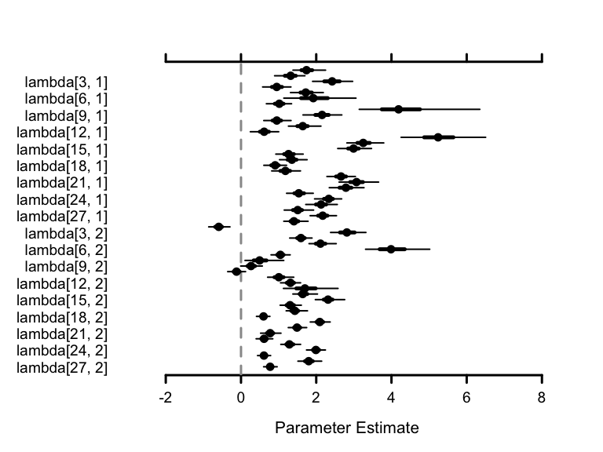
How to Interpret the Visuals: Each dot represents the mean estimate for a specific parameter. The horizontal lines stretching outwards illustrate the 95% Credible Interval.
- A wider line indicates high uncertainty (a broader credible interval) for that parameter.
- A shorter, narrower line indicates the model is highly confident in its estimate (a tighter credible interval) for that parameter.
 Next Steps
Ready to dive deeper? Check out the Advanced Tutorial to learn about customizing models, diagnosing chains, and configuring the PGDCM engine natively.

