# CS 3540 Game Programming

# Assignment X

# 3D Modeling

**Nik Bear Brown**

**nik@ccs.neu.edu**

**Spring 2016**

### One of the assignments 4-8 of your choice.

### Assignments 4-8 are of your choice from the 13 assignments provided.

### Create a 3D Model

Create a 3D Model that MUST be used in a game.

Option 1 – Build a Model in 3D Software (Maya/Blender/etc.)

Create a 3D Model. Apply at least 2 shaders/textures to the model. Upload the model to Blackboard along with the images from renders from at least 3 distinct camera angles with and without shaders/textures.

You can build a model from scratch or tweak an existing model. If you tweak an existing model you must provide the base model, reference it and provide additional renders that illustrate the tweaks/changes made.

Option 2 – Create a Model by digitizing a real-world object with a 3D scan, cleaning it up and 3D printing it.

3D scan a real world object from photos using software like 123D Catch (<http://www.123dapp.com/catch>) 123D Catch turn photos into 3D models. Capture places, people and things in 3D using your iPad, iPhone, Android device, or any camera. Share your catches, or 3D print a real object! If you choose this option you must create a 3D print (as cheap as $10) from your 3D scan and submit pictures of your 3D print along with your model file.

Learn how to use 123d Catch

Videos and documentation to help you get started, or get more advanced with 123D Catch – a free app that turns photos into 3D models.

<http://www.123dapp.com/howto/catch>

Examples of 3D Models that aren’t “Too Simple”

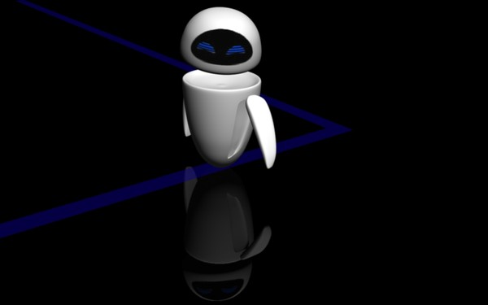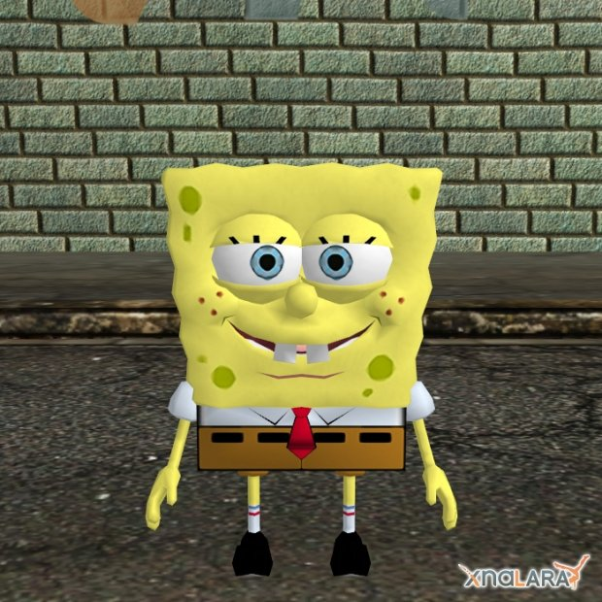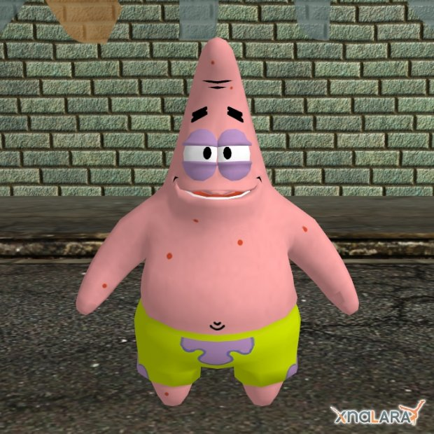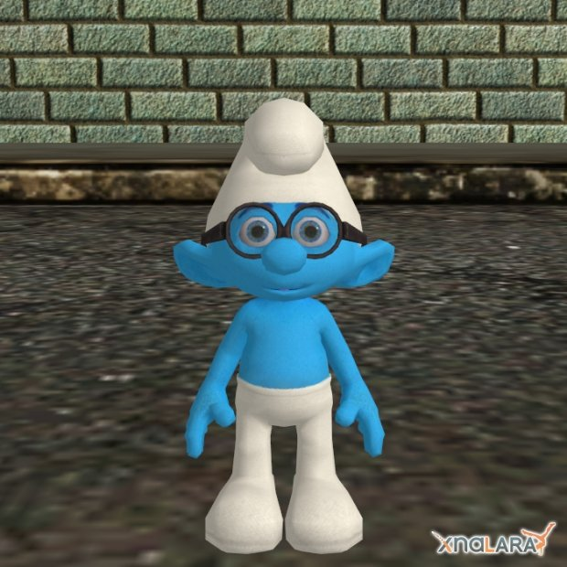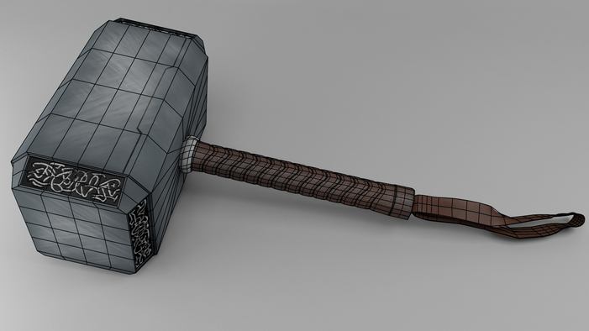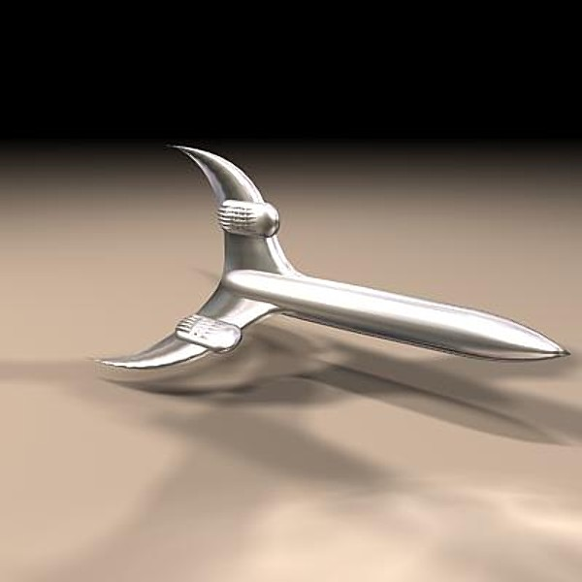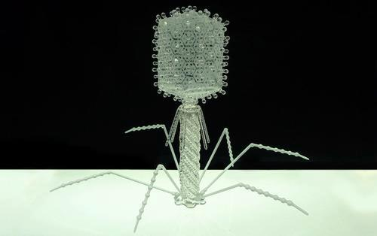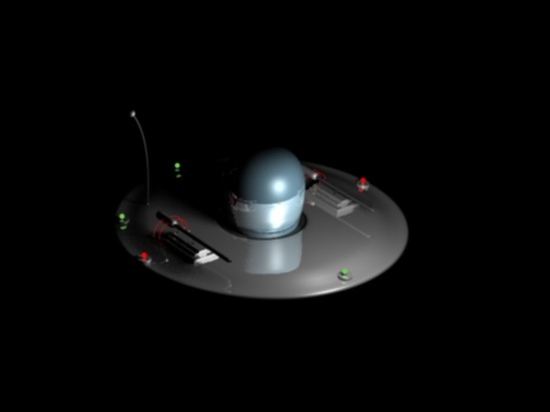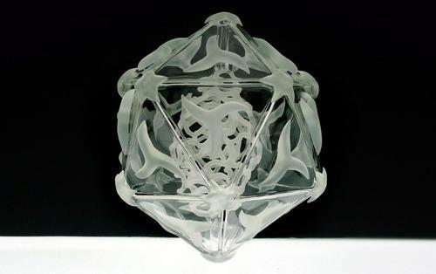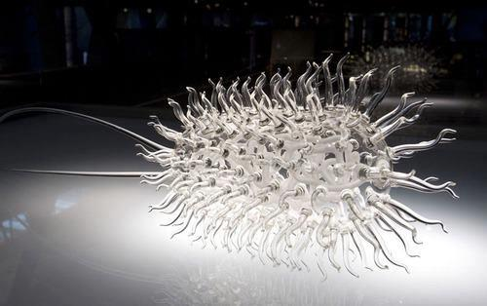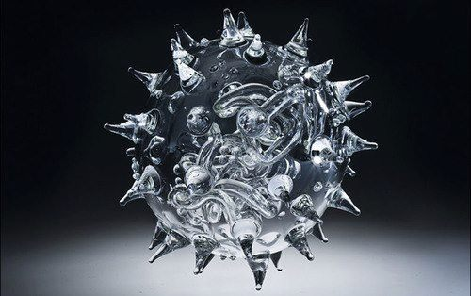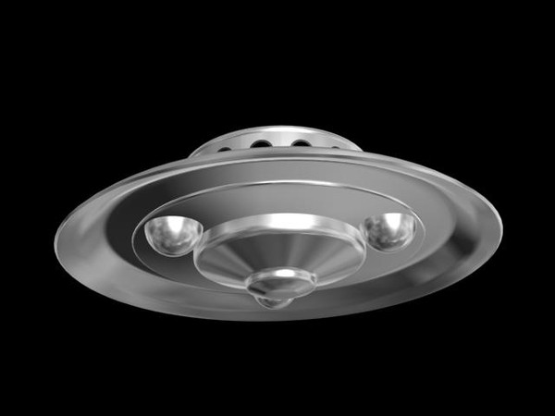

E-mail [nik@ccs.neu.edu](mailto:nik@ccs.neu.edu) if you are unsure if your model is “too simple.”

Examples of previous 3D Models from CS 4300 Computer Graphics, CS 4850/5850 Building Game Engines & CS 3540 Game Programming

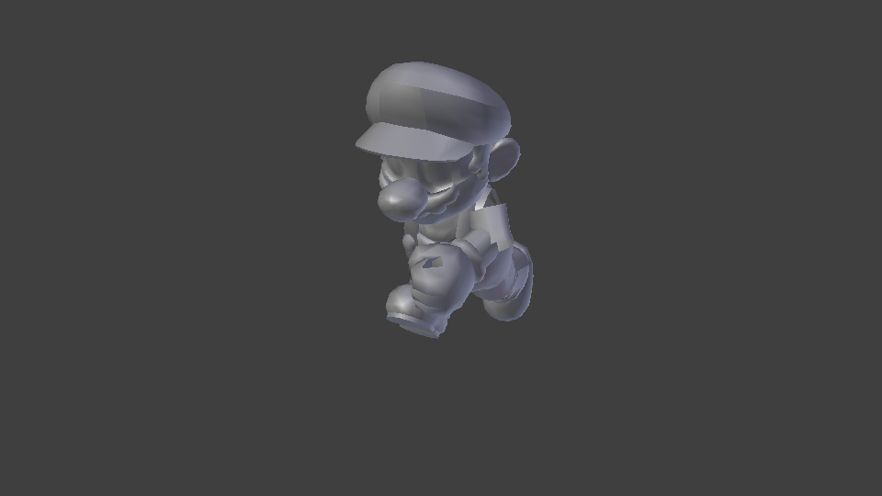

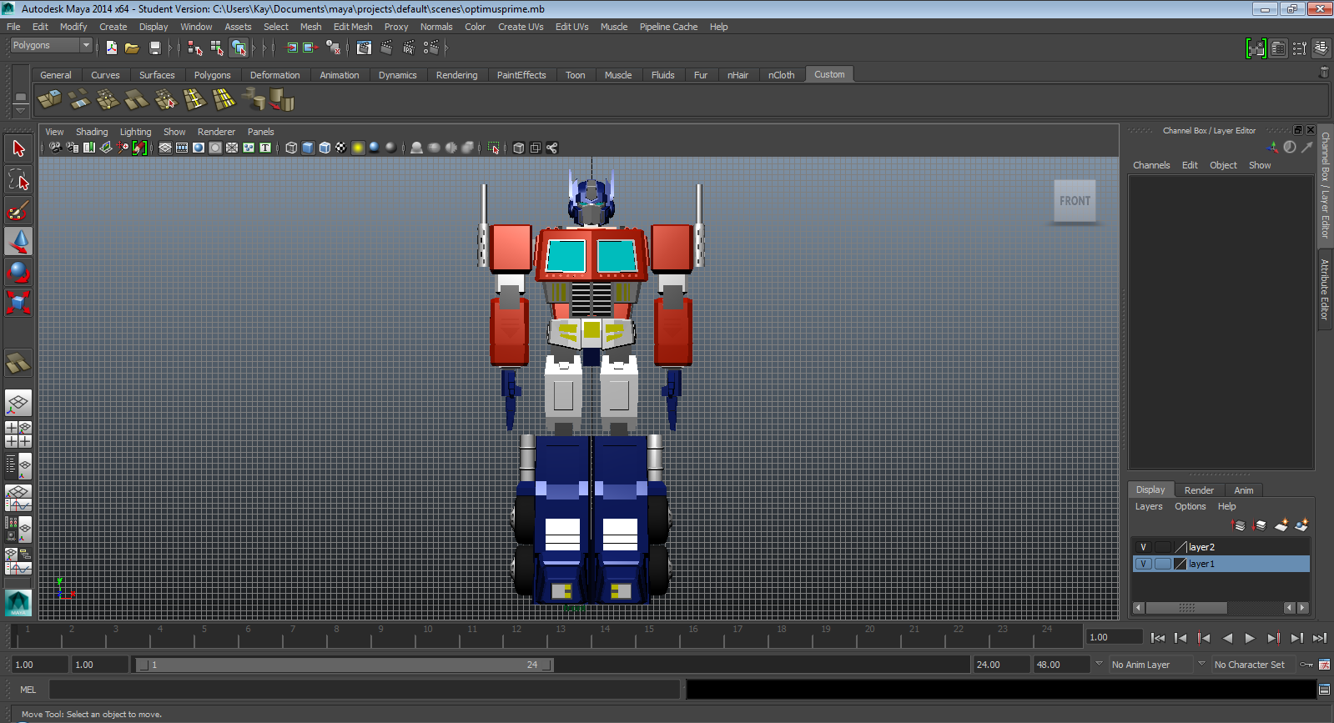

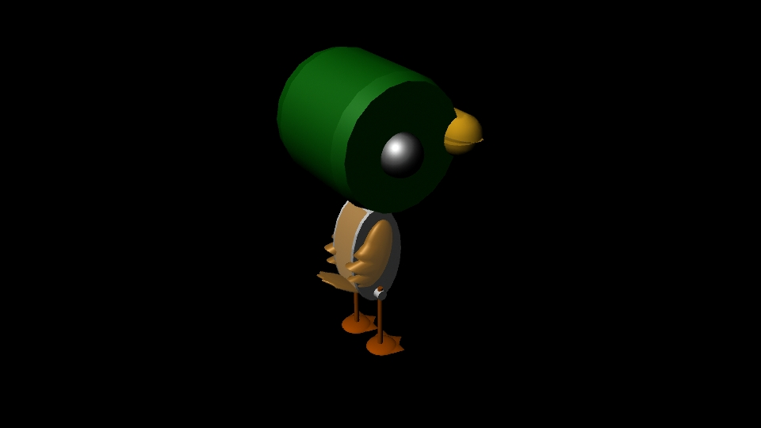

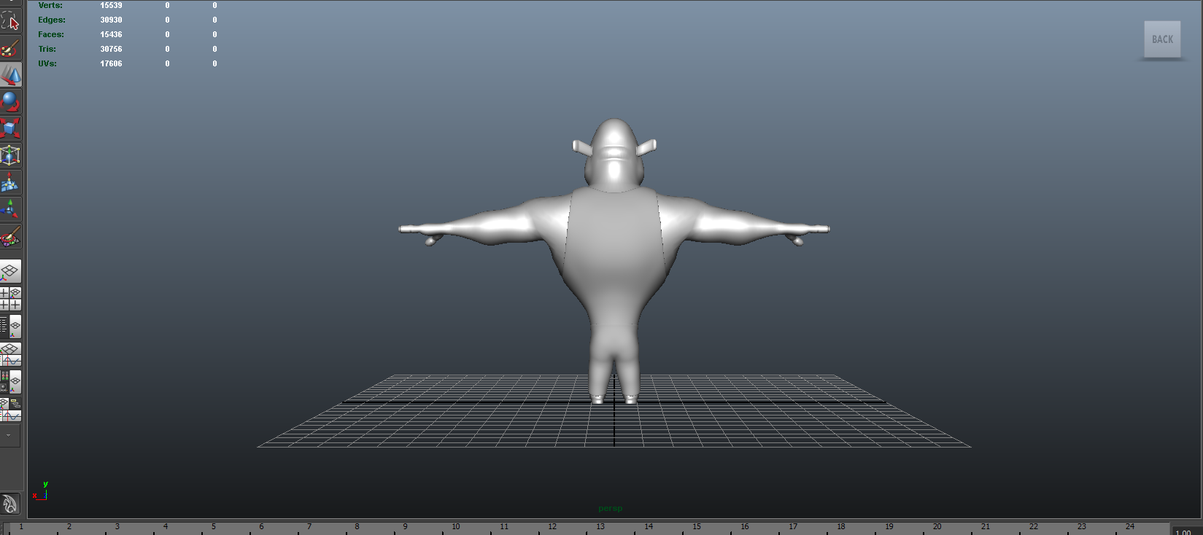

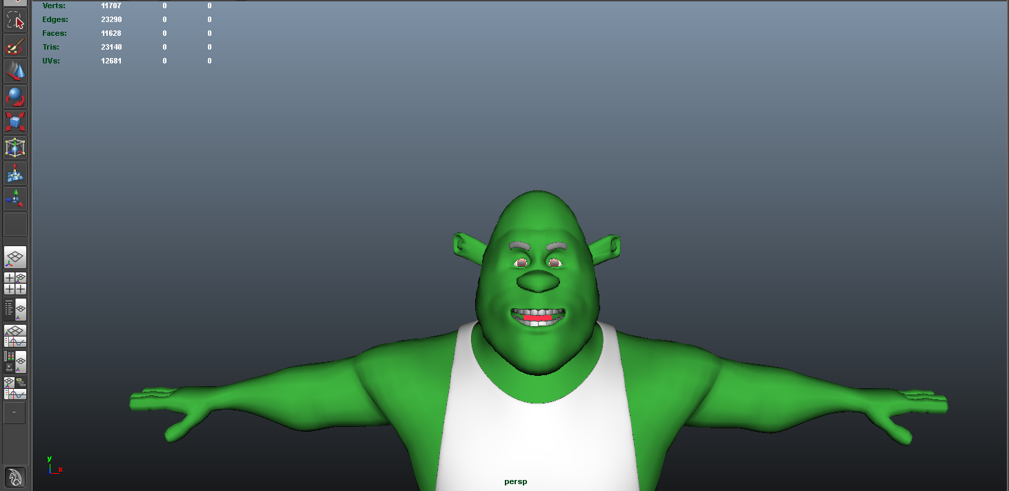

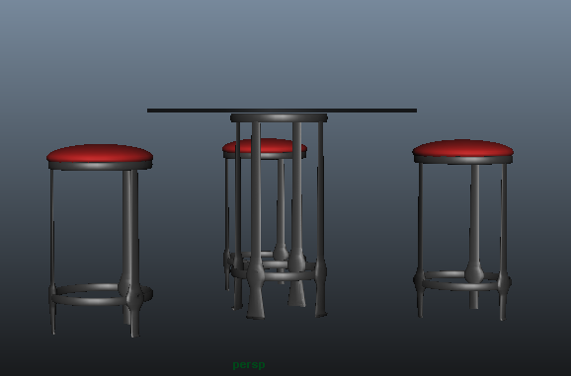

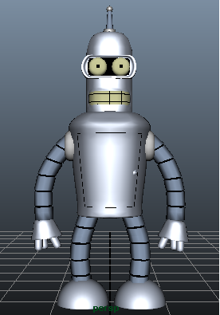

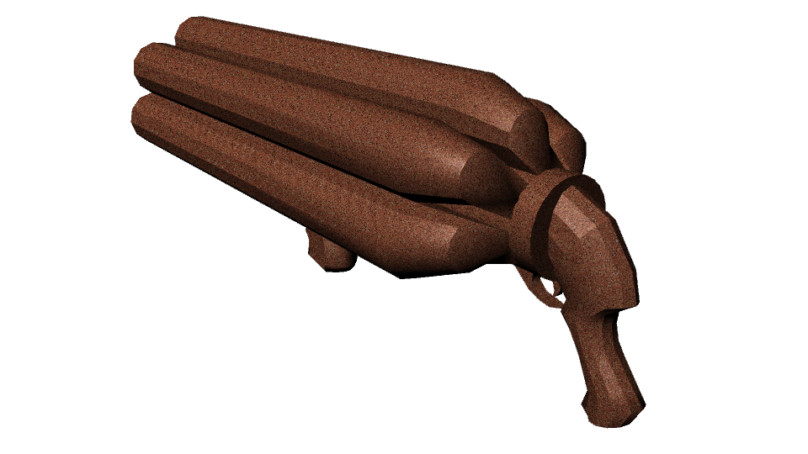

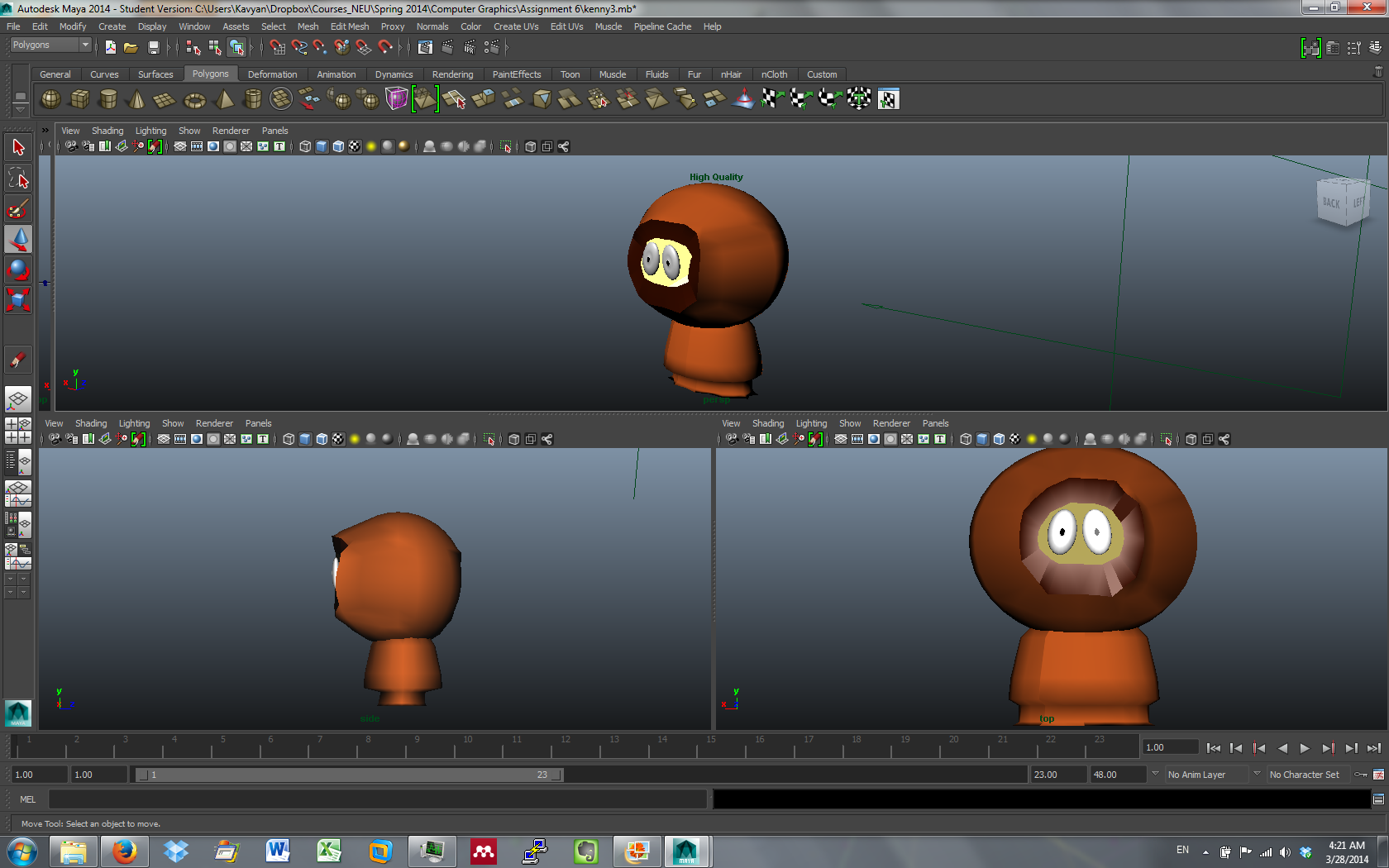

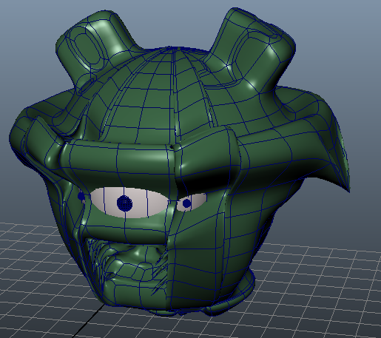

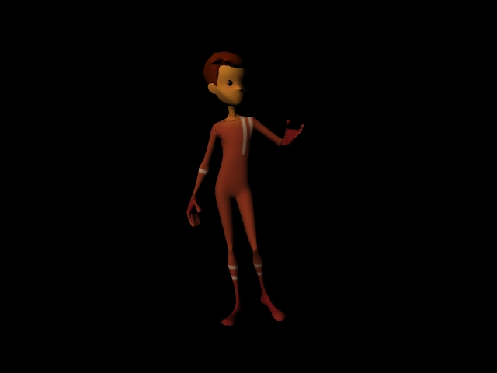

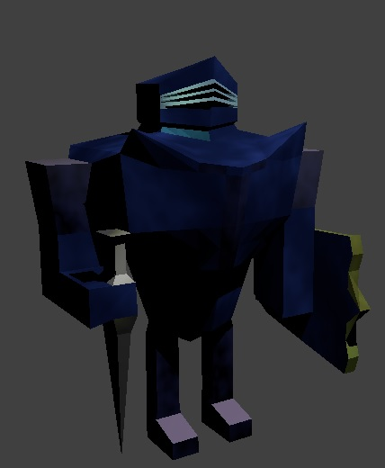

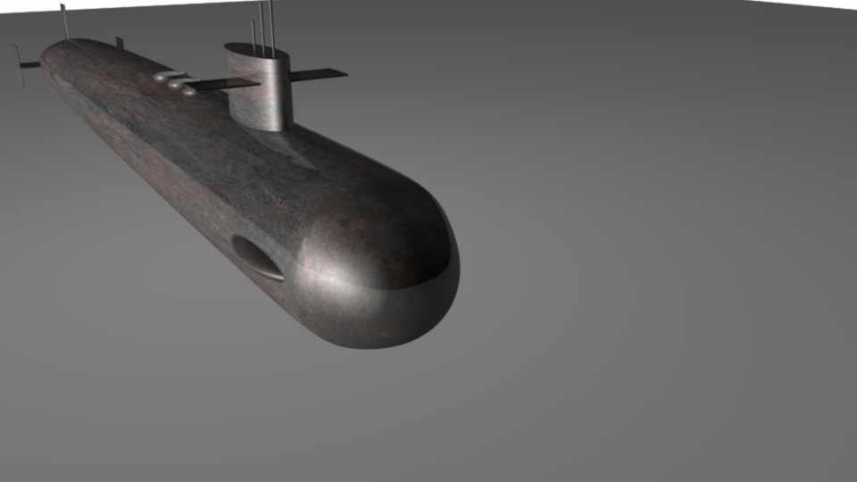

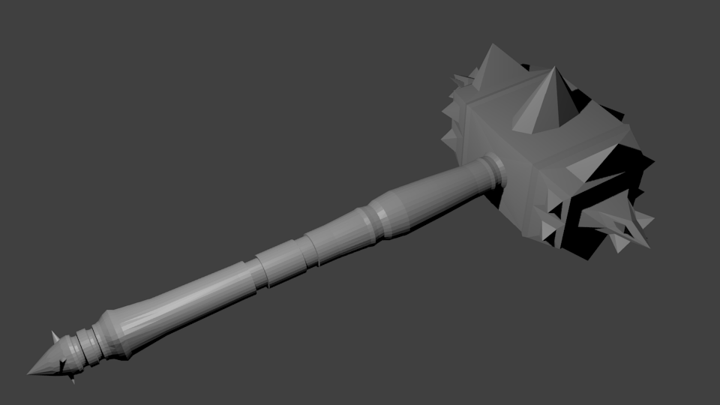

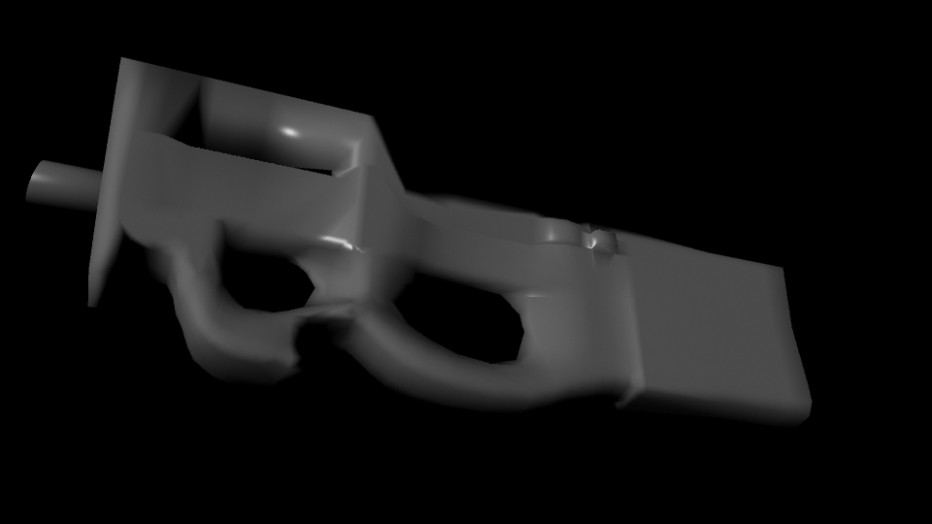

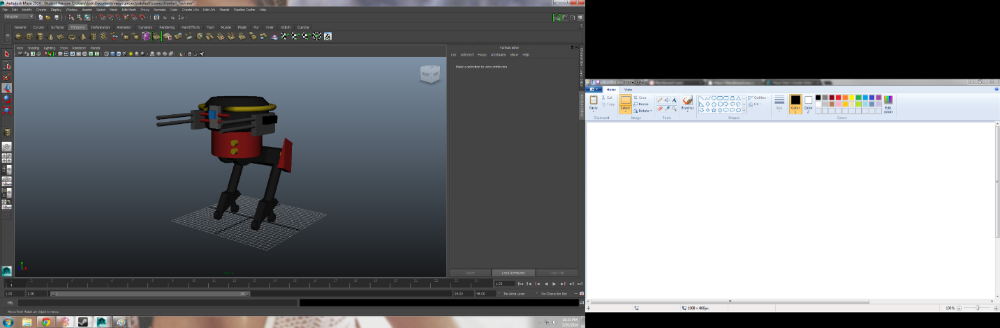

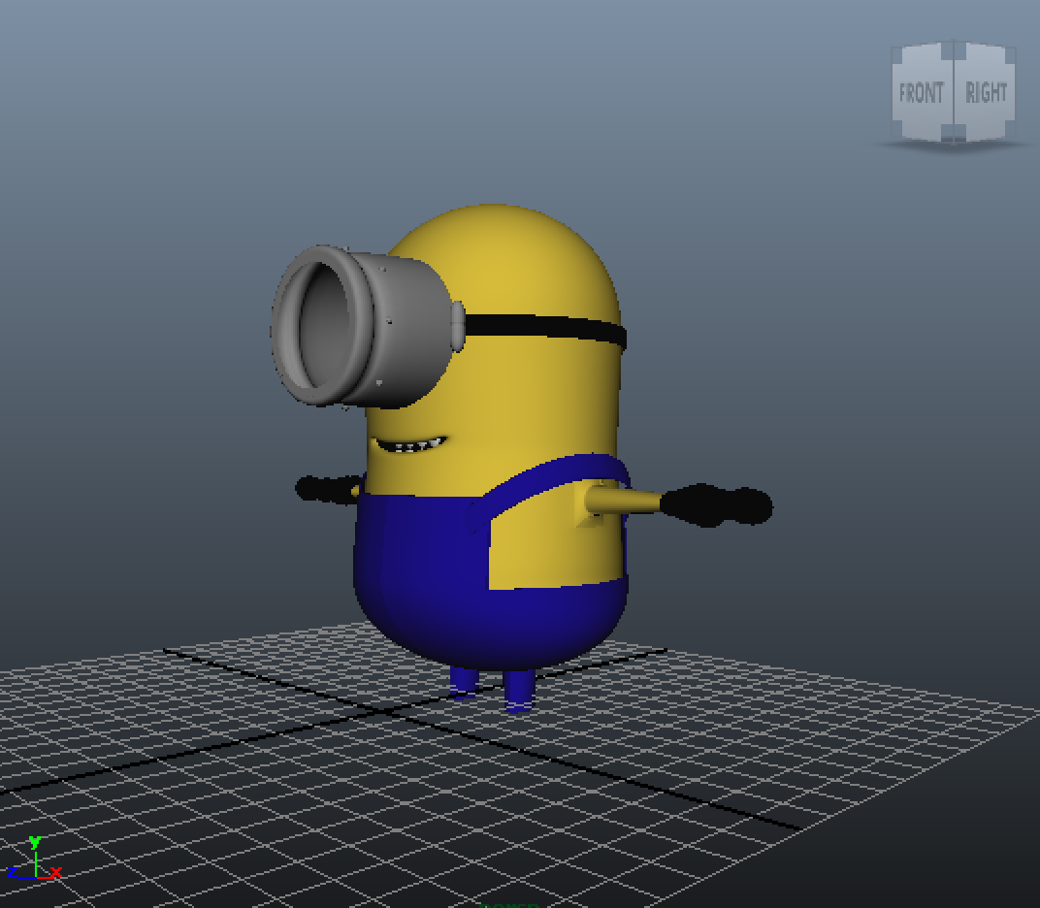

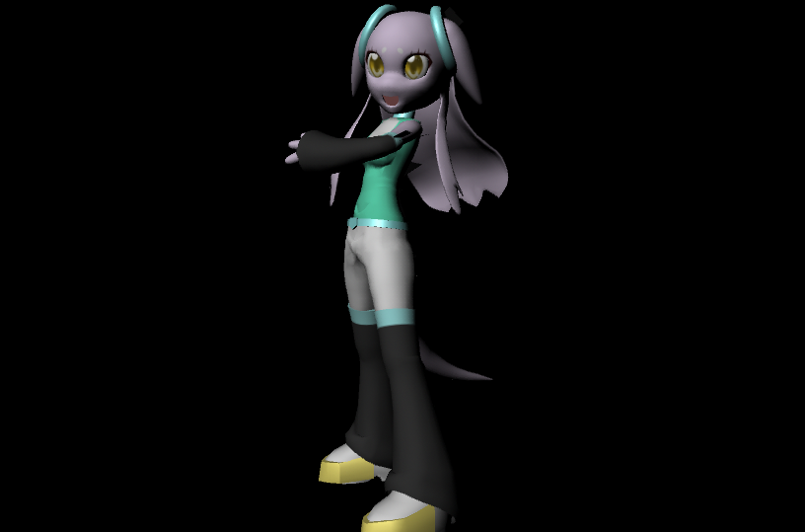



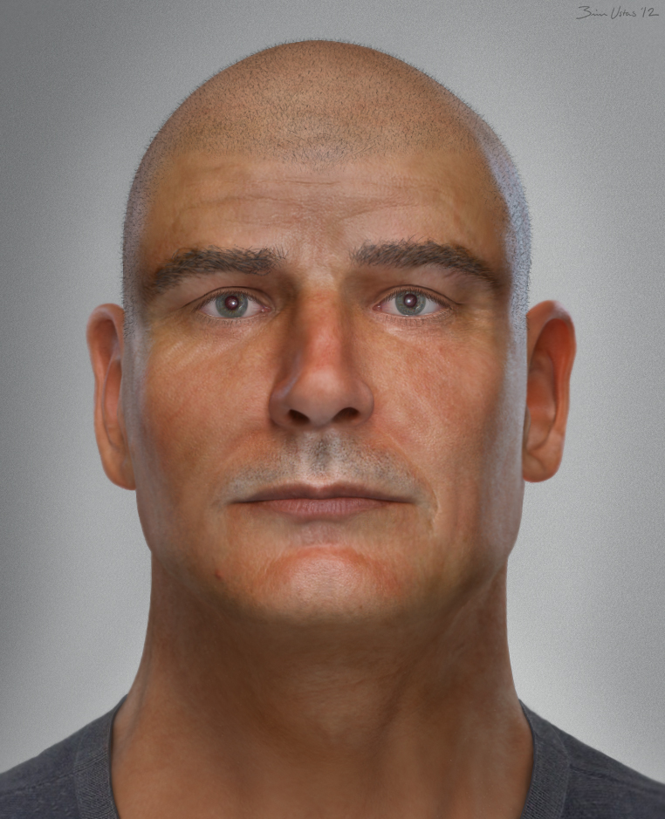

3D Printing Contest

I’ll contribute $10 to 3D print any 3D model that receives a score of 100, if it is printable and the student desires a 3D print of their model.

Scoring Rubric

100 points possible

Option 1 - Create a 3D Model

|  |  |
| --- | --- |
| **Requirement** | **Points** |
| Greater than 1000 polygons or vertices | 25 |
| Renders from at least 3 distinct camera angles. | 20 |
| 2 shaders/textures applied to model | 15 |
| Artistic merit | 25 |
| Quality/professionalism | 10 |
| Assignment naming | 5 |

Option 2 - Create and print a 3D Scan

|  |  |
| --- | --- |
| **Requirement** | **Points** |
| 3D scan quality | 50 |
| 3D print quality | 25 |
| Digitizing a “complex” object (not too simple) | 15 |
| Quality/professionalism | 10 |
| Assignment naming | 5 |

**Submission**

You will submit your assignment via BlackBoard. Upload to the week that you do the assignment. If you submit this in week 4 upload to assignment 4, if you submit this in week 5 upload to assignment 5, etc.

Click the title of assignment (blackboard -> assignment -> <Title of Assignment>), to go to the submission page.

### 3D Resources

Maya Essentials 2: Polygonal Modeling Techniques with George Maestri

<http://www.lynda.com/Maya-tutorials/Maya-Essentials-2-Polygonal-Modeling-Techniques/96715-2.html>

Game Character Creation in Maya with Chris Reilly

<http://www.lynda.com/tutorials/Game-Character-Creation-in-Maya/83095-2.html>

Modeling Vehicles in Maya with Ryan Kittleson

<http://www.lynda.com/Maya-tutorials/Modeling-Vehicles-Maya/114004-2.html>

Character Animation Fundamentals with Maya with George Maestri

<http://www.lynda.com/Maya-tutorials/Character-Animation-Fundamentals-with-Maya/54994-2.html>

Working with HumanIK Rigs in Maya with Adam Crespi

<http://www.lynda.com/Maya-tutorials/Working-Human-IK-rigs-Maya/122440-2.html>

Maya Essentials 5: Animation Tools with George Maestri

<http://www.lynda.com/Maya-tutorials/Maya-Essentials-5-Animation-Tools/96719-2.html>

Facial Modeling Timelapse <http://www.sergicaballer.com/facial-modeling-timelapse/>

*Nice sources of 3D Models*

<http://rigging101.com/>

<http://tf3dm.com/>

<http://www.creativecrash.com/>

<http://www.turbosquid.com/>

<http://www.turbosquid.com/Search/?keyword=ufo&sort_column=A5&sort_order=asc>

<http://www.turbosquid.com/Search/Index.cfm?keyword=rocket&sort_column=A5&sort_order=asc>

<http://www.turbosquid.com/Search/Index.cfm?keyword=robot&sort_column=A5&sort_order=asc>

*SpringerLink Books*

Understanding 3D Animation Using Maya

Authors: John Edgar Park <http://link.springer.com/book/10.1007/b138279>

Principles of Computer Graphics Theory and Practice Using OpenGL and Maya®

Authors: Shalini Govil-Pai

<http://link.springer.com/book/10.1007/b135398>