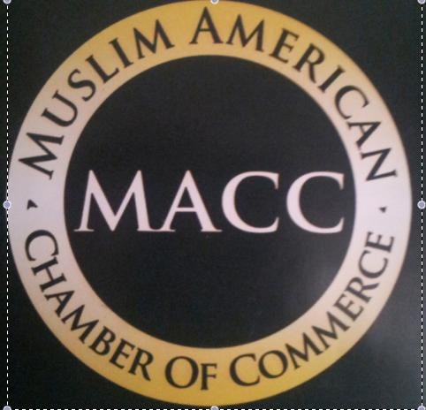
MUSLIM AMERICAN CHAMBER OF COMMERCE

MEMBER APPLICATION

New___________ Renewal___________

________________________________________ |  | _________________ |  |  | _______________
Name Of Applicant |  |  | Title |  | Date
_______________________________________________ |  |  | _____________________________________
Name Of Business/Organization |  |  | Business Type
________________________________________ _______________ _______________ |  |  |  |  | _________
Address |  | City |  | State | zip
_____________________________ | ___________________________ |  |  | _________________________
Telephone | Fax |  |  | Cell
________________________________________ |  | ________________________________________
Email Address |  |  | Web Address
One Year Membership Check One
_____$35.00 - Student | ____$75.00- Small Business/Non-Profit Organization/Corporation
_____$250.00–Government Institutions/Large Non-Profit |  |  | ____$500.00 – United States Major Corporations
CHARGE MY o Visa o Master Card o Discover |  | o Amex Card # ______________________________
________________________________ ______________________________ |  |  |  |  | _______________
Print Name (on card) | Cardholder’s Signature |  |  |  | Exp. Date

Enclosed please find my membership check in the amount of: $____________

Please make check payable to Muslim American Chamber of Commerce.

Mail to:

Muslim American Chamber of Commerce
410-A Lyons Ave. Newark, NJ 07112
Tel: 973-923-5006 Fax: 973-923-2012
Email: hquddus@maccomm.org or nnash@maccomm.org
Website: MuslimAmericanChamberofComm.org

For Office Use Only: Date Received:____________ Date Membership Package Mailed:__________

