Edgar Anderson’s Iris Data

Table of Contents

# Description

This famous ([Fisher’s](https://en.wikipedia.org/wiki/Ronald_Fisher) or [Anderson’s](https://en.wikipedia.org/wiki/Edgar_Anderson)) iris data set gives the measurements in centimeters of the variables sepal length and width and petal length and width, respectively, for 50 flowers from each of 3 species of iris. The species are *Iris setosa, versicolor, and virginica*.

# Usage

iris

# Format

iris is a data frame with 150 cases (rows) and 5 variables (columns) named:

* **Sepal.Length**
* **Sepal.Width**
* **Petal.Length**
* **Petal.Width**
* **Species**

# Source

Anderson, Edgar (1935). “The irises of the Gaspe Peninsula.” *Bulletin of the American Iris Society,* **59**: 2–5.

Fisher, Ronald A. (1936). “The use of multiple measurements in taxonomic problems.” *Annals of Eugenics,* **7** (Part **II**): 179–188.

# Examples

We investigate the Sepal and Petal leaves for the three species in the Iris data:

summary(iris)

## Sepal.Length Sepal.Width Petal.Length Petal.Width   
## Min. :4.300 Min. :2.000 Min. :1.000 Min. :0.100   
## 1st Qu.:5.100 1st Qu.:2.800 1st Qu.:1.600 1st Qu.:0.300   
## Median :5.800 Median :3.000 Median :4.350 Median :1.300   
## Mean :5.843 Mean :3.057 Mean :3.758 Mean :1.199   
## 3rd Qu.:6.400 3rd Qu.:3.300 3rd Qu.:5.100 3rd Qu.:1.800   
## Max. :7.900 Max. :4.400 Max. :6.900 Max. :2.500   
## Species   
## setosa :50   
## versicolor:50   
## virginica :50   
##   
##   
##

To examine the Sepal leaves, we select the length and the width:

llen <- iris$Sepal.Length  
lwid <- iris$Sepal.Width

Then we plot the data:

plot(llen, lwid, xlab = "Length", ylab = "Width",  
pch = 20, col = as.numeric(iris$Species))  
legend("bottomright", legend = levels(iris$Species), col = 1:3, pch = 20)

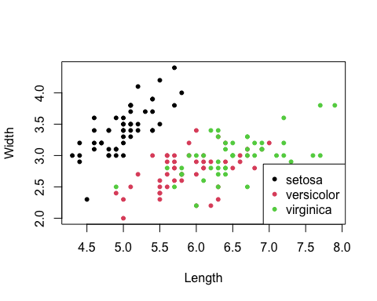

We can also select the Petal leaves:

llen <- iris$Petal.Length  
lwid <- iris$Petal.Width

This gives us the following plot:

