Problem 1

1. D2

|  |  |  |  |  |  |
| --- | --- | --- | --- | --- | --- |
| 0 | 1 | 7 | 4 | 11 | 9 |
| 5 | 0 | 12 | 3 | 23 | 4 |
| 2 | 3 | 0 | ∞ | 3 | 2 |
| 3 | -2 | 22 | 0 | 2 | 1 |
| 4 | 2 | 2 | 4 | 0 | 4 |
| 8 | 3 | 3 | 5 | 1 | 0 |

D4

|  |  |  |  |  |  |
| --- | --- | --- | --- | --- | --- |
| 0 | 1 | 7 | 4 | 6 | 5 |
| 5 | 0 | 7 | 3 | 5 | 4 |
| 2 | 3 | 0 | 6 | 3 | 2 |
| 3 | -2 | 5 | 0 | 2 | 1 |
| 4 | 2 | 2 | 4 | 0 | 4 |
| 5 | 3 | 3 | 5 | 1 | 0 |

D8

|  |  |  |  |  |  |
| --- | --- | --- | --- | --- | --- |
| 0 | 1 | 7 | 4 | 6 | 5 |
| 5 | 0 | 7 | 3 | 5 | 4 |
| 2 | 3 | 0 | 6 | 3 | 2 |
| 3 | -2 | 4 | 0 | 2 | 1 |
| 4 | 2 | 2 | 4 | 0 | 4 |
| 5 | 3 | 3 | 5 | 1 | 0 |



D1

|  |  |  |  |  |  |
| --- | --- | --- | --- | --- | --- |
| 0 | 1 | 7 | ∞ | ∞ | 10 |
| 5 | 0 | 12 | 3 | ∞ | 15 |
| 2 | 3 | 0 | ∞ | ∞ | 2 |
| ∞ | -2 | ∞ | 0 | 20 | 1 |
| ∞ | ∞ | 2 | 4 | 0 | ∞ |
| ∞ | 3 | ∞ | ∞ | 1 | 0 |

D2

|  |  |  |  |  |  |
| --- | --- | --- | --- | --- | --- |
| 0 | 1 | 7 | 4 | ∞ | 10 |
| 5 | 0 | 12 | 3 | ∞ | 15 |
| 2 | 3 | 0 | 6 | ∞ | 2 |
| 3 | -2 | 10 | 1 | 20 | 1 |
| ∞ | ∞ | 2 | 4 | 0 | ∞ |
| 8 | 3 | 15 | 6 | 1 | 0 |

D3

|  |  |  |  |  |  |
| --- | --- | --- | --- | --- | --- |
| 0 | 1 | 7 | 4 | ∞ | 9 |
| 5 | 0 | 12 | 3 | ∞ | 14 |
| 2 | 3 | 0 | 6 | ∞ | 2 |
| 3 | -2 | 10 | 1 | 20 | 1 |
| 4 | 5 | 2 | 4 | 0 | 4 |
| 8 | 3 | 15 | 6 | 1 | 0 |

D4

|  |  |  |  |  |  |
| --- | --- | --- | --- | --- | --- |
| 0 | 1 | 7 | 4 | 24 | 5 |
| 5 | 0 | 12 | 3 | 23 | 4 |
| 2 | 3 | 0 | 6 | 26 | 2 |
| 3 | -2 | 10 | 1 | 20 | 1 |
| 4 | 5 | 2 | 4 | 0 | 4 |
| 8 | 3 | 15 | 6 | 1 | 0 |

D5

|  |  |  |  |  |  |
| --- | --- | --- | --- | --- | --- |
| 0 | 1 | 7 | 4 | 24 | 5 |
| 5 | 0 | 12 | 3 | 23 | 4 |
| 2 | 3 | 0 | 6 | 26 | 2 |
| 3 | -2 | 10 | 1 | 20 | 1 |
| 4 | 5 | 2 | 4 | 0 | 4 |
| 5 | 3 | 3 | 5 | 1 | 0 |

D6

|  |  |  |  |  |  |
| --- | --- | --- | --- | --- | --- |
| 0 | 1 | 7 | 4 | 6 | 5 |
| 5 | 0 | 7 | 3 | 5 | 4 |
| 2 | 3 | 0 | 6 | 8 | 2 |
| 3 | -2 | 4 | 1 | 2 | 1 |
| 4 | 5 | 2 | 4 | 0 | 4 |
| 5 | 3 | 3 | 5 | 1 | 0 |

Problem 2

1. 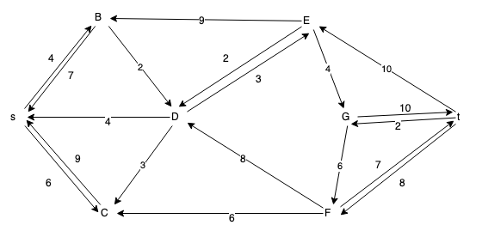
2. p = {s, B, D, E, G, t}  
   cf(p) = 2
3. 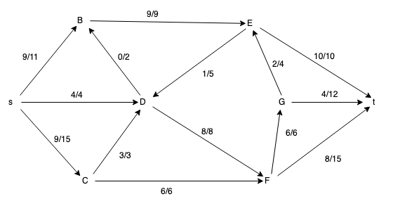
4. min cut = { {s, B, C} , {D, E, F, G, t} } = 22  
   By max-flow-min-cut theorem, max flow = 22

Problem 3

1. Let T’1 and T’2 be the MST of G that remove edge e = (u, v)  
   after increasing the weight, there will be two cases:   
   1. e = (u, v) is still the lightest edge  
   this mean T’ = T  
     
   2. there is e’ = (u’, v’) that lighter than e = (u, v)  
   this mean e’ = (u’, v’) is added to connect T’1 and T’2 , and therefore T and T’ differ by at most one edge.
2. Assume we know the weight of edge e = (u, v) has been change to new weight.  
   Go through the MST and separate the nodes into two sets(T1, T2) by removing edge e = (u, v) [O(V)]  
   Go through all the edges and find those that can connect T1 and T2 as Econnect [O(E)]  
   Look for the min cost edge in Econnect, and connect T1 and T2 . [O(1)]