GlassBoxAI — Project Build Outline
Tagline: Explainable AI decisions with ethical transparency

Phase 0: Product Definition (Do This First)
This prevents scope creep and keeps the project interview-ready.

0.1 Problem Statement
Problem:
AI systems often act as “black boxes,” making decisions without transparency, fairness explanations, or user recourse.
Solution:
GlassBoxAI allows users to:
- Submit a decision request (e.g., resume screening, loan approval, content moderation)
- View AI output
- See how and why the AI made that decision
- Audit bias indicators, confidence, and ethical risk flags

0.2 Core Use Case (Pick ONE initially)
Start narrow. You can expand later.
Recommended MVP Use Case:
AI Resume Screening Transparency Tool
User uploads:
- Resume text
- Job description
GlassBoxAI returns:
- Decision (Pass / Review / Reject)
- Feature importance
- Bias flags
- Ethical explanation

Phase 1: System Architecture (Before Coding)
- 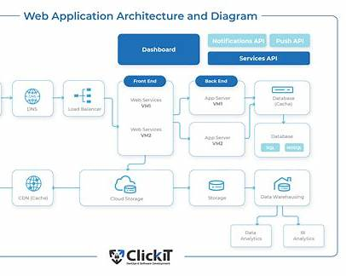
- 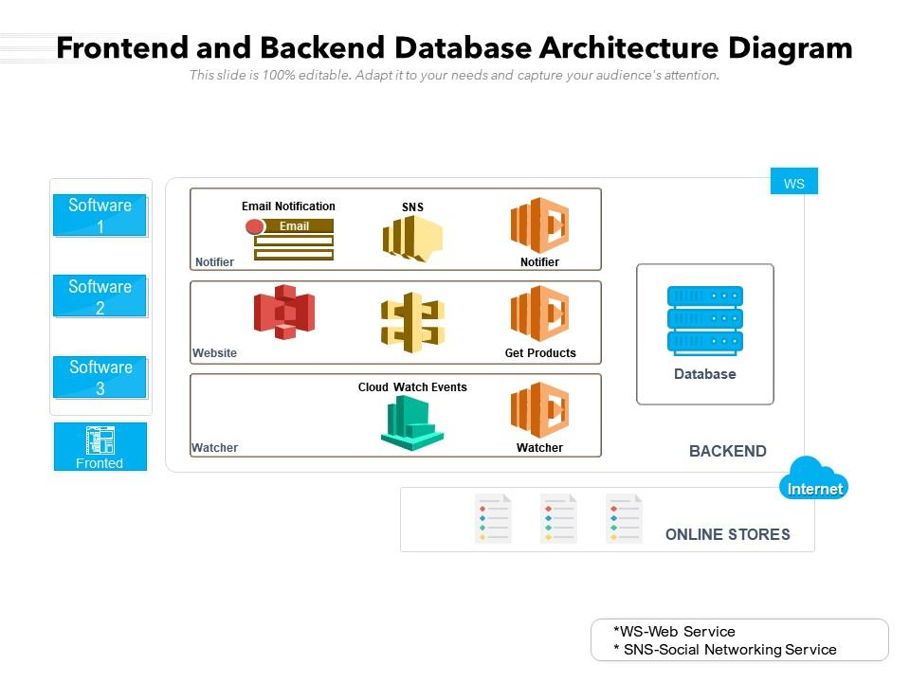
- 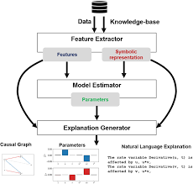
- 1.1 Tech Stack (Interview-Optimized)
Layer | Tech
Frontend | Next.js (React, TypeScript)
Backend API | Node.js + Express
Database | Supabase (Postgres)
Auth | Supabase Auth
AI | OpenAI API (LLM + embeddings)
Explainability | SHAP-style logic + prompt-based reasoning
Cloud Hosting | Vercel (frontend) + Supabase (backend/db)
Logging | Basic audit logs (DB + console)
- ✅ Supabase is an excellent choice for both DB and hosting backend logic.

Phase 2: Database Design (Build Before Backend Logic)

2.1 Core Tables
users
- id
- email
- role
- created_at

requests
- id
- user_id
- input_type
- input_text
- created_at

ai_results
- id
- request_id
- decision
- confidence_score
- explanation
- created_at

ethics_audit
- id
- request_id
- bias_flags
- risk_level
- fairness_notes
Why this matters in interviews:
You show data separation, traceability, and auditability—huge for AI governance.

Phase 3: Backend API (Build First “Real” Code)

3.1 API Endpoints (Order Matters)
- POST /api/request
- POST /api/analyze
- GET /api/results/:id
- GET /api/audit/:id

3.2 Backend Responsibilities
- Input validation
- AI prompt construction
- Explainability logic
- Ethics evaluation
- Store results + logs

Phase 4: AI Logic (The Core Differentiator)
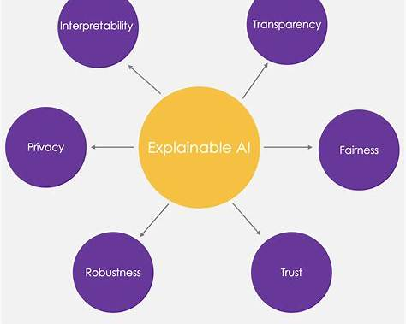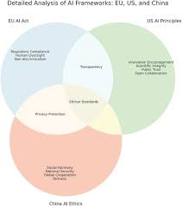
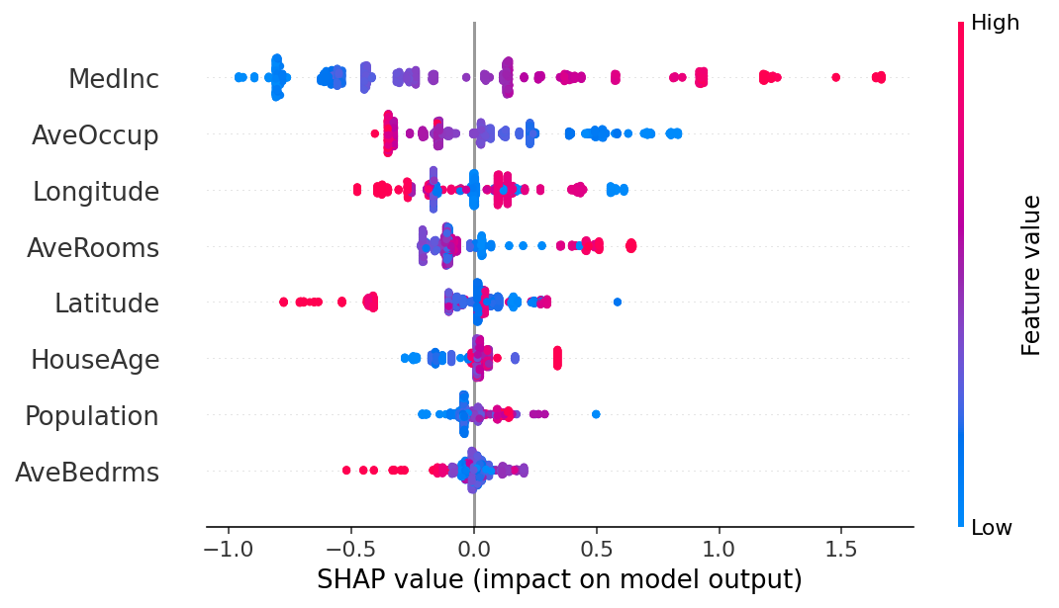

4.1 AI Decision Flow
- Pre-process input
- Run AI inference
- Extract reasoning signals
- Generate:
  - Decision
  - Explanation
  - Bias check
  - Confidence score

4.2 Ethics Checks (Simple but Powerful)
- Gendered language detection
- Overweighting education vs experience
- Missing data penalty detection
You’re not claiming perfect ethics—you're showing process awareness.

Phase 5: Frontend UI (Showcase Design + UX)

5.1 Pages (Build in This Order)
- Landing Page (what & why)
- Login / Auth
- Submission Form
- Results Dashboard
- Ethics Breakdown Panel

5.2 Key UI Components
- Decision badge
- Confidence meter
- Explainability accordion
- Ethics warning indicators

Phase 6: Deployment & Cloud (Critical for Your Goals)
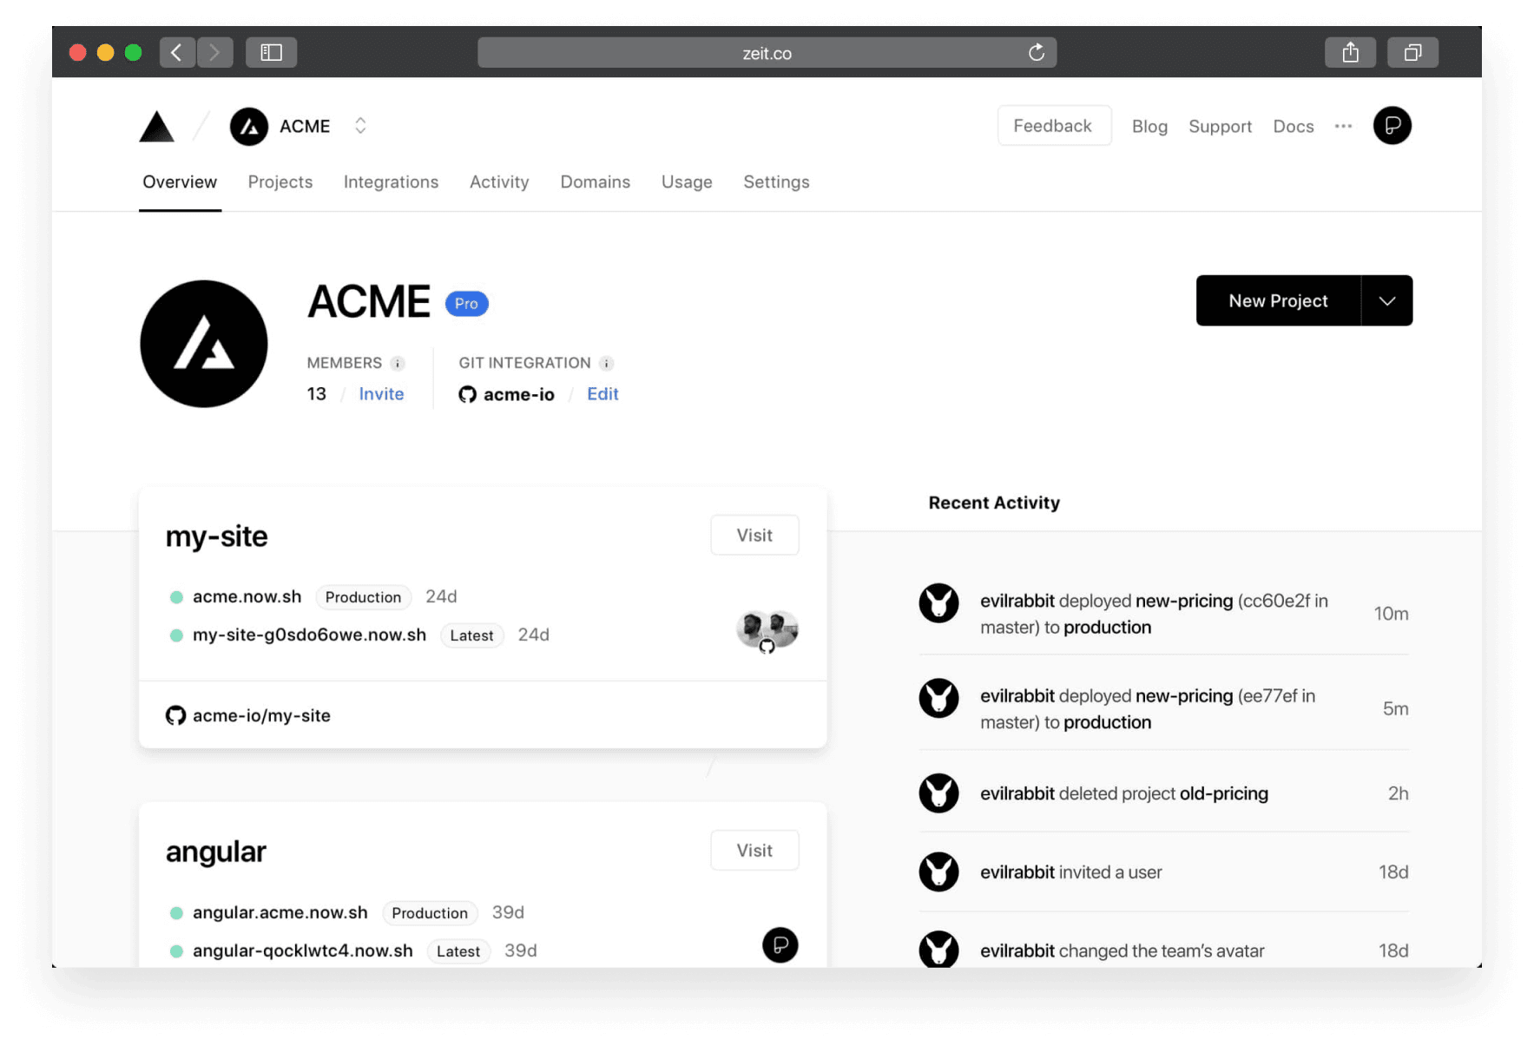
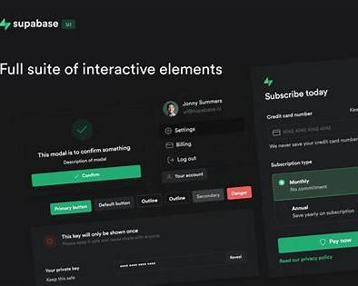
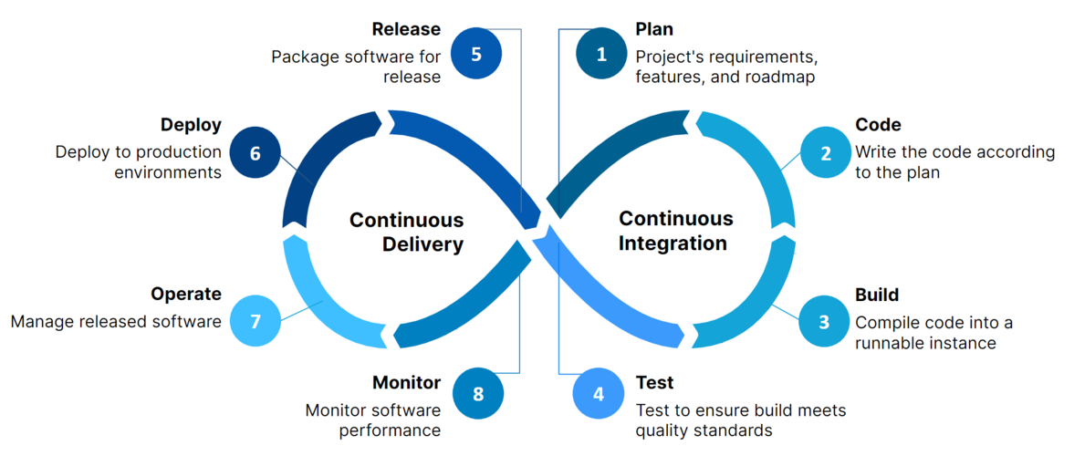

6.1 Deployment Order
- Supabase project + tables
- Backend API live
- Frontend deployed to Vercel
- Environment variables
- Public demo URL

Phase 7: Documentation (Interview GOLD)

7.1 Must-Have Docs
- README.md
- System architecture diagram
- Ethics framework overview
- Sample API requests
- Screenshots / GIFs

Phase 8: Portfolio Polish
- Live demo link
- GitHub repo
- 2–3 sample case studies
- “What I’d improve next” section

Stretch Goals (After MVP)
- Role-based access
- Admin audit dashboard
- Model comparison
- Bias trend analytics
- Cloud logging + monitoring

Why This Project Works for You
This aligns perfectly with:
- Your AI ethics coursework
- Your cloud career goals
- Your full-stack experience
- Your preference for structured, documented builds

