Knitr16Oct

# A title

knitr::opts_chunk$set(message = FALSE, warning = FALSE, fig.width = 3)

3 + 4

## [1] 7

## [1] 142

Filler text There are 1704 rows of data for us to work with,

aust <- gapminder%>%  
 filter(country == "Australia")  
aust

## # A tibble: 12 x 6  
## country continent year lifeExp pop gdpPercap  
## <chr> <chr> <dbl> <dbl> <dbl> <dbl>  
## 1 Australia Oceania 1952 69.1 8691212 10040.  
## 2 Australia Oceania 1957 70.3 9712569 10950.  
## 3 Australia Oceania 1962 70.9 10794968 12217.  
## 4 Australia Oceania 1967 71.1 11872264 14526.  
## 5 Australia Oceania 1972 71.9 13177000 16789.  
## 6 Australia Oceania 1977 73.5 14074100 18334.  
## 7 Australia Oceania 1982 74.7 15184200 19477.  
## 8 Australia Oceania 1987 76.3 16257249 21889.  
## 9 Australia Oceania 1992 77.6 17481977 23425.  
## 10 Australia Oceania 1997 78.8 18565243 26998.  
## 11 Australia Oceania 2002 80.4 19546792 30688.  
## 12 Australia Oceania 2007 81.2 20434176 34435.

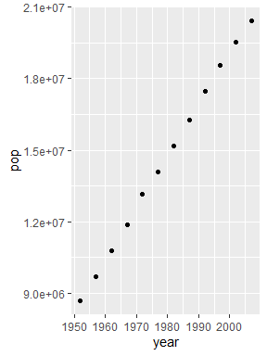 Make text bold **bold** or *italics* or code

* First thing to do
* Second thing to do
* Third thing to do

Some text that needs footnoting [1].

ggplot(aust,aes(x = year, y = pop)) +  
geom_point()



1. list 1
2. second
3. last

[link to our notes](https://csiro-data-school.github.io/rmarkdown)



“caption”

## A subtitle

## A second

### Section header

This document was produced using R 3.6.1 and the tidyverse1.2.1

1. And here is my footnote text