TECHNICAL DOCUMENTATION
4-UAV Real-Time Direct-Georeferencing
Video Mosaicking Pipeline
Deterministic frame-to-world registration from telemetry alone. No feature matching, no prior map, no bundle adjustment. Unity simulation through to a live map layer inside Mission Planner.
Property | Value
Document scope | System design, mathematics, wire protocol, simulation setup, deployment, limits
Registration method | Direct georeferencing — ray/plane intersection from pose, intrinsics and laser range
Fleet | 4 aircraft, EO active, IR wired but dormant
Update rate | 10 Hz fusion loop; measured 30.3 ms median per tick
Registration accuracy | NCC 0.9961 against synthetic ground truth, correlation peak at 0 m offset
Verification | 168 automated tests, all passing
Software | Python 3.10, OpenCV 4.10, NumPy 2.2, FFmpeg 7.1 (optional)
Simulation | Unity 2022.3 LTS, Universal Render Pipeline
Display | Mission Planner 1.3.80+ — WMS map layer, MJPEG HUD, or H.264 over UDP

Contents
§ | Section | Covers
1 | System Overview and Core Methodology | Executive summary · why feature matching fails · the direct-georeferencing paradigm
2 | Mathematical Blueprint and Coordinate Frames | Handedness bridge · ray/plane intersection · 3-tier plane cascade · weight rule
3 | Network Architecture and Wire Protocol | Dataflow topology · byte-level packet specification · daemon thread pattern
4 | Unity Simulation Setup | Camera configuration · script parameters · swarm flight dynamics
5 | Deployment and Operation | Quick start · Mission Planner configuration · target coordinate extraction
6 | System Limits and Troubleshooting | Flat-plane parallax · failure modes · coordinate validation checklist
A | Source Material | Papers and reference implementations analysed
B | Command-Line Reference | Every backend flag
C | Verification Inventory | What the 168 tests cover

1 System Overview and Core Methodology

1.1 Executive Summary
Four UAVs survey a shared area. Each carries an electro-optical camera on a stabilised gimbal, a laser rangefinder, and a telemetry source giving position and attitude. The operational requirement is a single, live, metrically correct picture of the ground, on which a target seen by any aircraft reads out at true world coordinates.
The constraint that decides the design: the four fields of view may or may not overlap. Aircraft fly separate lanes. At maximum optical zoom the ground footprint is 1649 m across while lane spacing is 2000 m, leaving a 351 m strip that no camera sees. Any method that registers images against each other has nothing to work with in that condition.
This pipeline registers every frame against the world, not against its neighbours. Camera pose, intrinsics and laser range are sufficient to compute which patch of ground each pixel observed. Registration becomes arithmetic on telemetry rather than a search over pixels. Two frames that never touch still land in correct relative position, because both were placed by the same arithmetic against the same world frame.
Requirement | Delivered | Evidence
Non-overlapping fields of view | Supported by construction | Registration never reads a second frame
Real-time, 5-10 Hz | 10 Hz, 30.3 ms median tick | Per-stage p50/p90/p99 instrumentation
Deterministic mathematics only | No feature detector in the spatial path | georef.py imports no feature module
Metric accuracy | NCC 0.9961, peak at 0 m offset | Synthetic ground-truth comparison
Asynchronous daemon architecture | 4 receiver threads + 4-thread warp pool | All release the GIL
Explicit handedness resolution | One module, unit-tested | coords.py, golden nadir case

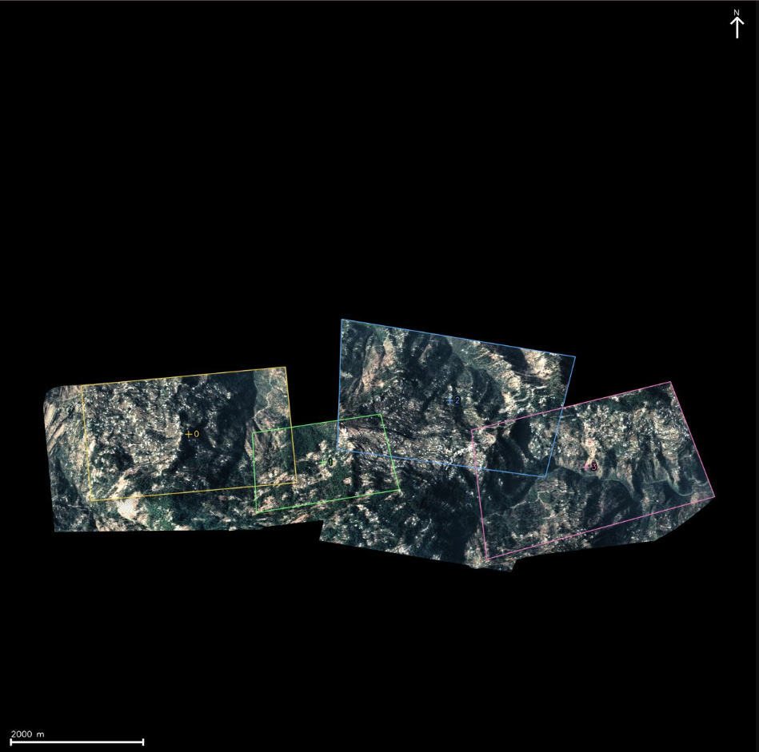
Figure 1.1 - Live output roughly 20 seconds of coverage. The four blocks are individual aircraft lanes. Black is ground not yet imaged. Numerals mark current aircraft positions.

1.2 Why Feature-Based Stitching Fails Here
Classical mosaicking estimates a homography H between two images from point correspondences: a detector (SIFT, ORB), a descriptor matcher, and RANSAC to reject outliers. The failure in this application is structural, not a matter of tuning.
H has 8 degrees of freedom ⇒ a solution needs ≥ 4 correspondences
A correspondence requires the same ground point visible in both images
Disjoint footprints ⇒ the set of shared ground points is empty
⇒ 0 correspondences ⇒ H is undefined, not merely inaccurate
Formula 1.1 - A rank deficiency, not a noise problem. No detector, descriptor or robust estimator changes an empty correspondence set.
Three further problems apply even where images do overlap:
- Drift. Relative homographies compose. Chaining N frames multiplies N estimates and error accumulates without bound. Correcting it needs loop closure or bundle adjustment, neither of which is real-time at fleet scale.
- No absolute anchor. A feature-matched mosaic is internally consistent but floats. It cannot report latitude and longitude without external control points.
- Shallow-angle collapse. The SkyPin study benchmarks matchers at -30 deg to -60 deg pitch and reports that even the best of them struggles. Oblique gimbal geometry is the normal case here, not the exception.
MGRAPH is the informative counter-example
MGRAPH (Ruiz et al., RA-L 2018) is a well-executed graph-based mosaicking system: ORB features, brute-force Hamming matching, RANSAC, 4-DoF similarity edges, periodic non-linear optimisation. Its graph edges exist only where images match. On a disjoint four-aircraft survey the graph is four isolated components with no known relative transform between them.
Useful reframing: direct georeferencing is MGRAPH collapsed to a star graph. There is one virtual reference vertex - the world - and every absolute homography comes from telemetry instead of a chain of relative edges. Because no edge is a chained estimate, drift cannot accumulate, so graph fusion and non-linear refinement are structurally unnecessary rather than merely skipped.
One result from MGRAPH is retained: its Eq. 3 zero-overlap distance D_max = 2·√(F_w² + F_h²), used here not for registration but as a cheap predictor of which aircraft pairs will contend for canvas pixels.

1.3 The Direct-Georeferencing Paradigm
Every frame carries the five quantities that fix its geometry: camera position, camera orientation, focal length, image size, and range to ground. From those, each pixel defines a ray in world space, and the intersection of that ray with the ground surface is the world point the pixel observed.
Step | Operation | Cost
1 | Build K from focal length and image size at the current zoom | negligible
2 | Convert the Unity quaternion to an ENU-to-camera rotation matrix | negligible
3 | Solve the ground plane from the laser range (3-tier cascade, 2.4) | negligible
4 | Cast the four image corners to that plane | 4 ray/plane solves
5 | cv2.getPerspectiveTransform on the four corner pairs | one 8x8 solve
6 | cv2.warpPerspective into the canvas region of interest | dominant, 12-30 ms
7 | Composite under the adaptive max-weight rule (2.5) | 2-5 ms

Only four rays are cast per frame. The homography derived from those four corner correspondences is exact for a planar scene, and warpPerspective resamples every interior pixel through it.
Why one homography per frame is exact, not an approximation
GROMS partitions an orthorectification into blocks, measures elevation variance per block, and applies a single fast remap to flat blocks while reserving per-pixel correction for rugged ones. A laser-derived ground plane makes every block flat by definition, so one homography per frame is the degenerate-exact case of GROMS's own fast path rather than a shortcut around it.
A second consequence is worth stating. Hinzmann reports his backward-projection path as 25-100x slower than his forward homography and treats the two as a quality/speed trade. That gap exists because his backward path ray-traces against a digital surface model. On a plane, the backward mapping is the inverse homography, and cv2.warpPerspective already samples backward internally. The result is backward-projection quality at forward-projection cost; the published trade-off does not apply to this configuration.

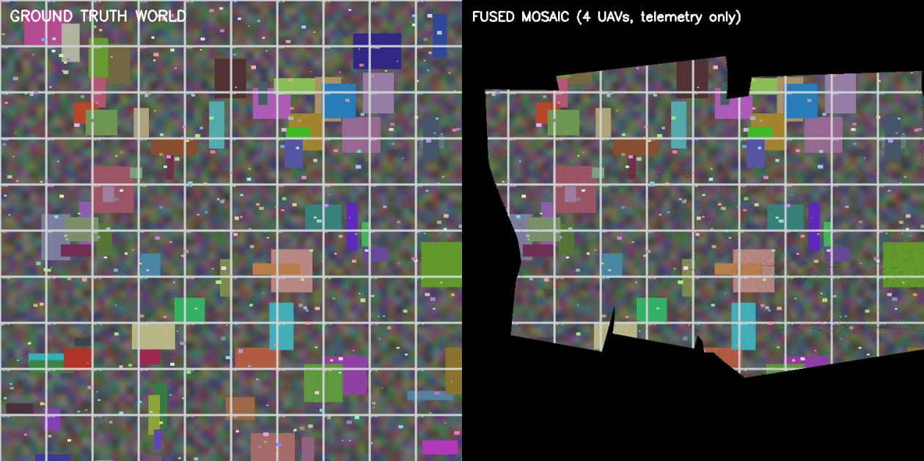
Figure 1.2 - Registration validation. Left: synthetic ground-truth world. Right: the mosaic fused from four aircraft using telemetry only. Grid intersections coincide. Normalised cross-correlation 0.9961 with the correlation peak at exactly 0 m offset, so there is no systematic bias in any direction.

2 Mathematical Blueprint and Coordinate Frames
Frame convention: ENU throughout
The world frame is ENU - X East, Y North, Z Up - and Z increases upward. NED does not appear anywhere in the implementation. Every formula in this section, every sign, and every gate assumes ENU. Substituting NED silently inverts the sign of the descent test in 2.3 and the mosaic collapses.

2.1 The Four Frames
Frame | Axes | Handedness | Origin
Unity world | X right, Y up, Z forward | Left | Unity scene origin
Unity camera | X right, Y up, Z along the optical axis | Left | camera
CV camera | X right, Y down, Z along the optical axis | Right | camera
Local ENU | X East, Y North, Z Up | Right | geodetic anchor

Two fixed matrices bridge them. Both are involutions (S² = F² = I) and both have determinant -1, which is exactly what converts left-handed to right-handed.
[ 1 0 0 ] [ 1 0 0 ]
S = [ 0 0 1 ] F = [ 0 -1 0 ]
[ 0 1 0 ] [ 0 0 1 ]

ENU <- Unity world Unity camera <- CV camera

S maps E = x_u, N = z_u, U = y_u. F flips the camera Y axis.
det(S) = -1 and det(F) = -1 -- both asserted in tests/test_coords.py
Formula 2.1 - The handedness bridge. Defined once, in uavmosaic/coords.py.
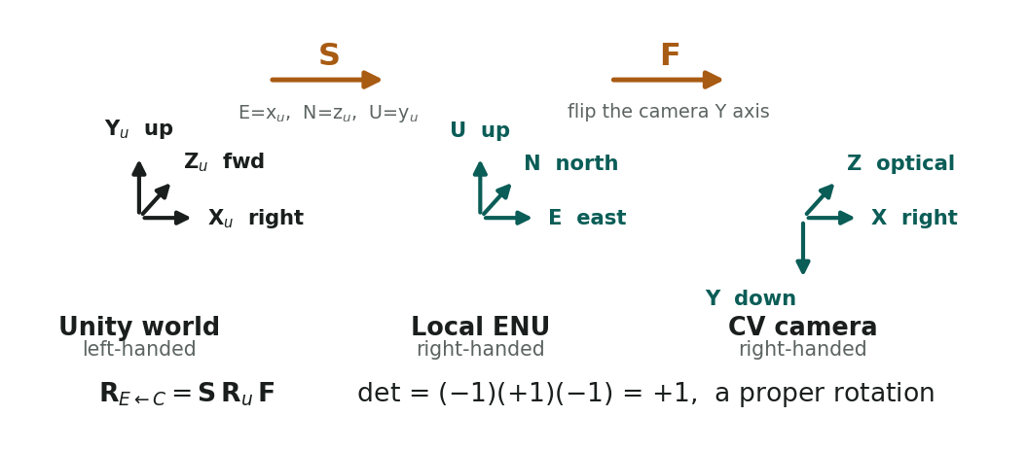
Figure 2.1 - The three frames and the two matrices that connect them. Unity is left-handed with Y up; ENU and the CV camera frame are right-handed. The composition of two determinant -1 matrices with a proper rotation yields a proper rotation.

2.2 The Rotation Chain
Unity reports q, the camera orientation in Unity world space. Let R_u = R(q) be Unity's own quaternion-to-matrix conversion, which is self-consistent within its left-handed frame and maps Unity-camera to Unity-world. Then:
R_E←C = S · R_u · F

det = (-1)(+1)(-1) = +1, a proper rotation, as required
Camera position: C = S · p_unity
Formula 2.2 - The only rotation that matters. Everything downstream consumes R_E←C and C.

Test Case
A nadir camera whose image-up direction points along Unity +Z. This case is asserted exactly in tests/test_coords.py::test_nadir_north_up:
[ 1 0 0 ] [ 1 0 0 ]
R_u = [ 0 0 -1 ] R_E<-C = S R_u F =[ 0 -1 0 ]
[ 0 1 0 ] [ 0 0 -1 ]

X_cv (image right) -> ( 1, 0, 0) = East correct
Y_cv (image down) -> ( 0, -1, 0) = South correct: image y grows southward
Z_cv (optical axis) -> ( 0, 0, -1) = Down correct
Formula 2.3 - If this case is wrong, every mosaic is mirrored or rotated. It is checked on every test run, along with orthonormality and det = +1 for randomised quaternions.
Design rule to remove bug
The Unity C# sender performs zero coordinate conversion. It transmits raw Unity floats. Every left-to-right-handed operation lives in one Python module, coords.py, behind unit tests. Correia et al. spend five pages on frame chains precisely because that conversion is where projects break; splitting it across two languages and two codebases is how it becomes unfindable.

2.3 Intrinsics and Ray/Plane Intersection
Intrinsics are recomputed per frame, because optical zoom changes focal length in flight (Correia Eq. 32-33):
f_x = f[mm] * W[px] / SensorWidth[mm] [ f_x 0 c_x ]
f_y = f[mm] * H[px] / SensorHeight[mm] K = [ 0 f_y c_y ]
[ 0 0 1 ]

If Unity reports horizontal FOV instead: f_x = (W/2) / tan(FOV_h / 2)
Both are transmitted, so the backend cross-checks and warns on disagreement.
Formula 2.4 - K is rebuilt every frame. EO and IR carry separate blocks.
For each of the four image corners (u, v):
d_c = K⁻¹ [u, v, 1]ᵀ ray in the CV camera frame
d_w = R_E←C · d_c ray in ENU

reject the frame if d_w.z ≥ -ε the ray does not descend
cosθ = -d_w.z / ‖d_w‖ incidence angle
reject the frame if θ > θ_max = 65°

λ = (z_plane - C.z) / d_w.z λ > 0 since C.z > z_plane, d_w.z < 0
G = C + λ · d_w the ground point, in ENU
Formula 2.5 - Ray/plane intersection. Three independent sources state this identically: Hinzmann Alg. 2, Correia Eq. 60-61, and SkyPin Eq. 4.
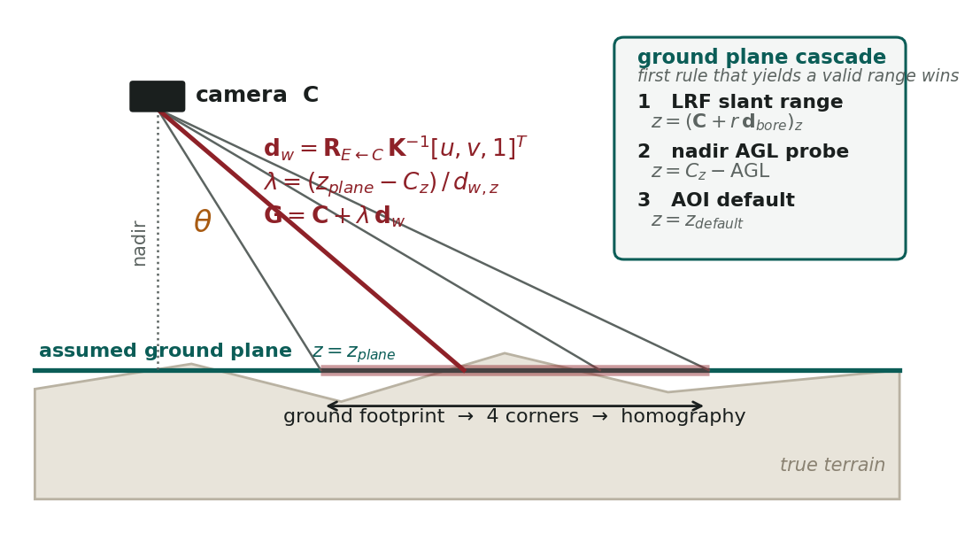
Figure 2.2 - Ray/plane intersection and the ground-plane cascade. Four corner rays are intersected with the assumed plane; the resulting quadrilateral becomes the homography target. The true terrain, shown beneath, is what the plane approximates - the source of the error analysed in 6.1.
ENU is then converted to canvas pixels by a fixed affine transform. This is the reason the area of interest is fixed rather than growing: the mapping never changes, so no frame's placement depends on when it arrived.
x_px = (E - E_min) / GSD
y_px = (N_max - N) / GSD // N is flipped: image y grows southward

H = cv2.getPerspectiveTransform(src_corners, dst_corners_in_ROI)
warped = cv2.warpPerspective(frame, H, (roi_w, roi_h))
Formula 2.6 - ENU to canvas. The warp is done into a region of interest, never into the full 5600 x 5600 canvas.
Guards on the footprint
Descent test. A ray with d_w.z >= 0 points at or above the horizon and has no ground intersection. The frame is rejected.
Incidence gate. Rejected past 65 deg off nadir, following Map2DFusion's axis.dot(downLook) < 0.4 threshold. On the delivered configuration the worst measured corner was 48.5 deg, so nothing is rejected in normal flight.
Extent clamp. A footprint larger than 20x the nadir diagonal indicates a near-horizon ray. The frame is retried using only the lower half of the image - the ground-facing part under a tilted gimbal - and dropped if that also fails.

2.4 Three-Tier Ground-Plane Cascade
The boresight direction in world space is the third column of R_E←C. The first rule that yields a valid range wins:
d_bore = R_E←C · [0, 0, 1]ᵀ

1. slant range valid AND d_bore.z < -sin(10°): z_plane = (C + r · d_bore).z
2. elif AGL valid: z_plane = C.z - AGL
3. else: z_plane = z_default
Formula 2.7 - Implemented in georef.solve_ground_plane.
Tier | Source | Correct when | Failure mode
1 | Laser slant range along the boresight | Always, including an oblique gimbal - it takes the elevation of the point the boresight actually strikes | Returns nothing over water or beyond maximum range
2 | Nadir AGL probe | Exact at nadir | Degrades over sloped terrain, because it measures beneath the aircraft rather than where the camera looks
3 | Configured area elevation (--plane-z) | A last resort that keeps the frame usable | Fixed value; error equals local relief

Each aircraft solves its own plane, every frame. There is no single global plane. The d_bore.z < -sin(10°) condition on tier 1 prevents a near-horizontal boresight from projecting the range to an absurd elevation. The tier actually used is logged and shown in the engineering overlay.

2.5 Adaptive Weight and the Compositing Rule
Where two aircraft see the same ground, one pixel must win. The weight is the product of three terms:
w(u,v) = w_radial(u,v) · w_incidence(u,v) · w_gsd
Formula 2.8 - Map2DFusion's paper describes an adaptive weight over height, view angle and pixel location, but its released code ships only the radial term. The other two are implemented here.
Term | Form | Rationale | Cost
w_radial | (1 - r/r_max)², floored at 1e-5 | Lens falloff and residual distortion are worst at the frame border | Cached once per image size
w_incidence | max(0, cosθ(u,v))² | Hinzmann's closest-to-nadir rule, made continuous rather than a hard choice | Evaluated on a 1/16-scale grid, then resized
w_gsd | gsd_ref / gsd_frame | A lower-flying or zoomed-in aircraft resolves more detail and should win | One scalar per frame

Compositing is deliberately single-threaded. The rule is a read-modify-write on shared pixels, and two threads writing overlapping regions would race. It is also cheap, so there is nothing to gain from parallelising it.
same_owner = (OWNER_roi == uav_id)
update = valid & (same_owner | (w_new > WEIGHT_roi))

CANVAS_roi[update] = warped[update]
WEIGHT_roi[update] = w_new[update]
OWNER_roi[update] = uav_id
STAMP_roi[update] = t_now
Listing 2.1 - The canvas update rule, from uavmosaic/canvas.py. In production the masked assignment is cv2.copyTo, which measured 0.28 ms against 22.88 ms for np.copyto(where=mask[:,:,None]) - an 80x difference on the same operation.
The same-owner clause is essential
Without it, an aircraft's own stale high-weight pixels block its fresh frames the moment it drifts to a marginally worse viewing angle. The mosaic freezes beneath the aircraft while it is still transmitting - a failure that looks like a dropped link but is not one.
The rule: an aircraft always overwrites itself. Maximum weight arbitrates only between different aircraft.

Seam feathering
A hard weight comparison produces a visible brightness step where two frames meet, because the same ground photographed at different zoom or angle returns slightly different exposure. The composite cross-fades over a band proportional to the peak weight:
alpha = clip((w_new - w_cur) / (feather * w_peak) + 0.5, 0, 1) * valid
alpha[valid & (w_cur <= 0)] = 1.0 # never blend against unwritten canvas
alpha[valid & (owner == uav_id)] = 1.0 # never blend against one's own stale pixels
cv2.blendLinear(warped, dst, alpha, 1 - alpha, dst=dst)
Listing 2.2 - Division-free alpha ramp. Default --feather 0.3. Measured effect: the photometric step across a seam falls from 108.5 to 53.6 levels out of 255, for about 1 ms per tick.
Both guard lines were found by measurement, not by inspection
The first version blended against the unwritten black canvas at the edge of coverage. End-to-end correlation against ground truth fell from 0.995 to 0.885 - the mosaic was measurably worse while looking smoother. Both putmask lines above exist to prevent that, and the end-to-end test now asserts the correlation floor.

3 Network Architecture and Wire Protocol

3.1 Dataflow Topology
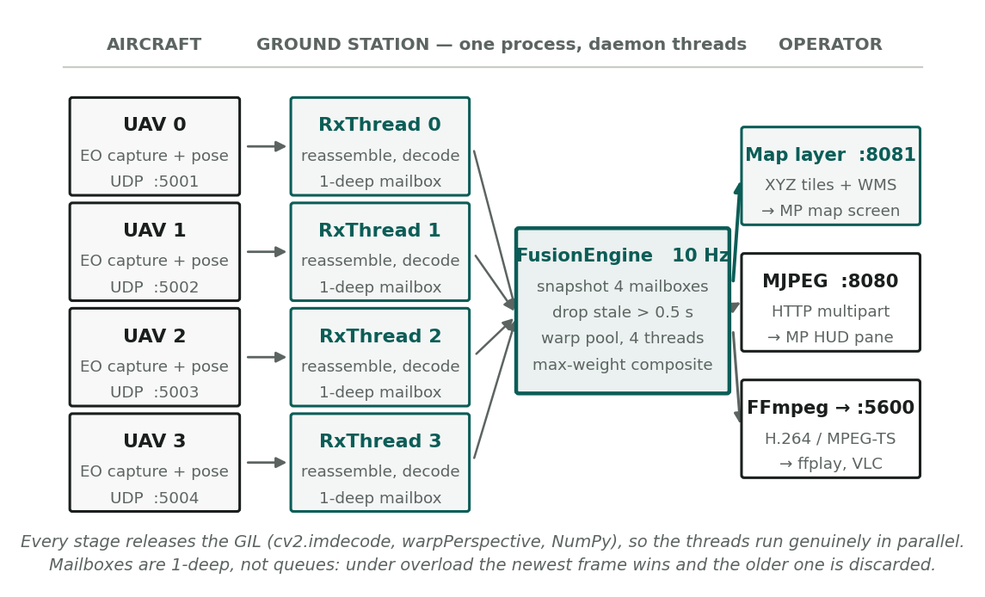
Figure 3.1 - End-to-end dataflow. Four aircraft, four dedicated receiver threads, one fusion loop, three output paths. Everything to the right of the receivers runs inside a single Python process.
Stage | Concurrency | Blocks on | Never does
UdpReceiver x 4 | one daemon thread each | recvfrom, 0.5 s timeout | touch the canvas
LatestSlot x 4 | lock-guarded, 1 deep | nothing measurable | grow, queue or allocate
FusionEngine | one daemon thread | a fixed-rate 10 Hz tick | socket I/O
warp pool | 4 worker threads | ThreadPoolExecutor.map | mutate shared state
FfmpegSink | one daemon writer | ffmpeg stdin | block fusion; it drops instead
TileServer, MjpegSink | HTTP server threads | client sockets | hold the canvas lock across a network write

Threads, not processes
Every expensive call in the loop - cv2.imdecode, cv2.warpPerspective, cv2.resize, NumPy element-wise operations - releases the GIL, so these threads achieve genuine parallelism.
Processes would be strictly worse: the canvas is 375 MB across its four buffers (94 MB colour, 125 MB weight, 31 MB owner, 125 MB timestamp at 5600 x 5600), and pickling any part of that across a pipe every tick would cost more than the work being distributed.

The mailbox is one deep, and that is deliberate
LatestSlot holds exactly one frame per stream. A new arrival overwrites whatever was there and increments a superseded counter. It is not a queue.
- A queue under sustained overload grows without bound, and every frame drawn from it is older than the last. Latency debt accumulates until the display is minutes behind the aircraft while appearing to work normally.
- A one-deep mailbox discards the older frame. Latency stays bounded at one tick regardless of load, and the superseded counter makes the overload visible as a number rather than as a slowly worsening feeling.

3.2 Wire Protocol
MJPEG carried in UDP datagrams. Little-endian throughout. Each datagram is a 36-byte header, a 64-byte telemetry block, then a slice of the JPEG.
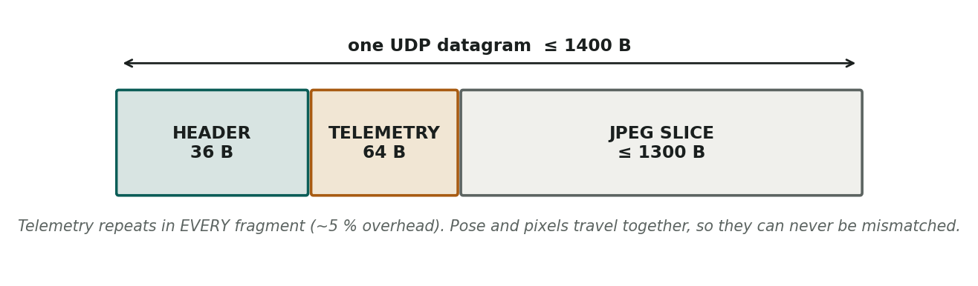
Figure 3.2 - Datagram layout. The telemetry block repeats in every fragment, not only the first.

Header, 36 bytes
Off | Size | Type | Field | Meaning
0 | 4 | u32 | magic | 0x31564155, reads as 'UAV1'. Rejects foreign traffic on the port.
4 | 1 | u8 | version | Protocol version, currently 1
5 | 1 | u8 | uav_id | 0 to 3
6 | 1 | u8 | sensor_id | 0 = EO, 1 = IR
7 | 1 | u8 | flags | bit0 LRF valid, bit1 AGL valid, bit2 telemetry present
8 | 4 | u32 | frame_id | Monotonic per (uav, sensor). Detects loss and reordering.
12 | 8 | u64 | t_capture_us | Unity capture time in microseconds. The sync key.
20 | 2 | u16 | frag_index | 0-based index of this fragment
22 | 2 | u16 | frag_count | Total fragments in this frame
24 | 2 | u16 | frag_len | JPEG bytes carried in this datagram
26 | 4 | u32 | total_len | JPEG bytes in the complete frame
30 | 2 | u16 | telem_len | Always 64
32 | 4 | u32 | frag_offset | Byte offset of this slice within the JPEG

frag_offset exists because of a real defect
The first implementation omitted it and had the receiver reconstruct each slice's position by multiplying frag_index by an assumed chunk size. That works only while every fragment is exactly the same length, which stops being true the moment the MTU changes or a final short fragment appears. The offset is now transmitted explicitly, so reassembly never infers geometry it was not told.

Telemetry, 64 bytes, present in every fragment
Off | Size | Type | Field | Meaning
0 | 12 | f32 x3 | pos_unity | Camera position, raw Unity world coordinates, metres
12 | 16 | f32 x4 | quat_world_cam | Camera orientation x, y, z, w, raw Unity
28 | 4 | u16 x2 | img_w, img_h | Image dimensions in pixels
32 | 16 | f32 x4 | fx, fy, cx, cy | Intrinsics in pixels at the current zoom
48 | 16 | f32 x4 | lrf_slant_m, agl_m, hfov_deg, zoom | Laser slant range along the boresight, height above ground, horizontal field of view for cross-check, and zoom factor

Why telemetry repeats in every fragment
It costs about 64 B x 25 fragments = 1.6 KB per frame, roughly 5 % overhead, and buys the property that matters: pose and pixels are atomic. Lose fragment 0 on a real radio link and the remaining fragments still carry the full pose.
Nothing in the system can ever pair frame N's pose with frame N+1's image, because they never travelled separately. The alternative - a telemetry stream alongside a video stream, correlated by timestamp - is the standard design and the standard source of subtle registration error.

Fragmentation and loss policy
Parameter | Value | Reason
MTU | 1400 B | Loopback tolerates ~64 KB, but a protocol only exercised on loopback hides fragmentation bugs that appear on the first real link
Payload per fragment | 1300 B | 1400 minus 36 header minus 64 telemetry
Frame deadline | 150 ms | A frame missing any fragment is dropped whole at this age
In-flight frames | 2 per stream | Bounds memory, so loss cannot grow the heap
Partial JPEG | never decoded | A truncated JPEG is not a partial image, it is noise
EO ports | 5001-5004 | One socket per stream gives per-aircraft OS buffering
IR ports | 5011-5014 | Wired, dormant until --ir

Typical load: 1280 x 720 at quality 65 gives about 31 KB per frame, so 25 fragments. Four aircraft at 10 Hz is roughly 1000 datagrams per second. Section 5.5 covers what happens when those datagrams start disappearing.

3.3 Why Background Daemons Prevent Buffer Overflow
A UDP socket's receive buffer is fixed. If the application does not call recvfrom fast enough, the kernel discards arriving datagrams silently - no error, no exception, just missing fragments and frames that never complete.
The failure is easy to create: do the georeferencing work on the same thread that reads the socket. Warping takes 12-30 ms; during that window nothing is draining the buffer, and at 1000 datagrams per second the buffer fills.
- Separation. Receiver threads do nothing but recvfrom, reassemble, decode, and publish to a mailbox. They never touch the canvas and never block on the fusion loop.
- Enlarged buffers. Each socket requests an 8 MB receive buffer, roughly 6000 datagrams of headroom against a scheduling hiccup.
- Bounded work per datagram. Reassembly is a dictionary insert and a memory copy. JPEG decode releases the GIL, so other receivers keep draining during it.
- Daemon threads. All are daemon=True, so Ctrl+C terminates the process without waiting on a blocking recvfrom.
- Failures degrade to counters. A malformed packet, an undecodable JPEG, or a socket error increments a counter and drops one frame. A receiver thread that died silently would be indistinguishable from an aircraft going quiet.

4 Unity Simulation Setup

4.1 Install the Scripts
Three C# files. The third adds a Unity menu that performs the rest of the setup.
File | Copy to | Purpose
UavStreamer.cs | Assets/Scripts/Mosaicking/ | Captures the camera, reads pose and range, fragments and transmits
UavRandomFlight.cs | Assets/Scripts/Mosaicking/ | Autonomous lawnmower flight, gimbal wander, optical zoom modulation
MosaickingSetup.cs | Assets/Editor/ | Editor menu. Must sit directly inside a folder named Editor or Unity compiles it into the runtime assembly and the build fails

1. In Windows Explorer, open your Unity project folder and find Assets.
2. Inside Assets, create Scripts, then Mosaicking inside that. Right-click empty space, then New then Folder.
3. Back in Assets, create a folder named exactly Editor.
4. Copy the three files to the destinations in the table above.
5. Switch to Unity and wait for the spinner in the bottom-right corner to stop.
6. Open Window then General then Console. It must show no red errors before you continue.

4.2 Camera Configuration
The mapping camera is separate from the existing seeker camera. They have opposing requirements and cannot be the same object.
 | Seeker camera (existing) | Mapping camera (added)
Purpose | Operator view, target tracking | Ground coverage for the mosaic
Orientation | Forward or operator-slewed | Nadir, within a small wander cone
Field of view | Whatever the operator selects | Modulated 16 to 50 degrees vertical
Rendering | Continuous, to a display | On demand only, at the capture rate
Incidence | Frequently past 65 degrees off nadir | Held under the gate by design
Consequence | Unusable for mapping - most frames rejected | Every frame usable

Tools then Mosaicking then Set Up 4-UAV Streaming creates the mapping camera as a child of each aircraft, points it down, attaches both scripts, and assigns identifiers 0 to 3 with ports 5001 to 5004. Revert 4-UAV Streaming removes everything it added. Check Scene (read-only) reports what it finds and changes nothing - run it first.

4.3 UavStreamer Parameters
Inspector field | Default | Notes
Uav Id | 0, 1, 2, 3 | Must be unique per aircraft. Selects the port.
Eo Camera | auto | The mapping camera. Auto-assigned by the setup menu.
Ir Camera | empty | Optional. Backend ignores it unless started with --ir.
Host | 127.0.0.1 | Ground-station address. Change for a radio link.
Eo Port Base | 5001 | Port used is eoPortBase + uavId.
Ir Port Base | 5011 | Same arithmetic for the infrared stream.
Mtu | 1400 | Must match the backend. Do not raise it for a real link.
Capture Width / Height | 1280 x 720 | Reduce for a constrained link.
Jpeg Quality | 65 | See the measured trade-off below.
Target Hz | 10 | Transmission rate. 3 is appropriate over a radio.
Stagger | true | Offsets each aircraft's capture phase so all four do not transmit in the same millisecond.
Max Range Metres | 12000 | Laser rangefinder maximum. Beyond it the flag clears and the backend falls to tier 2.
Log Stats | true | Prints transmitted frames and bytes to the Unity Console.

JPEG quality, measured on this terrain
Quality | Frame | 4 aircraft at 10 Hz | Mean pixel difference vs q90
50 | 100 KB | 32.7 Mbit/s | 3.66 / 255
65 | ~120 KB | ~39 Mbit/s | ~3.2 / 255
80 | 170 KB | 55.7 Mbit/s | 2.56 / 255
90 | 247 KB | 80.9 Mbit/s | reference

Quality 65 is the default. It costs a third less traffic than 80 for a mean pixel difference below one part in 255, and the canvas resamples to 2.5 m/px in any case, so the additional bits were being discarded downstream.

4.4 Swarm Flight Dynamics
UavRandomFlight.cs flies a lawnmower survey: parallel lanes, one aircraft per lane, with continuous gimbal wander and optical zoom modulation so that no two frames share geometry.
Inspector field | Value | Effect
Mode | Lawnmower | Also Racetrack and Wander. Lawnmower is how real surveys are flown.
Unique Seed | -1 | -1 derives the seed from uavId, so each aircraft takes a different lane and a different slice of the noise field.
Survey Half Extent | 4000 m | An 8 x 8 km survey box. Must stay comfortably inside the backend's --extent 7000.
Lane Spacing | 2000 m | Width of one aircraft's lane.
Lane Count | 4 | One per aircraft.
Passes Per Lane | 3 | Parallel passes before the lane repeats.
Altitude Min / Max | 4050 / 4350 | Absolute Unity Y, not height above ground. See the callout below.
Max Climb Rate | 14 m/s | Limits vertical acceleration so pose stays smooth.
Speed Min / Max | 45 / 80 m/s | Ground speed range.
Max Turn Rate | 9 deg/s | Turn limit at the lane ends.
Max Bank / Pitch | 25 / 8 deg | Airframe attitude, visual only - the gimbal is stabilised separately.
Gimbal Wander Deg | 8 deg | How far off straight-down the gimbal drifts. Well inside the 65 degree rejection gate.
Fov Min / Max Deg | 16 / 50 | Vertical field of view. Smaller is zoomed in. This is the optical zoom modulation.

Resulting geometry, computed
Vertical FOV | Horizontal FOV | Footprint | Aircraft GSD
16 deg (zoomed in) | 28.1 deg | 1649 x 928 m | 1.29 m/px
25 deg | 43.0 deg | 2601 x 1463 m | 2.03 m/px
35 deg | 58.5 deg | 3700 x 2081 m | 2.89 m/px
50 deg (zoomed out) | 79.3 deg | 5471 x 3078 m | 4.27 m/px

Aircraft ground sample distance spans 1.29 to 4.27 m/px, which brackets the canvas resolution of 2.5 m/px. That is why 2.5 was chosen: zoomed-in frames contribute genuine detail, and zoomed-out frames are downsampled rather than upsampled.
The 351 m gap is deliberate
Lane spacing is 2000 m and the narrowest footprint is 1649 m, so at maximum zoom there is a 351 m strip that no camera observes. This is the required no-overlap case, exercised on every run.
The mosaic still places every frame correctly. There is simply unimaged ground between lanes, rendered black, because nothing looked at it. Reduce laneSpacing below 1649 to close the gap at all zoom levels.

Height above ground | Footprint range | Aircraft GSD | Lanes for 8 km | Flight time, 4 aircraft
3300 m (delivered) | 1649 - 5471 m | 1.29 - 4.27 m/px | 5 | 0.05 h

Two things break at low altitude. Coverage time rises by a factor of 60, and aircraft resolution reaches 0.02 m/px against a 2.5 m/px canvas, so roughly 99 % of every transmitted pixel is discarded during compositing. Low-altitude survey is a valid mission; it needs a canvas GSD near 0.05 m and a correspondingly smaller area of interest, not merely a lower altitude.
footprint_width = 2 · AGL · (W/H) · tan(vFOV / 2)
aircraft_GSD = footprint_width / W

To retarget: choose the GSD you need, solve for AGL, then set
altitudeMin/Max = AGL + mean_terrain_elevation.
Formula 4.1 - Retargeting altitude for a different survey area. W and H are capture width and height in pixels.

5 Deployment and Operation

5.1 Quick Start
Two terminals, in this order, every time.
1. Install once. pip install opencv-python numpy. FFmpeg is optional and needed only for the H.264 route in 5.3.
2. Terminal 1 - start the ground station. Change to the project directory and run the command below. Wait for running -- ctrl-c to stop.
python -m uavmosaic.app --extent 7000 --gsd 2.5 \
--anchor 33.6844,73.0479,540 --plane-z 904 \
--mjpeg --tiles --fit-view
Listing 5.1 - The canonical command. Every section of this document uses this exact line. --extent 7000 is required: at the widest zoom a footprint near the edge of the 8 km survey box reaches about 2.7 km beyond it, and a smaller extent clips those frames.
1. Terminal 2 - start the aircraft. Either press Play in Unity, or run the simulator: python tools/sim_sender.py --duration 180 --hz 10 --gsd 2.5
2. Verify. Open http://127.0.0.1:8080/stream.mjpg in a browser. A picture should build within a few seconds.
3. Display. Configure Mission Planner as in 5.2.
4. Stop. Stop Play in Unity, then Ctrl+C in terminal 1.

Reading the status line
ticks=1103 fused=1452 rejected=0 outside_aoi=0 overruns=29 coverage=20.9%
| uav0/EO: 363f 3.3Hz 11.6Mb/s | uav1/EO: 363f 3.3Hz 12.4Mb/s | ...

Counter | Meaning | Expected
fused | Frames composited onto the canvas | Rising steadily
rejected | Frames failing the descent test, incidence gate or extent clamp | 0 in level flight; a few during sharp turns
outside_aoi | Frames whose footprint falls outside the mapped area | 0. If rising, --extent is too small or the aircraft left the box
overruns | Ticks that exceeded the 100 ms budget | A few is harmless. Hundreds means the machine cannot keep up
coverage | Fraction of the area imaged at least once | Climbs throughout; a full survey reaches 60-80 %

5.2 Mission Planner: the Map Layer (recommended)
This route places the mosaic on the map screen, beneath the aircraft icons, rather than in the small video pane. Mission Planner already loads map imagery from tile servers; the backend presents itself as one.
1. Start the ground station and the aircraft. Let it run for a minute so there is coverage to see.
2. Verify in a browser first: http://127.0.0.1:8081/. If that page does not load, fix it before touching Mission Planner, which reports errors far less clearly.
3. In Mission Planner click FLIGHT PLAN in the top button row. The map source control exists only on this screen, not on FLIGHT DATA.
4. At the top-right of the map, open the map-source dropdown - it normally reads GoogleSatelliteMap.
5. Select WMS from the list.
6. A prompt asks for the server URL. Enter http://127.0.0.1:8081/wms and click OK.
7. Mission Planner requests the capabilities document and then lists the available layers, numbered. Enter the number for the layer named mosaic and click OK.
8. The map turns grey or blank. This is expected - you have selected a map that covers only the survey area. Pan and zoom to the survey area and the mosaic appears. The startup log prints the exact corner coordinates.
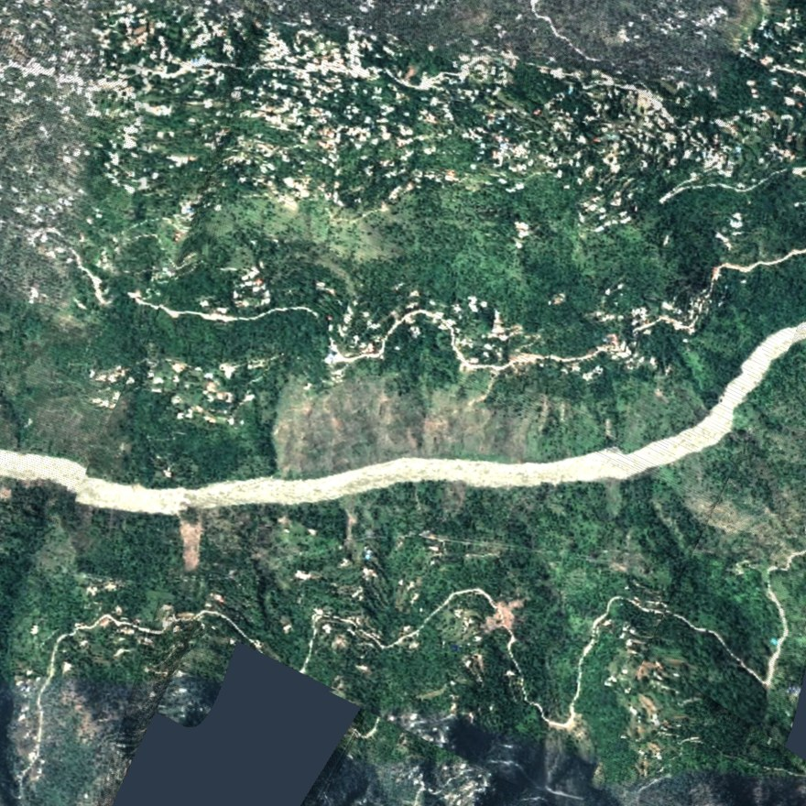
Figure 5.1 - The map layer as Mission Planner renders it. Imaged ground is opaque; everything else is transparent, so an underlying base map still shows through where the aircraft have not yet flown.
Conformance is tested against Mission Planner's own source
Five tests in tests/test_mission_planner_wms.py replay the exact requests Mission Planner constructs and assert against each of its five acceptance checks, transcribed from GCSViews/FlightPlanner.cs and ExtLibs/Maps/WMSProvider.cs: a WMT_MS_Capabilities root element, exactly one GetMap element, a Format containing image/png, an SRS containing EPSG:4326, and at least one //Layer/Layer carrying a Name.
This found a real defect. The capabilities document emitted xlink:href without declaring the xlink namespace. .NET's XmlDocument rejects that as malformed, so Mission Planner would have displayed a message box and refused the server, while a test that only checked 'a PNG came back' would have passed. Fixed by declaring xmlns:xlink on the root element.

5.3 Mission Planner: Video Routes
Two video paths exist in addition to the map layer. Both place the mosaic in the HUD pane on the FLIGHT DATA screen, behind the instruments.
Route | Backend flag | Mission Planner configuration | Notes
MJPEG over HTTP | --mjpeg | FLIGHT DATA screen. Right-click the artificial horizon, choose Set MJPEG Source, enter http://127.0.0.1:8080/stream.mjpg | Native. Nothing to install. The more reliable of the two.
H.264 over UDP | on by default, --out-port 5600 | FLIGHT DATA screen. Right-click the HUD, choose the GStreamer or UDP video option, and point it at UDP port 5600 | Requires FFmpeg on the sending side and a working GStreamer install in Mission Planner. Verify with ffplay udp://127.0.0.1:5600 first.

ffmpeg -f rawvideo -pix_fmt bgr24 -s 1280x1280 -r 10 -i - -an \
-c:v libx264 -preset ultrafast -tune zerolatency -b:v 4M -g 5 -bf 0 \
-pix_fmt yuv420p -f mpegts udp://127.0.0.1:5600?pkt_size=1316
Listing 5.2 - The encoder command the backend builds. -g 5 places a keyframe every half second, so a late-joining viewer synchronises quickly. -bf 0 removes B-frames, which would add reordering latency. Switch to --container rtp for Mission Planner's GStreamer path.
Recommendation
Use the map layer (5.2) as the primary display. It is georeferenced, it sits under the aircraft icons where the operator is already looking, it pans and zooms with the map, and it needs no codec.
Use MJPEG as a secondary view or for a quick check in a browser.
Use H.264 only when the mosaic must travel to another machine over a bandwidth-constrained link, which is the one case where the codec earns its complexity.

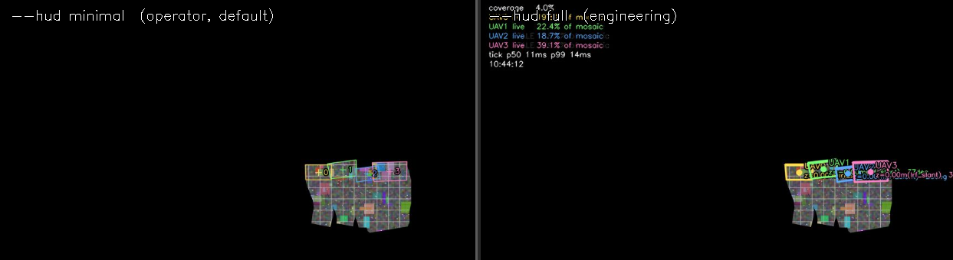
Figure 5.2 - Overlay levels. Left: --hud minimal, the default operator view - aircraft markers, north arrow, scale bar. Right: --hud full, adding camera angles, plane-cascade tier, per-aircraft coverage share and tick timings. Full is a diagnostic view, not an operator view.

5.4 Target Coordinate Extraction
A target may be designated either on the canvas or in an aircraft's source frame. Both resolve to latitude and longitude; the two paths differ in how the ray is constructed.

From a canvas pixel
E = E_min + x_px · GSD
N = N_max - y_px · GSD // inverse of Formula 2.6, exact

then (E, N, z_plane) → ECEF → WGS-84 latitude, longitude, altitude
Formula 5.1 - TargetResolver.from_canvas_px. The canvas-to-ENU mapping is a fixed affine, so this inversion is exact and costs no search.

From a source-frame pixel
This is the higher-accuracy path, because it uses that frame's own pose and plane rather than the composited result:
d_c = K⁻¹ [u, v, 1]ᵀ
d_w = R_E←C · d_c
λ = (z_plane - C.z) / d_w.z
G = C + λ · d_w → ECEF → WGS-84
Formula 5.2 - TargetResolver.from_source_px. A single ray, back-projected and intersected with that frame's plane. No interpolation.
Why not interpolate between the four corners
The Argus reference implementation reads a target out by bilinear interpolation across the four projected footprint corners. For a perspective quadrilateral that is wrong: perspective is not affine, so the interpolant deviates from the true projection everywhere except at the corners themselves, with the error largest at the centre - exactly where an operator is most likely to click.
targets.bilinear_error_metres quantifies the difference for any given footprint, and the exact inverse homography is used instead.

The geodetic anchor
--anchor lat,lon,alt fixes the ENU origin to a point on the Earth. Without it the mosaic is metrically correct but has no absolute position, the map layer cannot be served, and target read-out returns ENU only.
The conversion uses exact WGS-84 ECEF mathematics implemented in coords.py, with no pyproj dependency. Every target record carries uav_id, sensor, t_capture, canvas pixel, ENU, latitude and longitude, the plane-cascade tier used, and the incidence angle - so accuracy is auditable per fix rather than assumed.
Quality label | Condition | Interpretation
good | Tier 1 plane, incidence below 30 degrees | Laser-measured ground elevation, near-nadir geometry
fair | Tier 1 or 2, incidence 30 to 50 degrees | Usable; parallax error grows with the tangent of the angle
poor | Tier 3 plane, or incidence above 50 degrees | Ground elevation is a configured default, or the geometry is shallow. Treat as indicative

5.5 Radio Link Deployment
The ground station runs on the ground, on the same machine as Mission Planner. It must: the mosaic is built from all four aircraft, so all four streams have to arrive in one place. There is therefore exactly one constrained link, aircraft to ground. Everything downstream is inside one computer.
Change | Where | Value
Accept traffic from the radio interface | backend | --bind 0.0.0.0
Tolerate slower arrival | backend | --max-age 1.5
Ground-station address | UavStreamer.Host | the radio-side IP
Transmission rate | UavStreamer.Target Hz | 3
Picture size | Capture Width / Height | 960 x 540
Compression | Jpeg Quality | 60

Bandwidth, measured on this terrain, all four aircraft
Picture | Quality | Rate | Per frame | Four aircraft | Suitable for
1280 x 720 | 65 | 10 Hz | 124 KB | 40.5 Mbit/s | Cable or loopback only
1280 x 720 | 55 | 3 Hz | 106 KB | 10.4 Mbit/s | A strong link, short range
960 x 540 | 60 | 3 Hz | 71 KB | 6.9 Mbit/s | Recommended default
640 x 360 | 55 | 3 Hz | 37 KB | 3.6 Mbit/s | Weak or long-range link

A typical UAV datalink carries 2 to 10 Mbit/s for the whole fleet, so the middle two rows are the realistic options. Reduce frame rate before reducing picture size: a sharp frame arriving less often builds a better mosaic than a soft one arriving constantly.

Packet loss is the harder constraint
A frame is discarded unless every one of its fragments arrives, because a truncated JPEG is not a partial image. Survival therefore falls as (1 - loss) raised to the fragment count. Measured against the reassembler directly, with sockets and timing removed:
Picture | Fragments | 1 % | 2 % | 3 % | 5 % | 10 %
1280 x 720 | 25 | 77 % | 59 % | 44 % | 27 % | 7 %
960 x 540 | 15 | 87 % | 72 % | 62 % | 48 % | 22 %
640 x 360 | 8 | 92 % | 84 % | 78 % | 67 % | 44 %

At 3 % loss - an ordinary radio, not a poor one - a 1280 x 720 stream loses more than half its frames, while 640 x 360 keeps three quarters. This is a stronger argument for a smaller picture than bandwidth is.
Frame loss degrades a mosaic far less than it degrades video
The canvas accumulates. A lost frame is not a gap in a sequence; it is a frame that does not contribute, and the ground it would have covered is covered by the next one a third of a second later.
At 3 Hz with half the frames lost, each aircraft still delivers about 1.5 usable frames per second. At 60 m/s that is 40 m of travel between frames against a footprint over 1600 m wide - overlap remains enormous. The mosaic fills in more slowly and nothing else changes: no tearing, no misregistration, no corruption.

python tools/sim_sender.py --duration 180 --hz 3 --gsd 2.5 --quality 60 --loss 0.03
Listing 5.3 - Rehearse a lossy link before flying. --loss discards that fraction of datagrams at the sender, exercising reassembly paths that loopback never reaches.

6 System Limits and Troubleshooting

6.1 Flat-Plane Parallax
The dominant error source, and the one that cannot be removed within this architecture. The projection assumes the ground is a plane. Any object or terrain standing off that plane is drawn where its ray meets the plane, not where it actually is.
displacement ≈ Δh · tan θ

Δh height of the point above the assumed plane, metres
θ incidence angle of the ray, degrees off nadir
Formula 6.1 - Parallax displacement. It is independent of altitude and of focal length; only height above the plane and viewing angle matter.
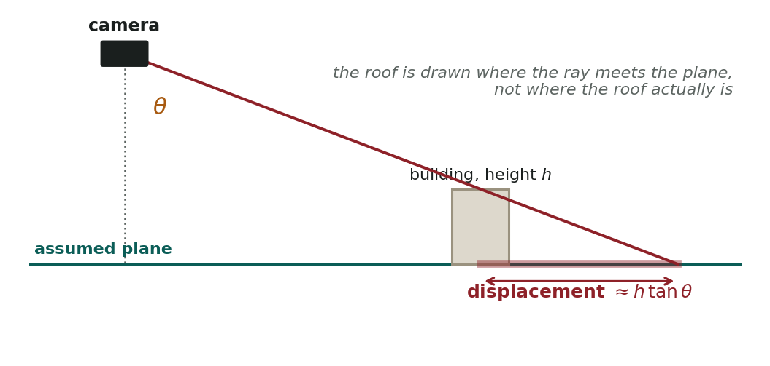
Figure 6.1 - Why a building leans. The ray from the roof is drawn where it crosses the assumed plane. The roof is therefore displaced outward from nadir by approximately h·tanθ.
Height above plane | 0 deg | 10 deg | 20 deg | 30 deg | 45 deg | 65 deg
10 m | 0.0 m | 1.8 m | 3.6 m | 5.8 m | 10.0 m | 21.4 m
50 m | 0.0 m | 8.8 m | 18.2 m | 28.9 m | 50.0 m | 107.2 m
200 m | 0.0 m | 35.3 m | 72.8 m | 115.5 m | 200.0 m | 428.9 m
500 m | 0.0 m | 88.2 m | 182.0 m | 288.7 m | 500.0 m | 1072.3 m

What this means on the delivered terrain
Ground under the survey box spans 283 m to 1766 m, a relief of 1483 m, against a flying height of about 3300 m. The relief-to-height ratio is 0.45, which is high - flat-plane projection is normally applied where that ratio is a few per cent.
The laser cascade limits the damage: each frame gets the elevation of the ground its boresight actually strikes, so Δh is local relief within one footprint rather than the full 1483 m. But two aircraft viewing the same ridge from different angles still place it in slightly different positions, and where their frames meet, a linear feature such as a river shows a visible kink.
Seam feathering cannot fix this. Feathering removes the brightness step; the geometric offset is already baked into each frame at projection time. The only complete fix is to project onto a digital surface model instead of a plane, which costs roughly 25x more per frame and requires elevation data.

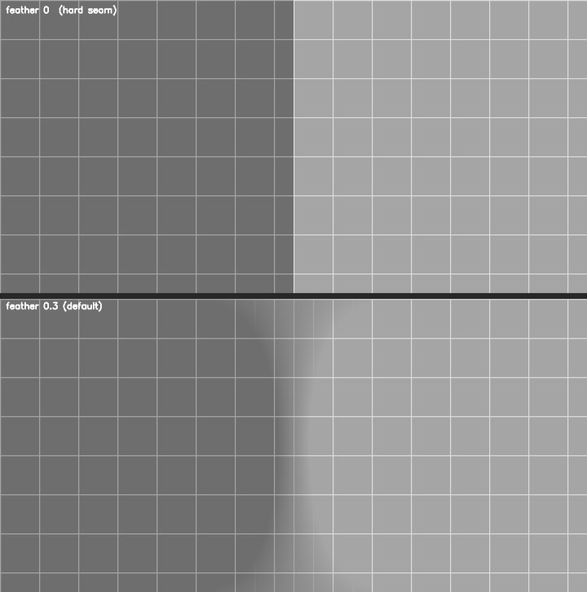
Figure 6.2 - What feathering does and does not do. Top: hard weight comparison, --feather 0. Bottom: the default --feather 0.3. A deliberately harsh test - two frames of the same grid at different exposure. The brightness step falls from 108.5 to 53.6 levels of 255. Geometric alignment is identical in both; feathering is a photometric fix only.

Mitigations already in place
Measure | Effect
65 degree incidence gate | Truncates the tail of the tan curve. Worst measured corner on the delivered configuration was 48.5 degrees, so nothing is rejected in normal flight
Incidence weighting, cos²θ | Where two aircraft overlap, the more nearly vertical view wins automatically
Per-frame laser plane | Δh is local relief within one footprint, not relief across the whole area
Radial weighting, (1-r/r_max)² | Frame edges, where projection error and lens distortion are both worst, lose to frame centres in the overlap
Ground-sample weighting | The frame that resolves more detail wins, so a zoomed-in near-nadir view outranks a distant oblique one

6.2 Other Stated Limits
- Accuracy is bounded by telemetry, not by this software. In Unity the pose is ground truth, so Correia's two-decimal result is the realistic ceiling. On real hardware expect the 1-3 m class: Map2DFusion reports 3.07 and 5.71 m, GROMS reports 1.11 and 0.64 m mean absolute error.
- No loop closure, no bundle adjustment, no drift correction - by design. There is nothing to correct, because every frame is independently anchored to the world rather than to its neighbours.
- Hard exposure seams where aircraft with differing gain meet. Unity's identical virtual cameras largely avoid this; feathering handles the residual. Multi-band blending is designed in as a quality toggle if real cameras make it necessary.
- Fixed area of interest. A frame whose footprint falls outside the declared box is counted and discarded. This buys constant memory and an allocation-free loop, at the cost of robustness if an aircraft strays. Appropriate because a survey has a defined box.
- One planar ground per aircraft per frame - not a single global plane. Each aircraft solves its own from its own laser return.

6.3 Coordinate Frame Validation Checklist
Run this before trusting any mosaic from a new scene. A frame error produces a mosaic that looks plausible but is mirrored, rotated or transposed.
# | Check | Expected | If it fails
1 | python -m pytest tests/test_coords.py -q | All pass, including the golden nadir case | Stop. Nothing downstream is trustworthy
2 | Determinant of R_E←C for random quaternions | +1 to within 1e-12 | S or F has been modified; both must have determinant -1
3 | Orthonormality: R'R = I | Identity to within 1e-12 | The quaternion is not normalised at the sender
4 | North arrow in the overlay points to the top of the canvas | Always | The N flip in Formula 2.6 is inverted
5 | Aircraft moving east moves right on the canvas | Always | The S matrix rows are transposed
6 | rejected stays near zero in level flight | 0 with an 8 degree gimbal wander | The mapping camera is not pointing down. Run Check Scene
7 | A known landmark reads out at its true latitude and longitude | Within a few metres in simulation | The --anchor value is wrong, or the Unity origin is not at the anchor

If your Unity scene has a rotated world
This build assumes Unity +Z is North and +X is East. A scene rotated by yaw angle psi about the vertical needs one extra rotation folded into S. It belongs in coords.py beside the existing matrices, not in the Unity sender - the sender transmits raw values by design, and splitting the frame conversion across two languages is how it becomes unfindable.

6.4 Failure Modes
Symptom | Cause | Remedy
'python' is not recognized | Python not on PATH | Reinstall Python with Add python.exe to PATH ticked
A log line pasted into the shell errors | The startup banner prints addresses, not commands | Addresses go in a browser or into Mission Planner when prompted
Canvas stays black, no per-aircraft counters | Nothing is arriving | Confirm the ground station started before Unity. Check Host and port in the streamer
Canvas black, counters present, outside_aoi rising | Footprints fall outside the mapped area | --extent 7000, and Survey Half Extent 4000 in Unity
rejected climbing steadily | Cameras beyond the 65 degree gate | The mapping camera is not nadir. Run Tools > Mosaicking > Check Scene
Frames arrive but coverage is patchy | Fragments lost, frames never completing | Reduce capture size, which reduces fragments per frame. See 5.5
Hundreds of overruns | Machine cannot sustain the tick | Raise --gsd to 5, or lower --hz to 5. GSD is by far the larger lever
Address already in use | A previous run did not release the port | Close the old process, or change --tiles-port and --mjpeg-port
Mission Planner refuses the WMS server | Wrong URL, or the backend is not running | The address must end in /wms. Verify port 8081 in a browser first
Mission Planner accepts it, map stays empty | Viewport is elsewhere in the world | Pan to the coordinates printed at startup. This is the most common cause
FFmpeg errors on startup | FFmpeg missing or misconfigured | Harmless for the map and MJPEG routes. Add --no-encoder to silence it
Unity Console shows red errors | MosaickingSetup.cs in the wrong folder | It must sit directly inside a folder named Editor
Mosaic freezes under one aircraft while it still transmits | The same-owner clause has been removed or broken | See 2.5. Verify tests/test_canvas.py passes

First diagnostic step, always
python -m pytest tests/ -q. If all 168 pass, the mathematics, the protocol and the compositing rules are intact, and the fault is in wiring: a port, a folder, a startup order, a firewall. If any fail, start with the failing test rather than with the symptom.

A Source Material
Every source below was read in full, including its mathematics. Where a formula, sign or convention was ambiguous in the text, it was verified against that project's own source code; the derivations in Section 2 follow the code, not the prose.

A.1 Papers
Source | Contribution to this design | Used / Rejected
Correia et al., Sensors 2022, 22, 604  Research Papers/Correia et al.pdf | The mathematical spine. Intrinsics under variable zoom (Eq. 32-33), the full transformation chain (Eq. 51-54), the z_C solution (Eq. 60-61), field of view (Eq. 66). Validated in Unreal Engine 4 with AirSim against a virtual UTM origin, recovering a target to two decimal places - the same class of experiment as this Unity setup. | Used. Formulas 2.4 and 2.5
Hinzmann et al., aerial_mapper (ETH ASL)  Research Papers/hinzmann2017mapping.pdf | The corner-projection to getPerspectiveTransform to warpPerspective pattern, and the best-viewing-angle rule that became the incidence weight. Timing anchor: 17.4 ms per image at 752x480 in C++. | Used. Section 1.3, 2.5
Bu et al., Map2DFusion, IROS 2016  Research Papers/Map2DFusion_...pdf | The plane-local frame concept, the incidence gate (axis.dot(downLook) < 0.4, about 66 degrees), the radial weight map floored at 1e-5, explicit metres-to-pixels scaling, and per-pixel max-weight selection rather than weighted averaging. | Used. Section 2.5
Yao et al., GROMS  Research Papers/GROMS.pdf | The hybrid block/pixel orthorectification argument that formally justifies one homography per frame on a plane. Runtime budget anchor (Table 6). Its critique of flat-plane methods is the honest caveat in Section 6.1. | Partially used. Its map-prior and SLAM pose path violates the no-prior-map constraint and is rejected
Ruiz et al., MGRAPH, RA-L 2018  Research Papers/MGRAPH.pdf | The deliberate counter-example: ORB, brute-force Hamming, RANSAC, graph fusion. Its Eq. 3 zero-overlap distance is retained as a contention predictor. Its GCS-overlay split - send transform plus image, composite at the ground station - matches this architecture. | Rejected for registration. Section 1.2
SkyPin, Drones 2026, 10, 500  Research Papers/drones-10-00500.pdf | A third independent statement of the ray/plane formula (Eq. 2-4). Benchmarks matchers at 100-200 m altitude and -30 to -60 degree pitch, reporting that even the best struggle at shallow angles - direct evidence for the incidence gate. | Partially used. Its map-prior and feature-matching pipeline is excluded

A.2 Reference Implementations
Repository | Taken | Not taken
Map2DFusion (Bu et al.)  github repo 1 - Map2d fusion/ | MultiBandMap2DCPU.cpp:311-558 - weight map, max-weight selection, incidence gate. Map2D.h:54-61 | Monocular SLAM, RANSAC plane fitting (the laser replaces it), the growing tiled canvas, OpenGL, Qt, Svar
aerial_mapper (Hinzmann et al.)  github repo 2 - Aerial Mapper/ | ortho-forward-homography.cc:74-132 - the corner-to-ground-to-warp pattern | ROS, aslam, grid_map, GDAL, the digital surface model, the per-cell loop. Three defects were identified and deliberately not reproduced: batch() uses the mosaic width for both x and y offsets (line 154-158); layer_num_observations(x,y) += layer_num_observations(x,y) never increments off zero (line 93); and the forward path has no metres-to-pixels scale at all, implicitly fixing ground sample distance at 1 m/px
Argus  github repo 3 - Argus/ | advanced_mapping.py:132-401 - the cleanest Python reference in the set. Region-of-interest local warping, the 20x footprint sanity clamp, the lower-half retry, alpha as a validity mask | FastAPI, SQLAlchemy, COLMAP, OpenDroneMap, multiprocessing pools, Voronoi seams. spatial.py:18-45 reads targets out by bilinear interpolation across four corners, which is wrong for a perspective quadrilateral - the exact inverse homography is used instead (5.4)

B Command-Line Reference

Area and geometry
Flag | Default | Effect
--extent | 7000 | Half-width of the mapped area in metres. 7000 gives a 14 km square, large enough that a wide-zoom footprint near the survey edge is not clipped
--gsd | 2.5 | Canvas resolution, metres per pixel. Halving it quadruples memory. The largest single performance lever
--anchor | required | lat,lon[,alt] of the area centre. Required for the map layer and for target read-out
--plane-z | 0.0 | Ground elevation used only when both laser tiers fail
--max-incidence | 65.0 | Reject a frame whose worst corner exceeds this angle off nadir

Output
Flag | Default | Effect
--tiles | off | Serve the mosaic as a map layer, XYZ tiles plus WMS. Requires --anchor
--mjpeg | off | Serve MJPEG over HTTP. Mission Planner reads this natively
--fit-view | off | Zoom the video output to the imaged region. Does not affect the map layer, which stays georeferenced
--hud | minimal | off, minimal (operator), or full (engineering)
--feather | 0.3 | Cross-fade width between aircraft. 0 gives a hard seam
--save | none | Write the final mosaic to this PNG on exit
--no-encoder | off | Disable the H.264 output entirely
--container | mpegts | mpegts for ffplay and VLC, rtp for Mission Planner's GStreamer path
--out-width, --out-height | auto | Output size. Defaults to matching the area aspect so there are no black bars

Network
Flag | Default | Effect
--bind | 127.0.0.1 | Interface to listen on. 0.0.0.0 for a radio link
--max-age | 0.5 | Ignore frames older than this. Raise to 1.5 at 3 Hz
--tiles-port | 8081 | Map layer port
--mjpeg-port | 8080 | MJPEG port
--out-host, --out-port | 127.0.0.1:5600 | H.264 destination
--bitrate | 4M | H.264 target bitrate
--hz | 10 | Fusion loop rate. Independent of the aircraft transmit rate

Diagnostics
Flag | Default | Effect
--stats | off | Print the per-stage latency table on exit
--duration | unlimited | Stop after this many seconds
--ir | off | Also composite the infrared streams
-v | off | Verbose logging

C Verification Inventory
168 automated tests. The list below states what each file proves, not how many assertions it contains.
Test file | Proves
test_coords.py | The golden nadir north-up case hand-derived in 2.2, plus 45 degree pitch and roll cases. Orthonormality and determinant +1 for randomised quaternions. Nothing else is trustworthy if this fails
test_georef.py | Ray/plane intersection against Correia's published worked example - an independent, peer-reviewed ground truth rather than a self-consistency check. The 3-tier cascade, the descent test, the incidence gate, the extent clamp and the lower-half retry
test_protocol.py | Round trip, fragment reordering, fragment loss, duplicate fragments, oversized frames, and a bounded-memory assertion under sustained loss
test_canvas.py | The same-owner overwrite rule, cross-owner max-weight arbitration, area clipping, region-of-interest translation, and the feathering guards from Listing 2.2
test_targets.py | Exact inverse-homography read-out, and the measured error of the bilinear approximation it replaces
test_unity_wire.py | Byte-level agreement between the C# sender's layout and the Python parser, so a field added on one side cannot silently misalign the other
test_end_to_end.py | Full pipeline against a synthetic ground-truth world: NCC floor 0.99, correlation peak at zero offset. This is the test that caught the feathering regression described in 2.5
test_tiles.py | Web Mercator tile boundaries, WMS bounding-box parsing including the 1.3.0 latitude-longitude axis-order reversal, and transparent responses outside coverage
test_mission_planner_wms.py | Mission Planner's own five acceptance checks, transcribed from its source. Found the namespace defect described in 5.2

cd C:\Users\Workstation\Fatima\UAVmosaicking
python -m pytest tests/ -q
Listing C.1 - Expect 168 passed in about 15 seconds.

C.1 Measured Performance
Stage | Median | Note
Full tick | 30.3 ms | Against a 100 ms budget at 10 Hz, 0 overruns
JPEG decode x 4 | 2-4 ms | Parallel, GIL released
Projection and homography x 4 | < 0.5 ms | Four corners each, pure arithmetic
Weight maps x 4 | ~2 ms | Radial cached, incidence at 1/16 scale then resized
warpPerspective x 4 | 12-30 ms | Parallel, dominant cost
Composite 4 regions | 2-5 ms | cv2.copyTo, 0.28 ms versus 22.88 ms for np.copyto(where=...)
Overlay and encoder copy | 3-5 ms | Encoding itself is out of process

