**Introduction-to-python_class: minor corrections**

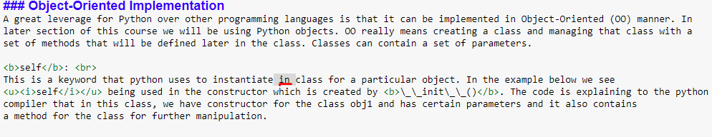

-changed ‘in’ to ‘a’

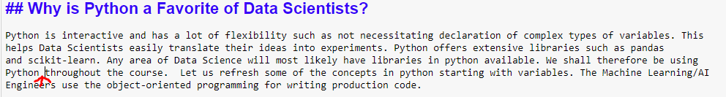

-Added ‘libaries’ to where the arrow is.

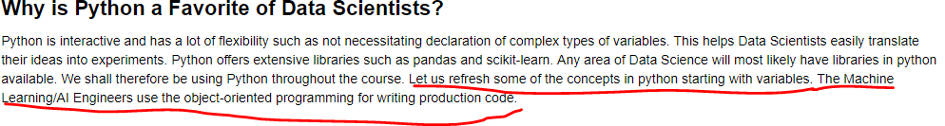

Changed the underlined statements to: Before getting in python libraries, we will explain foundation concepts in python such as variables and object-orientation programming which are major parts of machine learning/AI engineering.



Converted this to a list.

**Built-in Functions**

Some of the typical built-in functions are :

• print() - for printing to system output

• str() - to convert an object to a printable string

• int() - to return an integer object from a number or string (with digits only)

• file() - Constructor for file object representing a file.

• open() - to open a file for reading, writing or appending.

etc

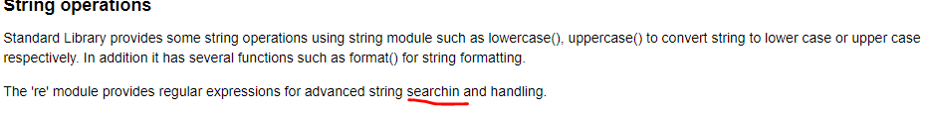

Change “searchin” to “searching”

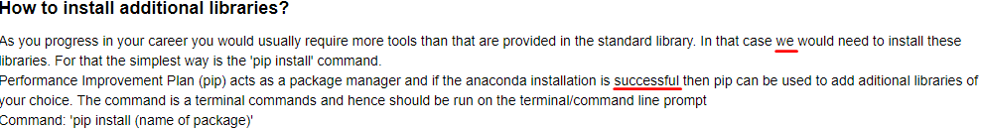

Change “we” to “you”



Change to : We would like to establish a connection between the 2 versions, for instance, if you have V2 but need to work with the V3 synthax for work practices or other reasons, we can simply use it this way