**DJANGO DJANGO**

**Walk through-MTV**

1. Create a project with

**django-admin startproject** *name*

1. Create project app with

**Python manage.py startapp** *name*

1. Create a template under you main project.
2. Create an app inside your template.
3. Create html files inside your app.

**In setting.py**

1. Create a template directory so Django can know where your tampletes located.

TEMPLATE_DIR=os.path.join(BASE_DIR,’tamplete’)

1. In TAMPLETE list add your TAMPLETE_DIR inside DIR with a comma.
2. In INSTALLED_APP add your app here.

**In Models.py**

1. Here create the various classes

Example:

Class User(models.Model):

First_name=model.CharField(max_length=128)

Last_name=model.CharField(max_length=128,unique=True)

……

(remembers that models are just component your database with tables as classes and attributes as columns)

**In views.py**

1. Import your models from your app.

Eg: from apptwo.model import User.

1. Create views:

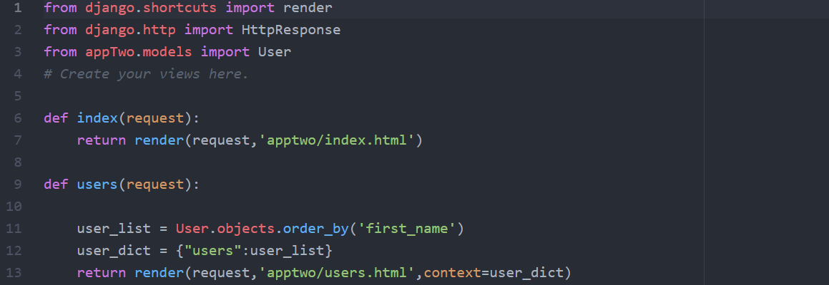

The index view here is like the homepage.

The user_dict is a dictionary with the contact we are going to use connect the html.

**Setting up url files**

1. Under app create a url.py file.(Remember there another urls below for the entire projects.)

Eg.

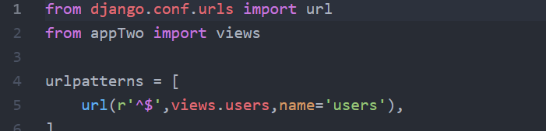

1. **Edith the url.py for the entire project.**

**Eg** 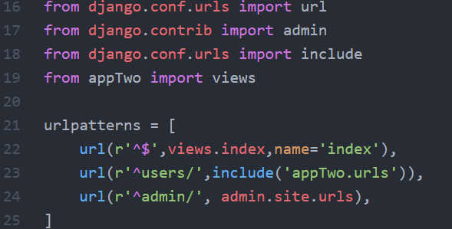

1. **Then now we migrate to models to actual databases with:**

*python manage.py migrate*

1. Then we register the changes to the applicatetion with:

*Python manage.py makemigrations name(app name)*

1. Rerun the migrate again.

*python manage.py migrate*

1. To use the admin interface we need to register our site in admin.py .

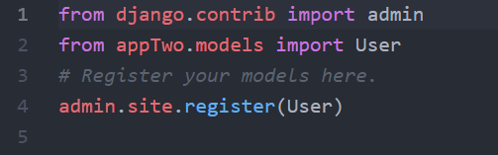

1. Add a superuser.This permit for logging in and out as an administrator.

Code is: *python manage.py createsuperuser*

Enter your email and create a password.

**Populate database with fake data(depending on your case)**

1. **Create a new file under your project.eg**

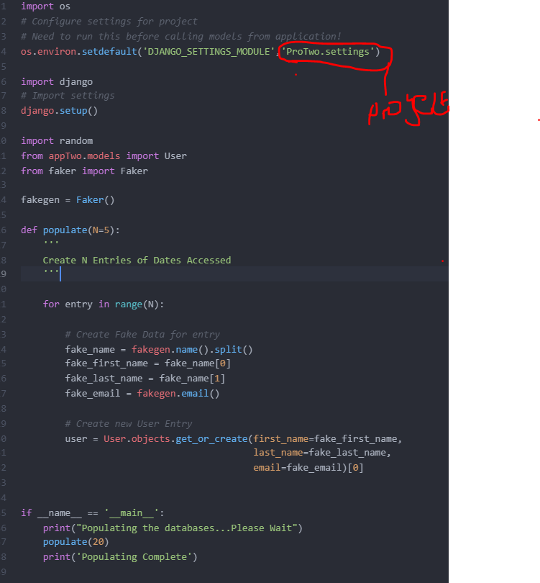

1. In command line run

*python populate_user.py*

**Template tagging**

**This is done in your html file eg:**

