1. **Create a jupyter notebook**: Click here [dealing_with_string](https://refactored.ai/dsin100days/play/notebooks/cs/usr/dsin100days/content/02-Python_for_Data_Scientists/04-Dealing_with_strings_and_dates/Lab-dealing-with-strings-and-dates.ipynb) and follow instructions on the notebook thereafter.
2. Save jupyter notebook created as a pdf file under the name “dealing_with_string”, following instructions on the screenshot below.

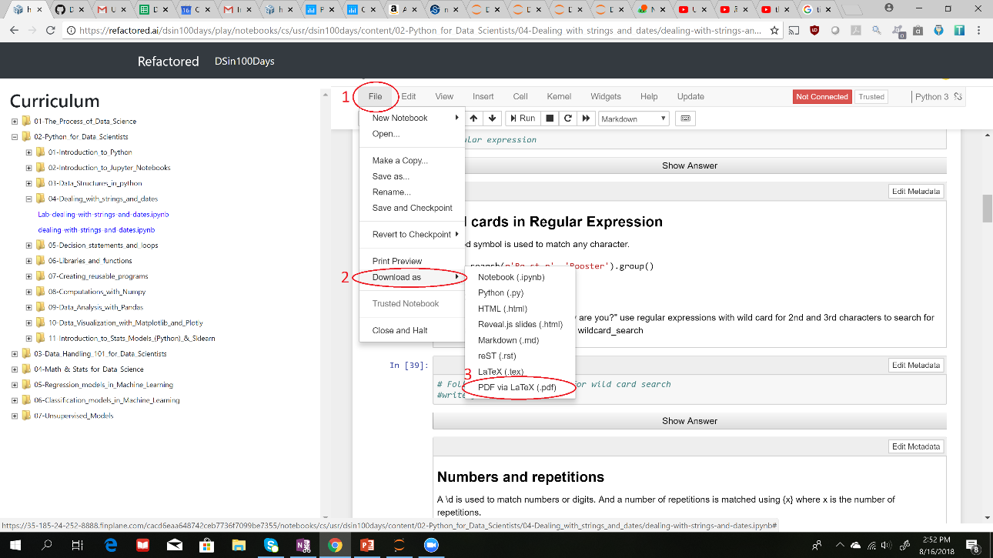

1. **Deliverables:** Submit your saved pdf (dealing_with_string) file.