1. **Create a jupyter notebook**: Click here [Loops](https://refactored.ai/dsin100days/play/notebooks/cs/usr/dsin100days/content/02-Python_for_Data_Scientists/05-Decision_statements_and_loops/Lab-decision-statements-and-loops.ipynb) and follow instructions on the notebook thereafter.
2. Save jupyter notebook created as a pdf file under the name “loops”, following instructions on the screenshot below.

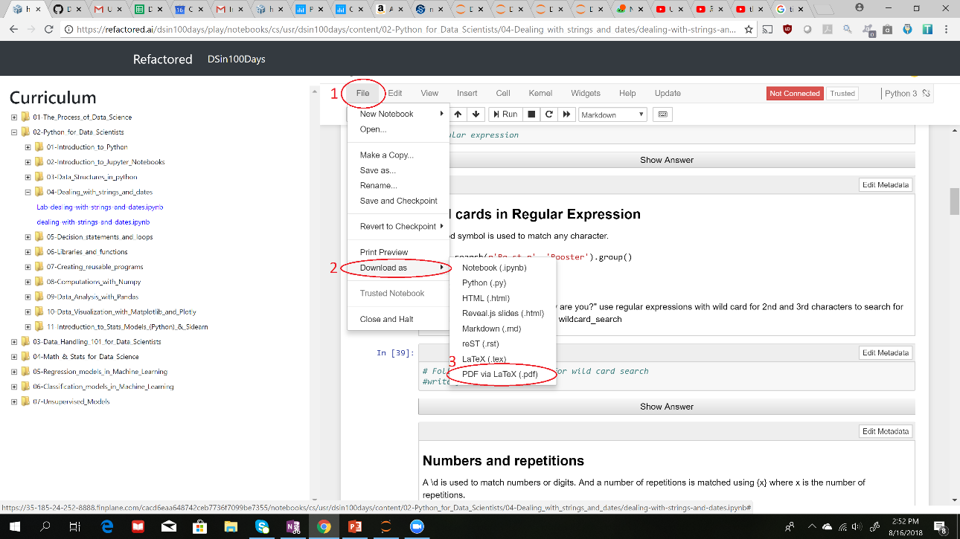

1. **Deliverables:** Submit your saved pdf (loops) file.