1. **Create a jupyter notebook**: Click here Thinking_[DataScience](https://refactored.ai/dsin100days/workspace/user-cc91247e724442db9d6c41f10173ad85/notebooks/cs/usr/dsin100days/content/01-The_Process_of_Data_Science/02-How_to_do_Data_Science/Lab-How_to_do_Data_Science.ipynb) and follow instructions on the notebook thereafter.
2. Save jupyter notebook created as a pdf file under the name “thinking_datascience”, following instructions on the screenshot below.

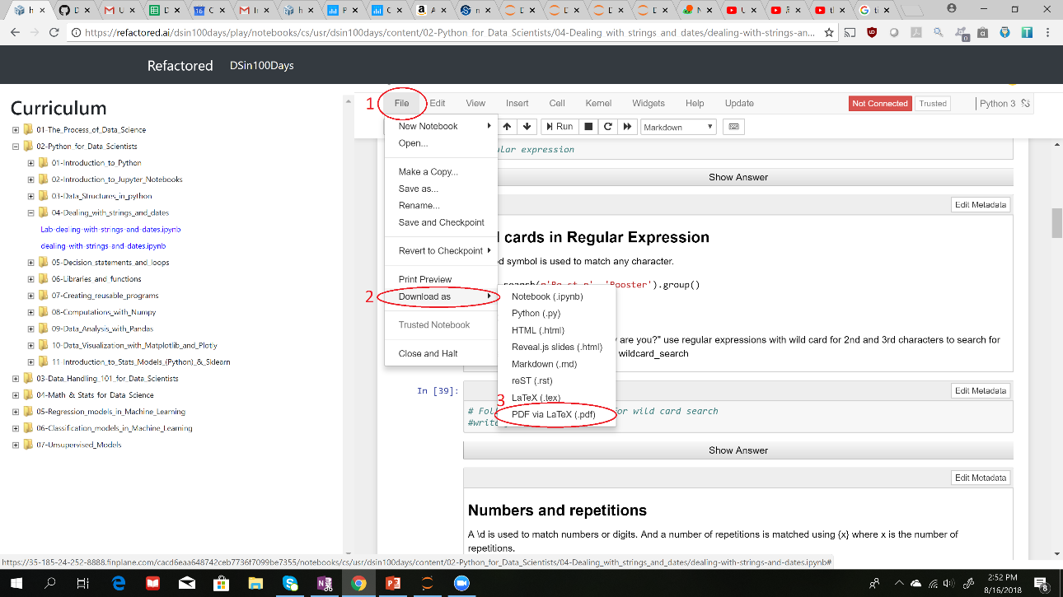

1. **Deliverables:** Submit your saved pdf (thinking_datascience) file.