Table of Contents
Submission Information 3
Presentation Title 3
Iron Man Suits (Agents as Smart Objects): Bridging Three Decades of Software Architecture to Healthcare AI 3
Abstract (250 words) 3
Learning Objectives 4
Target Audience 4
Relevance to Content Area #4: Innovation Frontiers 6
1. Novel Conceptual Framework 6
2. Systematic Assessment and Implementation Methodology 6
3. Production Validated Approach to Regulatory Compliance 6
Speaker Biography 6
Key Takeaways for Attendees 6
Detailed Session Outline (20 minutes) 7
Part 1: The Paradigm Shift (5 minutes) 7
Part 2: The INPACT™ Framework (7 minutes) 7
Part 3: The 7-Layer Architecture (5 minutes) 7
Part 4: Implementation and ROI (3 minutes) 7
Supporting Materials 7
Submission Information 8
Presentation Title 8
Abstract (250 words) 8
Learning Objectives 10
Target Audience 10
Relevance to Content Area #1: AI Strategy and Leadership 11
1. Evidence-Based Problem Diagnosis 11
2. Actionable Assessment Framework 11
3. Change Management Playbook 11
Speaker Biography 11
Key Takeaways for Attendees 11
Detailed Session Outline (20 minutes) 12
Part 1: The Crisis of Trust and Failure (5 minutes) 12
Part 2: The INPACT™ Diagnostic Framework (7 minutes) 12
Part 3: Building the Business Case (5 minutes) 12
Part 4: The 90-Day Execution Playbook (3 minutes) 12
Supporting Materials 12
Presenter Acknowledgment 13
Contact Information 13

ISPE 2026 AI Summit - Proposal #1 Submission
Content Area #4: Innovation Frontiers and Future Horizons

Submission #1 Information
Presenter: Ram Katamaraja
Organization: Colaberry Inc.
Title: CEO & Framework Creator
Email: ram@colaberry.com
Phone: 339-368-1181
Presentation Format: 20-minute presentation + 10-minute Q&A

Presentation Title

Iron Man Suits (Agents as Smart Objects): Bridging Three Decades of Software Architecture to Healthcare AI

Abstract (250 words)
The pharmaceutical industry stands at a critical inflection point. MIT research documents a 95% failure rate for enterprise AI pilots despite $40 billion in investment. The gap isn't in AI capabilities—it's in understanding the fundamental paradigm shift occurring in software architecture.

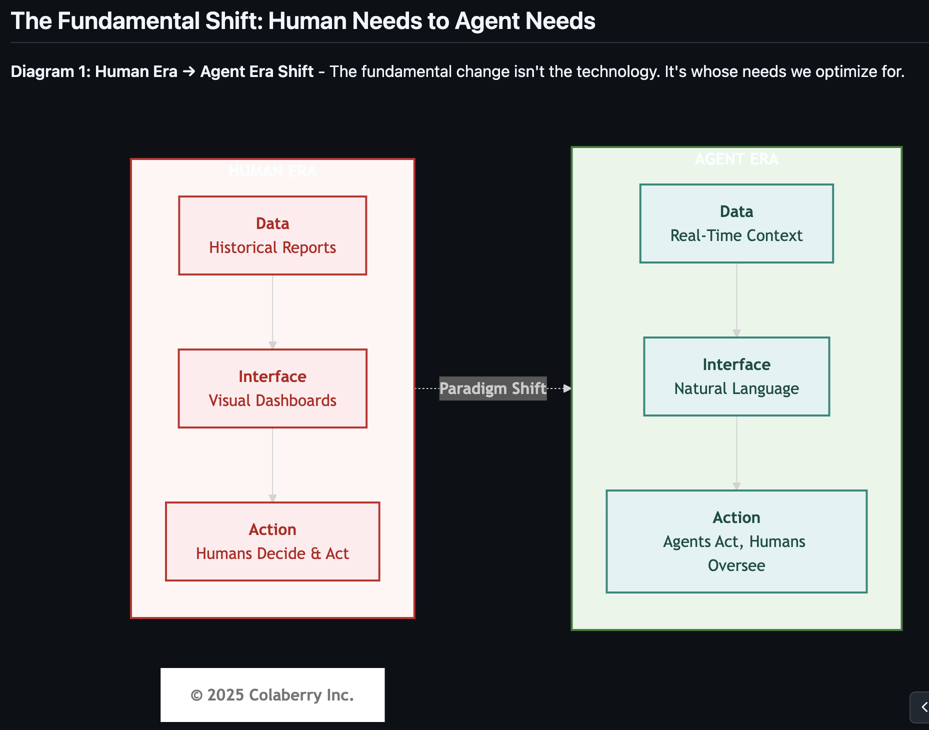

This session introduces a novel framework that bridges 30 years of software engineering evolution to enterprise AI implementation. Drawing from production experience with AIXcelerator platform and research for the forthcoming book "Title: Trust Before Intelligence
Subtitle: Why 95% of Agent Projects Fail and the Architecture Blueprint That Fixes Infrastructure in 90 Days" we reveal why traditional BI-era infrastructure cannot support agent-based systems and present the INPACT™ Framework - six architectural needs that separate successful implementations from failed pilots.
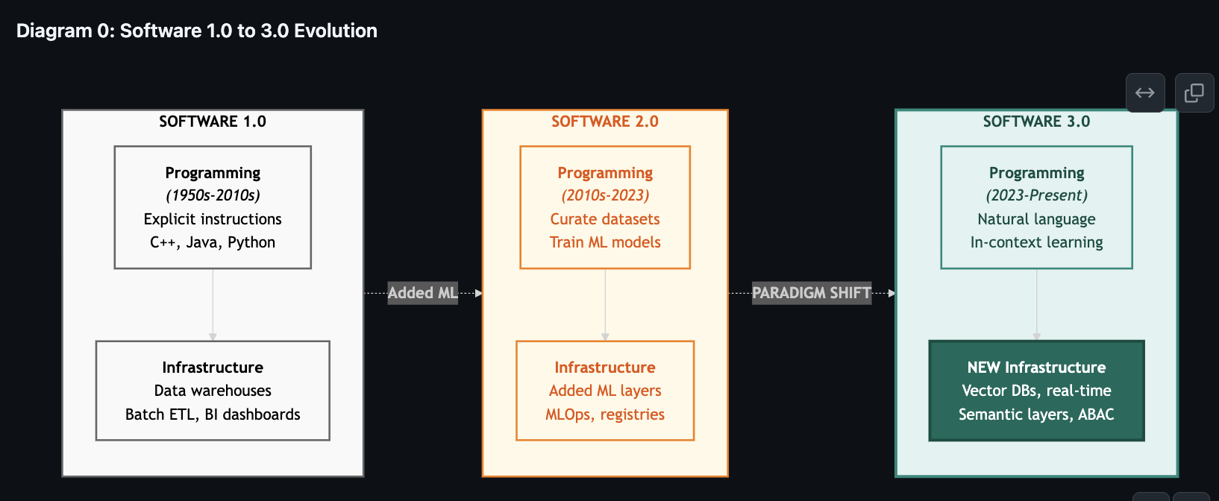
Just as Object-Oriented Programming transformed software development by introducing encapsulation, inheritance, and polymorphism, AI agents represent a similar architectural paradigm requiring fundamental infrastructure transformation. We explore the Software 3.0 evolution (from procedural to ML to agent-based systems) and introduce the 7-Layer Agent-Ready Architecture that delivers on all six INPACT™ needs: Instant response (<2 seconds), Natural language understanding, Permitted access (dynamic authorization), Adaptive learning, Contextual integration, and Trusted transparency.
Attendees will learn how the GOALS™ operational framework (Governance, Observability, Accessibility, Language, Soundness) maintains production readiness and receive a 90-day transformation roadmap applicable to GxP environments. This session positions AI agents not as autonomous systems requiring full trust, but as "Iron Man Suits" - augmentation systems with bounded autonomy that deliver measurable ROI while maintaining regulatory compliance.

Learning Objectives
Attendees will be able to:
- Understand the architectural paradigm shift: Recognize why Software 3.0 (agent based systems) requires fundamental infrastructure transformation, not feature additions to existing BI-era platforms
- Apply the INPACT™ Framework: Evaluate your organization's readiness across six architectural dimensions (Instant, Natural, Permitted, Adaptive, Contextual, Transparent) and identify specific infrastructure gaps
- Implement the 7-Layer Architecture: Map the technical components required for agent-ready infrastructure, from multi-modal storage through real-time data fabric to agent-aware governance
- Maintain production readiness: Use the GOALS™ framework to ensure operational excellence across Governance, Observability, Accessibility, Language, and Soundness dimensions in GxP-regulated environments

Target Audience
This session is designed for:
- CDOs and CTOs evaluating AI agent investments
- Data architects designing next-generation infrastructure
- IT leaders responsible for AI platform implementation
- Quality and compliance officers ensuring GxP readiness
-  Source: Karpathy, A. (2025, June 18). "Software Is Changing (Again)." Keynote at Y Combinator AI Startup School. https://www.youtube.com/watch?v=LCEmiRjPEtQ

Relevance to Content Area #4: Innovation Frontiers
This submission aligns with the Innovation Frontiers content area by addressing how organizations can "anticipate regulatory change, manage investment risks, and navigate ethical considerations while building flexible roadmaps and creating ecosystems that balance experimentation with compliance."
The session presents three genuinely innovative contributions to the field:

1. Novel Conceptual Framework
The "Iron Man Suits (Agents as Smart Objects)" paradigm bridges established computer science principles (Object-Oriented Programming) to emerging AI systems. This framework provides a familiar mental model for technical leaders, enabling them to apply decades of software engineering wisdom to agent architecture. Just as OOP introduced encapsulation, inheritance, and polymorphism, agent-based systems require analogous patterns for bounded autonomy, contextual awareness, and trust transparency.

2. Systematic Assessment and Implementation Methodology
The INPACT™ Framework (six architectural needs) and GOALS™ operational targets (five dimensions) provide quantifiable assessment criteria. Organizations can score their readiness (0-100 scale) and prioritize investments systematically. The 90-day transformation roadmap demonstrates that infrastructure modernization is achievable within quarterly planning cycles, not multi-year programs.

3. Production Validated Approach to Regulatory Compliance
The session addresses the pharmaceutical industry's unique challenge: rapid AI innovation within strict GxP requirements. By positioning agents as "Iron Man Suits" (augmentation with bounded autonomy) rather than fully autonomous systems, the framework provides a path to regulatory compliance while maintaining innovation velocity. The GOALS™ framework specifically addresses HIPAA, FDA 21 CFR Part 11, and GAMP 5 alignment.

Speaker Biography
Ram Katamaraja is CEO of Colaberry Inc., an AI transformation company, and creator of AIXcelerator platform. He is the author of the forthcoming book "Title: Trust Before Intelligence
Subtitle: Why 95% of Agent Projects Fail and the Architecture Blueprint That Fixes Infrastructure in 90 Days" and creator of the INPACT™ Framework (six agent needs), 7-Layer Agent-Ready Architecture, and GOALS™ operational methodology (Governance, Observability, Accessibility, Language, Soundness).
Ram's work bridges three decades of software engineering evolution—from procedural programming through Object-Oriented design to agent-based systems—applying established computer science principles to enterprise AI implementation.

Key Takeaways for Attendees
Attendees will leave with:
- INPACT™ Assessment Scorecard: One page tool to evaluate their organization's readiness across six dimensions
- 7-Layer Architecture Reference: Visual map of technical components required for agent-ready infrastructure
- 90 Day Roadmap Template: Phase gated implementation plan adaptable to their organization's starting point
- GOALS™ Health Tracker: Operational metrics for maintaining production readiness in GxP environments

Detailed Session Outline (20 minutes)

Part 1: The Paradigm Shift (5 minutes)
- The 95% failure rate: MIT research on enterprise AI pilots
- Software 1.0 → 2.0 → 3.0 evolution framework
- Why BI-era infrastructure cannot support agent needs
- "Iron Man Suits (Agents as Smart Objects)" conceptual model

Part 2: The INPACT™ Framework (7 minutes)
- Six architectural needs that separate success from failure
- Instant: Sub-2-second response requirements
- Natural: Semantic understanding and business glossaries
- Permitted: Dynamic authorization and ABAC
- Adaptive: Continuous learning and feedback loops
- Contextual: Cross domain data integration
- Transparent: Logs, audit trails, and explainability

Part 3: The 7-Layer Architecture (5 minutes)
- Technical implementation framework overview
- Layer 1-2: Foundation (multi-modal storage, real-time fabric)
- Layer 3-4: Intelligence (semantic layer, RAG infrastructure)
- Layer 5-7: Trust & orchestration (governance, observability, products)

Part 4: Implementation and ROI (3 minutes)
- 90-day transformation roadmap overview
- GOALS™ operational framework for production readiness
- Healthcare case example: 477% ROI, 10 week payback
- GxP compliance considerations

Supporting Materials
The following materials will be available to attendees:
- Digital copies of presentation slides (PDF)
- INPACT™ Assessment Scorecard (downloadable template)
- 7-Layer Architecture Reference Guide (one-page visual)
- 90-Day Roadmap Template (customizable for different archetypes)
- Access to online assessment tool at colaberry.ai/assessment

ISPE 2026 AI Summit - Proposal #2 Submission
Content Area #1: AI Strategy and Leadership

Submission #2 Information
Presenter: Ram Katamaraja
Organization: Colaberry Inc.
Title: CEO & Framework Creator
Email: ram@colaberry.com
Phone: 339-368-1181
Presentation Format: 20-minute presentation + 10-minute Q&A

Presentation Title
The $40B Trust Paradox: Why 95% of Healthcare AI Pilots Fail and the Six Architectural Needs That Enable the Successful 5%

Abstract (250 words)
Despite $40 billion in enterprise AI investment, MIT's 2025 research reveals a sobering reality: 95% of generative AI pilots fail to deliver measurable business value. In healthcare specifically, organizations face a unique paradox - patients and clinicians demand AI assistance while simultaneously expressing deep mistrust in AI systems.
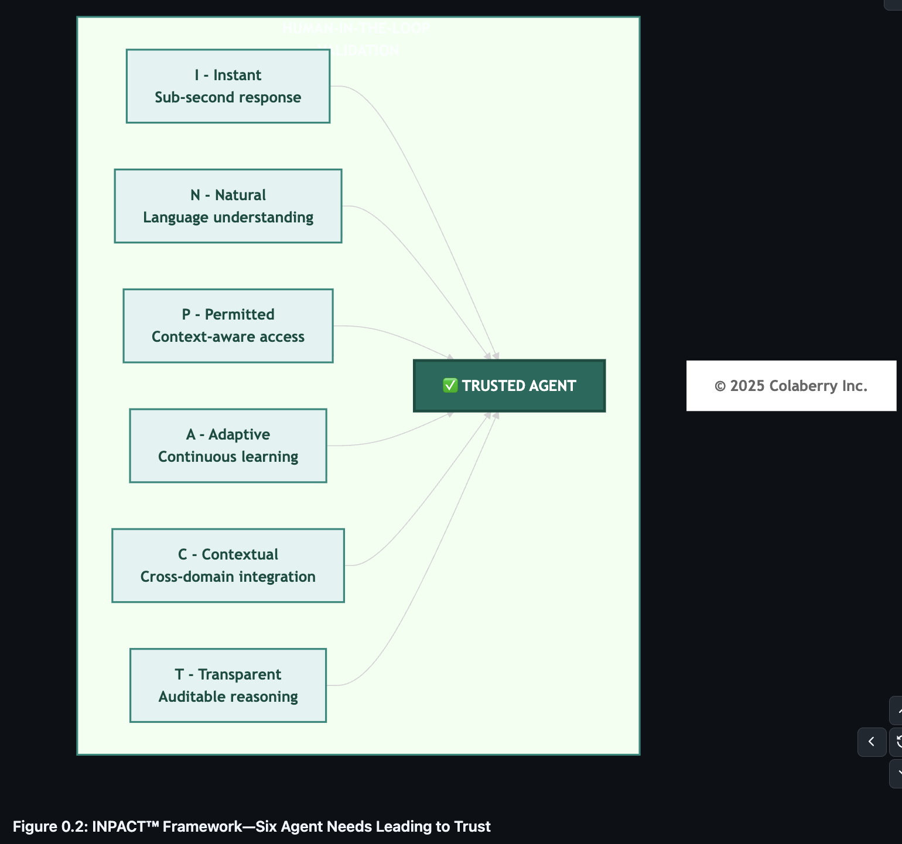
This session addresses the root cause: enterprises are attempting to deploy agent-based systems on BI-era infrastructure designed for human analytics. The gap isn't algorithmic. Modern LLMs achieve superhuman performance on many tasks. The gap is architectural readiness.
Drawing from research for the forthcoming book "Trust Before Intelligence: Why 95% of Agent Projects Fail and the Architecture Blueprint That Fixes Infrastructure in 90 Days", this session introduces the INPACT™ Framework - six fundamental needs that AI agents require from data infrastructure. When these needs go unmet, trust collapses and pilots fail. When fulfilled, agents deliver quantifiable value: sub-2-second responses, 85%+ accuracy, HIPAA compliance, and measurable ROI.
Attendees will learn how to assess their organization's readiness using a 0-100 scoring framework, prioritize infrastructure gaps systematically, build executive support with ROI models, and execute transformation using the GOALS™ operational framework (Governance, Observability, Accessibility, Language, Soundness). This session provides both the strategic foundation and 90-day execution playbook for becoming an AI-driven organization that delivers on the promise of intelligent automation while maintaining regulatory compliance.
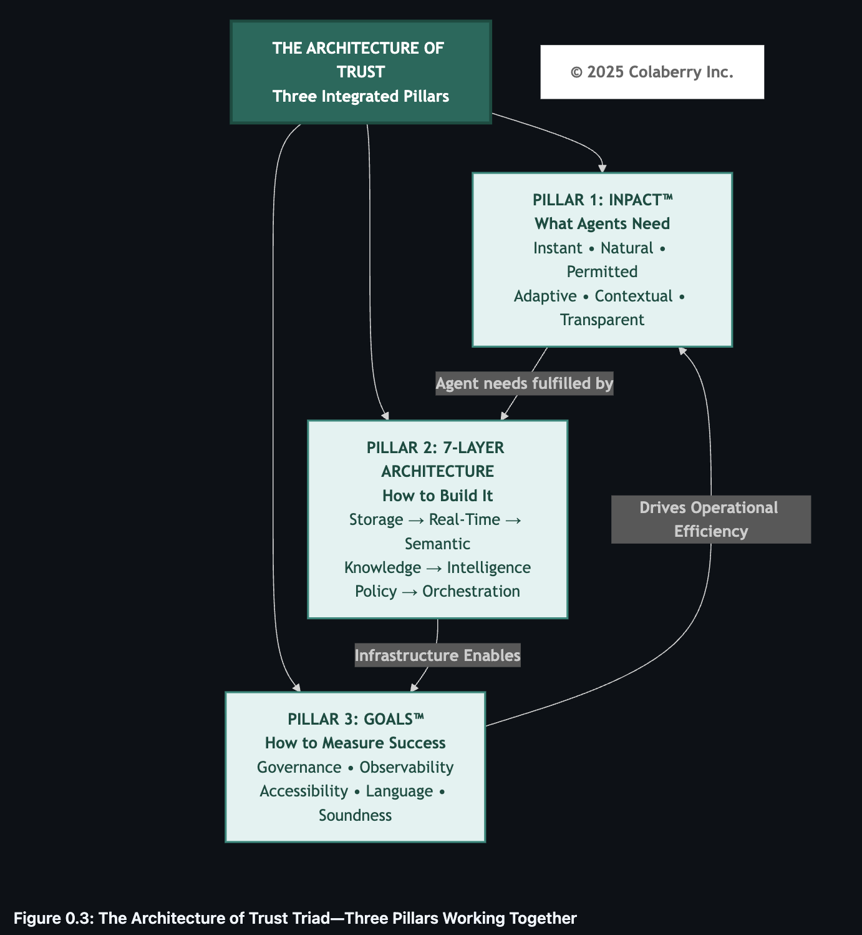

Learning Objectives
Attendees will be able to:
- Diagnose infrastructure readiness: Use the INPACT™ assessment framework to score your organization's capability across six dimensions (Instant, Natural, Permitted, Adaptive, Contextual, Transparent) and identify which gaps cause pilot failures
- Build the strategic business case: Quantify the cost of remaining unprepared versus the investment required for transformation, with ROI models adapted to healthcare economics and regulatory requirements
- Overcome organizational resistance: Apply proven change management strategies for bridging cultural gaps, securing executive sponsorship, and aligning cross-functional stakeholders around agent readiness
- Execute systematic transformation: Follow the 90-day acceleration playbook with phase gated deliverables, GOALS™ health monitoring, and risk mitigation strategies specific to GxP regulated environments

Target Audience
This session is designed for:
- C-suite executives evaluating AI strategy and investment priorities
- Enterprise architects designing transformation roadmaps
- Change management leaders driving organizational adoption
- Strategy and innovation teams building AI capabilities

Relevance to Content Area #1: AI Strategy and Leadership
This submission directly addresses the AI Strategy and Leadership content area's focus on "setting a clear vision for AI adoption, aligning stakeholders, and leading with confidence in a rapidly evolving regulatory and technological landscape."
The session provides three critical strategic contributions:

1. Evidence-Based Problem Diagnosis
The MIT research on 95% failure rates provides third-party validation that the challenge isn't AI capabilities, it's organizational readiness. This frames AI adoption as a strategic infrastructure investment, not an IT project. Leaders can use this evidence to build executive support and secure appropriate budget allocation for systematic transformation rather than piecemeal pilots.

2. Actionable Assessment Framework
The INPACT™ Framework translates abstract readiness into concrete, measurable dimensions. Organizations can score 0-100 across six needs, benchmark against industry archetypes (BI-First, Data Lake, ML-First, Data Mesh, Greenfield), and generate customized roadmaps. This systematic approach enables leaders to answer the question: "Where do we start and how long will it take?"

3. Change Management Playbook
The 90-day transformation approach addresses "overcoming cultural resistance, bridging skill gaps, and driving transformation through executive sponsorship" with specific tactics. Phase-gated deliverables maintain momentum, GOALS™ metrics track operational health, and stakeholder communication templates ensure cross-functional alignment. The methodology has been validated in regulated healthcare environments where compliance and change management complexity are highest.

Speaker Biography
Ram Katamaraja is CEO of Colaberry Inc., an AI transformation company, and creator of AIXcelerator platform. He is the author of the forthcoming book "Trust Before Intelligence: Why 95% of Agent Projects Fail and the Architecture Blueprint That Fixes Infrastructure in 90 Days" and creator of the INPACT™ Framework (six agent needs), 7-Layer Agent-Ready Architecture, and GOALS™ operational methodology (Governance, Observability, Accessibility, Language, Soundness).
Ram's work addresses the strategic gap between AI ambition and infrastructure reality. His frameworks translate cutting-edge AI capabilities into systematic transformation methodologies that executives can champion, architects can implement, and organizations can operationalize within quarterly planning cycles.

Key Takeaways for Attendees
Attendees will leave with:
- INPACT™ Readiness Assessment: Self-scoring tool to evaluate organizational capability across six dimensions with gap prioritization matrix
- ROI Business Case Template: Financial models showing cost of inaction vs. investment required, with healthcare-specific metrics and payback calculations
- 90-Day Transformation Playbook: Week-by-week roadmap with phase gates, success criteria, and risk mitigation strategies
- Stakeholder Communication Kit: Executive briefing templates, technical deep-dive presentations, and change management messaging frameworks

Detailed Session Outline (20 minutes)

Part 1: The Crisis of Trust and Failure (5 minutes)
- MIT research: 95% failure rate despite $40B investment
- The paradox: Demand for AI + Deep mistrust = Strategic paralysis
- Root cause: Agent-based systems on BI-era infrastructure
- Cost of inaction: Competitive disadvantage, talent attrition, missed opportunities

Part 2: The INPACT™ Diagnostic Framework (7 minutes)
- Six architectural needs that predict success vs. failure
- Assessment methodology: 0-100 scoring across dimensions
- Five enterprise archetypes with different starting points
- Gap prioritization: Which needs to address first based on use case
- Interactive element: Audience self-assessment via mobile tool

Part 3: Building the Business Case (5 minutes)
- Investment ranges by organization size and archetype
- ROI drivers: Efficiency gains, experience improvements, revenue opportunities
- Healthcare case example: Transformation economics and payback
- Securing executive sponsorship: Framing AI as strategic infrastructure

Part 4: The 90-Day Execution Playbook (3 minutes)
- Three phases: Foundation, Intelligence, Production
- GOALS™ framework for operational excellence
- Change management strategies for cross-functional alignment
- Risk mitigation for GxP environments

Supporting Materials
The following materials will be available to attendees:
- Digital copies of presentation slides (PDF)
- INPACT™ Readiness Assessment tool (online and downloadable Excel)
- ROI Business Case Template (customizable for different organizations)
- 90-Day Transformation Playbook (week-by-week guide)
- Access to online assessment tool at colaberry.ai/assessment

Presenter Acknowledgment
By submitting this proposal, I acknowledge that:
- This presentation is free of commercial intent and focuses on sharing frameworks and methodologies
- If accepted, I will attend and present in-person at the ISPE 2026 AI Summit
- My organization (Colaberry Inc.) will support my attendance
- I am responsible for my own travel and accommodation arrangements
- I am submitting as a framework creator and book author, presenting intellectual contributions to the field

__________________________________________________
Signature
Date: ___11/14/2025________________

Contact Information
Organization: Colaberry Inc.
Website: colaberry.ai
Assessment Tool: colaberry.ai/assessment (TBD)
Book Information: "Enterprise Data Readiness for AI Agents" (Colaberry Press, 2026)
For Questions: ram@colaberry.com
INPACT™ and GOALS™ are trademarks of Colaberry Inc.

