VPGate on Linux
(aka vpgnix)

Port Design Notes

Steve Yackey
4/15/2022
VPGate on Linux – Port Design Notes
Table of Contents
1 Revision History 2
2 Introduction 3
2.1 Objectives 4
2.2 Non-objectives 4
3 Critical Items 5
3.1 Replace Windows System Facilities 5
3.2 The Waitables 6
4 Important Items 7
5 Separable Items 7
5.1 (Re-)Config 7
5.2 Managed Host 7
5.3 Alarm Interface 8
5.4 Redundancy 8
6 Mundane Items 8
6.1 Type Transformation 8
7 Other Items 8
7.1 Licensing 8
7.2 Plugins 9
7.3 Installation/Update 9
8 Conclusion 9

Revision History
Date | Who | Description
4/15/2022 | Yackey | Alpha and Omega

Introduction
This paper briefly describes some basic ideas regarding a port of VPGate to Linux.
However, chances for improvement will be taken.
- Move to SOLID principles
- Best practices
  - coding
  - platform
The porting issues discussed below, are categorized.
- critical items
- important items
- separable Items
- mundane items
- other items

The result is a native Linux application(set).

Objectives
- Provide a native port of VPGate to Linux.
- Aim for improvement where possible.
  - For example:
    - move towards SOLID principles
    - dependency injection
    - composition root (IoC)
- The target platform is Ubuntu 20.04.
- The target development environment is standard Linux (Ubuntu) C++ development environment.
  - g++ -std=c++2a, clang-*
  - gmake (no CMake)
- Use standard C++ types and components – C++20
- Follow Linux best practices, e.g., daemon(7) and systemctl(1)
- Don’t forget - the value is in the logic and functionality – so don’t break it !!

… you end up with a native LinuxVPGate.

Non-objectives
This is a port of a native Windows application to a native Linux application.
There are no emulators or compatibility layers. These simply add complexity and additional support concerns.
No Boost, logging frameworks etc.
IoC will be part of the improvement. IoC has several benefits such as a move towards open/closed principle (OCP), separation of concerns (SRP) and easier maintainability. A DI container won’t be used, however. Dependency injection will be a manual. Mainly because the most useful containers (Hypodermic, BoostDI) have not had repository activity in years. DI containers are helpful in that they require structure and order. However, there is nothing wrong with a manual composition root.

Critical Items
These are items that are prerequisites for any semblance of success.

Replace Windows System Facilities
The Unix mantra – from long ago – and now in the Linux world: Everything is a file descriptor.
Window’s facilities that provide HANDLE operations include:event operations, waitable timer operations and thread exit.
WaitForMultipleObjects operates on one or more HANDLES.
Message exchange is a per thread Windows facility provided by:
Sinks – PeekMessage, GetMessage
Sources – PostThreadMessage, PostMessage
Thread creation ala OS_ThreadCreate, not a platform facility (wrapper), but is included for completeness.

The objective is to provide porting replacements, using Linux platform facilities that, at their core, are file descriptor based. This collection I call the ‘waitables’.

The Waitables
These are the port replacements for Window’s platform facilities. All use standard Linux platform facilities.

Windows  Facility | Port  Replacement | Underlying  Linux Facility | Notes
CreateEvent  SetEvent  ResetEvent | WaitableEvent | eventfd(2)
OS_ThreadCreate | WaitableThread | std::thread/std::function with event(fd) | Not actually platform provided per se.
ThreadExit | WaitableThread | evntfd(2)
WaitableTimer | PostableTimer  WaitableTimer | timer_create(2)  timerfd_create(2) | Delivers WM_TIMER  Waitable via WaitForMultipleObjects
PeekMessage | WaitableMessageSink | messageQueue(7) | Message queue descriptor is a file descriptor
GetMessage | WaitableMessageSink | messageQueue(7)
PostThreadMessage | WaitableMessageSource | messageQueue(7)
PostMessage | WaitableMessageSource | messageQueue(7)
WaitForMultipleObjects | WaitForMultipleObjects | epoll(7) | Everything is a file descriptor !!

The key underlying idea: Everything is a file descriptor.

Important Items
These are items that exist in both platform environments. While there may be differences, the basic Windows platform functionality exists in basic Linux platform functionality.
The main thought here is:
- Network stuff
- Loading plug-ins

Separable Items
VPGate contains a lot of functionality. The port offers the opportunity to separate some of the ‘embedded’ functionality into external cooperating processes.

(Re-)Config
Typical Linux services (re)evaluate configuration changes in response to a signal, typically SIGHUP (kill -1).
That will be the pattern here.
A ‘front-end’ to the configuration information, e.g. web page or whatever, will be a totally separate application/service. Obviously, it can be developed independently. When the front-end is happy with configuration changes, the vpgate daemon can be signaled. The daemon will wait for signal delivery through signalfd(2).
Note: I also prototyped and observer/subscriber based on inotify(7). The signal method seemed preferable, allowing independent configuration mechanisms. Observer/subscriber will likely watch the signal.

Managed Host
Similar to (re)config managed host communications are an independent external service. Developed totally independently. This would also be a signal(7) operation.

Alarm Interface
Really a subset of the managed host described above in terms of an independent externalized development. The plumbing is reversed however, with vpgate having information for the managed host external application. For this it makes sense to use either a message queue or a Unix domain socket.
A message queue seems appropriate, but either is fine. Note: the choice depends somewhat on the variability in the size of the messages. I have no code to look at and I don’t recall. Either is fine.

Redundancy
My shakiest ground, no code to look at + feeble memory :) Redundancy would seem to be able to be a separate, external service. Notification to VPGate would be a signal(7) operation.

Mundane Items
This is the grunge work in porting. Its not that its easy or fast, just not rocket surgery.

Type Transformation
Windows types will be changed to standard C++ types. Not by some typedef based redefinition mechanism, but actually changed in the code.
The most obvious ways include a) a shell script with a bunch of sed(1) directives 2) an awk(1p) script using a file of transformation definitions. Awk is built for pattern matching, so it is the natural choice. Additionally, the awk script will be far more readable than the convoluted sed syntax. And when done, will provide a good form of documentation.
The transformation will include simple types, e.g., DWORD as well as complex types, e.g., CString.
The entire ‘transformation’ process will be a makefile target.

Other Items

Licensing
I only include this ‘separately’ because I do not recall the code details (and obviously can’t look :)) Therefore, it is unclear if there are any Windows platform specific items that need attention. However, it would seem that licensing would remain ‘the same’.

Plugins
Plug-ins are not discussed here, obviously there would need to be a device plug-in or two :)
Without having code to look at, its hard to be precise.
But that is do-able, too.

Installation/Update
Follow Linux packaging best practices utilizing the facilities of dpkg(1).

Conclusion

- The ‘waitables’ provide a foundational structure to allow a port of VPGate to Linux, vpgnix.
- They are straightforward and not overly complex. Additionally, they could be the basis for a port of all of Scout; or other ‘components’, such as ASP consumer.
- Vpgnix can take advantage of the chance to change by allowing existing ‘monolithic’ portions of VPGate to become independent external components.
  - Architecturally desirable
  - Allows parallel development if desired
- Code transformation can be automated to a large extent. Allowing ‘fast follow’ updates.
  - New features, bug fixes, etc.
- There is no emulation or compatibility layers. These simply add complexity to the code base as well as additional support concerns.

Totally do-able !!

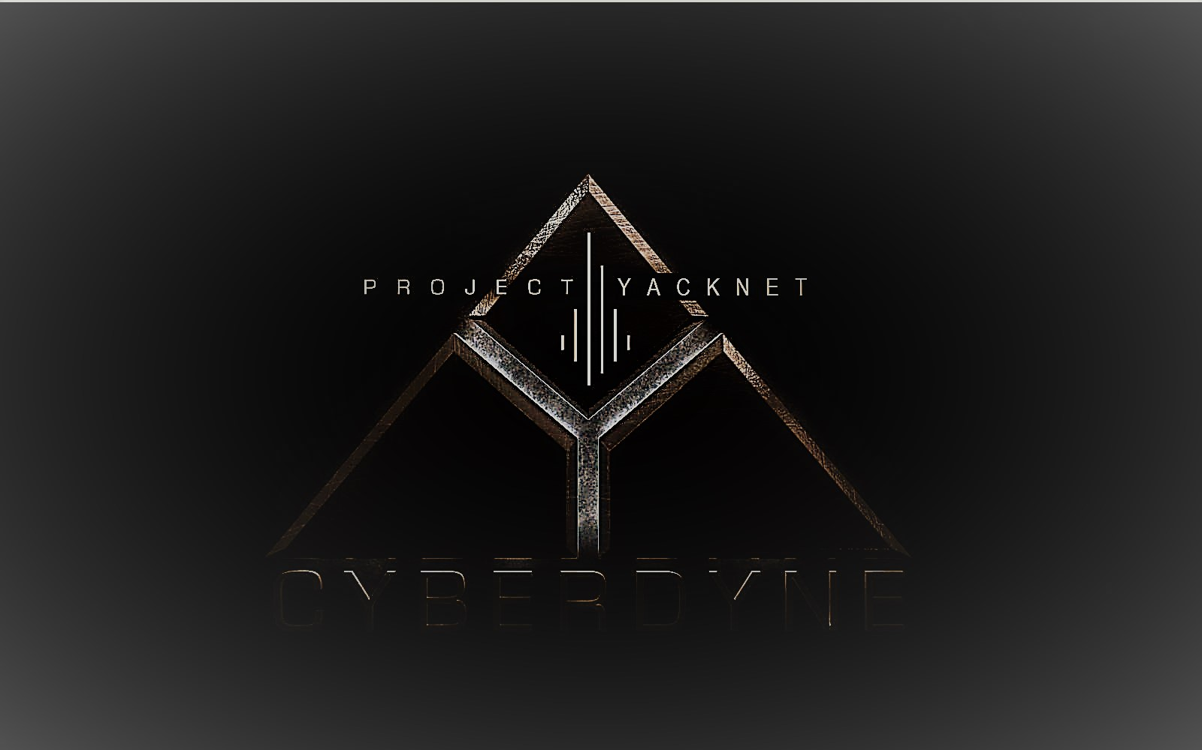

All Rights Reserved

daemon(7) https://man7.org/linux/man-pages/man7/daemon.7.html
systemctl(1) https://man7.org/linux/man-pages/man1/systemctl.1.html
eventfd(2) https://man7.org/linux/man-pages/man2/eventfd.2.html
timer_create(2) https://man7.org/linux/man-pages/man2/timer_create.2.html
timerfd_create(2) https://man7.org/linux/man-pages/man2/timer_create.2.html
messageQueue(7) https://man7.org/linux/man-pages/man7/mq_overview.7.html
epoll(7) https://man7.org/linux/man-pages/man7/epoll.7.html
signal(7) https://man7.org/linux/man-pages/man7/signal.7.html
signalfd(2) https://man7.org/linux/man-pages/man2/signalfd.2.html
inotify(7) https://man7.org/linux/man-pages/man7/inotify.7.html
Unix(7) https://man7.org/linux/man-pages/man7/unix.7.html
sed(1) https://man7.org/linux/man-pages/man1/sed.1.html
awk(1p) https://man7.org/linux/man-pages/man1/awk.1p.html
dpkg(1) https://man7.org/linux/man-pages/man1/dpkg.1.html

