QnA Markup Quick Start
http://www.qnamarkup.org
QnA is a markup language for people with little or no programming experience. It was designed with attorneys in mind and transforms blocks of text into interactive question and answer sessions (QnAs). These QnAs can be used as standalone expert systems or in the aid of rule­based document construction. Plus, the entire project is open source. Among other things, that means free.
A Few Examples

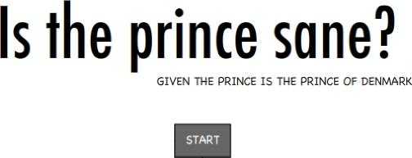
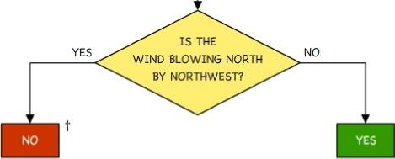
QnA uses specially formatted text (e.g., a Q: at the beginning of a line) to define how a computer will present text. These bits of formatting are called tags, and QnA only has ten. Let’s use two of them (Q & A) to rewrite the decision tree on the left. Of course, to see interactive output, you’ll need to type our text into a QnA editor/interpreter like the one available at the URL above.
The contents of Q (question) tags are rendered inside left­aligned text bubbles. The first Q tag's content is visible after loading. The content of other Q tags become visible after a user selects its preceding A tag.

So our decision tree becomes something like this.
These will become useful in a moment.
Q: Is the wind blowing north by northwest? A: Yes.

Q: No. Yet there is method in it.
A: No.
Q: Yes.
If you put the above into a QnA editor and hit “Update Outputs,” you’ll see an interactive version of the tree. You’ll also see a set of target ids added to your Q tags. For example:
Q(1): Is the wind blowing north by northwest? A: Yes.

Q(1.1): No. Yet there is method in it.
A: No.
Q(1.2): Yes.

Anyhow, it’s easy to see how you could continue this formatting for additional branches, and although this example doesn’t show it, you can include as many A tags as you like. Just remember indents are important.
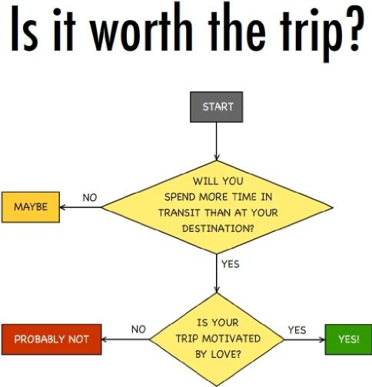
Q: Will you spend more time in transit than

at your destination?
A: Yes.
Q: Is your trip motivated by love?
A: Yes.
Q: Yes!
A: No.
Q: Probably not
A: No.
Q: Maybe

But what if we have a decision tree with branches that do more than fork? What if they join back on themselves? No problem. Take for example:

Q(1): Is the digraph after C?

A: Yes.
Q(1.1): E before I
A: No.
Q(1.2): Is the digraph an A sound as
in neighbor or weigh?
A: Yes.
Q(1.2.1):GOTO:1.1
A: No.
Q(1.2.2): Probably I before E,
but there could be an exception. English is
WEIRD!
See what we did with those target ids? We used a GOTO tag to redirect the user. This allows us to join branches.
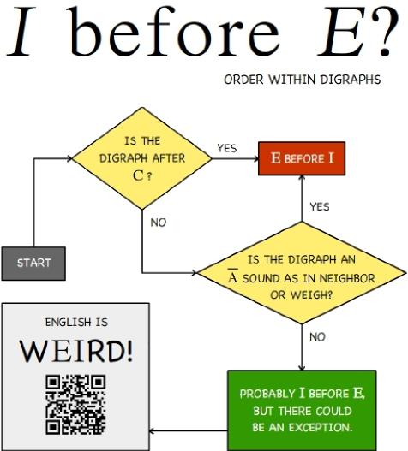
Now what about that weird QR Code? Can we add links to our QnA? Yes. You can add links to an A tag by placing the URL in brackets, like this:

[...]
Q(1.2.2): Probably I before E, but there could be an exception. English is WEIRD! A:[http://steve.wagar.com/ibeforee.htm] See for yourself.

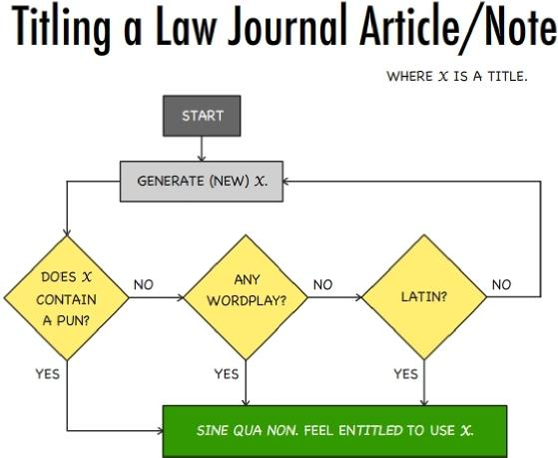 | If you want users to type an answer, you’ll need a new tag. The X tag works pretty much like the A tag, except that it renders the “answer” as a text field instead of a button. The text following an X tag becomes the name of a variable containing the user’s answer. You’ll see what that means in a minute. Let’s see what we can do with this decision tree?  For starters, we’ll turn “Generate (new)  X” into a question, “What is your working title?” For the full effect, you’ll want to drop this text in a QnA editor. Can you guess how it will render?

Q(mytitle): What is your working title?

X:
Q(1.1): Hum... Is there a pun in there?
A: Yes.
Q(1.1.1):GOTO:2
A: No.
Q(1.1.2): Any wordplay?
A: Yes.
Q(1.1.2.1):GOTO:2
A: No.
Q(1.1.2.2): Latin?
A: Yes.
Q(1.1.2.2.1):GOTO:2
A: No.
Q(1.1.2.2.2): Well that won't do. Think hard. GOTO:1
- Sine qua non. Feel enTITLED to use "<x>mytitle</x>."
That’s right, users are asked to type in their working title, and if it passes all the “tests,” it is shown to the user at the end. But that’s not all, you can do more than just send people to websites and parrot back things they typed. You can stitch everything together to create a document based on a user’s answers to questions. Find this and everything you need to build your own documents on the Syntax & Usage page at: http://www.qnamarkup.org/syntax/ You’ll also find an explanation of all ten tags.  After that, remember, practice makes... you better. | 
 | 