*Project:*

**Project Working Title:** Development of a Near-Infrared PL Emission Spectrometer

**Project End Date**: 10 May 2019 (The end of week 6 of spring term)

*Student:*

**Name**: Zach Colbert

**Affiliation:** Department of Physics, Oregon State University

*Biography*: Zach Colbert is a fourth-year undergraduate in the Department of Physics at Oregon State University. His background in physics, mathematics, and computing lead him to pursue a degree in physics, with emphasis on computational physics and computer science. He has maintained a relationship with the Micro-Femto Energetics Lab under Dr. Matthew Graham over the course of his undergraduate program, resulting in a SURE Science grant and senior thesis research in the summer of 2018.

Since fall 2016, Zach has worked as a technician for the Information Services division at OSU. While there, he has developed skills in domain management, systems administration, and network engineering.

Upon completion of his undergraduate degree, Zach plans to pursue a career in software development or data science.

*Statement*: I will work regularly and diligently on this project throughout the year and initiate meetings with my advisor to seek feedback and guidance on the research. I understand that a significant portion of the research should be completed by the end of winter term to enable me focus on the writing process in the PH403 class.

Student Signature: _____________________________

*Advisor:*

**Name** e.g. Dr. Matthew Graham

**Affiliation** e.g. Department of Physics, Oregon State University

I have read this thesis proposal. I agree that the scope is reasonable for completion by May 10, 2019 and that sufficient progress can be made by early winter term 2019 to allow significant revision of the thesis during the winter and spring terms of 2019.

Advisor Signature*:* _____________________________

**Project Summary**

The aim of this project is to construct an experimental setup capable of measuring the emission spectra of photoluminescent (PL) thin-films across the visible and near-infrared (NIR) ranges. A microscope and objective lenses will be used to illuminate single molecular domains with a diode laser light source.

**Project Description**

*Introduction*

Photoluminescence (PL) is the process by which materials will absorb a photon, exciting an electron to a higher-energy excited state, then emit a photon as the electron relaxes back to a lower-energy state. Measuring PL in different ways is a common method for characterizing the electronic band structure of materials, especially semiconductors and photovoltaic materials.

The most basic PL measurement is emission. Emission measurements use a single wavelength of incident light to excite the material and measure the intensity of light emitted across a spectrum.

The Micro-Femto Energetics (ufE) Lab has a system capable of measuring both PL emission and excitation of materials. This existing system has a diverse set of uses and is scientifically valuable to have but has a few specific drawbacks: wide-field illumination, complexity, and cost.

The existing system uses a xenon-arc lamp and double monochromator as its light source, leading to wide-field illumination on samples. Because defects in thin-film materials emit differently than pure domains, it is preferable to excite a single molecular domain; this is difficult to accomplish with the existing system.

Because it can take a wide range of measurements, the existing system can be complex to use. Configuring hardware and software to meet the requirements of each new experiment takes time and presents opportunities for user error. The existing system also has startup and shutdown times of up to one hour, making cursory measurements impractical.

Finally, the existing system relies on a liquid nitrogen-cooled detector for measurements in the NIR range which is both costly to operate and requires training. This project seeks to resolve these three drawbacks by assembling a new system that can illuminate single molecular domains, is simple and inexpensive to operate, and can measure PL emission with high accuracy.

*Plan of work*

The new experimental system will be built around an Olympus BX60M metallurgical microscope. This will act as the framework for coupling optics and detectors together to measure emission. Perkowitz’s PL system [1] is a good starting place for the design of this system, and using a microscope with objective lenses can be simplified to a few major components: a light source, a sample, a lens to focus PL light, filters to block unwanted laser light, and a monochromator and detector to measure emission.

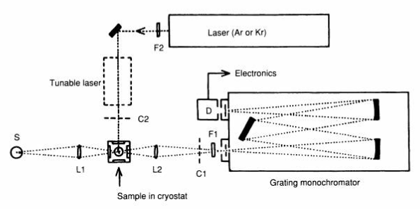

**Fig 1:** An experimental system for PL spectroscopy from Perkowitz  [1].

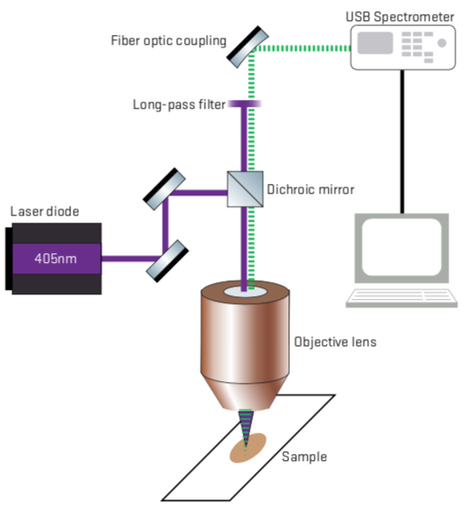

**Fig 2:** A new experimental system based on Perkowitz’s, using an Ocean Optics USB spectrometer to measure PL at visible wavelengths. Note that different laser diodes can be used to select other source wavelengths, but 405nm has a conveniently high energy for exciting materials.

The first stage of this project is to assemble the experimental system for measuring PL at visible wavelengths. This will include coupling a diode laser light source into the microscope, selecting filters and mirrors appropriate for directing source light onto the sample and filtering it from emission light, and coupling an Ocean Optics USB spectrometer to the system to measure the spectrum of emission light. Because the Ocean Optics spectrometer is designed to measure a spectrum of light on its own, no monochromator is needed for this setup. The greatest challenge in the first part of this experiment will be rigorously aligning optics to maximize optical power incident on the sample and collection of emission light by the detector.

The second stage of this project will be to adapt the system to use a detector sensitive to NIR wavelengths. The available detector is a linear indium-gallium-arsenide array camera, which will require the use of a monochromator or grating to measure the emission spectrum. This will present an interesting optical and computational challenge—aligning wavelengths of light to particular pixels on the camera, and mapping intensity data from each pixel onto the corresponding wavelength.

Finally, this project will measure the emission spectra of previously characterized thin-film materials and compare the resulting spectra to show that it returns accurate results. Comparable results will show spectral peaks of roughly the same shape and centered about the same wavelength. Peak height is not a significant factor when comparing PL spectra because the measurement is assumed to be a relative intensity, and may vary from one experiment to another.

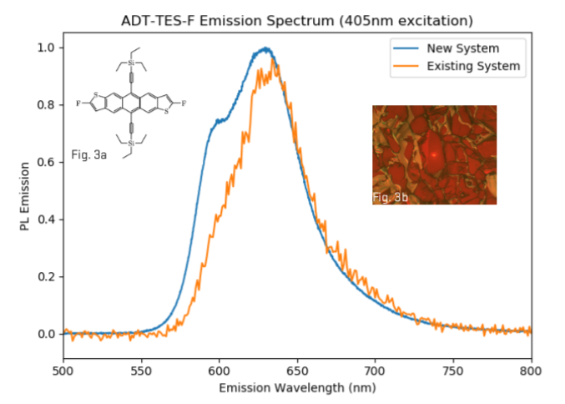

**Fig 3:** Early results comparing the PL of ADT TES-F crystals as measured by the new system and the Graham group’s existing commercial system. **Fig 3.a:** ADT TES-F molecular diagram. **Fig 3.b:** Region of interest measured for Figure 3, illuminated by 405nm laser and filtered for PL measurement.

Materials that could be used for final testing might include side-group variants of anthradithiophene (ADT) (used in previous Graham group theses [2], [3], [4]), cadmium selenide quantum dots, carbon nanotubes, and graphene. Samples of these materials are commonly the subject of studies by the Graham group, and readily accessible for measurement on this system.­­­

There is potential for collaboration in this project once the system is built and ready for testing. Other researchers from the Department of Physics and the School of Chemical, Biological, and Environmental Engineering have already proposed that this system be used to measure PL of their samples in the future.

*Timeline*

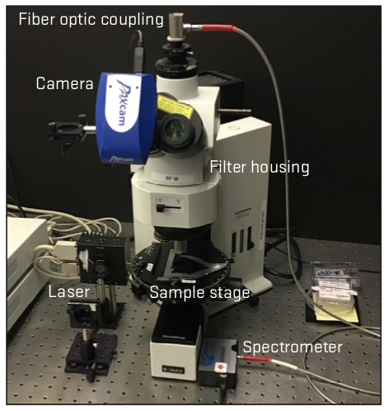

**Fig 4:** Completed first-stage system, capable of measuring PL at visible wavelengths. Needs more testing before progressing to second stage (NIR sensitivity).

A summer SURE project to begin this work completed the first-stage system, capable of measuring PL at visible wavelengths. Early results with the system are very promising, but measurements of ADT can be expanded on and analyzed more deeply before the end of fall term.

In the first half of winter break, most literature review should be complete so that an optical design for the NIR system can be drawn up in the second half of the break. If possible, this would be a good time to write complete drafts of the introduction and background sections of the thesis. By the end of winter break, the goal is to have a detailed optical schematic for the NIR system and have characterized all the new optics for that system (namely: a reflective blaze grating of unknown blaze angle).

By week 2 of winter term, the new optics for the NIR system should be well-aligned and the detector calibrated for measurements. By week 4, all code and methods for processing data collected by the NIR detector should be written and tested by measuring a well-characterized NIR emitter or alignment beam.

The bulk of measurements to test the NIR system should be complete by the end of week 5. Deadlines for each remaining section of the thesis are set in the subsequent weeks: methods in week 6, results in week 7, discussion in week 8, and conclusion in week 9. Ideally, these sections will be partially written in the process of completing all the above tasks so that revisions can be made to each section before their respective deadlines.

*Data management*

The Graham group has generously provided access to their network storage space, which is accessible on lab computers and can store data as it is collected. As necessary, I will use Box (online storage solution offered by OSU) to keep data and analyses that will be used in the thesis.

Code written for this project will be stored on my personal computer, version controlled, and backed up to GitHub. This includes LaTex document(s) used to write the thesis—which can be stored in a private repository and version-controlled in the process of drafting the final paper.

*Facilities, Equipment and Other Resources*

The Graham group has generously provided lab space, equipment, and access to some samples for the completion of this project. Any necessary purchasing was completed as part of the summer SURE project related to this work.

Shared lab equipment that may need to be used on a schedule includes the existing commercial PL system (for comparing results), and a monochromatic NIR laser source (for characterizing the grating for the NIR system). Lab users have been flexible with scheduling in the past, and equipment is often available in evening hours when I will be conducting much of my work anyway.

The Graham group has made a number of samples of visible emitters available for this project, but NIR emitters will need to be sourced from other labs. I have already been in contact with one possible source in the School of Chemical, Biological, and Environmental Engineering, and other Department of Physics groups in the field may have samples available. Sample sources will be confirmed before the start of winter term.

**References Cited**

[1] S. Perkowitz, *Optical Characterization of Semiconductors: Infrared, Raman, and Photoluminescence Spectroscopy* (Elsevier Science & Technology, Jordan Hill, UNITED KINGDOM, 2012).

[2] A. Lam, Polarization Dependent Spectral Analysis Reveals Dipole Alignment and Intermolecular Coupling in Anthradithiophene Organic Semiconducting Crystals, 2018.

[3] G. Brandt, The Impact of Crystal Morphology on the Opto-Electronic Properties of Amorphous and Organic Crystalline Materials, 2017.

[4] S. Grimm, Crystal Morphology and Dimensionality Determine the Electronic Response in Novel Semiconducting Materials, 2016.

[5] O. Ostroverkhova, Chem. Rev. **116**, 13279 (2016).