**Ensemble machine learning modeling for the prediction of artemisinin resistance in malaria**

**Colby T. Ford**1,2,* **and Daniel Janies**1

1**Department of Bioinformatics and Genomics, University of North Carolina at Charlotte, Charlotte, North Carolina, 28223, USA**

2**School of Data Science, University of North Carolina at Charlotte, Charlotte, North Carolina, 28223, USA**

\***Corresponding author: Colby T Ford** [**(colby.ford@uncc.edu)**](mailto:colby.ford@uncc.edu)

**Abstract**

Resistance in malaria is a growing concern affecting many areas of Sub-Saharan Africa and Southeast Asia. Since the emergence of artemisinin resistance in the late 2000s in Cambodia, research into the underlying mechanisms has been underway.

The 2019 Malaria Challenge posited the task of developing computational models that address important problems in advancing the fight against malaria. The first goal was to accurately predict artemisinin drug resistance levels of *Plasmodium falciparum* iso- lates, as quantified by the IC50. The second goal was to predict the parasite clearance

rate of malaria parasite isolates based on *in vitro* transcriptional profiles.

In this work, we develop machine learning models using novel methods for transform- ing isolate data and handling the tens of thousands of variables that result from these data transformation exercises. This is demonstrated by using massively parallel pro- cessing of the data vectorization for use in scalable machine learning. In addition, we show the utility of ensemble machine learning modeling for highly effective predictions of both goals of this challenge. This is demonstrated by the use of multiple machine learning algorithms combined with various scaling and normalization preprocessing steps. Then, using a voting ensemble, multiple models are combined to generate a final model prediction.

# Keywords

malaria, *Plasmodium falciparum*, machine learning, parallel computing, Apache Spark, big data, artemisinin, DREAM Com- petition

# Introduction

Malaria is a serious disease caused by parasites belonging to the genus *Plasmodium* which are transmitted by *Anopheles* mosquitoes in the genus. The World Health Organization (WHO) reports that there were 219 million cases of malaria in 2017 across 87 countries [1]. *Plasmodium falciparum* poses one of greatest health threats in Southeast Asia, being responsible for 62.8% of malaria cases in the region in 2017 [1].

Artemisinin-based therapies are among the best treatment options for malaria caused by *P. falciparum* [2]. The use of artemisinin in combination with other drugs, called artemisinin combination therapies, are the best treatment options today against malaria infections.

However, emergence of artemisinin resistance in Thailand and Cambodia in 2007 has been cause for research [3]. While there are polymorphisms in the kelch domain–carrying protein K13 in *P. falciparum* that are known to be associated with artemisinin resistance, many of the underlying molecular mechanisms that confer resistance remains unknown [4]. In early 2020, Birnbaum et al. discovered that the highly-conserved gene *kelch13* is associated with a molecular mechanism that allows the parasite to feed on host erythrocytes by endocytosis of hemoglobin [5]. Given that artemisinin is activated by hemoglobin degradation products, these mutations can confer resistance to artemisinin.

The established pharmacodynamics benchmark for *P. falciparum* sensitivity to artemisinin-based therapy is the parasite clearance rate [6, 7]. Resistance to artemisinin-based therapy is considered to be present with a parasite clearance rate greater than five hours[8]. By under- standing the genetic factors that affect resistance in malaria, targeted development can occur in an effort to abate further resistance or infections of resistant strains.

Previous research has shown success in applying similar machine learning methods in the explanation of genetic differences in plants [9], fungi [10], and even humans [11]. Previous work in machine learning-based tropical disease research, including malaria and other diseases, has shown effective in drug discovery [12, 13] and in the understanding of degradomes [14]. Also, other machine learning work in malaria has focused on the identification and diagnosis of malaria using image classification [15, 16, 17].

In this work, we create multiple machine learning-based models to address these issues around artemisinin resistance and parasite clearance. Given that the interpretation and analysis of many genes and their effects on resistance may be tedious, machine learning allows for a more power investigation into this relationship. Plus, we employ model explainability methods to help rank particular genes of interest in the malaria genome.

# Prediction of artemisinin IC50

First, we created a machine learning model to predict the IC50 of malaria parasites based on transcription profiles of experimentally-tested isolates. IC50, also known as the half maximal inhibitory concentration, is the drug concentration at which 50% of parasites die. This value indicates a population of parasites’ ability to withstand various doses of anti- malarial drugs, such as artemisinin.

## Methods

Training data was obtained from the 2019 DREAM Malaria Challenge [18, 19]. The training data consists of gene expression data of 5,540 genes of 30 isolates from the malaria parasite, *Plasmodium falciparum*. For each malaria parasite isolate, transcription data was collected at two time points [6 hours post invasion (hpi) and 24 hpi], with and without treatment of dihydroartemisinin (the metabolically active form of artemisinin), each with a biological replicate. This yields a total of at eight data points for each isolate. The initial form of the training dataset contains 272 rows and 5,546 columns, as shown in Table 1.

The transcription data was collected as described in Table 2. The transcription data set consists of 92 non-coding RNAs (denoted by gene IDs that begins with ’MAL’), while the rest are protein coding genes (denoted by gene IDs that start with ’PF3D7’). The feature to predict is *DHA*_*IC* 50.

## Data preparation

We used Apache Spark [21] to pivot the dataset such that each isolate was its own row and each of the transcription values for each gene and attributes (i.e. timepoint, treatment, biological replicate) combination was its own column. This exercise transformed the training dataset from 272 rows and 5,546 columns to 30 rows and 44,343 columns, as shown in Table 3. We completed this pivot by slicing the data by each of the eight combinations of timepoint, treatment, and biological replicate, dynamically renaming the variables (genes) for each slice, and then joining all eight slices back together.

By using the massively parallel architecture of Spark, this transformation can be completed in a minimal amount of time on a relatively small cluster environment (e.g., <10 minutes using a 8-worker/36-core cluster with PySpark on Apache Spark 2.4.3).

|  |  |  |  |  |  |  |  |  |
| --- | --- | --- | --- | --- | --- | --- | --- | --- |
| **Sample_Name** | **Isolate** | **Timepoint** | **Treatment** | **BioRep** | **Gene**1 | ... | **Gene**5540 | **DHA_IC50** |
| isolate_01.24HR.DHA.BRep1 | isolate_01 | 24HR | DHA | BRep1 | 0.008286 | ... | -2.48653 | 2.177 |
| isolate_01.24HR.DHA.BRep2 | isolate_01 | 24HR | DHA | BRep2 | -0.87203 | ... | -1.79457 | 2.177 |
| isolate_01.24HR.UT.BRep1 | isolate_01 | 24HR | UT | BRep1 | 0.03948 | ... | -2.49517 | 2.177 |
| isolate_01.24HR.UT.BRep2 | isolate_01 | 24HR | UT | BRep2 | 0.125177 | ... | -1.73531 | 2.177 |
| isolate_01.6HR.DHA.BRep1 | isolate_01 | 6HR | DHA | BRep1 | 1.354956 | ... | -0.82169 | 2.177 |
| isolate_01.6HR.DHA.BRep2 | isolate_01 | 6HR | DHA | BRep2 | -0.21807 | ... | -1.61839 | 2.177 |
| isolate_01.6HR.UT.BRep1 | isolate_01 | 6HR | UT | BRep1 | 1.31135 | ... | -2.62262 | 2.177 |
| isolate_01.6HR.UT.BRep2 | isolate_01 | 6HR | UT | BRep2 | 0.997722 | ... | -2.24719 | 2.177 |
| ... | ... | ... | ... | ... | ... | ... | ... | ... |
| isolate_30.6HR.UT.BRep2 | isolate_30 | 6HR | UT | BRep2 | -0.26639 | ... | -1.72273 | 1.363 |

### Table 1. Initial IC50 model training data format. Note that for Treatment, *UT* represents untreated samples and *DHA*

**represents samples treated with dihydroartemisinin.**

|  |  |
| --- | --- |
|  | **Training Set** |
| Array | Bozdech |
| Platform | Printed |
| Plexes | 1 |
| Unique Probes | 10159 |
| Range of Probes per Exon | N/A |
| Average Probes per Gene | 2 |
| Genes Represented | 5363 |
| Transcript Isoform Profiling | No |
| ncRNAs | No |
| Channel Detection Method | Two Color |
| Scanner | PowerScanner |
| Data Extraction | GenePix Pro |

**Table 2. IC**50 **training data information. (Adapted from Turnbull et al., (2017) PLoS One[20])**

|  |  |  |  |  |  |
| --- | --- | --- | --- | --- | --- |
| **Isolate** | **DHA_IC50** | **hr24_trDHA_br1_Gene**1 | **hr24_trDHA_br2_Gene**1 | ... | **hr6_trUT_br2_Gene**5540 |
| isolate_01 | 2.177 | 0.008286 | -0.87203 | ... | -2.24719 |
| ... | ... | ... | ... | ... | ... |
| isolate_30 | 1.363 | 0.195032 | 0.031504 | ... | -1.72273 |

**Table 3. Post-transformation format of the IC**50 **model training data.**

Lastly, the dataset is then vectorized using the Spark VectorAssembler, and converted into a Numpy[22]-compatible array. Vectorization allows for highly scalable parallelization of the machine learning modeling in the next step.

## Machine learning

We used the Microsoft Azure Machine Learning Service [23] as the tracking platform for retaining model performance metrics as the various models were generated. For this use case, 498 machine learning models were trained using vari- ous scaling techniques and algorithms. Scaling and normalization methods are shown in Table 14. We then created two ensemble models of the individual models using Stack Ensemble and Voting ensemble methods.

The Microsoft AutoML package [24] allows for the parallel creation and testing of various models, fitting based on a primary metric. For this use case, models were trained using Decision Tree, Elastic Net, Extreme Random Tree, Gradient Boosting, Lasso Lars, LightGBM, RandomForest, and Stochastic Gradient Decent algorithms along with various scaling methods from Maximum Absolute Scaler, Min/Max Scaler, Principal Component Analysis, Robust Scaler, Sparse Normalizer, Standard Scale Wrapper, Truncated Singular Value Decomposition Wrapper (as defined in Table 14). All of the machine learning algorithms are from the *scikit-learn* package[25] except for LightGBM, which is from the *LightGBM* package[26]. The settings for the model sweep are defined in Table 4. The ‘Preprocess Data?’ parameter enables the scaling and imputation of the features

in the data. Note that these models were evaluated using random sampling of the input training dataset provided by the DREAM Challenge, though the evaluation within the challenge was performed on an unlabelled testing dataset. The metrics in the Results section below reflect the evaluation on the sampled training data.

|  |  |
| --- | --- |
| **Parameter** | **Value** |
| Task | Regression |
| Number of Iterations | 500 |
| Iteration Timeout (minutes) | 20 |
| Max Cores per Iteration | 7 |
| Primary Metric | Normalized Root Mean Squared Error |
| Preprocess Data? | True |
| k-Fold Cross-Validations | 20 folds |

### Table 4. Model search parameter setting for the IC50 model search.

Once the 498 individual models were trained, two ensemble models (voting ensemble and stack ensemble) were then created and tested. The voting ensemble method makes a prediction based on the weighted average of the previous models’ predicted regression outputs whereas the stacking ensemble method combines the previous models and trains a meta-model using the elastic net algorithm based on the output from the previous models. The model selection method used was the Caruana ensemble selection algorithm[27].

## Results

The voting ensemble model (using soft voting) was selected as the best model, having the lowest normalized Root Mean Squared Error (RMSE), as shown in Table 5. The top 10 models trained are reported in Table 6. Having a normalized RMSE of only 0.1228 and a Mean Absolute Percentage Error (MAPE) of 24.27%, this model is expected to accurately predict IC50 in malaria isolates. See Figure 1 for a visualization of the experiment runs and Figure 2 for the distribution of residuals on the best model.

|  |  |
| --- | --- |
| **Metric** | **Value** |
| Normalized Root Mean Squared Error | 0.1228 |
| Root Mean Squared Log Error | 0.1336 |
| Normalized Mean Absolute Error | 0.1097 |
| Mean Absolute Percentage Error | 24.27 |
| Normalized Median Absolute Error | 0.1097 |
| Root Mean Squared Error | 0.3398 |
| Explained Variance | -1.755 |
| Normalized Root Mean Squared Log Error | 0.1379 |
| Median Absolute Error | 0.3035 |
| Mean Absolute Error | 0.3035 |

### Table 5. Model metrics of the final IC50 ensemble model.

|  |  |  |  |
| --- | --- | --- | --- |
| **Iteration** | **Preprocessor** | **Algorithm** | **Normalized RMSE** |
| 498 |  | VotingEnsemble | 0.12283293 |
| 370 | SparseNormalizer | RandomForest | 0.132003138 |
| 432 | StandardScalerWrapper | LightGBM | 0.133180215 |
| 240 | SparseNormalizer | RandomForest | 0.133779391 |
| 430 | StandardScalerWrapper | RandomForest | 0.137084337 |
| 65 | SparseNormalizer | RandomForest | 0.13884791 |
| 56 | SparseNormalizer | RandomForest | 0.14417843 |
| 68 | MaxAbsScaler | ExtremeRandomTrees | 0.151925822 |
| 470 | StandardScalerWrapper | RandomForest | 0.152262231 |
| 181 | MinMaxScaler | LightGBM | 0.15279075 |

**Table 6. Top 10 training iterations of the IC**50 **model search, evaluated by Root Mean Squared Error. Note that the top performing model (VotingEnsemble) is the final IC**50 **model discussed in this paper.**

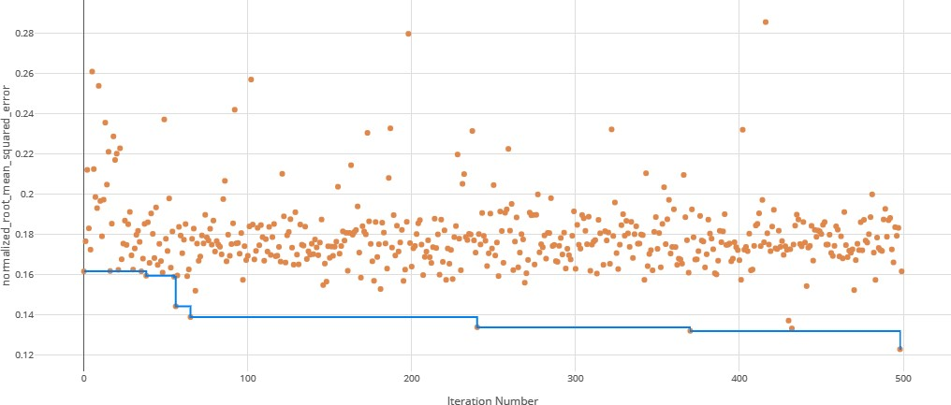

**Figure 1. Root Mean Squared Error (RMSE) by iteration of the IC**50 **model search. Each orange dot is an iteration with the blue line representing the minimum RMSE up to that iteration.**

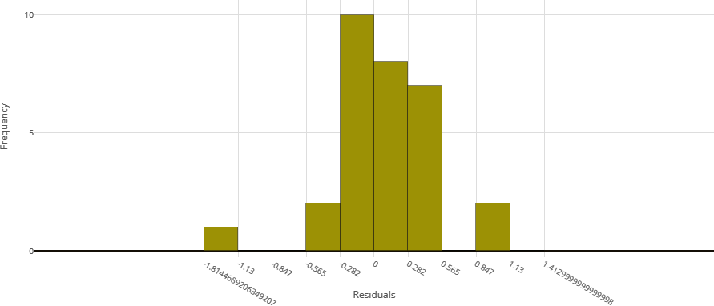

**Figure 2. Model residuals of the final IC**50 **ensemble model.**

**Prediction of resistance status**

The second task of this work was to create a machine learning model that can predict the parasite clearance rate (fast versus slow) of malaria isolates. When resistance rates change in a pathogen, it can be indicative of regulatory changes in the pathogen’s genome. These changes can be exploited for the prevention of further resistance spread. Thus, a goal of this work is to understand genes important in the prediction of artemisinin resistance. The relationship of this use case to the first is that parasite clearance is a measure of the effectiveness of a treatment regimen. While the first use case looked at the drug concentration, this use case looks into the speed at which the parasites are cleared as a result of a standard treatment.

## Methods

An *in vivo* transcription data set from Mok *et al.*, (2015) Science[28] was used to predict the parasite clearance rate of malaria parasite isolates based on *in vitro* transcriptional profiles (see Table 8).

The training data consists of 1,043 isolates with 4,952 genes from the malaria parasite *Plasmodium falciparum*. For each malaria parasite isolate, transcription data was collected for various *PF3D7* genes. The form of the training dataset contains 1,043 rows and 4,957 columns, as shown in Table 7. The feature to predict is *ClearanceRate*.

|  |  |  |  |  |  |  |  |
| --- | --- | --- | --- | --- | --- | --- | --- |
| **Sample_Names** | **Country** | **Asexual_stage hpi_** | **Kmeans_Grp** | **PF3D7_0100100** | **...** | **PF3D7_1480100** | **ClearanceRate** |
| GSM1427365 | Bangladesh | 20 | B | 0.226311 | ... | -0.64171 | Fast |
| ... | ... | ... | ... | ... | ... | ... | ... |
| GSM1427537 | Cambodia | 12 | C | 0.81096 | ... | -1.72825 | Slow |
| ... | ... | ... | ... | ... | ... | ... | ... |
| GSM1428407 | Vietnam | 8 | A | 0.999095 | ... | NaN | Fast |

### Table 7. Format of the clearance rate model training data.

**Data preparation**

The training data for this use case did not require the same pivoting transformations as in the last use case as each record describes a single isolate. Thus, only the vectorization of the data was necessary, which was performed using the Spark VectorAssembler and then converted into a Numpy-compatible array [22]. Note that this vectorization only kept the numerical columns, which excludes the Country, Kmeans_Grp, and Asexual_stage hpi_ attributes as they are either absent or contain non-matching factors (i.e. different set of countries) in the testing data.

|  |  |
| --- | --- |
|  | **Training Set** |
| Number  of isolates | 1043 |
| Isolate  collection site | Southeast Asia |
| Isolate  collection years | 2012-2014 |
| Sample  type | *in vivo* |
| Synchronized? | Not synchronized |
| Number  of samples per isolate | 1 |
| Additional attributes | ~18 hpi,  Non-perturbed, No replicates |

### Table 8. Training dataset information from Mok *et al.*, 2015[28].

**Machine learning**

Once the 98 individual models were trained, two ensemble models (voting ensemble and stack ensemble) were then created and tested as before. Model search parameters are shown in Table 9.

|  |  |
| --- | --- |
| **Parameter** | **Value** |
| Task | Regression |
| Number of iterations | 100 |
| Iteration timeout (minutes) | 20 |
| Max cores per iteration | 14 |
| Primary metric | weighted area under the receiver operating characteristic curve (AUC) |
| Preprocess data? | True |
| k-Fold cross-validations | 10 folds |

### Table 9. Model search parameter settings for the clearance rate model search.

**Results**

The voting ensemble model (using soft voting) was selected as the best model, having the highest area under the receiver operating characteristic curve (AUC), as shown in Table 11. The top 10 of the 100 models trained are reported in Table 10. Having a weighted AUC of 0.87 and a weighted F1 score of 0.80, this model is expected to accurately predict isolate clearance rates. A confusion matrix of the predicted results versus actuals is shown in Table 12. See Figure 3 for a visualization of the experiment runs and see Figures 4 and 5 for the ROC and Precision-Recall curves on the best model. Note that these models were evaluated using random sampling of the input training dataset provided by the DREAM Challenge, though the evaluation within the challenge was performed on an unlabelled testing dataset. The metrics in the Results section below reflect the evaluation on the sampled training data.

Note that the averages reported in Figures 4 and 5 are defined as follows:

* ‘micro’: Computed globally by combining the true positives and false positives from each class at each cutoff.
* ‘macro’: The arithmetic mean for each class. This does not take class imbalance into account.
* ‘weighted’: The arithmetic mean of the score for each class, weighted by the number of true instances in each class (support).

|  |  |  |  |
| --- | --- | --- | --- |
| **Iteration** | **Preprocessor** | **Algorithm** | **Weighted AUC** |
| 98 |  | VotingEnsemble | 0.870471056 |
| 99 |  | StackEnsemble | 0.865215516 |
| 65 | StandardScalerWrapper | LogisticRegression | 0.86062304 |
| 33 | StandardScalerWrapper | LogisticRegression | 0.859881677 |
| 97 | StandardScalerWrapper | LogisticRegression | 0.858791006 |
| 44 | StandardScalerWrapper | LogisticRegression | 0.856105491 |
| 73 | StandardScalerWrapper | LogisticRegression | 0.855502817 |
| 17 | RobustScaler | SVM | 0.855452622 |
| 43 | StandardScalerWrapper | LogisticRegression | 0.855368394 |
| 61 | RobustScaler | LogisticRegression | 0.854357599 |

### Table 10. Top 10 training iterations of the clearance rate model search.

**Note that the top performing model (VotingEnsemble) is the clearance rate model discussed in this paper.**

|  |  |
| --- | --- |
| **Metric** | **Accuracy** |
| f1_score_macro | 0.6084 |
| AUC_micro | 0.9445 |
| AUC_macro | 0.8475 |
| recall_score_micro | 0.8101 |
| recall_score_weighted | 0.8101 |
| average_precision_score_weighted | 0.8707 |
| weighted_accuracy | 0.8585 |
| precision_score_macro | 0.6217 |
| precision_score_micro | 0.8101 |
| balanced_accuracy | 0.6027 |
| log_loss | 0.4455 |
| recall_score_macro | 0.6027 |
| precision_score_weighted | 0.8 |
| AUC_weighted | 0.8705 |
| average_precision_score_micro | 0.8911 |
| f1_score_weighted | 0.8019 |
| f1_score_micro | 0.8101 |
| norm_macro_recall | 0.354 |
| average_precision_score_macro | 0.7344 |
| accuracy | 0.8101 |

**Table 11. Model metrics of the final clearance rate ensemble model.**

**Feature importance**

Feature importances were calculated using mimic-based model explanation of the ensemble model [29]. The mimic ex- plainer works by training global surrogate models to mimic blackbox models (i.e. complex models that are difficult to explain). The surrogate model is an interpretable model, trained to approximate the predictions of a black box model as

|  |  |  |  |  |
| --- | --- | --- | --- | --- |
| **Class** | | **Prediction** | | |
| **Fast (ID: 0)** | **Slow (ID: 1)** | **Null (ID: 2)** |
| **Actual** | **Fast (ID: 0)** | 661 | 74 | 0 |
| **Slow (ID: 1)** | 115 | 184 | 0 |
| **Null (ID: 2)** | 6 | 3 | 0 |

### Table 12. Confusion matrix of clearance rate predictions versus actual.

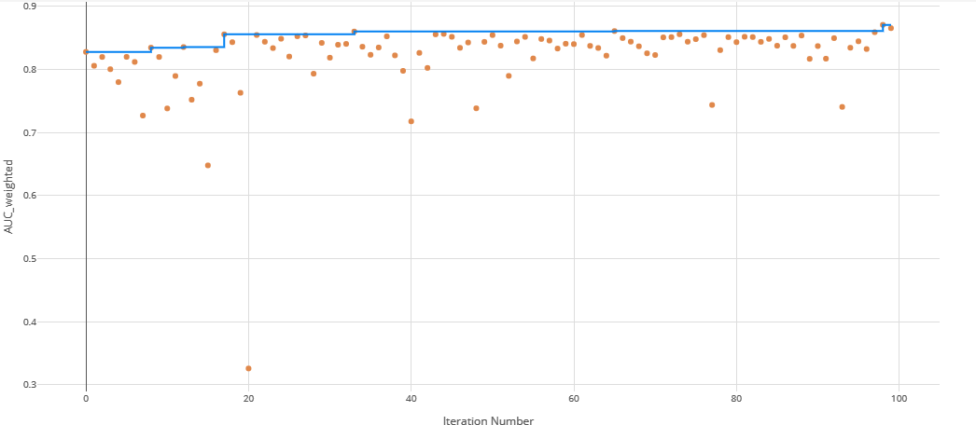

**Figure 3. Area under the receiver operating characteristic curve (AUC) by iteration of the clearance rate model. Each orange dot is an iteration with the blue line representing the maximum AUC up to that iteration.**

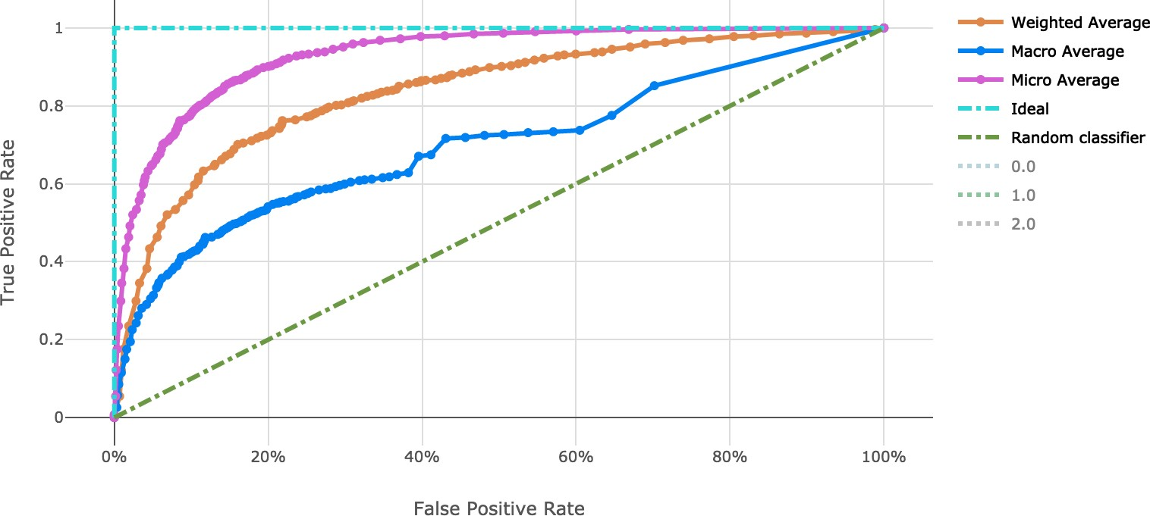

**Figure 4. Receiver operating characteristic curve of the clearance rate model.**

accurately as possible [30]. In Figure 6 and Table 13, the feature importance values for each class ("Slow", "Fast", and NULL) are shown. This shows which genes are important in the prediction of clearance rate.

The mimic explainer was opted over other traditional methods such as principal component analysis (PCA) because of its ability to provide clearer interpretations into the features’ importance. PCA occludes the true values of individual features by summarising multiple features together. Given that insights into particular genes’ importance on resistance were desired here, the mimic explainer provides this output in a more straightforward manner.

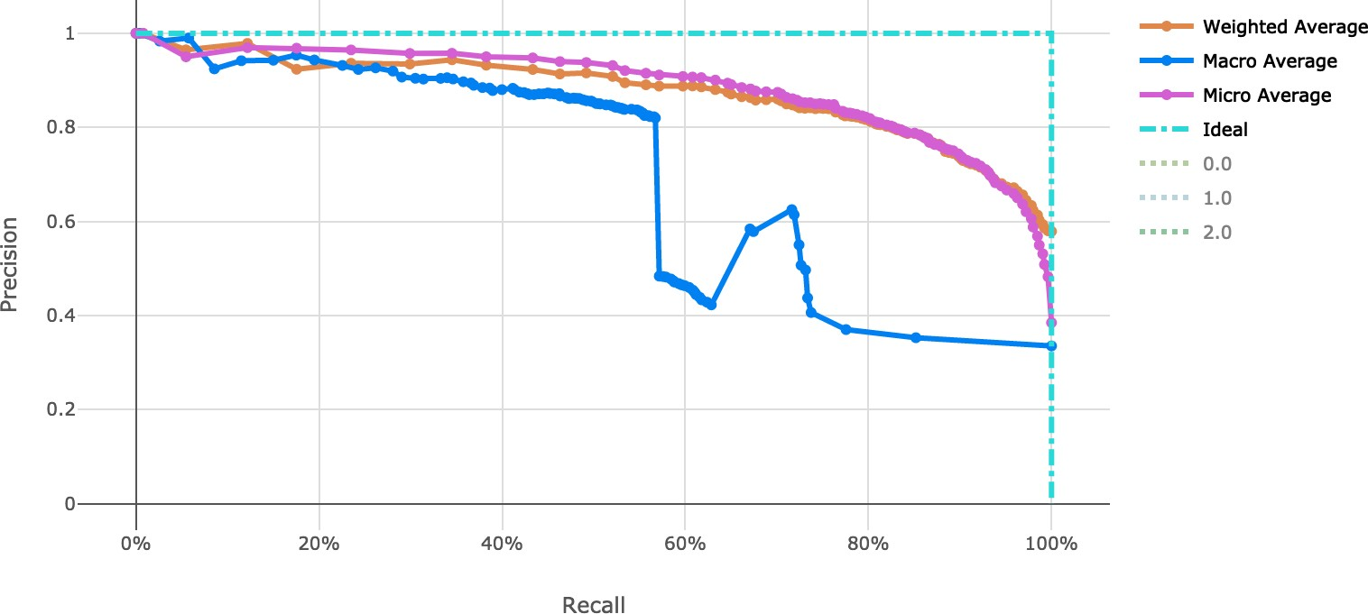

### Figure 5. Precision-Recall curve of the clearance rate model.

|  |  |  |  |  |  |
| --- | --- | --- | --- | --- | --- |
| **Rank** | **PF3D7 Gene** | **Slow Importance** | **Fast Importance** | **NULL Importance** | **Overall Importance** |
| 1 | PF3D7_1245300 | 0.292 | 0.118 | 0.000 | 0.410 |
| 2 | PF3D7_1107700 | 0.020 | 0.274 | 0.000 | 0.294 |
| 3 | PF3D7_1328400 | 0.154 | 0.123 | 0.000 | 0.277 |
| 4 | PF3D7_1372000 | 0.172 | 0.095 | 0.000 | 0.267 |
| 5 | PF3D7_1115600 | 0.083 | 0.179 | 0.000 | 0.262 |
| 6 | PF3D7_0608100 | 0.000 | 0.000 | 0.243 | 0.243 |
| 7 | PF3D7_0523000 | 0.154 | 0.087 | 0.000 | 0.241 |
| 8 | PF3D7_1205300 | 0.000 | 0.002 | 0.197 | 0.199 |
| 9 | PF3D7_1129100 | 0.008 | 0.191 | 0.000 | 0.199 |

**Table 13. Top 10 PF3D7 genes (features) in predicting clearance rate.**

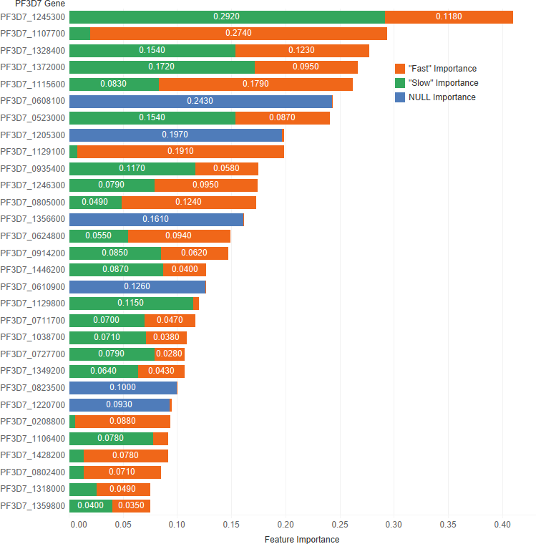

**Figure 6. Derived feature importances using the black box mimic model explanation of the clearance rate model. (Shown: Top 30 genes.)**

**Discussion**

By using distributed processing of the data preparation, we can successfully shape and manage large malaria datasets. We efficiently transformed a matrix of over 40,000 genetic attributes for the *IC*50 use case and over 4,000 genetic attributes for the resistance rate use case. This was completed with scalable vectorization of the training data, which allowed for many machine learning models to be generated. By tracking the individual performance results of each machine learning model, we can determine which model is most useful. In addition, ensemble modeling of the various singular models proved effective for both tasks in this work. While the number of training observations for each use case stand to be improved, the usage of adequate cross-validation can help to stabilize the risk of over fitting models to such a small dataset. Also note that there is an imbalance in the number of samples in each class in the clearance rate experiment, which stands to be remedied in future work. There are over double the number of “Fast" clearance rate isolates compared to “Slow". This can be seen in the variation in model performance as indicated by the macro average Precision-Recall curve (Figure 5).

The resulting model performance of both the *IC*50 model and the clearance rate model show relatively adequate fitting of the data for their respective predictions. While additional model tuning may provide a lift in model performance, we have demonstrated the utility of ensemble modeling in these predictive use cases in malaria. In both models, we show that IC50 and clearance rate can be effectively predicted using transcriptomic analysis data with machine learning. By extension, this is also predicting the phenotypic result of the genetic variations among the samples as is relates to resistance.

In a broader sense for the field parasitology, this exercise helps to quantify the importance of genetic features, spotlighting potential genes that are significant in artemisinin resistance. The merit of this work showcases the utility of machine learning to assist in the understanding of the underlying genetic/transcriptomic mechanisms that affect drug performance.

Specific examples include PF3D7 1245300, the most important feature in predicting slow parasite clearance. PF3D7 1245300 is the gene that codes for the NEDD8-conjugating enzyme UBC12 (UniProt ID: [Q8I4X8),](https://www.uniprot.org/uniprot/Q8I4X8) a ligase used in the ubiq- uitin conjugating pathway. Another example, PF3D7 1107700 is the most important gene for fast clearance rate. PF3D7 1107700 (UniProt ID: [Q8IIS5)](https://www.uniprot.org/uniprot/Q8IIS5) is important in the regulation of the cell cycle, specifically in the maturation of ribosomal RNAs and in the formation of the large ribosomal subunit. Future *in vitro* experiments of this *in silico* work should be performed to validate these findings. While biological confirmations of these genetic factors are needed, this analysis helps to rank the most probable factors by importance, therefore reducing the *in vitro* work to be performed.

These two examples of important genes identified here along with the other may one day be the target for future drugs or

may prove integral in the overall understanding of how resistance works in *P. falciparum*. The utility of these models will help in directing development of alternative treatments or coordination of combination therapies in resistant infections and provides an example of the usage of machine learning in the identification of important genetic feature in infectious disease research.

|  |  |
| --- | --- |
| **Scaling and Normalization** | **Description** |
| StandardScaleWrapper | Standardize features by removing the mean  and scaling to unit variance |
| MinMaxScalar | Transforms features by scaling each feature  by that column’s minimum and maximum |
| MaxAbsScaler | Scale each feature by its maximum absolute value |
| RobustScalar | This Scaler features by their quantile range |
| PCA | Linear dimensionality reduction using  singular value decomposition of the data to project it to a lower dimensional space |
| TruncatedSVDWrapper | This transformer performs linear dimensionality  reduction by means of truncated singular value decomposition.  Contrary to PCA, this estimator does not center the  data before computing the singular value decomposition. This means it can efficiently work with sparse matrices. |
| SparseNormalizer | Each sample (each record of the data) with  at least one non-zero component is re-scaled independently of other samples so that its norm (L1 or L2) equals one |

### Table 14. Scaling function information for machine learning model search [31].

**Preprint**

An earlier version of this article can be found on bioRxiv (doi:10.1101[/856922).](https://doi.org/10.1101/856922)

# Data availability

*Underlying data*

The challenge datasets are available from Synapse (<https://www.synapse.org/>; Synapse ID: [syn18089524).](https://www.synapse.org/#!Synapse%3Asyn18089524) Access to the data requires registration and agreement to the conditions for use at: [https://www.synapse.org/#!Synapse:](https://www.synapse.org/#!Synapse%3Asyn18089524) [syn18089524](https://www.synapse.org/#!Synapse%3Asyn18089524).

Challenge documentation, including the detailed description of the Challenge design, data description, and overall results can be found at: https://www.synapse.org/#!Synapse:syn16924919/wiki/583955.

Whole genome expression profiling of artemsinin-resistant Plasmodium falciparum field isolates, Accession number GSE59099:

<https://www.ncbi.nlm.nih.gov/geo/query/acc.cgi?acc=GSE59099>.

Zenodo: colbyford/malaria_DREAM2019: Ensemble Machine Learning Modeling for the Prediction of Artemisinin Re- sistance in Malaria - Initial Code Release for Research Publication (F1000). [https://doi.org/10.5281/zenodo.](https://doi.org/10.5281/zenodo.3590459) [3590459](https://doi.org/10.5281/zenodo.3590459). [32]

This project contains the following underlying data:

* /SubChallenge1/data/sc1_X_train.pkl (Pickle file of the SubChallenge 1 independent variables, pivoted by Timepoint,

Treatment, and BioRep.)

* /SubChallenge1/data/sc1_y_train.pkl (Pickle file of the SubChallenge 1 dependent variable, DHA_IC50.)
* /SubChallenge2/data/sc2_X_train.pkl (Pickle file of the SubChallenge 2 independent variables.)
* /SubChallenge2/data/sc2_y_train.pkl (Pickle file of the SubChallenge 2 dependent variable, ClearanceRate.)

Data are available under the terms of the [Creative Commons Zero "No rights reserved" data waiver](https://creativecommons.org/publicdomain/zero/1.0/) (CC0 1.0 Public domain dedication).

# Software availability

* Source code available from: <https://github.com/colbyford/malaria_DREAM2019>
* Archived source code at time of publication: <https://doi.org/10.5281/zenodo.3590459>[32]
* License: GPL-3.0

# Competing interests

No competing interests were disclosed.

# Grant information

This work was supported by the University of North Carolina at Charlotte Department of Bioinformatics and Genomics and the School of Data Science.

# References

1. Fact sheet about malaria. *World Health Organization*, Mar 2019. URL [https://www.who.int/news-room/fact-sheets/ detail/malaria](https://www.who.int/news-room/fact-sheets/detail/malaria).
2. *Guidelines for the treatment of malaria*. World Health Organization, 2015.
3. Arjen M. Dondorp, François Nosten, Poravuth Yi, Debashish Das, Aung Phae Phyo, Joel Tarning, Khin Maung Lwin, Frederic Ariey, Warunee Hanpithakpong, Sue J. Lee, Pascal Ringwald, Kamolrat Silamut, Mallika Imwong, Kesinee Chotivanich, Pharath Lim, Trent Herdman, Sen Sam An, Shunmay Yeung, Pratap Singhasivanon, Nicholas P.J. Day, Niklas Lindegardh, Duong Socheat, and Nicholas J. White. Artemisinin resistance in plasmodium falciparum malaria. *New England Journal of Medicine*, 361(5):455–467, 2009. doi: 10.1056/NEJMoa0808859. URL <https://doi.org/10.1056/NEJMoa0808859>. PMID: 19641202.
4. Amed Ouattara, Aminatou Kone, Matthew Adams, Bakary Fofana, Amelia Walling Maiga, Shay Hampton, Drissa Coulibaly, Ma- hamadou A. Thera, Nouhoum Diallo, Antoine Dara, Issaka Sagara, Jose Pedro Gil, Anders Bjorkman, Shannon Takala-Harrison, Ogobara K. Doumbo, Christopher V. Plowe, and Abdoulaye A. Djimde. Polymorphisms in the k13-propeller gene in artemisinin- susceptible plasmodium falciparum parasites from bougoula-hameau and bandiagara, mali. *The American Journal of Tropical Medicine and Hygiene*, 92(6):1202–1206, 2015. ISSN 0002-9637. doi: https://doi.org/10.4269/ajtmh.14-0605. URL [http:](http://www.ajtmh.org/content/journals/10.4269/ajtmh.14-0605)

[//www.ajtmh.org/content/journals/10.4269/ajtmh.14-0605](http://www.ajtmh.org/content/journals/10.4269/ajtmh.14-0605).

1. Jakob Birnbaum, Sarah Scharf, Sabine Schmidt, Ernst Jonscher, Wieteke Anna Maria Hoeijmakers, Sven Flemming, Christa Geeke Toenhake, Marius Schmitt, Ricarda Sabitzki, Bärbel Bergmann, Ulrike Fröhlke, Paolo Mesén-Ramírez, Alexandra Blancke Soares, Hendrik Herrmann, Richárd Bártfai, and Tobias Spielmann. A kelch13-defined endocytosis pathway mediates artemisinin resistance in malaria parasites. *Science*, 367(6473):51–59, 2020. ISSN 0036-8075. doi: 10.1126/science.aax4735. URL [https://science. sciencemag.org/content/367/6473/51](https://science.sciencemag.org/content/367/6473/51).
2. Sompob Saralamba, Wirichada Pan-Ngum, Richard J. Maude, Sue J. Lee, Joel Tarning, Niklas Lindegårdh, Kesinee Chotivanich, François Nosten, Nicholas P. J. Day, Duong Socheat, Nicholas J. White, Arjen M. Dondorp, and Lisa J. White. Intrahost modeling of artemisinin resistance in plasmodium falciparum. *Proceedings of the National Academy of Sciences*, 108(1):397–402, 2011. ISSN 0027-8424. doi: 10.1073/pnas.1006113108. URL <https://www.pnas.org/content/108/1/397>.
3. Nicholas James White. The parasite clearance curve. In *Malaria Journal*, 2011.
4. Elizabeth A. Ashley, Mehul Dhorda, Rick M. Fairhurst, Chanaki Amaratunga, Parath Lim, Seila Suon, Sokunthea Sreng, Jen- nifer M. Anderson, Sivanna Mao, Baramey Sam, Chantha Sopha, Char Meng Chuor, Chea Nguon, Siv Sovannaroth, Sasithon Pukrittayakamee, Podjanee Jittamala, Kesinee Chotivanich, Kitipumi Chutasmit, Chaiyaporn Suchatsoonthorn, Ratchadaporn Run- charoen, Tran Tinh Hien, Nguyen Thanh Thuy-Nhien, Ngo Viet Thanh, Nguyen Hoan Phu, Ye Htut, Kay-Thwe Han, Kyin Hla Aye, Olugbenga A. Mokuolu, Rasaq R. Olaosebikan, Olaleke O. Folaranmi, Mayfong Mayxay, Maniphone Khanthavong, Bouasy Hongvan- thong, Paul N. Newton, Marie A. Onyamboko, Caterina I. Fanello, Antoinette K. Tshefu, Neelima Mishra, Neena Valecha, Aung Pyae Phyo, Francois Nosten, Poravuth Yi, Rupam Tripura, Steffen Borrmann, Mahfudh Bashraheil, Judy Peshu, M. Abul Faiz, Aniruddha Ghose, M. Amir Hossain, Rasheda Samad, M. Ridwanur Rahman, M. Mahtabuddin Hasan, Akhterul Islam, Olivo Miotto, Roberto Amato, Bronwyn MacInnis, Jim Stalker, Dominic P. Kwiatkowski, Zbynek Bozdech, Atthanee Jeeyapant, Phaik Yeong Cheah, Tharis- ara Sakulthaew, Jeremy Chalk, Benjamas Intharabut, Kamolrat Silamut, Sue J. Lee, Benchawan Vihokhern, Chanon Kunasol, Mallika Imwong, Joel Tarning, Walter J. Taylor, Shunmay Yeung, Charles J. Woodrow, Jennifer A. Flegg, Debashish Das, Jeffery Smith, Meera Venkatesan, Christopher V. Plowe, Kasia Stepniewska, Philippe J. Guerin, Arjen M. Dondorp, Nicholas P. Day, and Nicholas J. White. Spread of artemisinin resistance in plasmodium falciparum malaria. *New England Journal of Medicine*, 371(5):411–423, 2014. doi: 10.1056/NEJMoa1314981. URL <https://doi.org/10.1056/NEJMoa1314981>. PMID: 25075834.
5. Douglas B Kell, Robert M Darby, and John Draper. Genomic computing. explanatory analysis of plant expression profiling data using machine learning. *Plant Physiology*, 126(3):943–951, 2001.
6. Amanda Clare. *Machine learning and data mining for yeast functional genomics*. PhD thesis, University of Wales, Aberystwyth, 2003.
7. Sangkyu Lee, Sarah Kerns, Harry Ostrer, Barry Rosenstein, Joseph O Deasy, and Jung Hun Oh. Machine learning on a genome-wide association study to predict late genitourinary toxicity after prostate radiation therapy. *International Journal of Radiation Oncology* Biology* Physics*, 101(1):128–135, 2018.
8. Dmitry Grapov, Johannes Fahrmann, Kwanjeera Wanichthanarak, and Sakda Khoomrung. Rise of deep learning for genomic, proteomic, and metabolomic data integration in precision medicine. *Omics: a journal of integrative biology*, 22(10):630–636, 2018.
9. Sean Ekins, Jair Lage de Siqueira-Neto, Laura-Isobel McCall, Malabika Sarker, Maneesh Yadav, Elizabeth L Ponder, E Adam Kallel, Danielle Kellar, Steven Chen, Michelle Arkin, et al. Machine learning models and pathway genome data base for trypanosoma cruzi drug discovery. *PLoS neglected tropical diseases*, 9(6), 2015.
10. Rui Kuang, Jianying Gu, Hong Cai, and Yufeng Wang. Improved prediction of malaria degradomes by supervised learning with svm and profile kernel. *Genetica*, 136(1):189–209, 2009.
11. Dev Kumar Das, Madhumala Ghosh, Mallika Pal, Asok K Maiti, and Chandan Chakraborty. Machine learning approach for automated screening of malaria parasite using light microscopic images. *Micron*, 45:97–106, 2013.
12. Zhaohui Liang, Andrew Powell, Ilker Ersoy, Mahdieh Poostchi, Kamolrat Silamut, Kannappan Palaniappan, Peng Guo, Md Amir Hossain, Antani Sameer, Richard James Maude, et al. Cnn-based image analysis for malaria diagnosis. In *2016 IEEE International Conference on Bioinformatics and Biomedicine (BIBM)*, pages 493–496. IEEE, 2016.
13. Mahdieh Poostchi, Kamolrat Silamut, Richard J Maude, Stefan Jaeger, and George Thoma. Image analysis and machine learning for detecting malaria. *Translational Research*, 194:36–55, 2018.
14. Sage Davis, Katrina Button-Simons, Taoufik Bensellak, Eren Mehmet Ahsen, Lisa Checkley, Gabriel J. Foster, Xinzhuan Su, Ahmed Moussa, Darlington Mapiye, Sok Kean Khoo, Francois Nosten, Timothy J. C. Anderson, Katelyn Vendrely, Julie Bletz, Thomas Yu, Sumir Panji, Amel Ghouila, Nicola Mulder, Thea Norman, Steven Kern, Pablo Meyer, Gustavo Stolovitzky, Michael T. Ferdig, and Geoffrey H. Siwo. Leveraging crowdsourcing to accelerate global health solutions. *Nature Biotechnology*, 37(8):848–850, 2019. ISSN 1546-1696. doi: 10.1038/s41587-019-0180-5. URL <https://doi.org/10.1038/s41587-019-0180-5>.
15. A. Ghouila, G. H. Siwo, J. D. Entfellner, S. Panji, K. A. Button-Simons, S. Z. Davis, F. M. Fadlelmola, M. T. Ferdig, N. Mulder,

T. Bensellak, A. Ghansah, K. Ghedira, A. Gritzman, I. Isewon, A. Kishk, A. Moussa, C. Loucoubar, P. Musicha, M. Pore, D. M. Sengeh,

D. S. Mapiye, P. K. Rallabandi, and M. Varughese. Hackathons as a means of accelerating scientific discoveries and knowledge transfer. *Genome Res.*, 28(5):759–765, 05 2018.

1. Lindsey B. Turnbull, Geoffrey H. Siwo, Katrina A. Button-Simons, Asako Tan, Lisa A. Checkley, Heather J. Painter, Manuel Llinás, and Michael T. Ferdig. Simultaneous genome-wide gene expression and transcript isoform profiling in the human malaria parasite. *PLOS ONE*, 12(11):1–20, 11 2017. doi: 10.1371/journal.pone.0187595. URL [https://doi.org/10.1371/journal.pone. 0187595](https://doi.org/10.1371/journal.pone.0187595).
2. Matei Zaharia, Reynold S. Xin, Patrick Wendell, Tathagata Das, Michael Armbrust, Ankur Dave, Xiangrui Meng, Josh Rosen, Shiv- aram Venkataraman, Michael J. Franklin, Ali Ghodsi, Joseph Gonzalez, Scott Shenker, and Ion Stoica. Apache spark: A unified engine for big data processing. *Commun. ACM*, 59(11):56–65, October 2016. ISSN 0001-0782. doi: 10.1145/2934664. URL <http://doi.acm.org/10.1145/2934664>.
3. Stéfan van der Walt, S. Chris Colbert, and Gaël Varoquaux. The numpy array: A structure for efficient numerical computation. *Computing in Science & Engineering*, 13(2):22–30, 2011. doi: 10.1109/MCSE.2011.37. URL [https://aip.scitation.org/ doi/abs/10.1109/MCSE.2011.37](https://aip.scitation.org/doi/abs/10.1109/MCSE.2011.37).
4. Microsoft Azure Machine Learning Service, 2019. URL [https://azure.microsoft.com/en-us/services/ machine-learning/](https://azure.microsoft.com/en-us/services/machine-learning/).
5. Microsoft. *Azure Machine Learning AutoML Core version 1.0.79*. 2019. URL [https://pypi.org/project/ azureml-automl-core/](https://pypi.org/project/azureml-automl-core/).
6. F. Pedregosa, G. Varoquaux, A. Gramfort, V. Michel, B. Thirion, O. Grisel, M. Blondel, P. Prettenhofer, R. Weiss, V. Dubourg, J. Van- derplas, A. Passos, D. Cournapeau, M. Brucher, M. Perrot, and E. Duchesnay. Scikit-learn: Machine learning in Python. *Journal of Machine Learning Research*, 12:2825–2830, 2011.
7. Guolin Ke, Qi Meng, Thomas Finley, Taifeng Wang, Wei Chen, Weidong Ma, Qiwei Ye, and Tie-Yan Liu. Lightgbm: A highly efficient gradient boosting decision tree. In I. Guyon, U. V. Luxburg, S. Bengio, H. Wallach, R. Fergus, S. Vishwanathan, and R. Garnett, editors, *Advances in Neural Information Processing Systems 30*, pages 3146–3154. Curran Associates, Inc., 2017. URL [http:// papers.nips.cc/paper/6907-lightgbm-a-highly-efficient-gradient-boosting-decision-tree.pdf](http://papers.nips.cc/paper/6907-lightgbm-a-highly-efficient-gradient-boosting-decision-tree.pdf).
8. Rich Caruana, Alexandru Niculescu-Mizil, Geoff Crew, and Alex Ksikes. Ensemble selection from libraries of models. In *Proceedings of the Twenty-first International Conference on Machine Learning*, ICML ’04, pages 18–, New York, NY, USA, 2004. ACM. ISBN 1-58113-838-5. doi: 10.1145/1015330.1015432. URL <http://doi.acm.org/10.1145/1015330.1015432>.
9. Sachel Mok, Elizabeth A. Ashley, Pedro E. Ferreira, Lei Zhu, Zhaoting Lin, Tomas Yeo, Kesinee Chotivanich, Mallika Imwong, Sasithon Pukrittayakamee, Mehul Dhorda, Chea Nguon, Pharath Lim, Chanaki Amaratunga, Seila Suon, Tran Tinh Hien, Ye Htut, M. Abul Faiz, Marie A. Onyamboko, Mayfong Mayxay, Paul N. Newton, Rupam Tripura, Charles J. Woodrow, Olivo Miotto, Dominic P. Kwiatkowski, François Nosten, Nicholas P. J. Day, Peter R. Preiser, Nicholas J. White, Arjen M. Dondorp, Rick M. Fairhurst, and Zbynek Bozdech. Population transcriptomics of human malaria parasites reveals the mechanism of artemisinin resistance. *Science*, 347(6220):431–435, 2015. ISSN 0036-8075. doi: 10.1126/science.1260403. URL [https://science.sciencemag.org/ content/347/6220/431](https://science.sciencemag.org/content/347/6220/431).
10. Scott M Lundberg and Su-In Lee. A unified approach to interpreting model predictions. In I. Guyon, U. V. Luxburg, S. Bengio, H. Wallach, R. Fergus, S. Vishwanathan, and R. Garnett, editors, *Advances in Neural Informa- tion Processing Systems 30*, pages 4765–4774. Curran Associates, Inc., 2017. URL [http://papers.nips.cc/paper/ 7062-a-unified-approach-to-interpreting-model-predictions.pdf](http://papers.nips.cc/paper/7062-a-unified-approach-to-interpreting-model-predictions.pdf).
11. Christoph Molnar. *Interpretable Machine Learning*. 2019. <https://christophm.github.io/interpretable-ml-book/>.
12. Microsoft. Microsoft Azure Machine Learning - AutoML Preprocessing, Nov 2019. URL [https://docs.microsoft.com/en-us/ azure/machine-learning/concept-automated-ml#automatic-preprocessing-standard](https://docs.microsoft.com/en-us/azure/machine-learning/concept-automated-ml#automatic-preprocessing-standard).
13. Colby Ford. colbyford/malaria_DREAM2019: Ensemble Machine Learning Modeling for the Prediction of Artemisinin Resistance in Malaria - Initial Code Release for Research Publication (F1000), December 2019. URL [https://doi.org/10.5281/zenodo. 3590459](https://doi.org/10.5281/zenodo.3590459).