Instructions/ reminders for user model

Make sure the optimizer is set up this way:

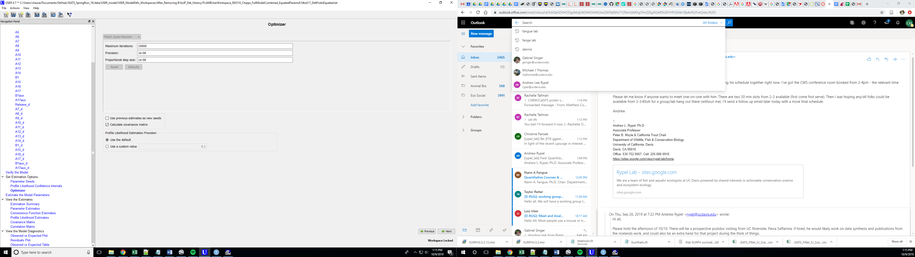

Tips for re-tooling model to get it to converge:

* Make sure the “Use previous estimates as new seeds” box in the optimizer is not checked (at least not initially) bc if you seeds first come out wonky it will keep using those wonky seeds as you re-parameterize your model and it will never converge

When you are trying to get your model to converge:

First: Look at the estimation summary, you are looking for the parameters that don’t have negative values- that means there are issues with the estimation of the parameters for that reach.

Next: Look at the Parameter estimates, see which estimates are totally off ( > 1, < 0). Then go through all of your reaches and figure out which detection probabilities can be fixed to 1 (or 0). You have to do this for both detection probability and survival becauase the program does not handle estimates that are on the boundary of 1 or 0 very well, so you need to tell it which ones are ones or zeros. To determine this, you need to have your excel sheet of your conditional counts and the sheet of your auxillary counts open.

Make an excel sheet (or written sheet) that looks like this (one for upper release fish, one for Delta fish):

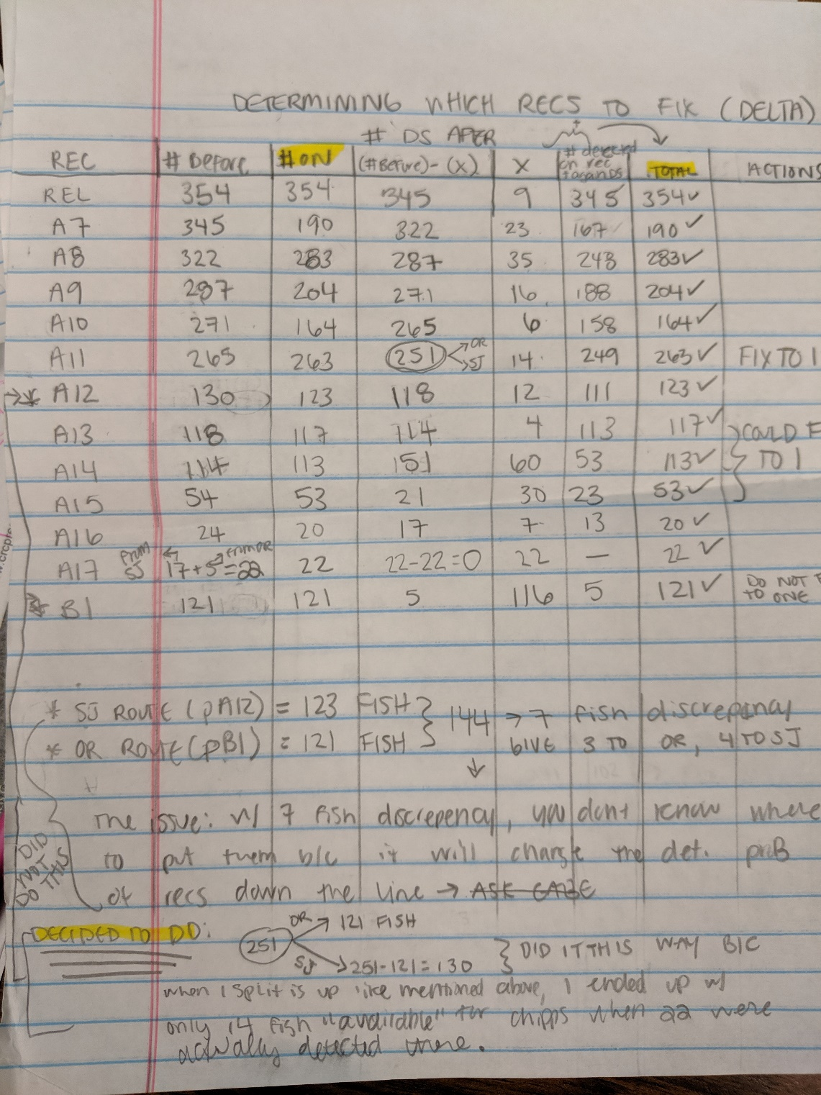

Basically, what you have to do start by determining how many fish you released at that location. That will be your starting number on the “Rel” line for “# Before” column.

“# On” should be the number heard on that receiver. For release, this number is just the number of fish released. For every other receiver location, get this number by adding up all the total hits on that receiver (filter for that receiver in the “Second Rec” column of the conditional count sheet).

“X” is the number of fish heard on that receiver and then never again. For the “Rel” line, that would be all the fish never detected on any receiver. Subtract X from the “# before” value to get the “# detected on receiver and again downstream” (ie column 6 in the spreadsheet above).

Add the “# detected on receiver and again downstream” and the “X” column to get the “Total” value. This number should match the “# on” column value (hence why they are highlighted.

The “# before” for the next line is taken from the the “# DS After (# before) – (x)” from the reach above it.

\*\*\*When the # before matches or is really close the “# on” value, fix the detection probability of that parameter to 1 in the model.

\*\*\*When “the # before” from the reach above matches or is very close to the “# before” for the reach below it (so x would have to = 0 for the reach above), fix survival probability of that parameter to 1 in the model (see highlighted portion of sheet below…)

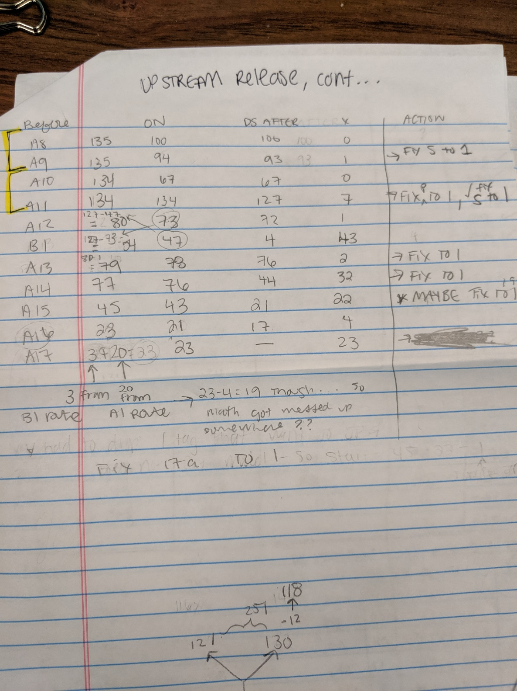

WHEN YOU GET TO A JUNCTION: This means that the value in the column “# DS After (# before) – (x)” for the receiver location right above the split must them be appropriately divided and then those numbers each become the “# Before” values for the new route. IF you don’t do this number will come out totally skrewed up. And then again- for this model, you must take into consideration how many fish are being detected at Chipps (A17) from the SJ route vs the OR route.

Other Things that are OK to do:

* Fix one line of a dual array and not the other. If there was bad detection on both lines, pool the array (if you can)
* Set parameter seeds to s specific value (though you should need to as long as its not on a boundary of 1 or 0, if it Is fix that parameter)

Useful information to remember:

The reason why we want make sure dual arrays are spaced so that they are close enough to assume 0 mortality between lines but far enough away that a fish heard on one line is not heard by the other line is because if a fish is moving really fast through an array or they are too close together, it might only get heard on one line. This is going to positively bias detection probability, which will negatively bias survival probability.

REMEMBER FOR PARAMETER SEEDS:

* Must set parameter seeds for transition probabilities (psi) so that they do not exceed one when added. Easier way to do this is just count the # of transition probs that you have and divide that by 1. – double check on this with gabe