**<Animal Shelter Program>**

**Software Requirements Specification**

**<Software Engineering Fundamentals (CEN 3031), Fall, 2019>**

**Modification history:**

For Modification History, please check our GitHub repository. All of the information is on there. Thank you.

GitHub Repository Link:

<https://github.com/colbynicoletti/AnimalShelterProgram>

**Team Name:** <Helping Hounds>

**Team Members:**

* <Colby Nicoletti: [cjnicoletti3183@eagle.fgcu.edu](mailto:cjnicoletti3183@eagle.fgcu.edu)>
* <Nick Gadomski: [ntgadomski3779@eagle.fgcu.edu](mailto:ntgadomski3779@eagle.fgcu.edu)>
* <Dory Mauretour: [dcmauretour992@eagle.fgcu.edu](mailto:dcmauretour992@eagle.fgcu.edu)>
* <Sam Njenga: [sknjenga6873@eagle.fgcu.edu](mailto:sknjenga6873@eagle.fgcu.edu)>
* <Fernando Ramirez: [feramirez5725@eagle.fgcu.edu](mailto:feramirez5725@eagle.fgcu.edu)>
* <Louis Sze: [lsze5821@eagle.fgcu.edu](mailto:lsze5821@eagle.fgcu.edu)>

**Contents of this Document**

Introduction

* Produced Software
* Definition, Acronyms, and Abbreviations

Product Overview

* Assumptions
* Use Case Diagram
* Use Case Descriptions

Specific Requirements

**SECTION 1: Introduction**

Produced Software:

* < The software we made is for an animal shelter. It allows us to add animals into the database. Upon launching the software will pull up a login screen where a new employee would type their first and last name along with their password and click create. A username will be auto generated for them and they can use that username and the password they made to log in to the employee view. Before logging in there is a popup that comes up and asks for a 4-digit code. This allows the system to be more secure. Once in the employee view, you can check in an animal and add them to the database. Once added, you can then schedule an event for an animal such as a grooming or check-up. This information will be saved into a display tab, so the employees do not miss the animals event. The last tab in the employee view is the adoption record tab. This tab keeps a record of every single animal adopted out of the shelter, so they know for documentation purposes when the animals have been adopted. On the login page, the customer clicks a button and logs into the customer view. Once in the customer view, they can find a specific animal by searching by species or breed. Once they find the animal they’re looking for, they can press the adopt button and adopt it. The adoption information will be recorded in the adoption record tab like stated above. The employee can also make an appointment in order to come back at a later date to meet an animal and see how they interact together or to come back later and adopt an animal. The customer also has the option of donating to a gofundme page. The page will be automatically opened when the customer clicks on the “Donate” button. The donations will support the shelter in giving food, blankets, toys and other miscellaneous items to keep the shelter running.>

Definitions, Acronyms, and Abbreviations:

* <GUI: Graphical User Interface>
* <ID: Identification>

**SECTION 2:** **Product Overview**

Assumptions:

* The hardware to run the software must be at least Windows 8 or greater and have at least 1 GB of RAM.
* The software we make will not interface with any other software as it is going to be able to run the whole shelter. There will not be another software needed besides the one we make.
* The technological environment where the software will be operating is inside of the shelter in multiple different rooms. For example, one computer at the front for someone to greet guests and adopt pets out and one in the back for employees and volunteers to use to interact with the database.
* This product would not be a COTS application because it will be specifically made for an animal shelter and if you aren’t running an animal shelter there would be no point to buying the software.

Use Case Diagram:

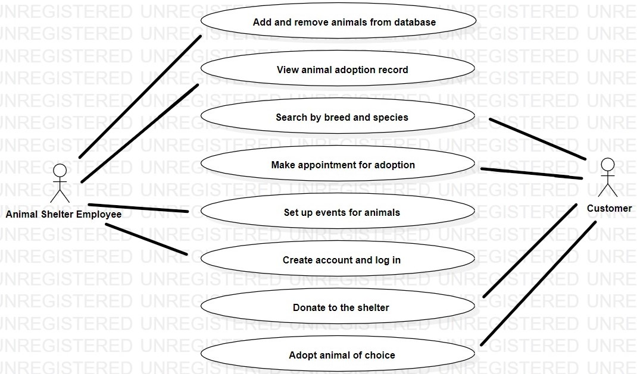

Use Case Descriptions:

**USE CASES**

**Add and remove animals from database**

The animal shelter employees are able to add new animals into the database and remove animals that have been adopted from the database.

Adding an animal to the database requires the employee to enter the necessary information about the animal as defined in the database’s field names such as breed, species, animalID (auto-generated), and their name.

**View animal adoption record**

The employees are able to view the record of who bought what animal in a list. This is for documentation purposes and allows them to have documentation showing that the animal has been adopted and given a new home.

**Search by breed and species**

The customers are able to search the database for a specific breed or species to best fit their needs. This is for a customer who is only looking for a species type of pet so they can quickly check out the database and see what animals the shelter has. If they have the animal they’re looking for, then they will be able to look at them in person.

**Make appointment for adoption**

The customer is able to input their name, phone number, set a date, set a time and enter their animal of interest. This is to give the customer an appointment to adopt their desired new pet.

**Set up events for animals**

The software allows for the employees to set up a specific event for the animal such as a check-up or a grooming. This is to keep the animals on a regular schedule while keeping it all in a easy and readable way for the employees.

**Create account and log in**

The login screen is designed strictly for the employee. The customer does not need a login to get into the customer view of the program. On the other hand, the employee does need a log in because that is where they can add and remove animals from the database, so it is very necessary there is protection from those who are not employees. There is an integrated function that creates the account when the first and last name are typed in the text fields. A password of their choosing is set by the employee.

**Donate to animal shelter**

Customers and organizations are able to make donations to the animal shelter through the link in the “Donate” tab. Donations will go towards food for the animals, toys, blankets, bathing supplies, cleaning supplies, and other basic necessities for the shelter to run smoothly.

**Adopt animal of choice**

The software allows the user to click on a specific animal and click adopt in order to adopt it. When the adopt button is clicked, a record will go inside of one of the tabs on the employee side in order to keep it all organized. This allows for documentation, so the shelter knows that the animal has been successfully adopted.

**SECTION 3: Specific Requirements**

|  |
| --- |
| **No:** **1** |
| **Statement:** The system shall have a database that will organize the animals names, ID-Tags, species, and breeds. |
| **No: 2** |
| **Statement:** The system shall be able to search through the database and pull a specific list of breed or species in the customer view. |
| **No: 3** |
| **Statement:** The system shall help clients adopt a pet that needs an owner. |
| **No: 4** |
| **Statement:** The system shall store and organize animals events into other table in the database to keep track of their grooming and check-ups. |
| **No: 5** |
| **Statement:** The system shall have a donate button that allows for customers to donate to the shelter in order to support the lives of the animals who live in the shelter. |
| **No: 6** |
| **Statement:** The system shall take less than 5 minutes to pick out and adopt a pet. |
| **No: 7** |
| **Statement:** The system shall pull up information that was asked for by the user in under 5 milliseconds. |
| **No: 8** |
| **Statement:** The system shall have a secure way for employees to login to so it is harder for people to gain access to the system and mess with the information. |
| **No: 9** |
| **Statement:** The system shall give error messages to the user when information/credentials are typed incorrectly. |
| **No: 10** |
| **Statement:** The system shall decrease the paperwork required to register a new patient to zero papers. |
| **No: 11** |
| **Statement:** The system shall minimize the amount of space archives take up in the workspace. |
| **No: 12** |
| **Statement:** The system shall keep a record of each animal adopted. |
| **No: 13** |
| **Statement:** The system shall be user-friendly with older generations by limiting the amount of options shown to you in the program. |
| **No: 14** |
| **Statement:** The system shall automatically generate an animalID when a new animal is being checked in. |
| **No: 15** |
| **Statement:** The system shall be functional and usable for an animal shelter. |

Template created by G. Walton ([GWalton@mail.ucf.edu](mailto:GWalton@mail.ucf.edu)) on Aug 30, 1999 and last updated Aug 15, 2000; updated by A. Koufakou, Aug 2014

This page last modified by <C. Nicoletti> (<cjn5307@gmail.com> ) on <12/04/19>