Colby Underhill

CIS 144

Lab 11 make up

12/19/2016

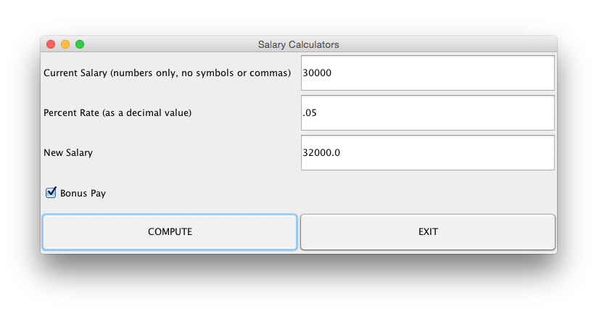

2 classes:

SimpleGuiTest.java class containing main:

package lab11;

import javax.swing.JOptionPane;

import lab11.SimpleGui;

public class SimpleGuiTest

{

public static void main(String[] args)

{

SimpleGui a = new SimpleGui();

a.setVisible(true);

a.setLocation(200, 200);

}

}

SimpleGui.java support class:

package lab11;

//Colby Underhill

import java.awt.GridLayout;

import java.awt.event.ActionEvent;

import java.awt.event.ActionListener;

import javax.swing.JButton;

import javax.swing.JCheckBox;

import javax.swing.JFrame;

import javax.swing.JLabel;

import javax.swing.JTextField;

import java.text.DecimalFormat;

//Colby Underhill, Lab 11

public class SimpleGui extends JFrame implements ActionListener

{

private static final long serialVersionUID = 1L;

JLabel l1, l2, l3, l4;

JButton b1, b2;

JTextField t1, t2, t3;

JCheckBox check1;

SimpleGui()

{

l1 = new JLabel(" Current Salary (numbers only, no symbols or commas)");

l2 = new JLabel(" Percent Rate (as a decimal value)");

l3 = new JLabel(" New Salary");

l4 = new JLabel(" ");

b1 = new JButton("COMPUTE");

b2 = new JButton("EXIT");

t1 = new JTextField(10);

t2 = new JTextField(10);

t3 = new JTextField(10);

check1 = new JCheckBox("Bonus Pay");

check1.setSelected(true);

add(l1);

add(t1);

add(l2);

add(t2);

add(l3);

add(t3);

add(check1);

add(l4);

add(b1);

add(b2);

b1.addActionListener(this);

b2.addActionListener(e -> System.exit(0));

check1 = new JCheckBox ("click to select");

check1.setSelected(true);

setSize(500, 300);

setLayout(new GridLayout(5, 2));

setTitle("Salary Calculators");

}

public void actionPerformed(ActionEvent ae)

{

float a, b, c;

if (ae.getSource() == b1)

{

a = Float.parseFloat(t1.getText());

b = Float.parseFloat(t2.getText());

c = (a\*b)+a;

t3.setText(String.valueOf(c));

if (check1.isSelected());

{

c = (a\*b) + a + 500;

t3.setText(String.valueOf(c));

}

}

}

}