**PROJECT Simple Java GUI: Salary Calculator**

**Objective** To type a simple Java program, execute ( run ) the program for some particular values, observe the output and then modify the program.

***PROJECT DESCRIPTION***

Design a program that uses Java Graphical User Interface ( GUI ) components such as frames, text boxes, labels, checkboxes, radio buttons and click buttons.

The initial starter code for your program is given in **Figure 1** .

First run and test the starter code, which primarily has Java GUI elements and has you enter a number into each of two textboxes ( input ) and then clicking a button to observe the sum of the numbers that appears within another textbox ( output ) .

After you test the original starter code and verify its functionality, you will then modify the program according to the instructions that follow.

Your completed program will perform the following tasks

• enter a current salary into the appropriate text field

• enter a decimal salary rate of increase into the appropriate text field

• select the checkbox, if required

• click the [ COMPUTE ] button

• observe the new salary (with bonus if applicable )

Basically, your program is outlined in the given starter code statements shown within **Figure 1** , which follows. Review the starter code to understand the mechanisms of the interactions between the two classes. Perform any modifications according to this project’s instructions.

Type, compile and run the basic Java program that is shown in **Figure 1** , which follows. Then compile and run your program, observe the output then modify the program.

***Information About This Project***

GUI objects in Java include these elements.

frames and containers

buttons

check boxes

labels

radio buttons

textboxes

***Steps to Complete This Project***

**STEP 1**  **Open NetBeans**

Open NetBeans and create a Java project with the following details.

For Project Name include **Lab11**

For the Main Class include **lab11.SimpleGUI**

In your **Code** window for this class, shown below, copy the program code shown in **Figure 1** below, in the appropriate places, except substitute your own name in place of Sammy Student.

**PROJECT Simple Java GUI: Salary Calculator**

**Figure 1 Source Code for the Simple GUI Program**

|  |
| --- |
| **import java.awt.*;**  **import java.awt.event.*;**  **import javax.swing.*;**  **//Sammy Student**  **public class SimpleGUI extends JFrame implements ActionListener**  **{**  **private static final long *serialVersionUID* = 1L;**  **JLabel l1, l2, l3;**  **JButton b1;**  **JTextField t1, t2, t3;**    **SimpleGUI()**  **{**  **l1 = new JLabel(" INPUT 1");**  **l2 = new JLabel(" INPUT 2");**  **l3 = new JLabel(" OUTPUT");**  **b1 = new JButton("BUTTON 1");**  **t1 = new JTextField(10);**  **t2 = new JTextField(10);**  **t3 = new JTextField(10);**    **add(l1);**  **add(t1);**  **add(l2);**  **add(t2);**  **add(l3);**  **add(t3);**  **add(b1);**  **b1.addActionListener(this);**    **setSize(500,300);**  **setLayout(new GridLayout(4,2));**  **setTitle("Simple Java GUI");**  **}**  **public void actionPerformed(ActionEvent ae)**  **{**  **float a, b, c;**  **if(ae.getSource() == b1)**  **{**  **a = Float.*parseFloat*(t1.getText());**  **b = Float.*parseFloat*(t2.getText());**  **c = a + b;**  **t3.setText(String.*valueOf*(c));**  **}**  **}** |

**PROJECT Simple Java GUI: Salary Calculator**

**Figure 1 Source Code for the Simple GUI Program ( continued )**

|  |
| --- |
| **public static void main(String args[])**  **{**  **SimpleGUI a = new SimpleGUI();**  **a.setVisible(true);**  **a.setLocation(200, 200);**  **}**  **}** |

**STEP 2 Build, Compile and Run the Program**

From the NetBeans Run menu select Run Project ( Lab11 ) to run your app.

**STEP 3 Test the Program**

Once you have successfully compiled your program, review the graphical user interface that appears, as shown in **Figure 2** . This represents a sample run of the program.

**Figure 2 Java Swing Interface**

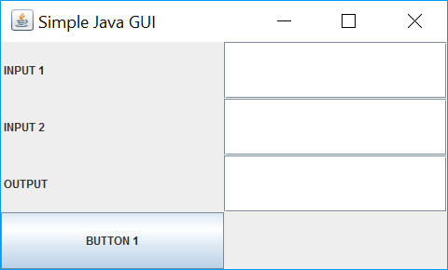

With the program running enter valid values in the input text boxes that appear.

Click the button and observe the output.

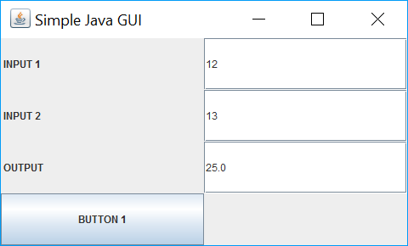

**PROJECT Simple Java GUI: Salary Calculator**

**STEP 4 Modify the Program**

For your first modification of the program you are to a new click button element to your graphical user interface. The purpose of this new button is to allow the user to exit the application.

To do this, perform the following tasks:

• Declare a new button by supplementing the JButton declaration statement to include a new button named b2 .

**JButton b1, b2;**

• In an appropriate location in your program code, instantiate the new button, named b2 .

**b2 = new JButton("EXIT");**

• In an appropriate location in your program code and directly below the line of code

**add(b1);**

place the new button on your GUI grid by writing this statement:

**add(b2);**

• In an appropriate location in your program code and directly below the line of code

**b1.addActionListener(this);**

add an action to the new button by writing this statement:

**b2.addActionListener(e -> System.*exit*(0));**

Test your modified program and the operation of the [ EXIT ] button.

**STEP 5 Modify Again the Program**

You will now expand your program’s layout by including a new row of GUI elements.

To accomplish this, perform these tasks:

• In the class definition and before the constructor method, declare a new JLabel name l1 and also declare a new JCheckBox element.

**JCheckBox check1;**

• In the class constructor, instantiate these two new GUI elements as follows:

**l4 = new JLabel(" ");**

**check1 = new JCheckBox("click to select");**

• In the class constructor, set the initial state of the textbox.

**check1.setSelected(true);**

**PROJECT Simple Java GUI: Salary Calculator**

• In the class constructor, place the new checkbox and label to appear between text field 3 and button 1 .

**add(check1);**

**add(l4);**

• Now change the settings of the GridLayout() to accommodate five rows and two columns instead of the existing four rows and two columns.

• Finally, add a skeletal if / else block directly below the existing if block that appears in the main() method.

**// verify the checkbox state**

**if (check1.isSelected())**

**{**

**// perform a task ...**

**}**

**else**

**{**

**// perform a different task ...**

**}**

Test your modified program and the operation of the program.

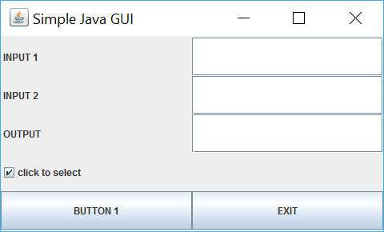

**STEP 6 Alter the Program**

Now change the GUI application such that the screen will appear as follows:

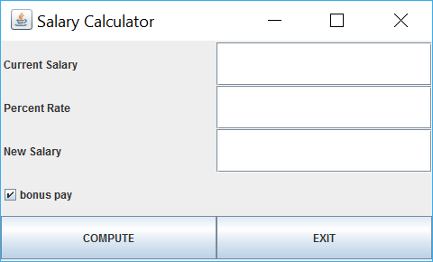

**PROJECT Simple Java GUI: Salary Calculator**

Then alter your program code such that when a current salary and percent rate is entered into the respective text fields a new salary is then computed, with a bonus amount added to the new salary if the checkbox is selected.

You can test your program with these two sample data scenarios:

**Scenario I ( bonus pay NOT included )**

Current Salary $ 30,000

Percent Rate 5 %

Bonus Pay NO

New Salary $ 31,500

**Scenario II ( bonus pay included )**

Current Salary $ 30,000

Percent Rate 5 %

Bonus Pay YES ( $ 500 )

New Salary $ 32,000

**STEP 7 Submit Your Project**

Once you have determined that your modified program is correctly displaying the required information, complete the submission process as follows:

Open MS Word and type a heading for a new document that includes your full name, course number, lab number and date.

Within the document paste snapshots of your modified program in action. Label the snapshots of your modified run with a reasonable description.

After your snapshot, paste in your finished source code as well copied in from your NetBeans editor.

Submit your MS Word document to Blackboard when complete.