Colby Underhill

CIS 144

Lab 12 make up

12/19/2016

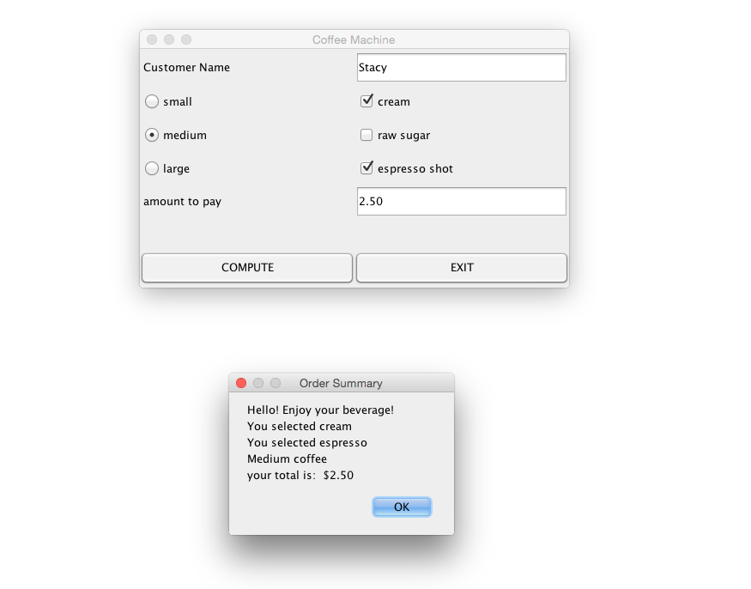

I used 2 class files:

CoffeeMachineTest.java containing the mainmethod:

package lab12;

import lab12.CoffeeMachine;

import javax.swing.JOptionPane;

//Colby Underhill

public class CoffeeMachineTest

{

public static void main(String[] args)

{

CoffeeMachine a = new CoffeeMachine();

a.setVisible(true);

a.setLocation(200,200);

}

}

And CoffeeMachine.java helper method:

package lab12;

import java.awt.GridLayout;

import java.awt.event.ActionEvent;

import java.awt.event.ActionListener;

import java.awt.Graphics;

import java.awt.Image;

import java.awt.Toolkit;

import javax.swing.JFrame;

import javax.swing.JPanel;

import javax.swing.SwingUtilities;

import javax.swing.ButtonGroup;

import javax.swing.JButton;

import javax.swing.JCheckBox;

import javax.swing.JLabel;

import javax.swing.JOptionPane;

import javax.swing.JRadioButton;

import javax.swing.JTextField;

import java.text.DecimalFormat;

//Colby Underhillu

public class CoffeeMachine extends JFrame implements ActionListener

{

private static final long serialVersionUID = 1L;

JLabel l1, l2, l3, l4, l5, l6;

JButton b1, b2;

JTextField t1, t2, t3;

JCheckBox cream, raw, espresso;

private JRadioButton small;

private JRadioButton medium;

private JRadioButton large;

private ButtonGroup group;

DecimalFormat df = new DecimalFormat("##,###.00");

CoffeeMachine()

{

l1 = new JLabel(" Customer Name");

l2 = new JLabel(" amount to pay");

l3 = new JLabel(" ");

l4 = new JLabel(" ");

l5 = new JLabel(" ");

l6 = new JLabel(" ");

b1 = new JButton("COMPUTE");

b2 = new JButton("EXIT");

t1 = new JTextField(10);

t2 = new JTextField(10);

small = new JRadioButton("small", true);

medium = new JRadioButton("medium", false);

large = new JRadioButton("large", false);

group = new ButtonGroup();

group.add(small);

group.add(medium);

group.add(large);

cream = new JCheckBox("cream", false);

raw = new JCheckBox("raw sugar", false);

espresso = new JCheckBox("espresso shot", false);

add(l1);

add(t1);

add(small);

add(cream);

add(medium);

add(raw);

add(large);

add(espresso);

add(l2);

add(t2);

add(l5);

add(l6);

add(b1);

add(b2);

b1.addActionListener(this);

b2.addActionListener(e -> System.exit(0));

setSize(500,300);

setLayout(new GridLayout(7,2));

setTitle("Coffee Machine");

}

public void actionPerformed(ActionEvent ae)

{

double price = 0.0;

String a = "", message = "";

if (cream.isSelected() == true)

{

price += 0.00;

message="You selected cream";

}

if (raw.isSelected() == true)

{

price += 0.00;

message +="\nYou selected raw";

// perform a task ...

}

if (espresso.isSelected() == true)

{

price += 0.75;

message +="\nYou selected espresso";

// perform a task ...

}

if (small.isSelected() == true)

{

System.out.println("small");

message +="\nSmall coffee";

price += 1.25;

// perform a task ...

}

if (medium.isSelected()== true)

{

System.out.println("medium");

message +="\nMedium coffee";

price += 1.75;

//perform a task...

}

if (large.isSelected() == true)

{

System.out.println("large");

message +="\nLarge coffee";

price += 2.30;

// perform a task ...

}

if(ae.getSource() == b1)

{

message += "\nyour total is: " + a + " $" + df.format(price);

t2.setText(df.format(price));

}

JOptionPane.showMessageDialog(null, "Hello! Enjoy your beverage! \n"

+ message,

"Order Summary", JOptionPane.PLAIN_MESSAGE);

}

}