Colby Underhill

CIS 144

Lab 13 makeup

12/21/16

First, testing with data provided in lab document:

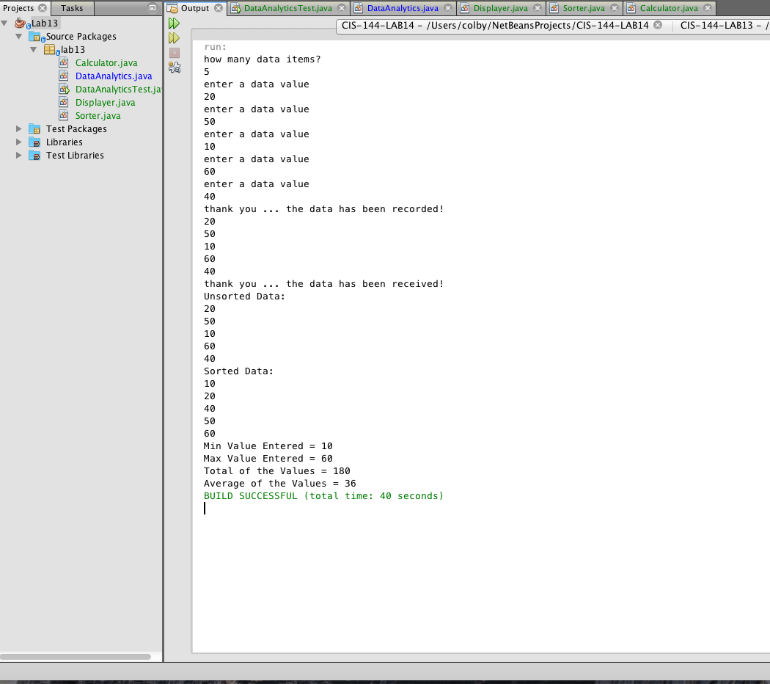

Next, I used float instead of int for calculating average to avoid rounding when it doesn’t divide evenly. Tested with numbers that create a decimal average:

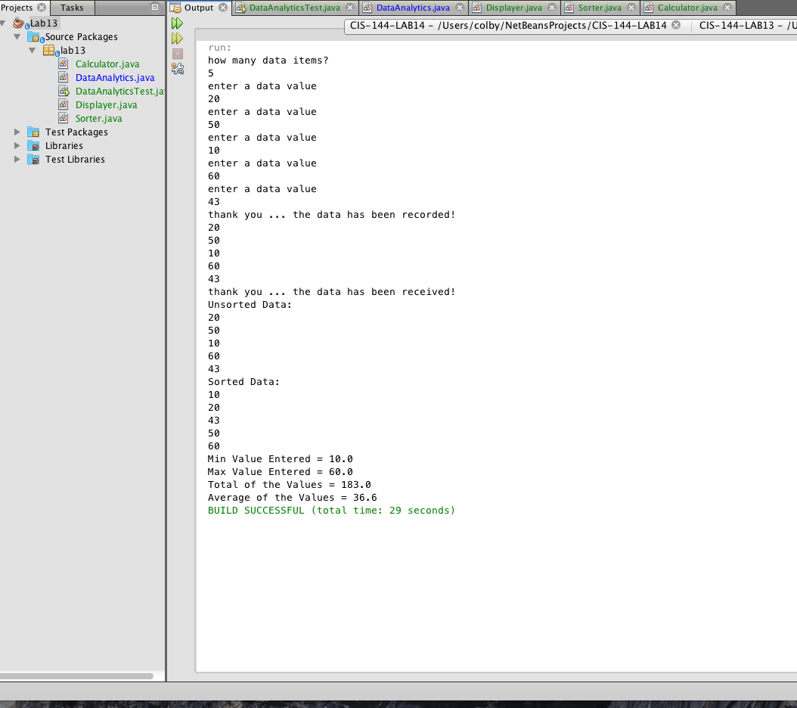

Source: I used multiple class files rather than the single file that was initially provided:

/\*\* This class provides the entry point into the program.

\*/

package lab13;

import lab13.DataAnalytics;

/\*\*

\*

\* @author colby

\*/

public class DataAnalyticsTest

{

public static void main(String[] args)

{

DataAnalytics a = new DataAnalytics();

a.Engine();

}

}

/\*\* This class provides the main engine of the program.

\*It creates and maintains the array list and calls external

\*classes that manipulate the data in the array list.

\*/

package lab13;

import java.io.BufferedReader;

import java.io.BufferedWriter;

import java.io.FileReader;

import java.io.FileWriter;

import java.util.ArrayList;

import java.util.Scanner;

import lab13.Displayer;

import lab13.Sorter;

import lab13.Calculator;

/\*\*

\*

\* @author colby

\*/

public class DataAnalytics

{

static int min = 0, max = 0;

Displayer d = new Displayer();

Sorter s = new Sorter();

Calculator c = new Calculator();

public void Engine()

{

// declare an object to receive the data

Scanner scan = new Scanner(System.in);

// declare an array list to hold the data

ArrayList<Integer> list;

list = new ArrayList<Integer>();

int count = 0;

int num = 0;

int val = 0;

String line = "";

try

{

// create or append to the file

FileWriter fileOut = new FileWriter("outData.txt");

BufferedWriter fout = new BufferedWriter(fileOut);

System.out.println("how many data items?");

count = scan.nextInt();

for (int i = 1; i <= count; i++)

{

System.out.println("enter a data value");

val = scan.nextInt();

fout.write(val + "\n");

}

System.out.println("thank you ... the data has been recorded!");

// close the output stream objects

fout.close();

fileOut.close();

scan.close();

// read the data

FileReader fileIn = new FileReader("outData.txt");

BufferedReader fin = new BufferedReader(fileIn);

while ((line = fin.readLine()) != null)

{

num = Integer.parseInt(line);

list.add(num);

System.out.println(num);

}

System.out.println("thank you ... the data has been received!");

fin.close();

fileIn.close();

System.out.println("Unsorted Data:");

d.DisplayData(list);

s.BubbleSort(list);//Sort the data!!!

System.out.println("Sorted Data:");

d.DisplayData(list);

c.Calculations(list); //display max, min, and other calculated values

}

catch (Exception e)

{

// catch an exception if any arises

System.err.println("Error: " + e.getMessage());

}

}

}

/\*\* This class is responsible for displaying the data in

\* the array list.

\*/

package lab13;

import java.util.ArrayList;

/\*\*

\*

\* @author colby

\*/

public class Displayer

{

public void DisplayData(ArrayList<Integer> num)

{

for (int i = 0; i < num.size(); i++)

{

System.out.println(num.get(i).toString());

}

}

}

/\*\* This class is responsible for sorting the data in

\* the array list.

\*/

package lab13;

import java.util.ArrayList;

/\*\*

\*

\* @author colby

\*/

public class Sorter

{

public void BubbleSort(ArrayList<Integer> num)

{

int j = 0;

boolean flag = true; // set the flag to true to begin first pass

int temp = 0; // define the holding variable

while (flag)

{

flag = false; //set flag to false awaiting a possible swap

for (j = 0; j < num.size() - 1; j++)

{

if (num.get(j) > num.get(j + 1)) // for descending sort change to <

{

temp = num.get(j); //swap the elements

num.set(j, num.get(j + 1));

num.set(j + 1, temp);

flag = true; //shows a swap occurred

}

}

}

}

}

/\*\* This class is responsible for performing calculations on the data in

\* the array list..

\*/

package lab13;

import java.util.ArrayList;

/\*\*

\*

\* @author colby

\*/

public class Calculator

{

public void Calculations(ArrayList<Integer> num)

{

float sum = 0, min = 0, max = 0;

min = num.get(0);

max = num.get(num.size()-1);

for (int i = 0; i<num.size();++i)

{

sum += num.get(i);

}

float avg = (sum/num.size());

System.out.println("Min Value Entered = " + min);

System.out.println("Max Value Entered = " + max);

System.out.println("Total of the Values = " + sum);

System.out.println("Average of the Values = " + avg);

}

}