Colby Underhill, CIS 144 JL

Lab 8, 11/02/2016

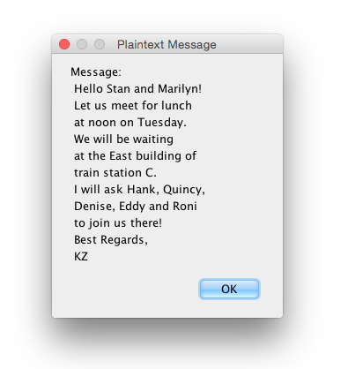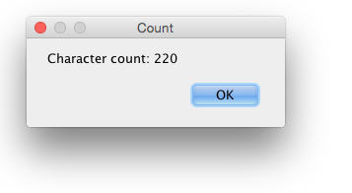

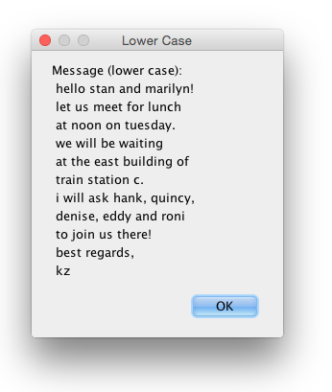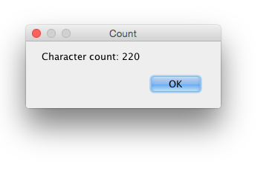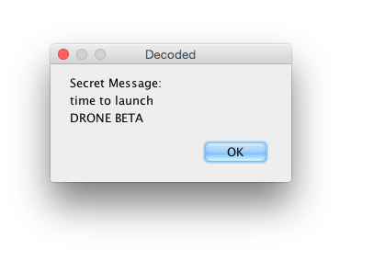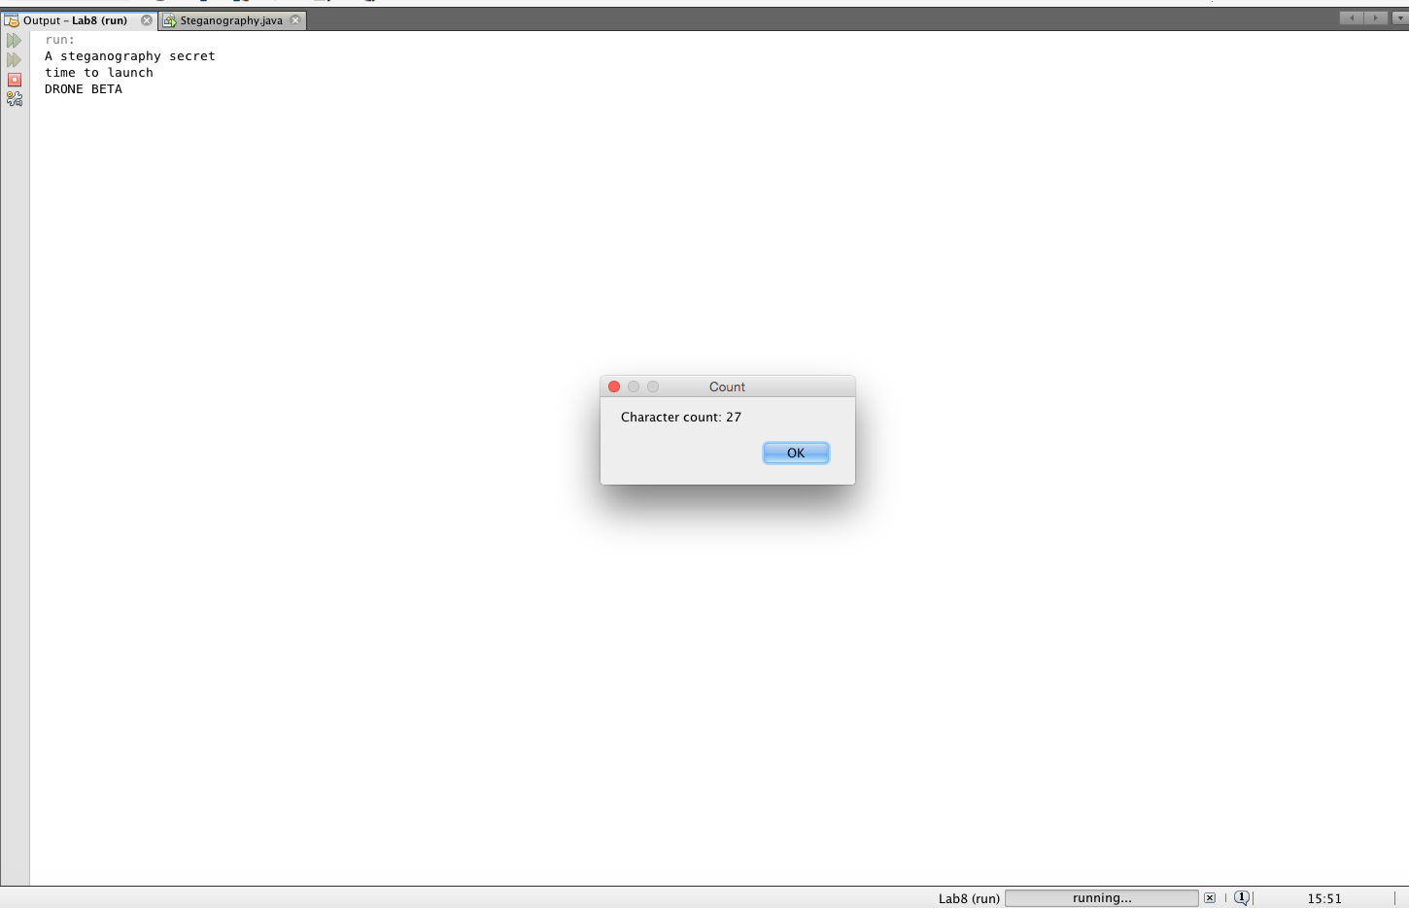package lab8;

/**

*

* @author colby

*/

import javax.swing.JOptionPane;

//Colby Underhill, Programmer

public class Steganography

{

public static void main(String args[])

{

// the plaintext message

String line1 = "Hello Stan and Marilyn!";

String line2 = "Let us meet for lunch";

String line3 = "at noon on Tuesday.";

String line4 = "We will be waiting";

String line5 = "at the East building of";

String line6 = "train station C.";

String line7 = "I will ask Hank, Quincy,";

String line8 = "Denise, Eddy and Roni";

String line9 = "to join us there!";

String line10 = "Best Regards,";

String line11 = "KZ";

String message = "\n";

// display the plaintext message

message += "\t" + line1 + "\n";

message += "\t" + line2 + "\n";

message += "\t" + line3 + "\n";

message += "\t" + line4 + "\n";

message += "\t" + line5 + "\n";

message += "\t" + line6 + "\n";

message += "\t" + line7 + "\n";

message += "\t" + line8 + "\n";

message += "\t" + line9 + "\n";

message += "\t" + line10 + "\n";

message += "\t" + line11 + "\n";

JOptionPane.showMessageDialog(null, "Message: " + message,

"Plaintext Message", JOptionPane.PLAIN_MESSAGE);

int length = message.length();

JOptionPane.showMessageDialog(null, "Character count: " + length ,

"Count", JOptionPane.PLAIN_MESSAGE);

// convert plaintext message to lower case

line1 = line1.toLowerCase();

line2 = line2.toLowerCase();

line3 = line3.toLowerCase();

line4 = line4.toLowerCase();

line5 = line5.toLowerCase();

line6 = line6.toLowerCase();

line7 = line7.toLowerCase();

line8 = line8.toLowerCase();

line9 = line9.toLowerCase();

line10 = line10.toLowerCase();

line11 = line11.toLowerCase();

String plaintext = "\n";

plaintext += "\t" + line1 + "\n";

plaintext += "\t" + line2 + "\n";

plaintext += "\t" + line3 + "\n";

plaintext += "\t" + line4 + "\n";

plaintext += "\t" + line5 + "\n";

plaintext += "\t" + line6 + "\n";

plaintext += "\t" + line7 + "\n";

plaintext += "\t" + line8 + "\n";

plaintext += "\t" + line9 + "\n";

plaintext += "\t" + line10 + "\n";

plaintext += "\t" + line11 + "\n";

JOptionPane.showMessageDialog(null, "Message (lower case): " + plaintext,

"Lower Case", JOptionPane.PLAIN_MESSAGE);

length = message.length();

JOptionPane.showMessageDialog(null, "Character count: " + length ,

"Count", JOptionPane.PLAIN_MESSAGE);

// define line messages field size with 20 indices

//or use for loop

int[] num =

{0, 1, 2, 3, 4, 5, 6, 7, 8, 9, 10, 11, 12, 13, 14, 15, 16, 17, 18, 19, 20};

// define the key variable and message object

int key = 0;

StringBuilder s = new StringBuilder();

// build the secret message

s.append("\n"); // new line

key = num[7]; // t

s.append(line1.substring(key, key + 1));

key = num[18]; // i

s.append(line1.substring(key, key + 1));

key = num[7]; // m

s.append(line2.substring(key, key + 1));

key = num[8]; // e

s.append(line2.substring(key, key + 1));

s.append(" "); // space

key = num[1]; // t

s.append(line3.substring(key, key + 1));

key = num[5]; // o

s.append(line3.substring(key, key + 1));

s.append(" "); // space

key = num[5]; // l

s.append(line4.substring(key, key + 1));

key = num[12]; // a

s.append(line4.substring(key, key + 1));

key = num[13]; // u

s.append(line5.substring(key, key + 1));

key = num[18]; // n

s.append(line5.substring(key, key + 1));

key = num[14]; // c

s.append(line6.substring(key, key + 1));

key = num[11]; // h

s.append(line7.substring(key, key + 1));

s.append("\n"); // new line

key = num[13]; // d

s.append(line1.substring(key, key + 1).toUpperCase());

key = num[17]; // r

s.append(line1.substring(key, key + 1).toUpperCase());

key = num[4]; // o

s.append(line1.substring(key, key + 1).toUpperCase());

key = num[9]; // n

s.append(line1.substring(key, key + 1).toUpperCase());

key = num[1]; // e

s.append(line1.substring(key, key + 1).toUpperCase());

s.append(" ");

key = num[8]; // B

s.append(line4.substring(key, key + 1).toUpperCase());

key = num[1]; // E

s.append(line1.substring(key, key + 1).toUpperCase());

key = num[7]; // T

s.append(line1.substring(key, key + 1).toUpperCase());

key = num[8]; // A

s.append(line1.substring(key, key + 1).toUpperCase());

s.append("\n"); // new line

length = s.length();

System.out.println("A steganography secret " + s);

JOptionPane.showMessageDialog(null, "Secret Message: " + s,

"Decoded", JOptionPane.PLAIN_MESSAGE);

JOptionPane.showMessageDialog(null, "Character count: " + length ,

"Count", JOptionPane.PLAIN_MESSAGE);

}

}