**PROJECT Cylinder Geometry - Sequential Control with Java 100 points**

**Objective** To type a simple Java program, execute ( run ) the program for some particular values, observe the output and then modify the program.

***PROJECT DESCRIPTION***

Type, compile and run the basic Java program that is shown in **Figure 1** , which follows.

Then compile and run your program, observe the output then modify the program.

***Information About This Project***

Programs like NetBeans and Eclipse are application development environments ( IDE ) which include text editors that you can use to write, compile and execute source code written in Java.

Business application software development often involves creating programs involving geometry. Such programs can be utilized by architects and other professionals.

This project has you create and modify a program that computes the volume and surface area of a right circular cylinder given the height of the cylinder and its base radius.

The formulas for these computations are:

***Volume V of a Right Circular Cylinder***

*V* = π *r* 2 *h* ( with π ≈ 3.1416 , *h* is the height and *r* is the base radius )

***Surface Area S of a Right Circular Cylinder***

*S* = 2 π *r* *h* + 2 π *r* 2 ( with π ≈ 3.1416 , *h* is the height and *r* is the base radius )

The Input, Process and Output ( IPOS ) requirements of this project are:

***Input*** the user name, the cylinder height and the cylinder base radius

***Process*** the volume of the cylinder and the surface area of the cylinder

***Output*** the user name, the volume of the cylinder, computed in cubic length units and the surface area of the cylinder, computed in square length units

The course code for the volume program is given and you will modify it to include the surface area.

***Steps To Complete This Project***

**STEP 1**  **Open NetBeans, Eclipse, or Similar Java Development Environment**

Open NetBeans or similar Java text editor. Here are the steps to create a Java project for this assignment using NetBeans for Windows or the Mac.

**Using NetBeans**

From the NetBeans main menu, click File , point to New Project…. When the the **New Java Application** dialog box opens, select and fill the settings as follows:

Set the project name : **Cylinder**

Set the project location / project folder : ( use the default locations )

Mac people:

Create Main Class : ( use the default )

Into the **Code** window, shown below, copy in the program code shown in **Figure 1** ,below, in the appropriate places, except substitute your own name in place of Sammy Student.

|  |
| --- |
|  |

**Figure 1 Source Code for the Volume Program**

|  |
| --- |
| **package cylinder;**  **/\***  **Program to calculate the volume of a right circular   cylinder.**  **Programmer: Sammy Student, File Name: Cylinder.java**  **\*/**  **// package for Scanner class objects**  **import java.util.Scanner;**  **public class Cylinder**  **{**  **public static void main(String args[]) {**  **// introduce a Scanner class object**  **Scanner sc = new Scanner(System.in);**  **// declare and initialize the variables**  **double height = 0, radius = 0, volume = 0;**  **String strName = "";**  **// greet the program user**  **System.out.println("Welcome to the Volume Program!");**  **// prompt user for their name**  **System.out.println("please enter your name");**  **// read the user name**  **strName = sc.nextLine();**  **//display the name back to the user**  **System.out.println("hello " + strName);**    **// input: assign values to the variables**  **System.out.print("Please enter the radius. ");**  **radius = sc.nextDouble();**  **System.out.print("Please enter the height. ");**  **height = sc.nextDouble();**    **// process: compute the required quantity**  **volume = 3.1416 * radius * radius * height;**  **// output: display the output to the user**  **System.out.print("The volume of the cylinder is: ");**  **System.out.print(volume);**  **System.out.println(" cubic length units ");**    **// dismiss the Scanner class object**  **sc.close();**  **}**  **}** |

**STEP 2 Build, compile and Run the Program**

From the NetBeans Run menu select Run Project (Cylinder) to run your app.

If you do not have any errors, proceed to the next step, otherwise read the error messages and make any necessary corrections by comparing your screen code to

the original code shown within **Figure 1** . Then run your program again.

**STEP 3 Test the Program**

Once you have successfully compiled your program, enter the following information, when prompted, into the output **Console** window of NetBeans.

*Name of Program User :*  ( enter your own name )

*The Base Radius :*  2.0

*The Cylinder Height :*  10.0

**STEP 4 Verify Your Output**

When you enter the above information the **Console**window should show your program output, similar to the following screen snapshot.

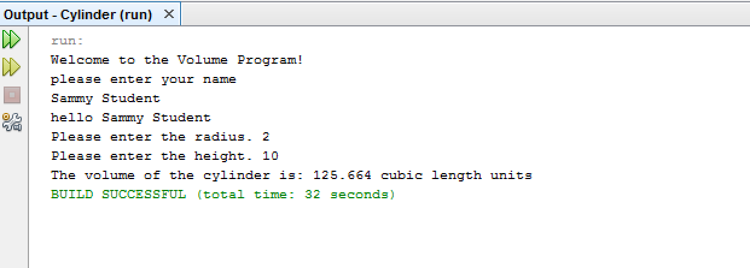

Your program has just computed the volume of a right circular cylinder whose base radius is 2.0 and whose height is 10.0 . ( Note: the volume of a cylinder is the product of π times the base radius squared times the height, where π is approximated as 3.1416 )

**STEP 5 Modify Your Program**

Close the console output screen to return to the NetBeans **Code** window. Within the **Code** window, modify your original program code such that the program will calculate the surface area of the cylinder in addition to the volume of the cylinder.

To modify your program, first change your program comment statement to indicate that your program will also compute the surface area of the cylinder, i.e. use:

|  |
| --- |
| **/\***  **Program to calculate the volume and surface area of a  right circular cylinder.**  **Programmer: Sammy Student, File Name: Cylinder.java**  **\*/** |

Next, modify your variable declaration statement to include any necessary newly required variables.

**double area = 0, height = 0, radius = 0, volume = 0;**

Also, modify the process proportion of your program by locating the following line of code

**// process: compute the required quantity**

**volume = 3.1416 * radius * radius * height;**

and directly below the above line, assign variable **area** an expression that will compute the surface area of the cylinder according to the formula listed previously.

Finally, locate your output statement block, shown below.

**// output: display the output to the user**

**System.out.print("The volume of the cylinder is: ");**

**System.out.print(volume);**

**System.out.println(" cubic length units ");**

Then add in an output line directly below the output block segment above that will display the surface area of the cylinder.

**STEP 6 Re - Run Your Program**

Next re - run your program by repeating the steps from **STEP 2** .

Test your code with data as shown below. Your output should now represent the snapshot shown below.

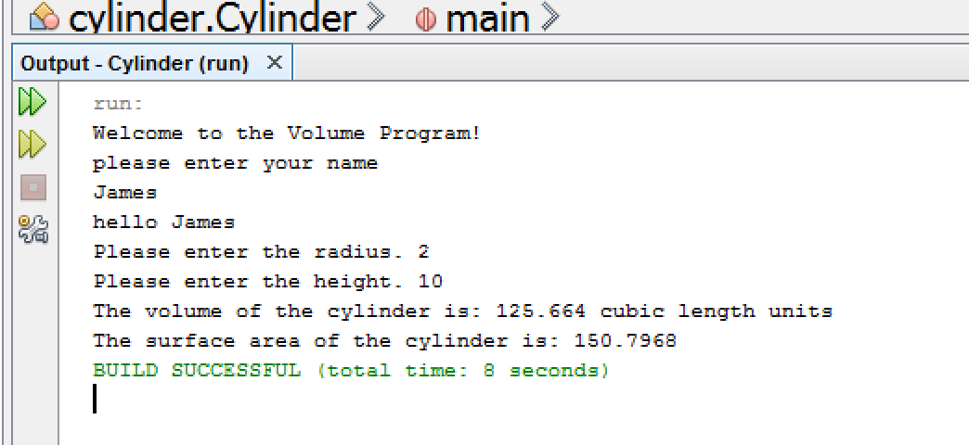

**STEP 7 Verify the Program’s Numerical Accuracy**

To verify your program’s output correctness you can open MS Excel for Windows and construct a simple worksheet, such as that given below, that will verify the output computations for your sample program run.

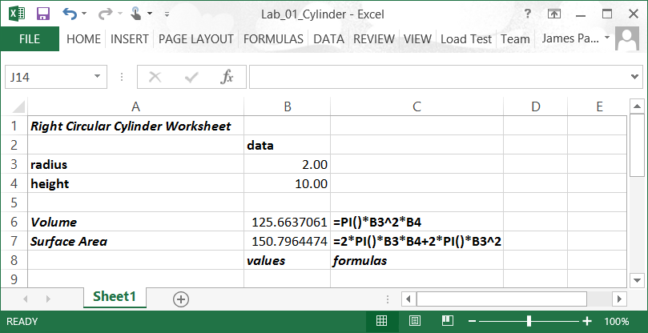

Your program’s values may differ slightly from the above worksheet since it uses the Excel intrinsic PI() function instead of our program’s 3.1416 approximation.

**STEP 8 Submit Your Project**

Once you have determined that your modified program is correctly computing the volume and surface area of a given right circular cylinder, complete the submission process as follows:

Open MS Word and type a heading for a new document that includes your full name, course number, lab number and date.

Within the document paste in a snapshot of your modified code. Label your snapshot with a reasonable description.

After your snapshot, paste in your finished source code copied in from your NetBeans editor.

*Note*- you can use the **Windows Snipping Tool**, which is part of the Windows Accessories Group, to easily capture your NetBeans **Console** window**.**

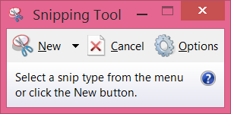

Your score for each lab project will generally be based upon the following factors: documentation, output correctness, content, organization, style and creativity.

Submit your MS Word document to Blackboard when complete.