Colby Underhill

09/12/2016

CIS144 JL

LAB 1

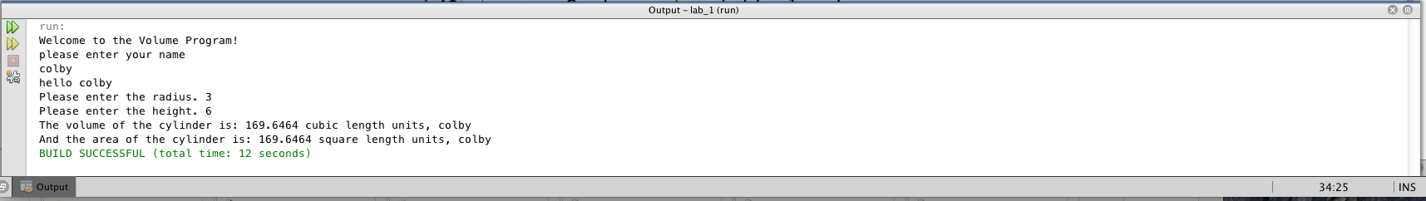

/*

Program to calculate the volume and surface area of a

right circular cylinder.

Programmer: cunderhill, File Name: lab_1.java

*/

package lab_1;

import java.util.Scanner;

/

*

* @author colbyu

*/

public class Lab_1 {

public static void main(String args[]) {

// introduce a Scanner class object

Scanner sc = new Scanner(System.in);

// declare and initialize the variables

// modified by colbyu 09-09-2016:

double area = 0, height = 0, radius = 0, volume = 0, rsquared = 0;

//original: double height = 0, radius = 0, volume = 0;

String strName = "";

// greet the program user

System.out.println("Welcome to the Volume Program!");

// prompt user for their name

System.out.println("please enter your name");

// read the user name

strName = sc.nextLine();

//display the name back to the user

System.out.println("hello " + strName);

// input: assign values to the variables

System.out.print("Please enter the radius. ");

radius = sc.nextDouble();

System.out.print("Please enter the height. ");

height = sc.nextDouble();

// for calculating surface area, added by cunderhill 09-09-16

rsquared = Math.pow(radius, 2);

// process: compute the required quantity

volume = 3.1416 * radius * radius * height;

// area added by colbyu 09-09-2016:

area = 2 * 3.1416 * radius * height + 2 * 3.1416 * rsquared;

// output: display the output to the user

System.out.print("The volume of the cylinder is: ");

System.out.print(volume);

System.out.println(" cubic length units, " + strName);

// area added by colbyu 09-09-2016:

System.out.print("And the area of the cylinder is: ");

System.out.print(area);

System.out.println(" square length units, " + strName);

// dismiss the Scanner class object

sc.close();

}

}

I also tried playing around with input validation, using somu suggestions I found on StackOverflow. That involved loops, which I am not too familiar with, but ot did give me some insight into the structure and use of them. That was a bit outside the scope of the solution for this lab, so I’m including it separately…

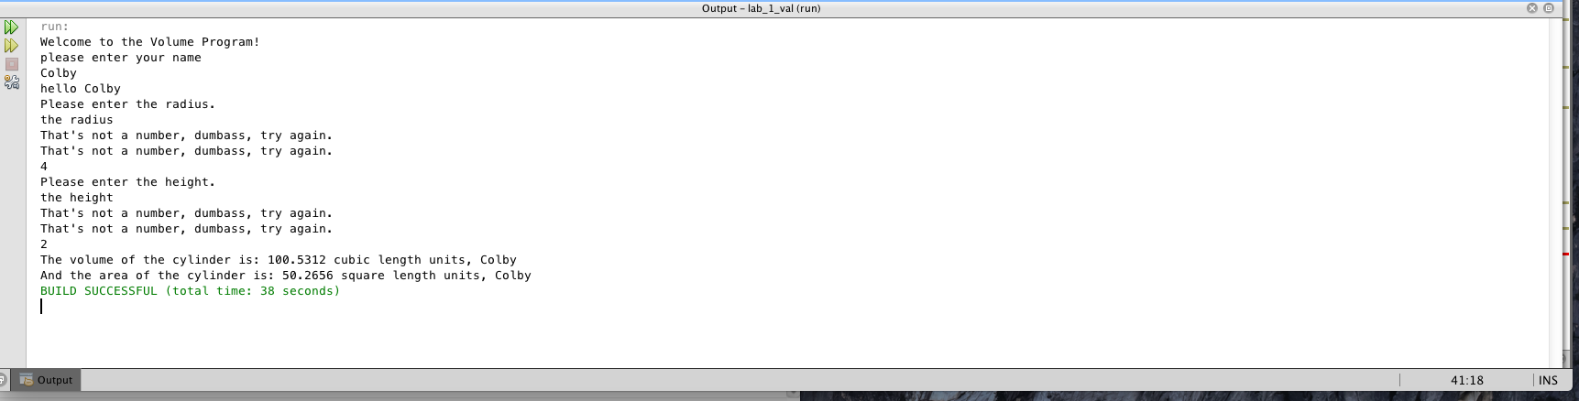

/*

Program to calculate the volume and surface area of a

right circular cylinder.

Programmer: cunderhill, File Name: lab_1.java

*/

/*

input validation code source: various posts on

StackOverflow and StackExchange

*/

package lab_1_val;

/**

*

* @author colby

*/

// introduce a Scanner class object

import java.util.Scanner;

public class Lab_1_val {

public static void main(String[] args) {

Scanner input = new Scanner(System.in);

Scanner sc = new Scanner(System.in);

// declare and initialize the variables

double area = 0, height = 0, radius = 0, volume = 0, rsquared = 0;

// for calculating surface area, added by cunderhill 09-09-16

rsquared = Math.pow(radius, 2);

//original: double height = 0, radius = 0, volume = 0;

String strName = "";

boolean isNumber = false;

// greet the program user

System.out.println("Welcome to the Volume Program!");

// prompt user for their name

System.out.println("please enter your name");

// read the user name

strName = sc.nextLine();

//display the name back to the user

System.out.println("hello " + strName);

// input: assign values to the variables

System.out.println("Please enter the radius. ");

do {

if (input.hasNextDouble()) {

radius = input.nextDouble();

isNumber = true;

} else {

System.out.println("That's not a number, dumbass, try again. ");

isNumber = false;

input.next();

}

} while (!(isNumber));

System.out.println("Please enter the height. ");

do {

if (input.hasNextDouble()) {

height = input.nextDouble();

isNumber = true;

} else {

System.out.println("That's not a number, dumbass, try again. ");

isNumber = false;

input.next();

}

} while (!(isNumber));

// process: compute the required quantity

volume = 3.1416 * radius * radius * height;

// area added by colbyu 09-09-2016:

area = 2 * 3.1416 * radius * height + 2 * 3.1416 * rsquared;

// output: display the output to the user

System.out.print("The volume of the cylinder is: ");

System.out.print(volume);

System.out.println(" cubic length units, " + strName);

// area added by colbyu 09-09-2016:

System.out.print("And the area of the cylinder is: ");

System.out.print(area);

System.out.println(" square length units, " + strName);

// dismiss the Scanner class object

sc.close();

}