Colby Underhill

CIS 144 JL

Lab 2

09/19/2016

Withdrawing too much:

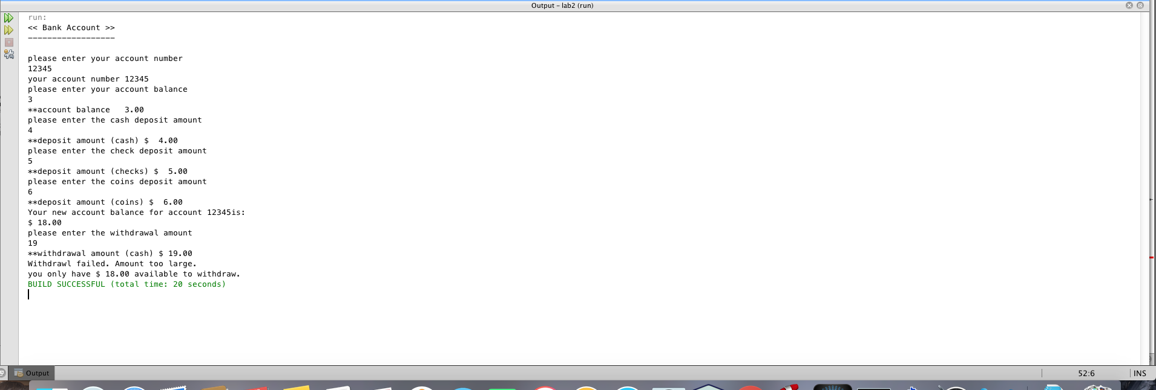

Good withdrawl:

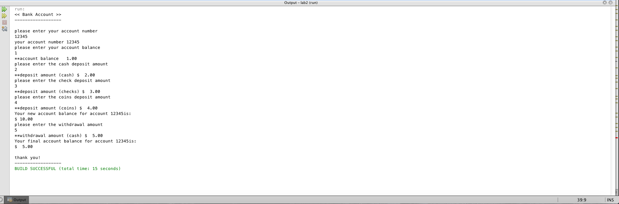

I used if / then to provide a simple check against overdraft. It currently aborts with an informative warning upon withdrawing too much. I think I could improve this by adding a loop to allow the user to try again with a smaller withdrawal, but I’m not sure how to implement that yet…

/\*

\* Program for BankAccount data including deposits and withdrawals.

\* Running balance is kept along the way and displayed at program end

\*/

package lab2;

import java.util.Scanner;

/\*\*

\* @author Colby Underhill

\*/

public class BankAccount {

/\*\*

\* @param args the command line arguments

\*/

public static void main(String[] args) {

// programs local variables

int acctNum = 0;

double acctBal = 0.0, currency = 0.0;

double checks = 0.0, coins = 0.0;

//double newBal = 0.0;

double withdraw = 0.0;

Scanner sc = new Scanner(System.in);

// the program header

System.out.println("<< Bank Account >>");

System.out.println("------------------");

System.out.println(" ");

// prompt user for data and receive data

System.out.println("please enter your account number");

acctNum = sc.nextInt();

System.out.println("your account number " + acctNum);

System.out.println("please enter your account balance");

acctBal = sc.nextDouble();

System.out.printf("\*\*account balance %6.2f\n" , acctBal);

System.out.println("please enter the cash deposit amount");

currency = sc.nextDouble();

System.out.printf("\*\*deposit amount (cash) $%6.2f\n" ,currency);

System.out.println("please enter the check deposit amount");

checks = sc.nextDouble();

System.out.printf("\*\*deposit amount (checks) $%6.2f\n" ,checks);

System.out.println("please enter the coins deposit amount");

coins = sc.nextDouble();

System.out.printf("\*\*deposit amount (coins) $%6.2f\n" ,coins);

double newBal = (acctBal + currency + checks + coins);

System.out.println("Your new account balance for account " + acctNum + "is: ");

System.out.printf("$%6.2f\n" ,newBal);

System.out.println("please enter the withdrawal amount");

withdraw = sc.nextDouble();

System.out.printf("\*\*withdrawal amount (cash) $%6.2f\n" ,withdraw);

if (newBal < withdraw){

System.out.println("Withdrawl failed. Amount too large.");

System.out.printf("you only have $%6.2f" ,newBal);

System.out.println(" available to withdraw.");

}

else {

System.out.println("Your final account balance for account " + acctNum + "is: ");

System.out.printf("$%6.2f\n" ,newBal - withdraw);

// the program footer

System.out.println(" ");

System.out.println("thank you!");

System.out.println("------------------");

}

}