Colby Underhill

CIS 144 JL

LAB 327

09/27/2016

I modified the application pretty heavily, added loops to check for errors in entering the shipping methods and allowing retries. I also added a second switch case to allow the separate choice of shipper (FedEx, DHL, etc… and shipping method.

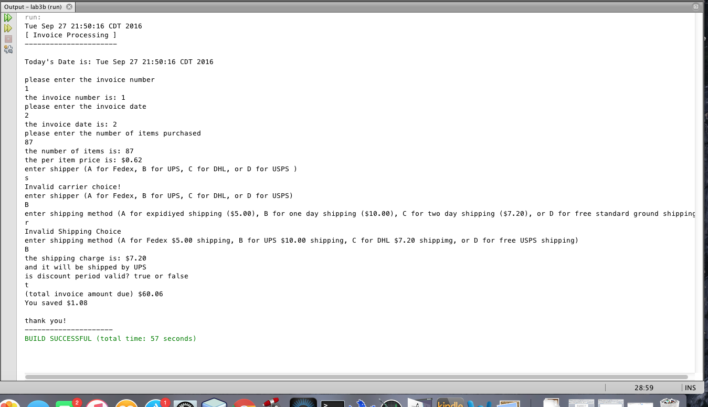

The code,

I feel like it’s a little sloppy but I ren out of time to finesse it…

package lab3b;

import java.util.\*;

public class Invoices {

public static void main(String args[]) {

// the cast of charactors

int invNum = 0;

int numItems = 0;

double itemPrice = 0.0, shipCharge = 0.0, totAmt = 0.0;

double discount = 0.02, subTotal = 0.0;

int carrier = 0;

String shipper = "";

char shipMethod = '\0';

String invDate = "";

boolean check = false;

Scanner sc = new Scanner(System.in);

//obtain today's date

Date date = new Date();

// display time and date using toString()

System.out.println(date.toString());

// the program header

System.out.println("[ Invoice Processing ]");

System.out.println("----------------------\n");

System.out.println("Today's Date is: " + date + "\n");

// prompt user for data and receive data

System.out.println("please enter the invoice number");

invNum = sc.nextInt();

System.out.println("the invoice number is: " + invNum);

System.out.println("please enter the invoice date");

invDate = sc.next();

System.out.println("the invoice date is: " + invDate);

System.out.println("please enter the number of items purchased");

numItems = sc.nextInt();

System.out.println("the number of items is: " + numItems);

//determine the per item price

if (numItems > 0 && numItems <= 10)

itemPrice = 0.75;

else if (numItems > 10 && numItems <= 50)

itemPrice = 0.65;

else

itemPrice = 0.62;

System.out.printf("the per item price is: $%.2f\n",itemPrice);

///////////////////////////////////////

//determine the shipper

///////////////////////////////////////

System.out.println("enter shipper (A for Fedex, B for UPS, C for DHL, or D for USPS )");

carrier = sc.next().charAt(0);

//Which company will deliver it?

switch(carrier) {

case 'A': case 'a': carrier = 1; break;

case 'B': case 'b': carrier = 2; break;

case 'C': case 'c': carrier = 3; break;

case 'D': case 'd': carrier = 4; break;

default: carrier = 5;

}

//Check and correct erronious entry:

do {

System.out.println("Invalid carrier choice!");

System.out.println("enter shipper (A for Fedex, B for UPS, C for DHL, or D for USPS)");

carrier = sc.next().charAt(0);

switch(carrier) {

case 'A': case 'a': carrier = 1; break;

case 'B': case 'b': carrier = 2; break;

case 'C': case 'c': carrier = 3; break;

case 'D': case 'd': carrier = 4; break;

default: carrier = 5;

}

}while(carrier == 5);

//Assign carrier a user friendly name

if (carrier == 1){

shipper = "Fedex";

}else if (carrier == 2){

shipper = "UPS";

}else if (carrier == 3){

shipper = "DHL";

}else if (carrier == 4){

shipper = "USPS";

}else{

shipper = "UPS";

}

///////////////////////////////////////////

//determine the shipping method

//////////////////////////////////////////

System.out.println("enter shipping method (A for expidiyed shipping ($5.00), B for one day shipping ($10.00), C for two day shipping ($7.20), or D for free standard ground shipping)");

shipMethod = sc.next().charAt(0);

//determine the shipping charge

switch(shipMethod) {

case 'A': case 'a': shipCharge = 5.00; break;

case 'B': case 'b': shipCharge = 7.20; break;

case 'C': case 'c': shipCharge = 10.00; break;

case 'D': case 'd': shipCharge = 0.00; break;

default: shipCharge = 20.00;

}

//Check and correct erronious entry:

do {

System.out.println("Invalid Shipping Choice");

System.out.println("enter shipping method (A for Fedex $5.00 shipping, B for UPS $10.00 shipping, C for DHL $7.20 shippimg, or D for free USPS shipping)");

shipMethod = sc.next().charAt(0);

switch(shipMethod) {

case 'A': case 'a': shipCharge = 5.00; break;

case 'B': case 'b': shipCharge = 7.20; break;

case 'C': case 'c': shipCharge = 10.00; break;

case 'D': case 'd': shipCharge = 0.00; break;

default: shipCharge = 20.00;

}

}while(shipCharge == 20.00);

System.out.printf("the shipping charge is: $%.2f\n" , shipCharge);

System.out.println("and it will be shipped by " + shipper);

//determine the days from invoice date to today's date

System.out.println("is discount period valid? true or false");

check = sc.hasNext();

if (sc.hasNextBoolean()) {

System.out.println("discount valid? " + check);

check = true;

}

//determine and display the total invoice amount

subTotal = numItems \* itemPrice;

if(check == true)

totAmt = subTotal \* (1 - discount) + shipCharge;

else

totAmt = subTotal + shipCharge;

double savings = subTotal \* discount;

System.out.printf("(total invoice amount due) $%.2f\n",totAmt);

System.out.printf("You saved $%.2f\n",savings );

// the program footer

System.out.println(" ");

System.out.println("thank you!");

System.out.println("---------------------");

}

}