Colby Underhill

CIS144

LAB 4

09/04/2016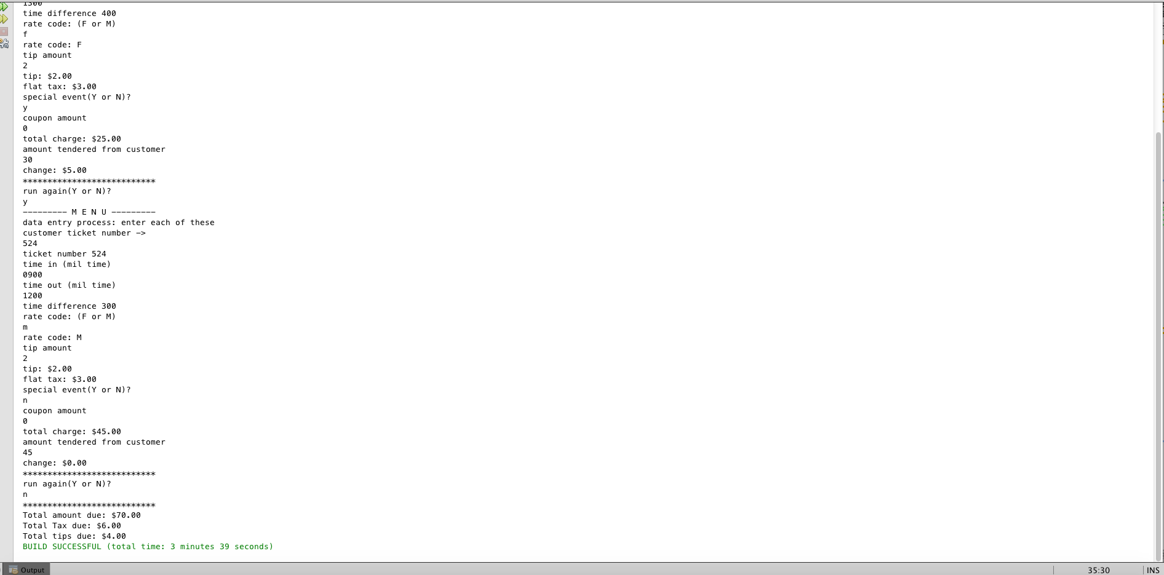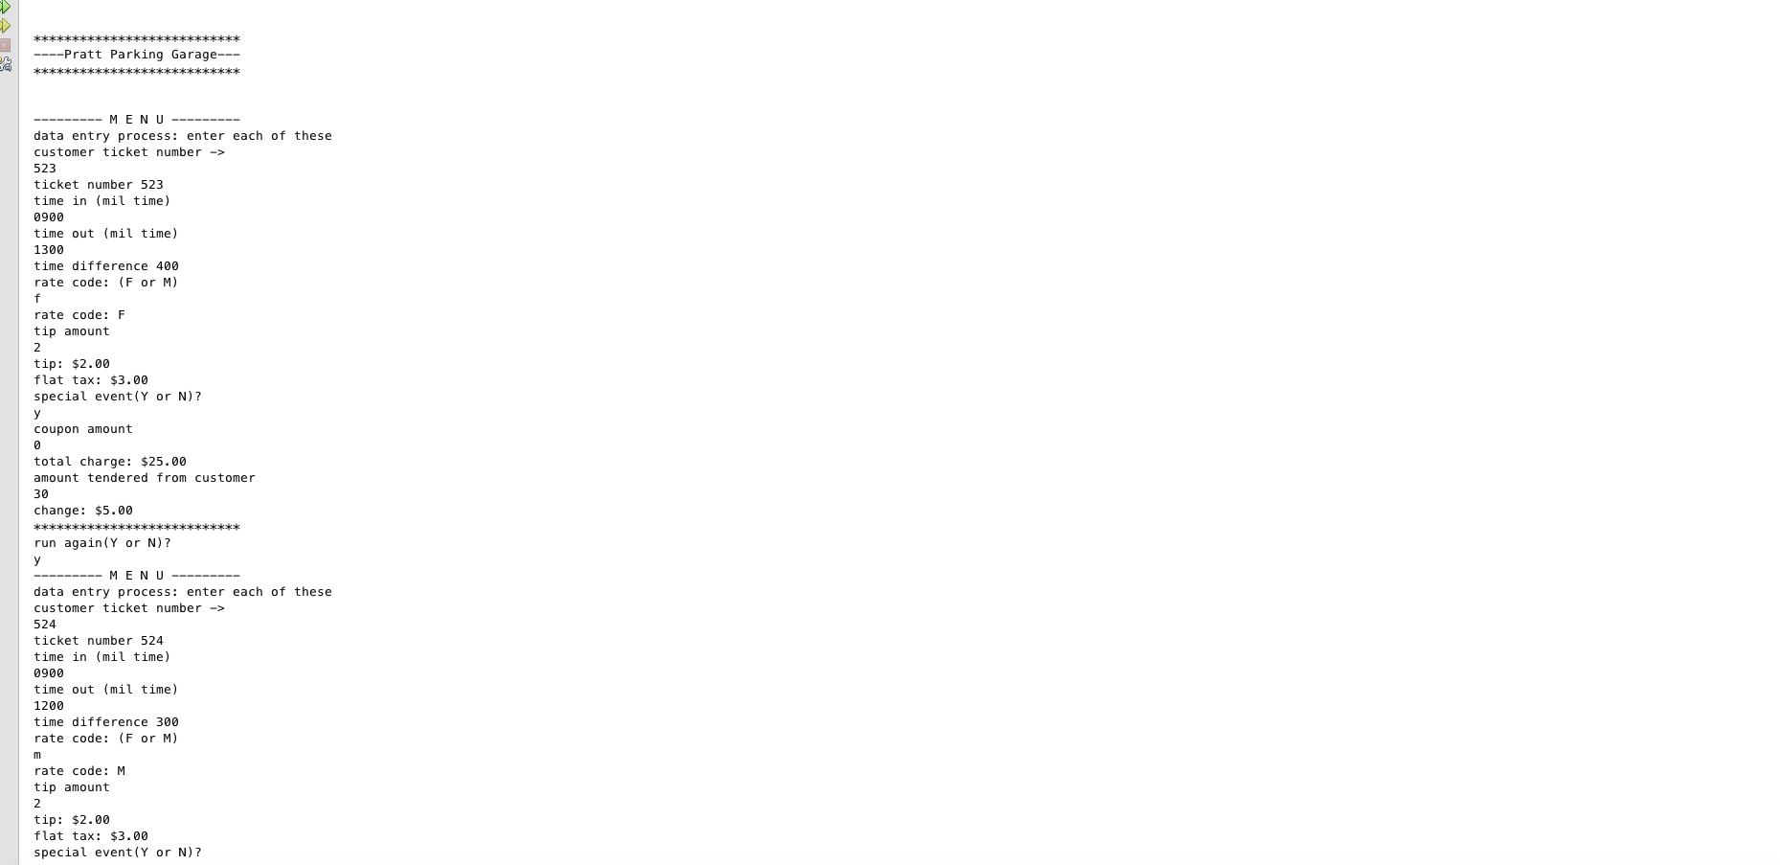

package lab4;

import java.util.Scanner;

// Colby Underhill, Programmer

public class PrattParkingGarage

{

static Scanner sc = new Scanner(System.in);

public static void main(String args[])

{

// the local variables declared and initialized

char answer = 'Y', specEvent = 'N', rateCode = '\0';

int ticketNum = 0;

int timeIn = 0, timeOut = 0, timeDiff = 0;

double amountTendered = 0.0, changeDue = 0.0;

double flatFee = 0.0, monthFee = 0.0;

double EXTRA_CHARGE = 0.0;

double coupon = 0.0, tip = 0.0;

double flatTax = 3.00, totalDueFromCust = 0.0;

double grandTotalDueFromCustomer = 0.0;

double grandTotalTipDueFromCustomer = 0.0;

double grandTotalTaxDueFromCustomer = 0.0;

System.out.println("");

System.out.println("");

System.out.println("***************************");

System.out.println("----Pratt Parking Garage---");

System.out.println("***************************");

System.out.println("");

System.out.println("");

while(answer == 'Y' )

{

System.out.println("--------- M E N U ---------");

System.out.println("data entry process: enter each of these");

System.out.println("customer ticket number ->");

ticketNum = sc.nextInt();

//while(!sc.hasNextInt())

//{

// System.out.println("Invalid Account number. Please enter only digits.");

// sc.next();

//}

System.out.println("ticket number " + (ticketNum));

System.out.println("time in (mil time)");

timeIn = sc.nextInt();

System.out.println("time out (mil time)");

timeOut = sc.nextInt();

timeDiff = timeOut - timeIn;

System.out.println("time difference " + (timeDiff));

System.out.println("rate code: (F or M)");

rateCode = sc.next().toUpperCase().charAt(0);

System.out.println("rate code: " + rateCode);

if (rateCode == 'F')

{

flatFee = 10.00;

totalDueFromCust = flatFee;

}

if (rateCode == 'M')

{

monthFee = 30.00;

totalDueFromCust = monthFee;

}

else

monthFee = 0.00;

System.out.println("tip amount");

tip = sc.nextDouble();

System.out.printf("tip: $%.2f\n", tip);

totalDueFromCust += tip;

System.out.printf("flat tax: $%.2f\n", flatTax);

totalDueFromCust += flatTax;

System.out.println("special event(Y or N)?");

specEvent = sc.next().toUpperCase().charAt(0);

if(specEvent == 'Y') EXTRA_CHARGE = 10;

totalDueFromCust += EXTRA_CHARGE;

System.out.println("coupon amount");

coupon = sc.nextDouble();

totalDueFromCust -= coupon;

System.out.printf("total charge: $%.2f\n", totalDueFromCust);

System.out.println("amount tendered from customer");

amountTendered = sc.nextDouble();

changeDue = amountTendered - totalDueFromCust;

System.out.printf("change: $%.2f\n", changeDue);

System.out.println("***************************");

System.out.println("run again(Y or N)?");

answer = sc.next().toUpperCase().charAt(0);

grandTotalDueFromCustomer += totalDueFromCust;

grandTotalTaxDueFromCustomer += flatTax;

grandTotalTipDueFromCustomer += tip;

}

System.out.println("***************************");

System.out.printf("Total amount due: $%.2f\n", grandTotalDueFromCustomer);

System.out.printf("Total Tax due: $%.2f\n", grandTotalTaxDueFromCustomer);

System.out.printf("Total tips due: $%.2f\n", grandTotalTipDueFromCustomer);

}// end main()

}// end class