Colby Underhill

CIS 144

Lab 5

10/11/2016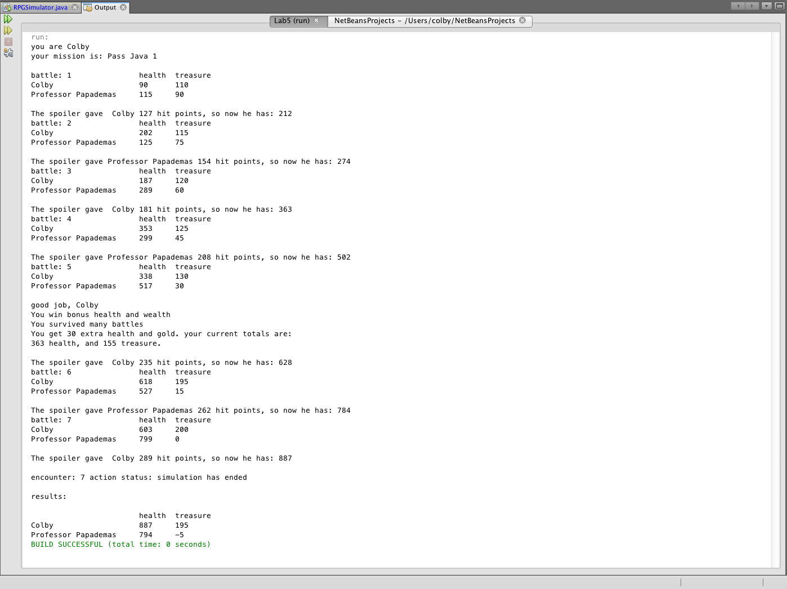

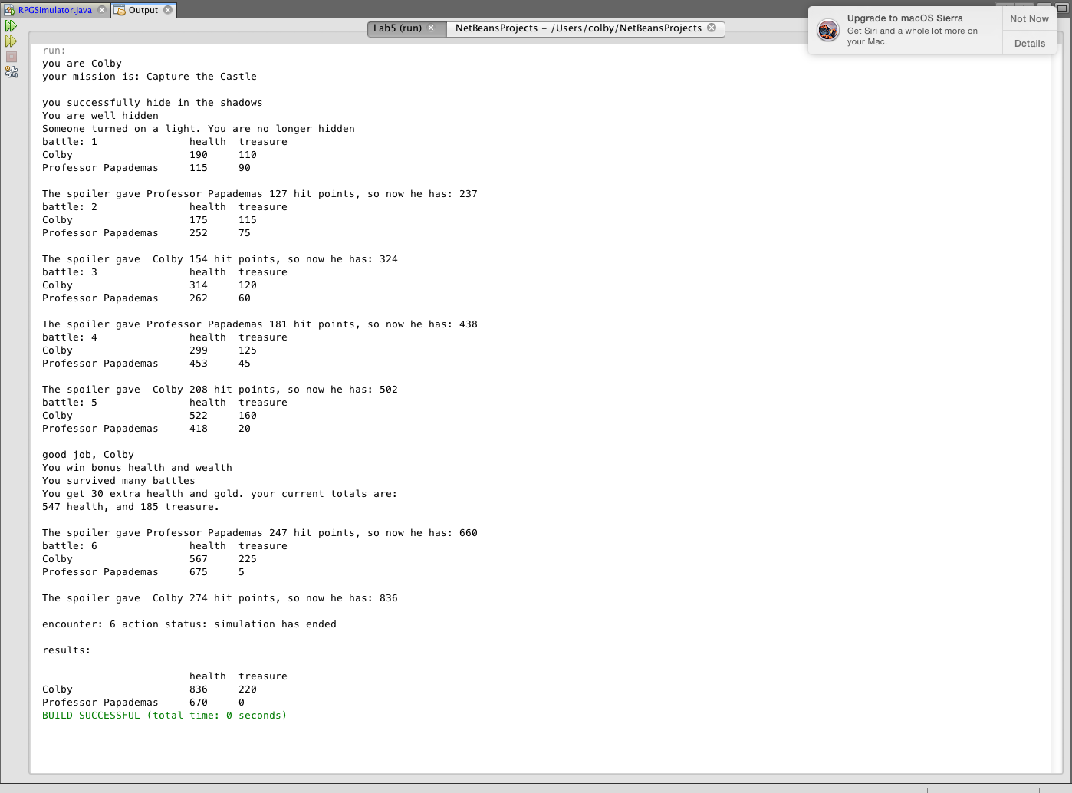

package lab5;

import java.util.Random;

// Colby Underhill, Elite Programmer

public class RPGSimulator {

public static void main(String args[]) throws InterruptedException

{

Random rand1 = new Random();

Random rand2 = new Random();

String mission1 = "Capture the Castle";

String mission2 = "Enter the Hidden City";

String mission3 = "Rescue the Princess";

String mission4 = "Traverse the Forest";

String mission5 = "Locate the Tunnel Entrance";

//my new missions

String mission6 = "Pass Java 1";

String mission7 = "Survive CCC";

String player1 = "", player2 = "", player3 = ""; //adde "The Spoiler"

char letter = '\0', role = '\0';

// initial health and treasures for the two players

//added "The Spoiler's treasure and health"

int number = 0, forrestry = 0,bonus = 0, p2Cloaked = 0, p1Cloaked = 0, mission = 0, health1 = 100, health2 = 100, health3 = 100;

int treasure1 = 100, treasure2 = 100, treasure3 = 100, encounter = 0;

// define your role

//modified character names

role = (char)(rand1.nextInt(26) + 'a');

if(role >= 'a' && role <= 'm')

{

player1 = "Colby ";

player2 = "Professor Papademas";

}

else

{

player1 = "Professor Papademas";

player2 = "Colby ";

}

System.out.println("you are " + player1);

// define your mission

//Added the neo missions to the randomizer

number = rand2.nextInt(7) + 1;

System.out.print("your mission is: ");

switch(number)

{

case 1: System.out.println(mission1); mission = 1; break;

case 2: System.out.println(mission2); mission = 2; break;

case 3: System.out.println(mission3); mission = 3; break;

case 4: System.out.println(mission4); mission = 4; break;

case 5: System.out.println(mission5); mission = 5; break;

//the new missions

case 6: System.out.println(mission6); mission = 6; break;

case 7: System.out.println(mission7); mission = 7; break;

}

System.out.println("");

//added the below feature to allow the player to attempt to cloak himself

if (mission == 1 && role >= 'a' && role <= 'm')//if I am player1

{

System.out.println("you successfully hide in the shadows");

p1Cloaked = rand2.nextInt(2);

if (p1Cloaked == 0)//0 is failure

{

System.out.println("Someone turned on a light. You are no longer hidden");

}

else if (p1Cloaked == 1)//1 is success

{

System.out.println("You are well hidden");

health1 += 100;

}

if (mission == 1 && role >= 'n' && role <= 'z')//if I am player2

p2Cloaked = rand2.nextInt(2);

if (p2Cloaked == 0)

{

System.out.println("Someone turned on a light. You are no longer hidden");

}

else if (p2Cloaked == 1)

{

System.out.println("You are well hidden");

health2 += 100;

}

}

if (mission == 4)//allows for the forrestry ability, player can avoid SOME

{ //encounters by hiding in the vegetation

forrestry = rand2.nextInt(2);

if (forrestry == 1)//played successfully hides, forrestry is set to 1

//and used in the encounters below

{

System.out.println("you successfully hide in the undergrowth. Your enemy has a hard time spotting you");

}

}

// let the game simulation commence (limit the # of encounters)

for (encounter = 1; encounter <= 20; encounter++)

{

letter = (char)(rand1.nextInt(3) + 'a');

number = rand2.nextInt(10) + 1;

// randomly encounter the enemy

if(letter == 'a' || letter == 'b')

//if(mission == 1 || mission == 2 || mission == 3)

if (forrestry == 1) //if the player won the previous forrestry check, it's

//used here to avoid 'a' & 'b' encouners

{

health1 -= 0;

health2 += 0;

health3 += 0;

treasure3 +=0;

treasure1 +=0;

treasure2 -= 0;

//Thread.sleep(5000);

System.out.print("battle: " + encounter);

System.out.println("You managed to hide from the enemy");

System.out.println("");

//encounter++;

}

else

{

health1 -= 10;

health2 += 15;

health3 += 32;

treasure3 +=100;

treasure1 += 10;

treasure2 -= 10;

//Thread.sleep(5000);

System.out.print("battle: " + encounter);

System.out.println("\t" + " health" + "\t" + "treasure");

System.out.println(player1 + "\t" + health1 + "\t" + treasure1);

System.out.println(player2 + "\t" + health2 + "\t" + treasure2);

System.out.println("");

}

else if(letter == 'c')

{

health1 += 20;

health2 -= 30;

health3 += 44;

treasure1 += 40;

treasure2 -= 20;

treasure3 += 76;

//Thread.sleep(500);

System.out.print("battle: " + encounter);

System.out.println("\t" + " health" + "\t" + "treasure");

System.out.println(player1 + "\t" + health1 + "\t" + treasure1);

System.out.println(player2 + "\t" + health2 + "\t" + treasure2);

System.out.println("");

//break;

}

else if(letter == 'd') //that sucks

{

health1 = 0;

health2 = 0;

System.out.println("You have died of dysentery :(");

//Thread.sleep(500);

System.out.print("battle: " + encounter);

System.out.println("\t" + " health" + "\t" + "treasure");

System.out.println(player1 + "\t" + health1 + "\t" + treasure1);

System.out.println(player2 + "\t" + health2 + "\t" + treasure2);

System.out.println("");

//break;

}

else

{

health1 += 30;

health2 -= 20;

health3 +=9;

treasure1 -= 30;

treasure2 += 20;

treasure3 += 542;

//Thread.sleep(500);

System.out.print("battle: " + encounter);

System.out.println("\t" + "health" + "\t" + "treasure");

System.out.println(player1 + "\t" + health1 + "\t" + treasure1);

System.out.println(player2 + "\t" + health2 + "\t" + treasure2);

System.out.println("");

//break;

}

health1 -= 5;

health2 -= 5;

health3 -= 5;

treasure1 -= 5;

treasure2 -= 5;

treasure3 -= 5;

//give a bonus for surviving

if (encounter == 5 && bonus == 0 && role >= 'a' && role <= 'm')

//if I am player1

{

health1 += 30;

treasure1 += 30;

bonus = 1;

System.out.println("good job, "+ player1);

System.out.println("You win bonus health and wealth");

System.out.println("You survived many battles");

System.out.println("You get 30 extra health and gold. your current totals are:");

System.out.println(health1 + " health, and " +treasure1 +" treasure.");

System.out.println(" ");

health1 += 30;

treasure1 += 30;

bonus = 1;

}

if (encounter == 5 && bonus == 0 && role >= 'n' && role <= 'z')

//if I am player2

{

health2 += 30;

treasure2 += 30;

bonus = 1;

System.out.println("good job, "+ player2);

System.out.println("You win bonus health and wealth");

System.out.println("You survived many battles");

System.out.println("You get 30 extra health and gold. your current totals are:");

System.out.println(health2 + " health, and " +treasure2 +" treasure.");

System.out.println(" ");

health1 += 30;

treasure1 += 30;

bonus = 1;

}

// here comes The Spoiler:

//there must be a more compact way of coding this...

if (health1 > health2 && role >= 'a' && role <= 'm')

{

health2 += health3;

System.out.println("The spoiler gave Professor Papademas "+ health3 + " hit points, so now he has: "+ health2);

}

else if (health1 > health2 && role >= 'n' && role <= 'z')

{

health2 += health3;

System.out.println("The spoiler gave Colby "+ health3 + " hit points, so now he has: "+ health2);

}

else if (health1 < health2 && role >= 'a' && role <= 'm')

{

health1 += health3;

System.out.println("The spoiler gave Colby "+ health3 + " hit points, so now he has: "+ health1);

}

else if (health1 < health2 && role >= 'n' && role <= 'z')

{

health1 += health3;

System.out.println("The spoiler gave Professor Papademas "+ health3 + " hit points, so now he has: "+ health1);

}

if (health1 <= 0 || health2 <= 0 || treasure1 <= 0 || treasure2 <= 0)

{

System.out.println(" ");

System.out.print("encounter: " + encounter + " action status: ");

break;

}

}

System.out.println("simulation has ended\n");

System.out.println("results:\n");

System.out.println("\t\t" + " health" + "\t" + "treasure");

System.out.println(player1 + "\t" + health1 + "\t" + treasure1);

System.out.println(player2 + "\t" + health2 + "\t" + treasure2);

}

}