Colby Underhill

CIS 144

Lab 6

01/19/2016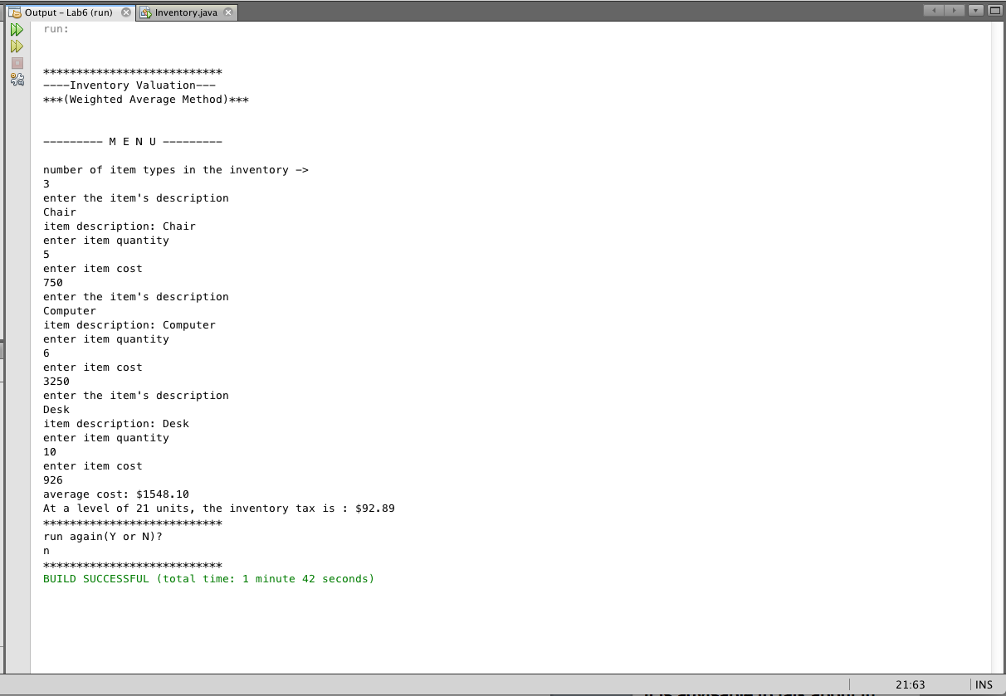

package lab6;

import java.util.Scanner;

//Colby Underhill, Programmer

public class Inventory

{

static int numItems = 0;

static double avgInvCost = 0;

static Scanner sc = new Scanner(System.in);

public static void main(String args[])

{

// begin local variable declaration / initialization zone

char answer = 'Y';

// end local variable declaration / initialization zone

displayMenu();

while(answer == 'Y' || answer == 'y')

{

// begin code block to display results

System.out.printf("average cost: $%.2f\n", averageCost());

System.out.print("At a level of " + numItems + " units, ");

System.out.printf("the inventory tax is : $%.2f\n", computeTax());

System.out.println("\*\*\*\*\*\*\*\*\*\*\*\*\*\*\*\*\*\*\*\*\*\*\*\*\*\*\*");

// end code block to display results

// begin code block to perform additional program run

System.out.println("run again(Y or N)?");

answer = sc.next().charAt(0);

// end code block to perform additional program run

}

System.out.println("\*\*\*\*\*\*\*\*\*\*\*\*\*\*\*\*\*\*\*\*\*\*\*\*\*\*\*");

}// end main() method

static void displayMenu()

{

// begin program menu

System.out.println("");

System.out.println("");

System.out.println("\*\*\*\*\*\*\*\*\*\*\*\*\*\*\*\*\*\*\*\*\*\*\*\*\*\*\*");

System.out.println("----Inventory Valuation---");

System.out.println("\*\*\*(Weighted Average Method)\*\*\*");

System.out.println("");

System.out.println("");

System.out.println("--------- M E N U ---------");

System.out.println("");

// end program menu

}// end method

static double averageCost()

{

double average = 0.0, cost = 0.0, totValue = 0.0;

int number = 0, sumItems = 0, quantity = 0;

String item = "";

// begin code block for inventory evaluation

System.out.println("number of item types in the inventory ->");

number = sc.nextInt();

for(int i = 1; i <= number; i++)

{

System.out.println("enter the item's description");

item = sc.next();

System.out.println("item description: " + item);

System.out.println("enter item quantity");

quantity = sc.nextInt();

sumItems += quantity;

System.out.println("enter item cost");

cost = sc.nextDouble();

totValue += cost \* quantity;

}

numItems = sumItems;

avgInvCost = totValue / sumItems;

// outside the for() loop

average = totValue / sumItems;

// end code block for inventory evaluation

return average;

}//end method

static double computeTax()

{

double tax = 0;

tax = avgInvCost \* .06;

return tax;

}//end method

}// end class