Fixora AI - An Intelligent Home Repair and Service Discovery & Coordination Engine
A Mini Project Report Submitted in the partial fulfillment of the requirements for the award of the degree of

BACHELOR OF TECHNOLOGY

In
DEPARTMENT OF COMPUTER SCIENCE ENGINNERING
Or
DEPARTMENT OF COMPUTER SCIENCE AND INFORMATION TECHNOLOGY
By
Anakala Sarayu – 2420030249
Manduri Varshitha – 2420030269
Divya Sree– 2420030287

Under the Esteemed Guidance of

Dr.Neelima Gogineni

Name of the SOA faculty of respective section





K L (Deemed to be) University
DEPARTMENT OF COMPUTER SCIENCE ENGINEERING
Or
DEPARTMENT OF COMPUTER SCIENCE AND INFORMATION TECHNOLOGY

DECLARATION

The Mini Project Report entitled Fixora AI – An Intelligent Home Repair and Service Discovery & Coordination Engine is a record of Bonafide work of Anakala Sarayu-2420030249,Manduri Varshitha-2420030269, ,Divya Sree-2420030287 submitted in partial fulfillment for the award of B. Tech in Computer Science and Engineering (or) Computer Science and Information Technology to the K L University. The results embodied in this report have not been copied from any other departments/University/Institute.

Anakala Sarayu– 2420030249
Manduri Varshitha – 2420030269
Divya Sree – 2420030287

K L (Deemed to be) University
DEPARTMENT OF COMPUTER SCIENCE ENGINEERING
Or
DEPARTMENT OF COMPUTER SCIENCE AND INFORMATION TECHNOLOGY
CERTIFICATE

This is certify that the mini project based report entitled Fixora AI – An Intelligent Home Repair and Service Discovery & Coordination Engine is a bonafide work done and submitted by Anakala Sarayu-2420030249,Manduri Varshitha-2420030269 ,Divya Sree-2420030287 in partial fulfillment of the requirements for the award of the degree of BACHELOR OF TECHNOLOGY in Department of Computer Science Engineering, K L (Deemed to be University), during the academic year 2026-2027.

Signature of the Course Co-ordinator Signature of HOD

ACKNOWLEDGEMENT

The success in this project would not have been possible but for the timely help and guidance rendered by many people. Our wish to express my sincere thanks to all those who has assisted us in one way or the other for the completion of my project.

Our greatest appreciation to my guide, Dr.Neelima Gogineni , Department of Computer Science which cannot be expressed in words for his/her tremendous support, encouragement and guidance for this project.

We express our gratitude to Dr. P.Venkateshwar Sir (CSE), Head of the Department for Computer Science Engineering/ Department for Computer Science and Information Technology for providing us with adequate facilities, ways and means by which we are able to complete this project-based Lab.

We thank all the members of teaching and non-teaching staff members, and also who have assisted me directly or indirectly for successful completion of this project. Finally, I sincerely thank my parents, friends and classmates for their kind help and cooperation during my work.

Anakala Sarayu– 2420030249
Manduri Varshitha – 2420030269
Divya Sree – 2420030287

TABLE OF CONTENTS

S.No. | Contents | Page no.
1. | Abstract | 6
2. | Introduction | 7
3. | Literature survey | 8-10
4. | Problem Statement and Objectives | 11
5. | Hardware and Software requirements | 12
6. | Implementation | 13-19
7. | Results & Discussion | 19-27
8. | Conclusion & Future Scope | 28
9. | References | 29

- ABSTRACT
Fixora AI is an intelligent home repair and service discovery and coordination platform designed to simplify the process of finding reliable service providers for household repair needs. The system allows users to describe their problems in natural language, which are analyzed using Artificial Intelligence (AI) to identify the appropriate service category and recommend relevant service providers. Unlike traditional service platforms that may display limited options, Fixora AI presents multiple provider recommendations simultaneously, enabling users to compare available providers and make informed decisions.
The platform is developed using React.js for the user interface, Spring Boot and Spring Cloud for backend services, PostgreSQL for data storage, and Spring AI with Large Language Model (LLM) APIs for intelligent problem understanding and service recommendations. Apache Kafka is used for event-driven communication, supporting real-time updates related to service requests, provider responses, confirmations, and service status changes. Spring Security and JSON Web Tokens (JWT) provide secure authentication and authorization, while Docker supports application deployment.
Fixora AI aims to improve convenience, reduce the time required to identify suitable professionals, and enhance communication between customers and service providers. By integrating artificial intelligence, microservices, and real-time event processing, the platform provides a scalable and user-friendly solution for home repair service coordination. The project demonstrates how modern software technologies can be combined to make household service discovery more efficient, organized, and accessible.
Team Name: Fixora AI – An Intelligent Home Repair and Service Discovery & Coordination Engine
Team Members:
- Anakala Sarayu-2420030249
- Manduri Varshitha-2420030269
- Divya Sree-2420030287

- INTRODUCTION

In today's fast-paced world, finding reliable and suitable professionals for household repair and maintenance services can be challenging. People often face difficulties in identifying the correct service provider, comparing available options, and coordinating with professionals for timely service. Traditional methods of finding technicians, plumbers, electricians, and other home repair professionals may require considerable time and effort. These challenges highlight the need for an intelligent and efficient platform that simplifies home repair service discovery and coordination.
Fixora AI is an intelligent home repair and service discovery and coordination platform designed to address these problems using modern technologies. The system allows users to describe their household repair issues in natural language. Artificial Intelligence (AI) analyzes the description, identifies the relevant service category, and recommends multiple suitable service providers simultaneously. This enables users to compare available options and choose a provider according to their requirements.
The project uses React.js for the frontend, Spring Boot and Spring Cloud for backend development, PostgreSQL for data management, and Spring AI with Large Language Model (LLM) APIs for intelligent service recommendations. Apache Kafka supports event-driven communication and real-time updates, while Spring Security and JSON Web Tokens (JWT) help secure user authentication and authorization. Docker supports application packaging and deployment.
The main objective of Fixora AI is to reduce the effort involved in finding home repair services, improve provider selection, and simplify communication between users and service professionals. This report presents the project's objectives, existing and proposed systems, system architecture, technologies used, implementation approach, and expected benefits.

- LITERATURE SURVEY

3.1 Urban Company – Home Service Booking Platform
Urban Company is an online home service platform that connects customers with professionals for household needs such as plumbing, electrical repairs, appliance servicing, cleaning, and carpentry. It allows users to explore service categories, review available services, and book appointments with suitable professionals. The platform simplifies the process of finding service providers for common household problems. However, Fixora AI focuses on understanding repair problems described in natural language and recommending multiple suitable providers based on the identified service requirements.

3.2 Angi – Home Improvement and Professional Discovery Platform
Angi is a home improvement platform that helps homeowners find professionals for repairs, maintenance, renovations, and cleaning services. Users can explore service providers, review ratings, and request quotations for different household projects. The platform helps customers evaluate professionals before selecting a service provider. However, Fixora AI extends this approach by incorporating AI-based problem classification and real-time coordination of service requests, provider responses, confirmations, and service status updates.

3.3 Thumbtack – Local Service Recommendation Platform
Thumbtack is an online platform that connects customers with local professionals offering services such as plumbing, electrical work, home improvement, and cleaning. Users can provide details about their requirements and discover professionals based on their needs. The platform supports provider comparison through information such as customer reviews, service details, and pricing. However, Fixora AI aims to use Large Language Models (LLMs) to understand household repair descriptions and recommend relevant providers through an intelligent and coordinated workflow.

3.4 Taskrabbit – On-Demand Home Service Platform
Taskrabbit connects customers with independent professionals who perform household tasks such as furniture assembly, minor repairs, mounting, and other maintenance activities. Users can explore professionals, compare their profiles, and arrange services according to their requirements. The platform provides a convenient way to connect customers with individuals offering relevant skills. However, Fixora AI focuses specifically on AI-assisted home repair identification and event-driven coordination of service requests, provider responses, and completion updates.

3.5 Porch – Home Service Matching Platform
Porch is a home services platform that helps homeowners find professionals for plumbing, electrical work, painting, remodeling, and general home maintenance. Users can provide details about their projects and connect with suitable service providers for their requirements. The platform helps customers explore professional services and evaluate available options before making a decision. However, Fixora AI aims to enhance this process by using AI to interpret repair descriptions, recommend multiple relevant providers, and coordinate service requests through real-time backend communication.

3.6 Handy – Home Cleaning and Repair Booking Platform
Handy is an online service platform that connects customers with professionals for home cleaning, furniture assembly, and selected home improvement tasks. It enables users to explore available services and arrange appointments according to their requirements. The platform simplifies household service booking by providing a structured way to access professionals. However, Fixora AI focuses on intelligent repair problem identification, service category prediction, multiple provider recommendations, and continuous tracking of service request progress.

3.7 Sewa Mitra – Local Service Provider Platform
Sewa Mitra is a service platform that helps users access local professionals, including electricians, plumbers, carpenters, painters, and other service workers. It aims to connect customers with suitable service providers and improve access to household and local services. The platform demonstrates the importance of making professional services accessible through a centralized digital system. However, Fixora AI proposes an additional AI-based approach in which user-described problems are analyzed to identify repair requirements and support coordinated communication between customers and service providers.

3.8 HomeAdvisor – Home Repair Professional Discovery
HomeAdvisor is a home improvement service that helps homeowners discover professionals for repairs, maintenance, renovations, and other household projects. Users can explore service categories, find contractors, and request estimates for their requirements. The platform helps customers connect with professionals who provide relevant home services. However, Fixora AI aims to go beyond conventional service discovery by combining natural-language problem understanding, AI-powered provider recommendations, and event-driven updates for service requests and provider responses.

3.9 Yelp Home Services – Local Business and Service Discovery
Yelp is a business discovery and review platform that allows users to find local service providers and evaluate them using customer reviews, ratings, and business information. Its home services features help users identify professionals for household repairs and improvement projects. Customers can explore businesses and submit service requests for suitable providers. However, Fixora AI focuses on analyzing the actual repair problem using AI before recommending providers, followed by coordinated service request management and real-time status updates.

3.10 Airtasker – Task Posting and Service Provider Matching
Airtasker is an online marketplace where users can post tasks and receive offers from people willing to complete them. It supports different types of work, including household repairs, cleaning, moving, and other everyday tasks. Users can compare offers and select a suitable person based on their requirements and available options. However, Fixora AI specifically focuses on home repair service coordination by automatically identifying the required service category, recommending relevant providers, and managing provider responses and service progress through an event-driven architecture.

3.11 Research Gap
Existing platforms demonstrate the importance of digital service discovery, professional matching, customer reviews, quotations, and online booking for household repairs. However, these capabilities differ across platforms, and users may still need to identify the correct service category, compare providers, communicate their requirements, and track service progress through separate steps.
Fixora AI addresses this gap by integrating AI-based repair problem understanding, service category identification, multiple provider recommendations, service request management, provider response coordination, and real-time status updates into a unified platform. The proposed system uses React.js, Spring Boot, Spring Cloud, Spring AI with LLM APIs, PostgreSQL, Apache Kafka, Spring Security, JWT, and Docker to provide an intelligent, secure, and scalable home repair service coordination solution.

- Problem Statement and Objectives
Problem Statement: Finding suitable and reliable home repair service providers and coordinating service requests efficiently is a challenging process for customers.
Problem Description: Traditional home repair service discovery often requires users to identify the correct service category, search for professionals, compare providers, and coordinate service updates manually. Fixora AI addresses this challenge using AI-based problem understanding, multiple provider recommendations, and real-time service coordination.
Objectives:
- AI-Based Problem Understanding: Analyze users' home repair problems described in natural language and identify the appropriate service category.
- Service Provider Recommendation: Recommend multiple suitable service providers based on the identified repair requirements.
- Service Request Management: Enable users to create service requests and manage provider responses, confirmations, and service progress.
- Real-Time Event Processing: Use Apache Kafka to support real-time communication and updates between backend services.
- Secure User Authentication: Implement Spring Security and JWT to provide secure authentication and authorization.
- Integrated Service Coordination: Develop a scalable and user-friendly home repair platform using React.js, Spring Boot, Spring Cloud, Spring AI, PostgreSQL, and Docker.

- HARDWARE AND SOFTWARE REQUIREMENTS
Hardware Requirements
- Processor: Intel Core i5 or equivalent AMD processor.
- RAM: Minimum 8 GB; 16 GB recommended for running multiple services.
- Hard Disk: Minimum 256 GB SSD; 512 GB recommended.
- Operating System: Windows 10/11, Linux, or macOS.
- Internet Connection: Stable internet connection for accessing LLM APIs and online services.
- Display: Standard monitor with a minimum resolution of 1366 × 768 pixels.

Software Requirements:
- Programming Languages: Java 21, JavaScript, HTML5, CSS3, SQL
- Frameworks: Spring Boot, Spring Cloud, React.js, Spring AI
- Database: PostgreSQL
- AI Technology: Ollama and Large Language Models (LLMs)
- Architecture & Communication: Microservices, REST APIs, Apache Kafka
- Security: Spring Security, JSON Web Tokens (JWT)
- Containerization: Docker
- Development Tools: Visual Studio Code, IntelliJ IDEA, Maven, Git, GitHub
- Testing Tools: Postman
- Runtime Environment: Node.js, npm
- Database Management Tool: pgAdmin

- IMPLEMENTATION
1. Frontend
The frontend of Fixora AI is developed using React.js, HTML5, CSS3, and JavaScript to provide an interactive and user-friendly interface. It allows users to describe their home repair problems, view AI-generated service recommendations, compare service providers, and track their service requests. The frontend communicates with the backend through REST APIs to display updated information and service details.
2. Backend
The backend is developed using Java 21, Spring Boot, and Spring Cloud to handle business logic and manage the application's services. It processes user requests, stores user and service provider information in PostgreSQL, and manages service request creation, provider responses, and status updates. Apache Kafka supports event-driven communication between services, while Spring Security and JWT provide secure authentication and authorization.
3. API Integration
Fixora AI uses REST APIs to enable communication between the React.js frontend and the Spring Boot backend. Spring AI integrates Ollama with the backend to analyze home repair problems described in natural language and identify suitable service categories and provider recommendations. Apache Kafka supports asynchronous communication and real-time event processing for service requests, provider responses, confirmations, and service status changes. This integration helps provide an intelligent and coordinated home repair service experience.
1.Frontend (HTML, CSS, JavaScript):
React.js along with HTML, CSS, and JavaScript is used for the Fixora AI frontend. The major frontend components/pages include:
- App.jsx: Main React application and routing configuration.
- Login.jsx: Provides user login functionality.
- Register.jsx: Allows new users to create an account.
- Dashboard.jsx: Displays service information and repair request details.
- Chat.jsx: Allows users to describe home repair problems in natural language.
- AIAnalysis.jsx: Displays AI-analyzed repair problems and suggested service categories.
- Providers.jsx: Displays suitable service providers and their details.
- ServiceRequests.jsx: Allows users to create and track service requests.
- Bookings.jsx: Displays and manages service bookings.
- Reviews.jsx: Allows users to submit reviews and view provider feedback.
- Navbar.jsx: Provides navigation between different sections of the application.
- api.js: Contains functions used to communicate with backend REST APIs, including authentication, AI analysis, providers, requests, bookings, and reviews.
- App.css / index.css: Contains styling and layout definitions for the application.

index.html:
<!doctype html>
<html lang="en">
<head>
<meta charset="UTF-8" />
<link rel="icon" type="image/svg+xml" href="/favicon.svg" />
<meta name="viewport" content="width=device-width, initial-scale=1.0" />
<title>frontend</title>
</head>
<body>
<div id="root"></div>
<script type="module" src="/src/main.jsx"></script>
</body>
</html>

2. Backend (JAVA):
The backend is implemented using Spring Boot, with separate packages for models, repositories, services, controllers, and security. Each component has its own responsibility in the Fixora AI application.
User Management
- User.java: Entity class representing user information.
- UserRepository.java: Handles database operations for users.
- UserService.java: Contains user registration and authentication-related business logic.
- UserController.java: Provides REST APIs for user operations.
Service Provider Management
- Provider.java: Represents home repair service provider information.
- ProviderRepository.java: Handles database operations for providers.
- ProviderService.java: Contains provider-related business logic.
- ProviderController.java: Provides REST APIs for provider management.
AI Service
- AIService.java: Integrates AI functionality to analyze users’ home repair problems.
- AIController.java: Provides REST APIs for AI-based problem analysis.
Service Matching
- MatchResult.java: Represents the results of matching repair requests with suitable providers.
- MatchingService.java: Contains logic for finding suitable service providers.
- MatchingController.java: Provides REST APIs for provider matching.
Service Request Management
- ServiceRequest.java: Represents home repair service requests.
- ServiceRequestRepository.java: Handles database operations for service requests.
- ServiceRequestService.java: Manages service requests and their status.
- ServiceRequestController.java: Provides REST APIs for service request operations.
- ProviderRequestController.java: Allows providers to access and manage their service requests.
Booking Management
- Booking.java: Represents service booking information.
- BookingRepository.java: Handles database operations for bookings.
- BookingController.java: Provides REST APIs for booking operations.
Review Management
- Review.java: Represents customer reviews and ratings for providers.
- ReviewRepository.java: Handles database operations for reviews.
- ReviewController.java: Provides REST APIs for submitting and retrieving reviews.
Dashboard Management
- CustomerDashboardController.java: Provides APIs for customer dashboard information.
- ProviderDashboardController.java: Provides APIs for provider dashboard information.
Security Management
- SecurityConfig.java: Configures application security and access permissions.
- JwtAuthenticationFilter.java: Validates JWT tokens for authenticated requests.
Application Configuration
- BackendApplication.java: Main entry point of the Spring Boot application.
- HomeController.java: Provides home or welcome-related API endpoints.
DTO (Data Transfer Object)
- MatchResult.java: Transfers provider matching results between application components.

- API Integration:….about integration files.

Contains functions to connect the React.js frontend with Spring Boot backend REST APIs for user authentication, AI-based repair problem analysis, service provider recommendations, service requests, bookings, and reviews.
api.js:
const API_URL = "http://localhost:8080/api";

function getAuthHeaders() {
const token = localStorage.getItem("token");
return {
"Content-Type": "application/json",
...(token && { Authorization: `Bearer ${token}` })
};
}

// User Authentication
export async function login(user) {
const response = await fetch(`${API_URL}/users/login`, {
method: "POST",
headers: { "Content-Type": "application/json" },
body: JSON.stringify(user)
});
if (!response.ok) throw new Error("Login failed");
const data = await response.json();
localStorage.setItem("token", data.token);
return data;
}

// AI Problem Analysis
export async function analyzeProblem(problem) {
const response = await fetch(`${API_URL}/ai/analyze`, {
method: "POST",
headers: getAuthHeaders(),
body: JSON.stringify({ problem })
});
if (!response.ok) throw new Error("Analysis failed");
return response.json();
}

// Service Providers
export async function getProviders() {
const response = await fetch(`${API_URL}/providers`, {
headers: getAuthHeaders()
});
if (!response.ok) throw new Error("Failed to load providers");
return response.json();
}

// Service Requests
export async function createRequest(request) {
const response = await fetch(`${API_URL}/requests`, {
method: "POST",
headers: getAuthHeaders(),
body: JSON.stringify(request)
});
if (!response.ok) throw new Error("Request failed");
return response.json();
}

// Bookings
export async function createBooking(booking) {
const response = await fetch(`${API_URL}/bookings`, {
method: "POST",
headers: getAuthHeaders(),
body: JSON.stringify(booking)
});
if (!response.ok) throw new Error("Booking failed");
return response.json();
}

// Reviews
export async function createReview(review) {
const response = await fetch(`${API_URL}/reviews`, {
method: "POST",
headers: getAuthHeaders(),
body: JSON.stringify(review)
});
if (!response.ok) throw new Error("Review submission failed");
return response.json();
}

- RESULTS & DISCUSSION
Output website screen shots with their explanation in 2 lines.
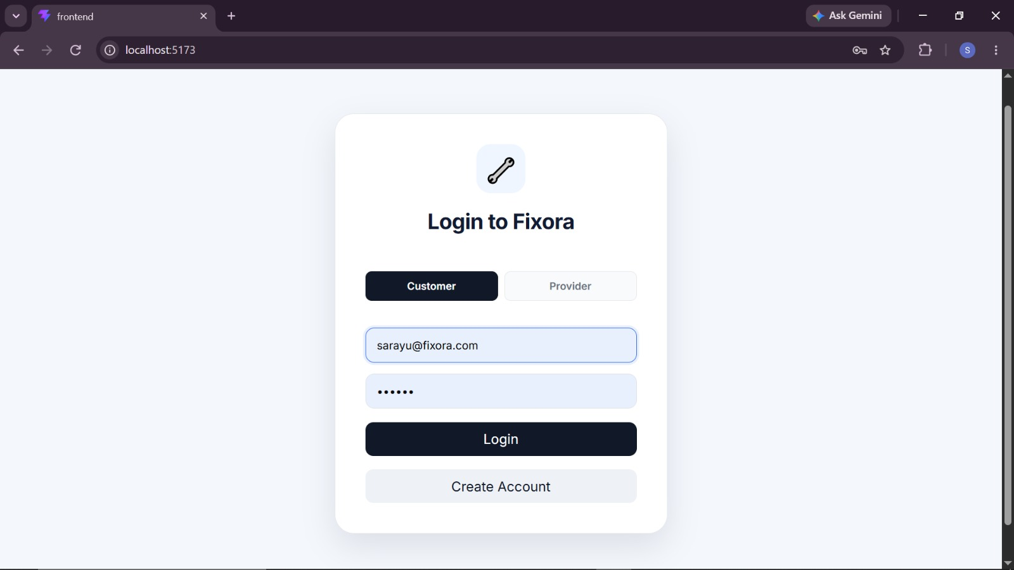
The Fixora AI login page provides secure access for customers and service providers through role-based login options. It includes email and password fields, account creation, and a simple, user-friendly interface for authentication

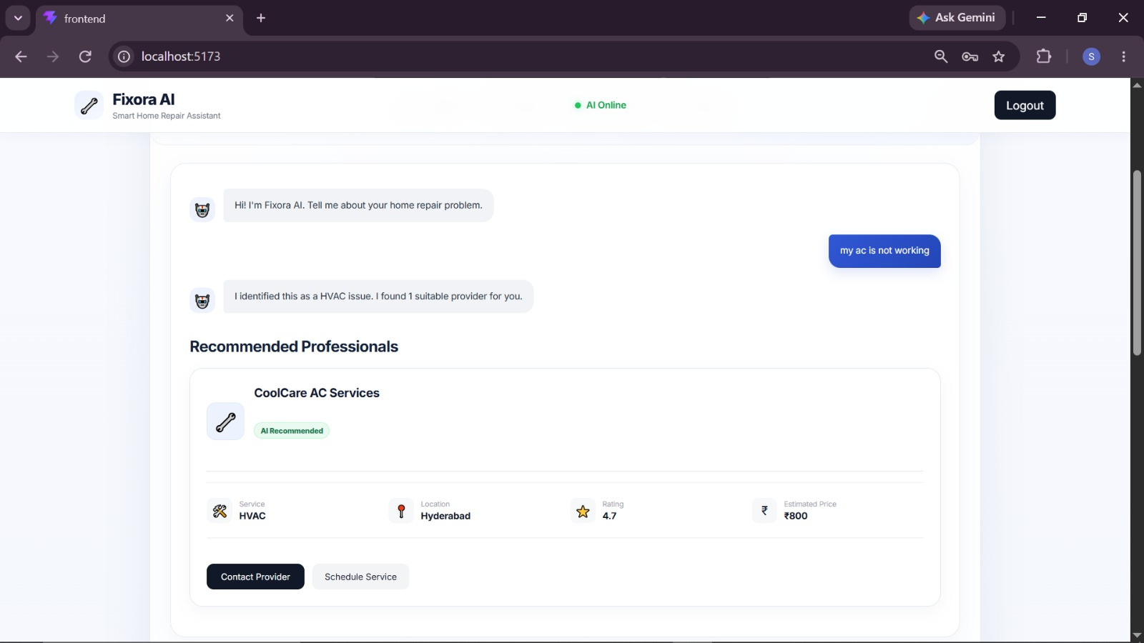
This page uses AI to analyze users’ home repair problems and recommend suitable service providers based on the identified service category. It displays provider details, ratings, estimated prices, and options to contact providers or schedule services.

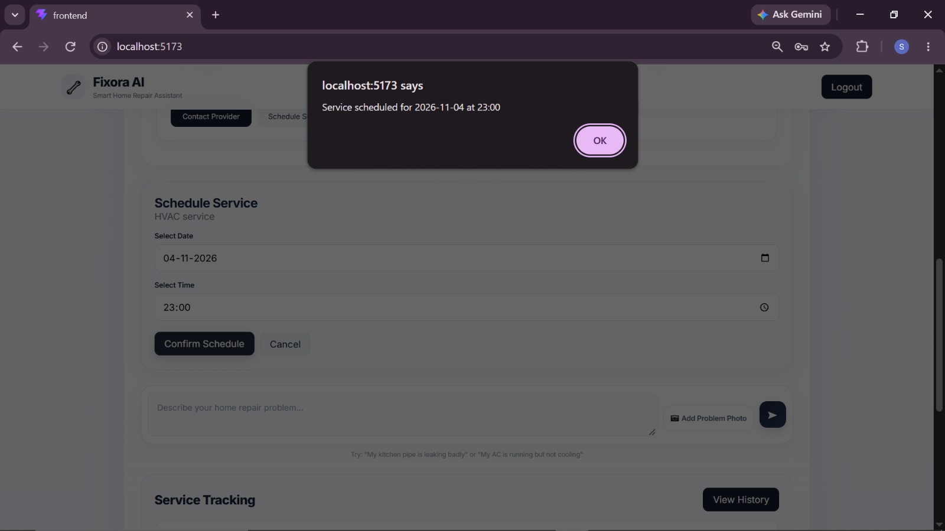
A confirmation popup appears with an “OK” button to notify the customer that the service has been scheduled successfully.

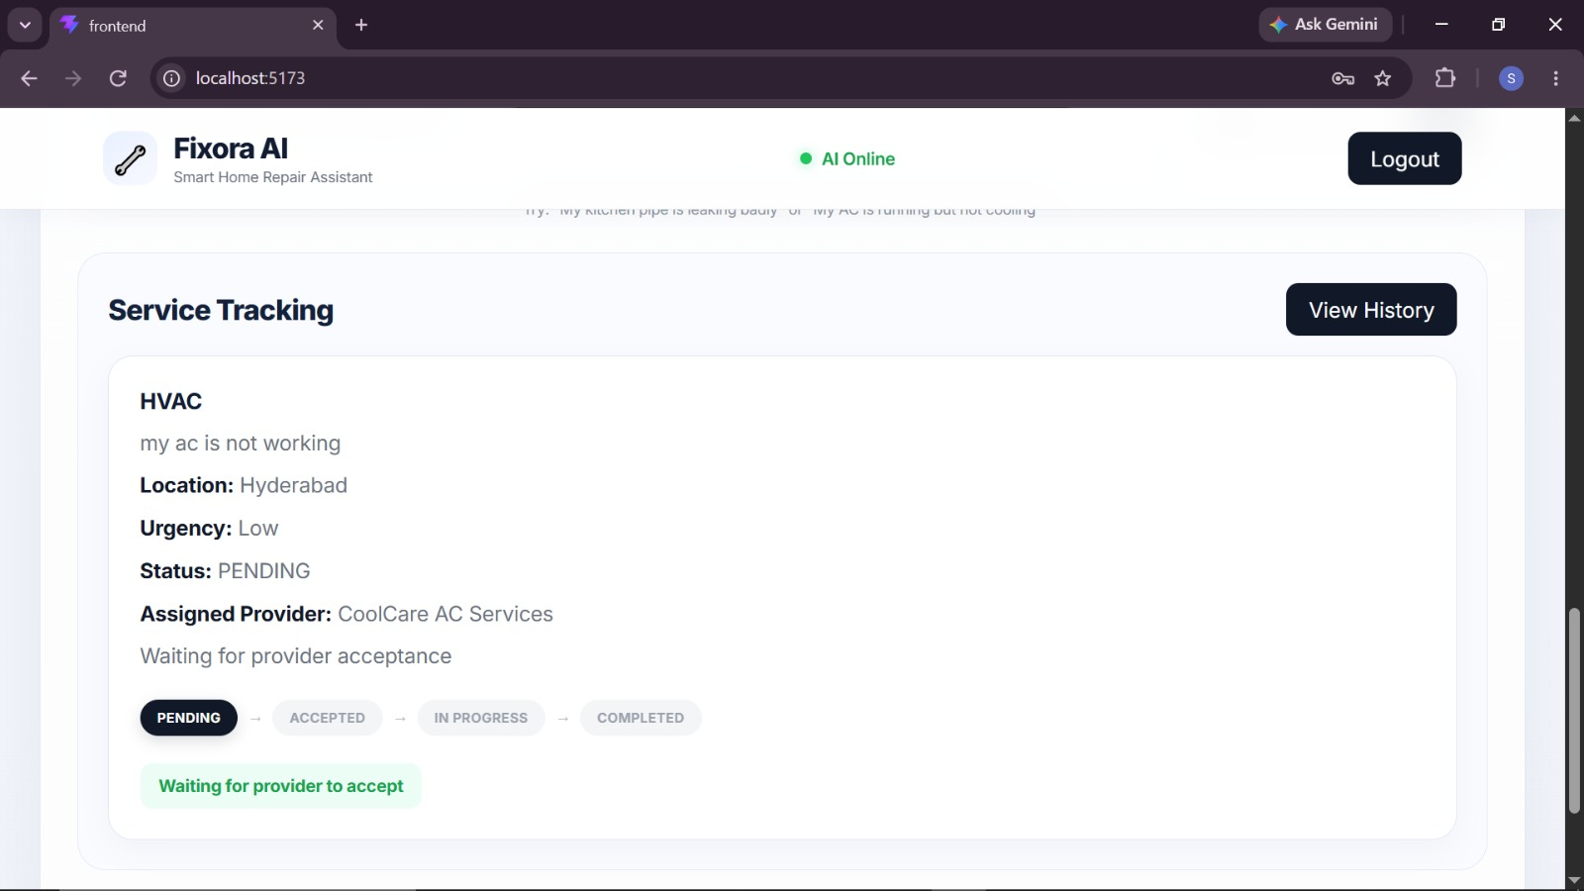
This page allows customers to track their home repair requests and monitor service progress through statuses such as pending, accepted, in progress, and completed. It also displays the assigned service provider and current request details.

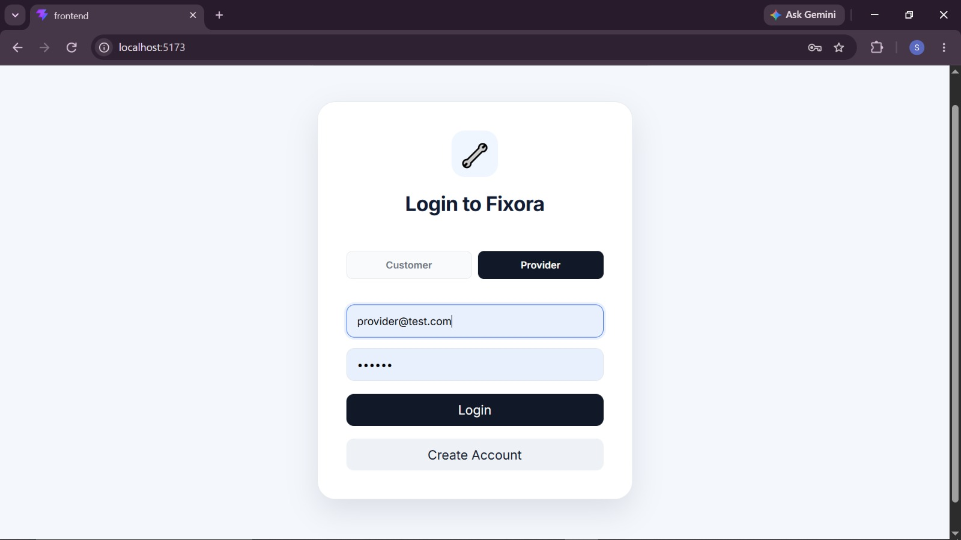
This page allows service providers to securely log in to Fixora AI using their email and password. It provides separate login options for customers and providers, along with an account creation feature.

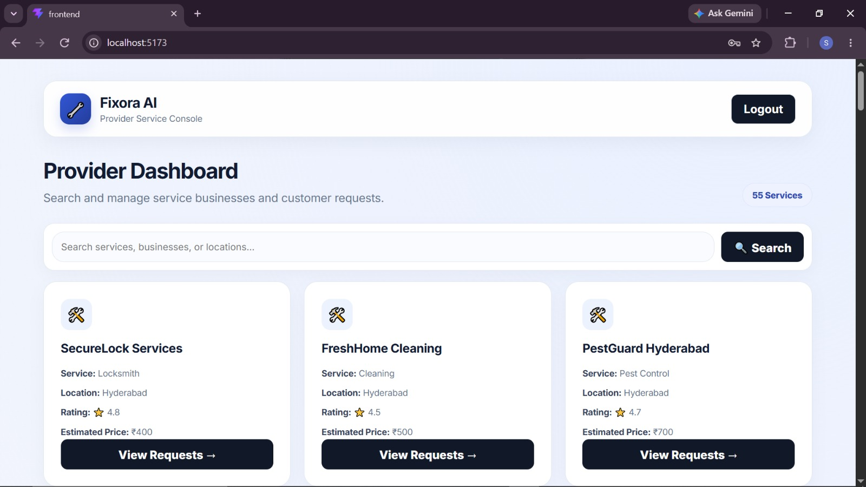
The provider dashboard displays available service businesses with their service categories, locations, ratings, and estimated prices. It helps customers or users search for suitable service providers and view their requests.

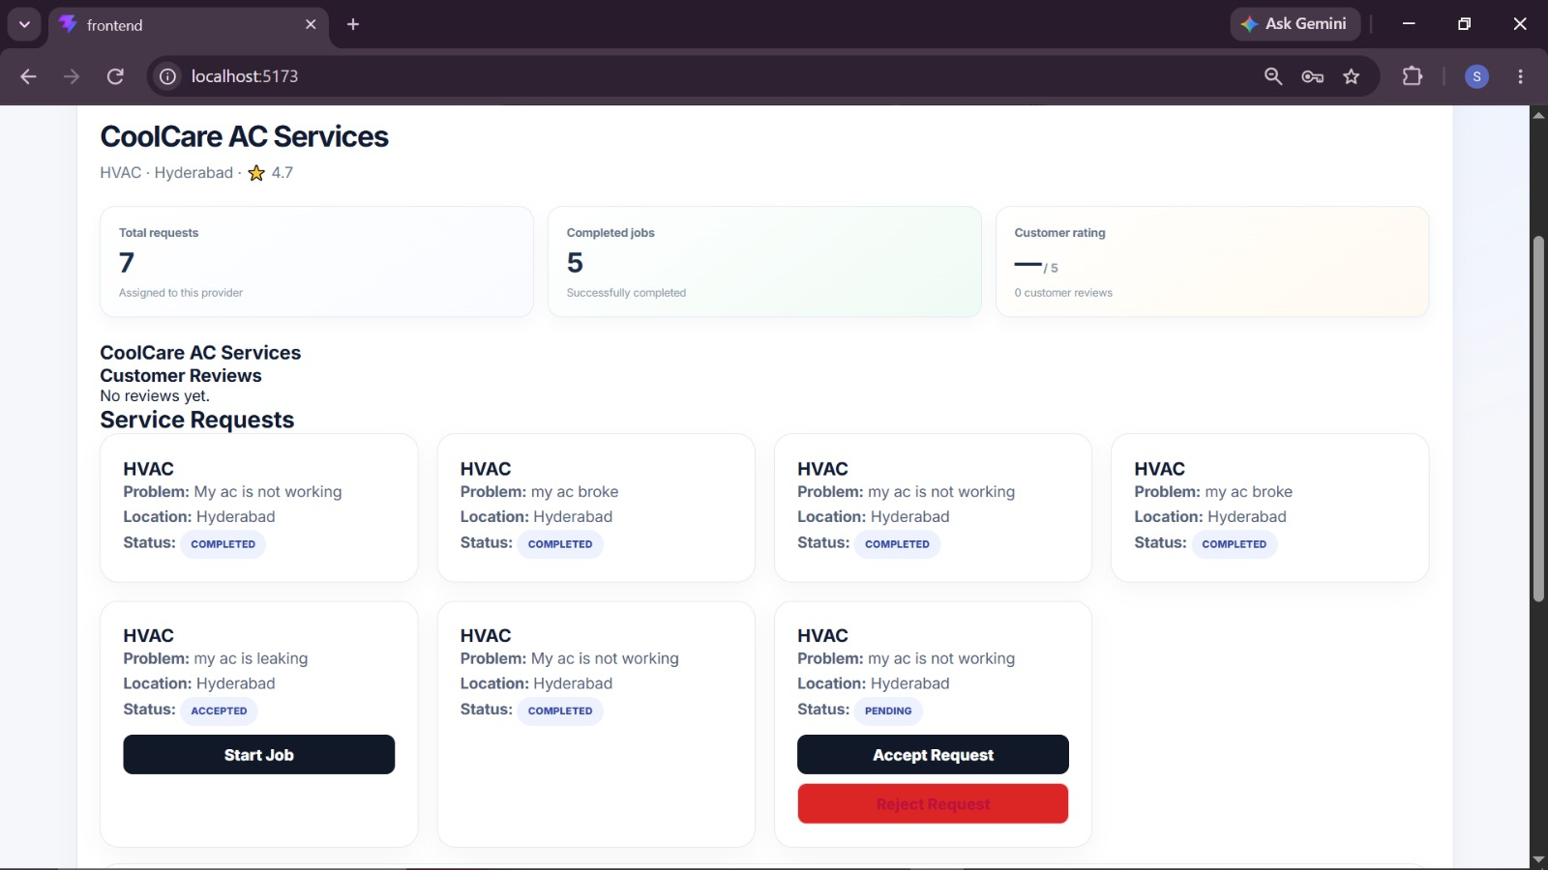
This page displays service requests assigned to a provider, including customer problems, locations, and request statuses. Providers can accept or reject requests and start jobs, helping them manage and track repair services efficiently.
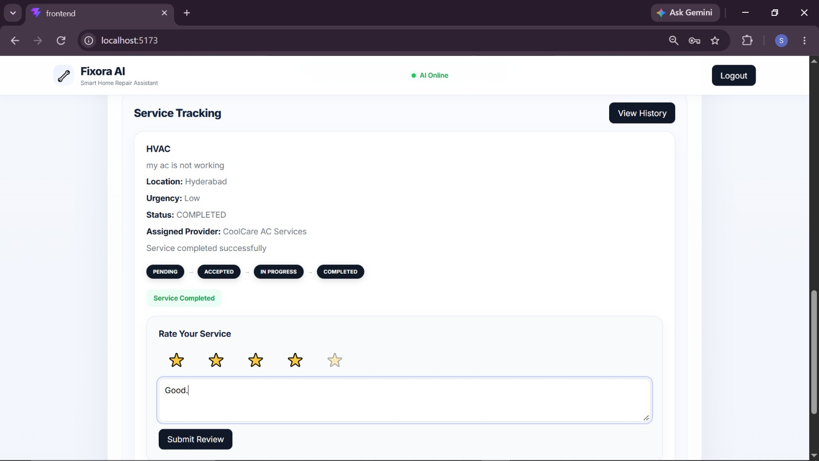
This page allows customers to rate completed home repair services and share feedback about their service providers. The ratings help other customers evaluate provider reliability and support better service quality.

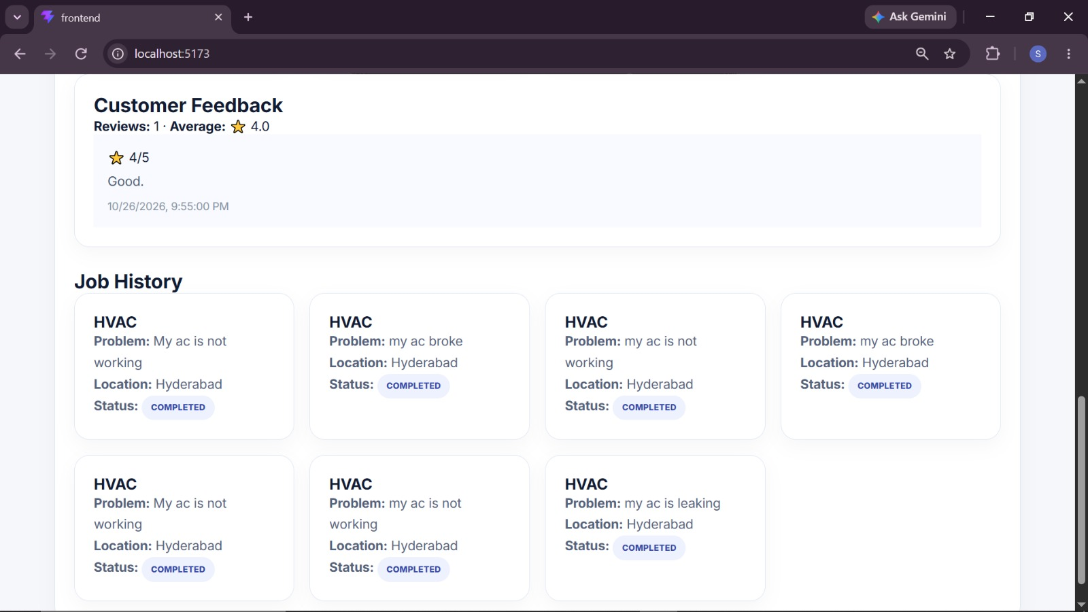
This page displays previously requested and completed home repair services, including service details and their current or final statuses. It helps customers review past bookings and track their service history for future reference.

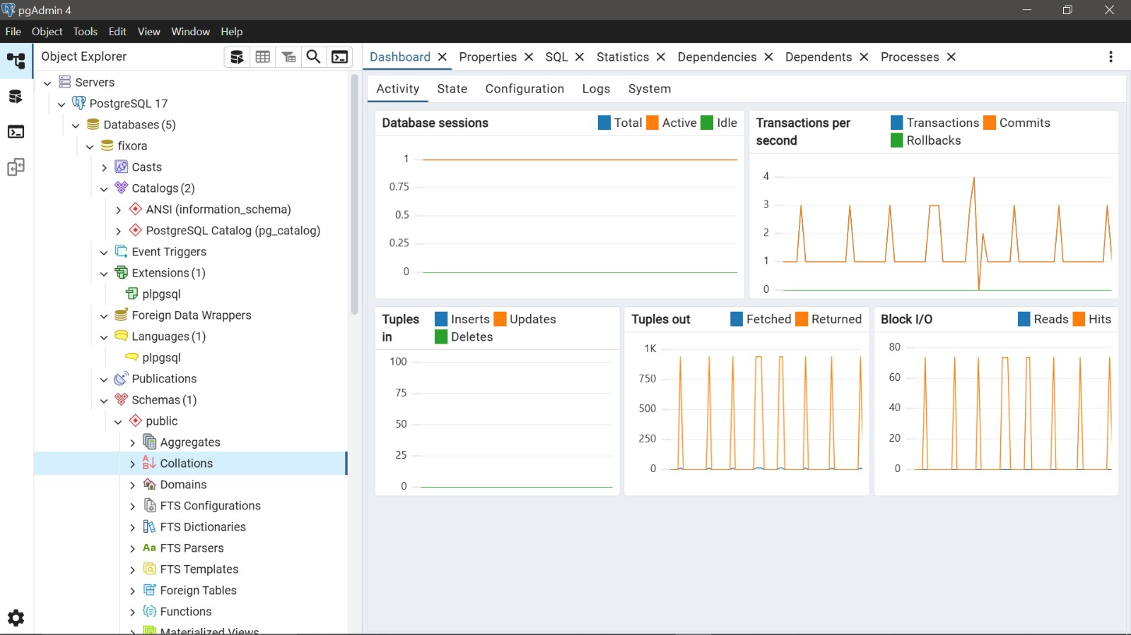
This section monitors database sessions and transactions per second to evaluate database activity and performance. It also tracks tuples inserted and deleted, along with block I/O operations, to analyze data modifications and disk read/write activity.
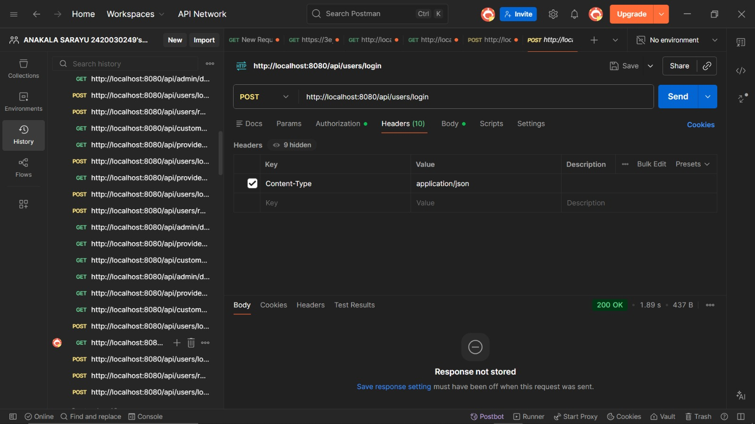
Postman is used to test the Fixora AI login API by sending user credentials and verifying the authentication response. It helps validate login functionality, error handling, and secure access to the application.

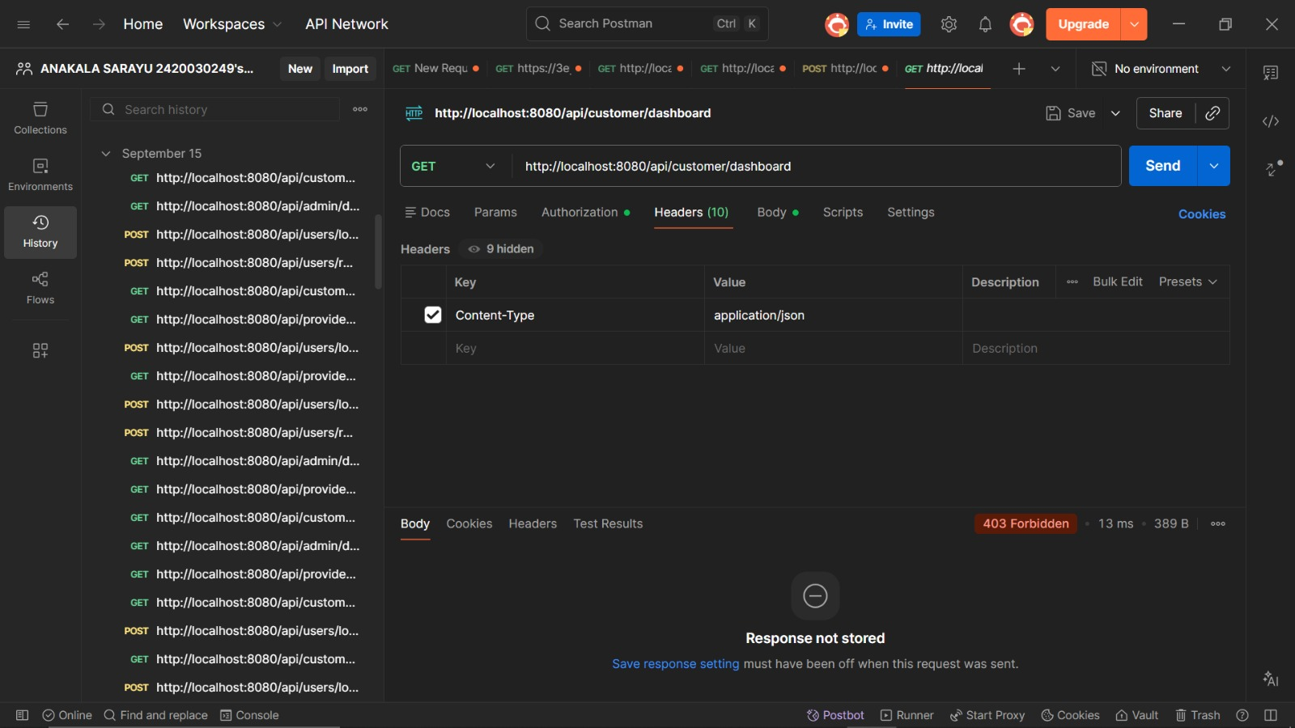
Postman is used to test the dashboard APIs and verify that the backend returns the correct service provider details, service requests, and dashboard data. It helps ensure reliable communication between the frontend and backend services.

- CONCLUSION & FUTURE SCOPE
Conclusion
Fixora AI is an intelligent home repair service discovery and coordination platform developed to simplify the process of identifying household repair problems and finding suitable service providers. The system uses Artificial Intelligence through Ollama and Large Language Models (LLMs) to understand user-described problems and recommend relevant service providers. By integrating React.js, Spring Boot, Spring Cloud, PostgreSQL, and Apache Kafka, the platform supports organized service request management and event-driven communication. Spring Security and JWT provide secure access, while Docker supports application deployment. Overall, Fixora AI aims to improve convenience, reduce the effort required to find suitable professionals, and make home repair service coordination more efficient and user-friendly.
Future Scope
1. Short-Term Enhancements
- Improve AI-based repair problem classification and provider recommendation accuracy.
- Add customer ratings, reviews, and provider verification.
- Enhance the user interface and provide clearer service status notifications.
2. Medium-Term Enhancements
- Integrate real-time provider availability and appointment scheduling.
- Add location-based provider recommendations using distance and service area.
- Implement online payments, quotation comparison, and digital invoices.
- Develop a mobile application for easier access to home repair services.
3. Long-Term Enhancements
- Integrate advanced AI models to support image-based repair problem identification using uploaded photographs.
- Develop predictive maintenance features to help users identify potential household issues early.
- Expand the platform to support multiple cities, additional service categories, and larger provider networks.
- Introduce AI-powered conversational assistance for troubleshooting, repair guidance, and personalized service recommendations.
These enhancements can help Fixora AI evolve into a more intelligent, scalable, and comprehensive home repair service platform.

- REFERENCES
- React.js Documentation: https://react.dev/
- Spring Boot Documentation: https://spring.io/projects/spring-boot
- Spring Cloud Documentation: https://spring.io/projects/spring-cloud
- Spring AI Documentation: https://docs.spring.io/spring-ai/reference/
- Ollama Documentation: https://docs.ollama.com/
- PostgreSQL Documentation: https://www.postgresql.org/docs/
- Apache Kafka Documentation: https://kafka.apache.org/documentation/
- Spring Security Documentation: https://spring.io/projects/spring-security
- Docker Documentation: https://docs.docker.com/
- JSON Web Tokens (JWT): https://jwt.io/introduction
- Urban Company – Home Service Platform: https://www.urbancompany.com/
- Angi – Home Improvement Services: https://www.angi.com/
- Taskrabbit – Home Services Platform: https://www.taskrabbit.com/
- Postman Documentation: https://learning.postman.com/docs/

