

Document Name: Sub-installer Functional Specification
Document Version: 1.10
Document Status: Under Review
Document Type: FS
Document Author: William Nguyen
Last Updated: Oct 17, 2011

NOTICE:
The materials contained herein are proprietary to Platform Computing and are presented in draft form for the purposes of your review and comment. By providing your comments and suggestions to Platform Computing, you acknowledge that the intellectual property rights in these materials and in your comments and suggestions regarding the materials shall vest in and remain the exclusive property of Platform Computing, for use by Platform Computing in its sole discretion and without attribution as to the source of any comments or suggestions received. These materials are not in a final form and are not intended to be relied upon by you and you specifically affirm that you will not rely on any statement contained in the materials as being a definitive position, opinion or statement of Platform Computing. The trademarks and registered trademarks contained herein are the property of their respective owners.

Platform Computing Confidential - No part of this document may be reproduced, copied or distributed
in any fashion without the express written permission of Platform Computing Corporation.
Detailed History of Changes
Error: Reference source not foundVersion | Date | Author | Description of Changes
1.0 | Dec 2, 2010 | William Nguyen | Prepared for Fujitsu review
1.1 | Dec 15, 2010 | William Nguyen | Updated based on Fujitsu’s feedback (Dec 14/10):  1.11 Update document to reflect Fujitsu's requirement of configuring installer and subinstallers in different subnets (sections: 3.2, 3.3, 4.3, 4.5, 7.1)  1.12 New ngedit enhancement to change CFM to send broadcast/multicast messages on installer/sub-installers (sections: 4.6, 6.5)  1.13 New ngedit enhancement to enable/disable DHCP on sub-installers (sections: 4.6, 6.5)
1.2 | Jan 5, 2011 | William Nguyen | Updated based on Fujitsu’s feedback (Dec 14, 16, 19 and 20/10):  1.21 Embed powerpoint diagrams in FS (3.2, 7.1)  1.22 DHCP server is auto-disabled on sub-installer if it has 1 NIC, and enabled if it has multiple NICs  (2.2, 3.3, 4.1, 4.3.3, 4.5.2, 4.6, 6.5, Appendix C)  1.23 Remove "-f" option from CLI examples (4.4)  1.24 Update kusu-cluster CLI summary view to show tier and node group (4.4.1)  1.25 Add "-g" option to kusu-cluster CLI to list node group info (4.4.4, 6.3)  1.27 Moved all details in section 5.1 to 5.4 into a separate Excel spreadsheet  1.28 Clarify that when a node is added to a custom network, addhost will accept DHCP requests on all provisioning interfaces on the installer/sub-installer node (4.3.1, 4.3.3)  1.29 Clarify that when adding nodes under sub-installer using addhost PXE listener, the sub-installer must be up and running (4.3.3)  1.211 Enhance netedit to output number of nodes in each network (4.2.4, 6.1)  1.212 Clarify broadcasting and multicasting cannot be enabled at same time for installer/sub-installer (4.6)  1.213 Update Use Case to show Two Network Tier + NFS Diskless case (as shown in slides) (7.1)  1.214 In Use Case, mention when we configure bonded network (7.1)  1.215 Update DNS/NTP behavior in hierarchical cluster based on changes in Corporate DNS/NTP FS (3.2, Appendix D)  1.217 In netedit CLI usage, fix typo. "-t" should be "-T" (6.1)  1.218 In cfmsync CLI usage, fix typo. "-m" should not require "=" sign. (6.4)  1.219 In cfmsync CLI usage, clarify "-P" option introduced by Package Group FS (6.4)  1.221 Change addhost to return error if user tries to add node on different network,and installer/subinstaller is using CFM broadcasting (Appendix E)  1.222 Change ngedit to return error if user tries to change installer/sub-installer to use CFM broadcasting when installer/sub-installer is managing nodes on different networks (4.6)  1.223 Add error messages for kusu-cluster command (Appendix E)  1.224 In netedit CLI usage, clarify “-S” and “-B” options are introduced by NIC Bonding FS (6.1)  1.225 Move details in section 4.5.1 into Appendix E.  1.226 Enhance cfmsync to make it easier to update and re-install nodes in a hierarchical cluster (4.5.3, 6.4)
1.3 | Jan 18, 2011 | William Nguyen | Updated based on Fujitsu’s feedback (Jan 13/11 and 14/11):  1.31 In 3.3 table, clarify that NICs are for provision networks.  1.32 In 4.1 “Provisioning Tasks” table, add a step to create new node group for both provisioning tasks.  1.33 In 4.3.2, explain difference between addhost “-i” and “-j” options.  1.34 In 4.3.4, clarify that “-p” cannot be used with MAC address file.  1.35 In 4.4.1, add “Num of Installers” to output  1.36 In 4.4.2, 3rd example, clarify that it is possible for a node group to contain nodes in different networks.  1.37 In 4.6, explain when to use broadcasting and multicasting, and mention ngedit TUI changes are in section 6.5.  1.38 In 7.1, add new use case step to configure broadcasting and multicasting.  1.39 In 4.5.3, list commands that could trigger automatic reboot of nodes.  1.311 In 6.3, add “-t” option to kusu-cluster CLI  1.312 In 6.3, 4.4.2 and 4.4.3, change “-p” to “-P” for kusu-cluster CLI  1.313 In 7.1, add kusu-cluster CLI sample output based for use case.  1.314 In 4.3.2, clarify that “-N” option and <custom networks> field can take public or private networks.  1.315 In 4.3.2, clarify that <IP> field only sets IP address of node’s provisioning interface. IP addresses for other interfaces are auto-assigned by addhost.  1.316 In 4.4.1, explain why compute nodes not listed in “Details” section.  1.317 In 4.4.1 and 7.1, change the “Details” section to list nodes by tier. This will help avoid confusion.  1.318 In 6.3, add kusu-cluster “-a” option to list all nodes
1.4 | Jan 20, 2011 | William Nguyen | Updated based on e-mail comments from Fujitsu (Jan 20/11):  1.41 Mention there is a Kusu bug that prevents user from importing arbitrary hostnames from MAC address file. (4.3.2, 4.3.3, Appendix G)  1.42 Add note to clarify how IP is automatically assigned to non-provisioning interfaces for a node imported from MAC address file. (4.3.2)
1.5 | Feb 2, 2011 | William Nguyen | Updated based on e-mail comments from Fujitsu (Jan 26/11 and 27/11):  1.51 In 4.5.2, indicate that rsync between subinstaller and its parent does not use SSH  1.52 In 3.3, explain why we disable DHCP on subinstaller nodes with 1 NIC.  1.53 In 3.3, clarify that a sub-installer multiple NICs connects to different networks.  1.54 In 3.3, clarify that NIC mention is for provision network.  1.55 In 4.2.1, clarify that network name is also auto-generated for non-ethernet devices  1.56 Add “kusu-“ prefix to these commands: netedit, addhost, cfmsync, ngedit, boothost and nghosts.  1.57 In 4.2.2, clarify that “increment” value can be customizable  1.58 In 4.2.3, clarify what “-c” and “-w” options are used for, and clarify how to check if network is in-use.  1.59 In 4.4.1 and 7.1, remove “Num of Sub-installers” from summary view.  1.511 In 4.4.2, mention that multiple subinstaller nodes can manage nodes from same node group which is already illustrated in slide 3.6 of subinstaller powerpoint slides.  1.512 In 4.4.4, mention that multiple subinstaller nodes can manage nodes from different node groups.  1.513 In 4.5.3, clarify that user can only use “kusu-boothost –r” to reset provision state of subinstaller and nodes under subinstaller to “Expired”. To re-install these nodes, use “kusu-cfmsync –r”.  1.514 In 6.1, provide description of “-q” option  1.515 In Appendix A, mention that all subinstaller node group properties can be changed.  Other changes based on other e-mail discussions:  1.516 In 4.3.2, explain that <IP> field in MAC address file can take multiple IP addresses.  1.517 In 4.3.2, explain that <hostname> field in MAC address file can accept *any* arbitrary hostname.  1.518 In 4.3.5 and 6.2, introduce new “-I” option to skip any hosts that couldn’t be imported from a MAC address file.  1.519 In 4.3.6, mention new MAC file syntax introduced by Subinstaller HA project.  1.521 Update 2.2, 4.1, 4.5.1, 4.6, 4.7, 6.5, 6.6 and 7.1 to explain that kusu-net-tool should be used to configure CFM broadcasting/multicasting on installer node, and kusu-ngedit should be used to configure CFM broadcasting/multicasting for sub-installer.  1.522 Remove confusing details from Appendix E, and add new details on how CFM works when broadcasting and multicasting is used.
1.6 | Feb 2, 2011 | William Nguyen | Small changes:  1.61 In 4.3.5, and 6.2, rename “-I” option to “-A”. The “-A” option will either import all hosts from MAC file, or none if error occurs.  1.62 In 4.3.2, clarify that networks specified in <custom networks> field of MAC address file must be an existing network that has been added to cluster using kusu-netedit.
1.7 | Mar 7, 2011 | William Nguyen | Small changes:  1.71 Incorporated the content from “Subinstaller questionaries.ppt” into Appendix G.  1.72 In section 4.3.1, add a table to show differences between NG-associated network, and custom network.
1.8 | July 18, 2011 | William Nguyen | 176565:  - In 4.2.2, 4.2.3, add “-e” option to make the kusu-netedit command example work properly  - In 4.2.3, add required options to make kusu-netedit “-c 123 –T NewTag” example work properly  - In 4.3.2, 4.3.3, 7.1: fix MAC address file specification, and example to include fields from other Fujitsu CE projects  - In 4.4.3, fix “-x” option for kusu-cluster example  - In 6.3, fix kusu-cluster “-x” option  - In 7.1, add “-e” and “-t” options to make kusu-netedit command example work properly  176301:  - In 6.5, update ngedit TUI screenshot  - In 7.1, change “Use Multicasting” to “Multicasting”  - In 7.1, change “Use Broadcasting” to “Broadcasting”  - In 7.1, change “Installer Services” to “CFM service”
1.9 | Sept 30, 2011 | William Nguyen | 177154: Add section 5.1 which describes user needs to sync subinstallers after creating new node group or package group.
1.10 | Oct 17, 2011 | William Nguyen | 181942: Updated based on Fujitsu’s review comments from 20111010:  - 4.3.2: Updated the description about how IP address is calculated for nodes added with kusu-addhost  - 4.4.1, 7.1: Correct the kusu-cluster output. It should show number of sub-installers (as originally specified in FS v1.3). Also explain what each node count under summary means.  - 4.5.2: Mention that rsync comes from RHEL OS  - 7.1: Add node group column to table  - Appendix E: Correct sentences which say “broadcast group” by changing it to “multicast group”

<!doctype html public "-//w3c//dtd html 4.0 transitional//en"><!doctype html public "-//w3c//dtd html 4.0 transitional//en">
Detailed History of Changes 2
1. Introduction 8
1.1 Purpose 8
1.2 Reviewers 8
2. Requirements 8
2.1 Context 8
2.2 Scope 8
3. System Description 9
3.1 System Overview 9
3.2 Cluster Layout 9
3.3 Comparison of Installer, Sub-Installer and Compute Nodes 10
4. Detailed Functional Description 11
4.1 Overview 11
4.2 New kusu-netedit operations 12
4.2.1 Auto-generate names when creating new network 12
4.2.2 Add multiple networks in one shot 13
4.2.3 Update/Delete multiple networks in one shot 13
4.2.4 View number of nodes in network 14
4.3 New kusu-addhost operations 14
4.3.1 Adding nodes to custom networks 14
4.3.2 Adding sub-installer nodes 15
4.3.3 Adding nodes under a sub-installer 18
4.3.4 Replacing MAC address for nodes under a sub-installer 19
4.3.5 Prevent import of nodes from MAC address file if errors occur 20
4.4 New kusu-cluster command 20
4.4.1 Provide summary view of cluster nodes 20
4.4.2 List a specific group of nodes 21
4.4.3 Executing remote commands on a specific group of nodes 22
4.4.4 List node groups under sub-installers 22
4.5 New kusu-cfmsync operations 23
4.5.1 Relay CFM messages from sub-installer nodes to nodes it manages 23
4.5.2 Updating Installer-specific files /directories on Sub-installer nodes 23
4.5.3 Updating nodes under sub-installer 24
4.6 New kusu-ngedit operations 26
4.7 New kusu-net-tool operations 27
5. Feature Interactions 27
5.1 Create new node groups and package groups 27
5.2 Other Interactions 27
6. Interface Changes 28
6.1 kusu-netedit CLI 28
6.2 kusu-addhost CLI 28
6.3 kusu-cluster CLI 29
6.4 kusu-cfmsync CLI 30
6.5 kusu-ngedit TUI changes 31
6.6 kusu-net-tool CLI changes 31
7. Use Cases 31
7.1 Use Case: Create a hierarchical cluster 32
Appendix A – Sub-Installer Node Group Configuration 36
Appendix B – Components 37
Appendix C – Services 37
Appendix D – Configuration Files 37
Appendix E – How CFM works in a hierarchical cluster 38
Appendix F – Error Messages and Conditions 38
Appendix G – Subinstaller questionaire 41

Introduction

Purpose
This is a Functional Specification covering the Sub-installer requirement as described in section 2.2.1 of the Fujitsu Exhibit A-2 document. This document also includes a Powerpoint supplement.

Reviewers
Reviewer’s Name | Company | Date Reviewed | Time Spent (in Days)
Leo Stutzmann | Platform | Dec 7, 2010 | 1

Requirements

Context
The purpose of the Sub-installer project is to allow the creation of a hierarchical cluster composed of smaller clusters. This allows the cluster to grow to tens of thousands of nodes.

Scope
Kusu will be enhanced to support the following features
Feature List | New/Updated Commands | New Cmd? | TUI | CLI
- Introduce new “Subinstaller” Node Group | kusu-ngedit | N | X
- Allow user to change CFM to send either broadcast or multicast messages from Installer nodes. | kusu-net-tool | N | - | X
- Allow user to change CFM to send either broadcast or multicast messages from Sub-installer nodes. | kusu-ngedit | N | X | -
- Auto-generate names when creating new network  - Add multiple networks in one shot  - Update/Delete multiple networks in one shot | kusu-netedit | N | - | X
- Add nodes to sub-installer node group  - Add nodes to custom networks  - Add nodes under an existing subinstaller | kusu-addhost | N | - | X
- Query nodes in a hierarchical cluster  - Execute commands on nodes in a hierarchical cluster | kusu-cluster | Y | - | X
- Relay CFM messages from sub-installer node to the nodes it manages.  - Updating installer-specific files on sub-installer node  - Updating nodes managed by sub-installer | kusu-cfmsync | N | - | X

The new features are supported on the following OS platforms.
OS Type | Version | Architecture
RHEL | 5.5 | x86_64
RHEL | 6.0 | x86_64

System Description

System Overview
For this project, there are three main components.
New Component | Description
Installer Node | Acts as the primary installer node.
Sub-Installer Node | Acts as a secondary installer node to offload the Installer Node.
Compute Node | Acts as nodes to run the user’s applications.

The basic idea for this project is:
- The user chooses a cluster layout that matches his requirements.
  - For small cluster, he builds his cluster using a flat layout.
  - For larger clusters, he builds his cluster using a hierarchical layout. He can combine flat and hierarchical layouts.
- For a flat layout, he builds the cluster as normal.
- For a hierarchical layout:
  - He provisions the Installer Node
  - He provisions one level of Sub-Installer Nodes
  - (Optional) He provisions another level of Sub-Installer Nodes
  - He provisions Compute Nodes under the Sub-Installer Nodes

Cluster Layout
With sub-installers, the user has the option to pick from one of 3 cluster layouts:
 | Cluster Layout | # Levels | Level 1  Nodes | Level 2 Nodes | Level 3  Nodes | Level 4 Nodes
1 | Flat Network | 2 | Installer Node | Compute Nodes
2 | 2 Network Tiers | 3 | Installer Node | Sub-Installer Nodes | Compute Nodes
3 | 2 Network Tiers + NFS Diskless | 4 | Installer Node | Sub-Installer Nodes | NFS Root Server | NFS Diskless Nodes

Cluster layouts #2 and #3 require special networking:

- The switches must be configured to relay all DHCP requests from the Sub-Installer subnets to the Installer node’s subnet.
- The switches must be configured to relay multicast messages from the Installer Node’s subnet to the Sub-Installer subnets.
- Layer 3 switches are needed.
  - Switches for subnets that require access to corporate DNS, NTP and NFS servers must be configured to connect to the subnets containing these corporate servers.
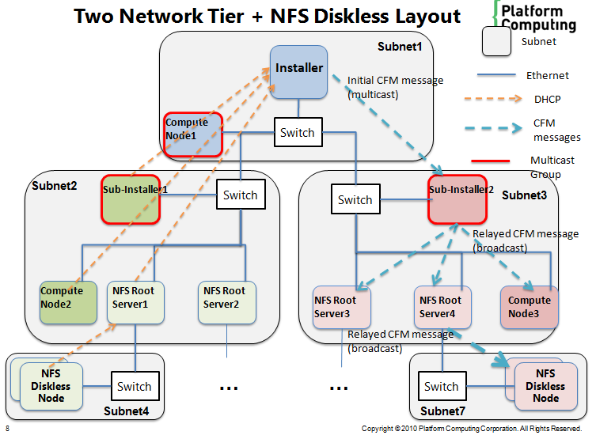

Comparison of Installer, Sub-Installer and Compute Nodes

Attributes | Installer Node | Sub-Installer Node | Compute Node
Managed by Kusu | Yes | Yes | Yes
Node Group Type | installer NG | sub-installer NG* | Any compute NG type
Admin Can Run Commands on Node | Yes | No | No
Stores Cluster Configuration | Yes | No | No
Minimum # of NICs (for provision networks) | 1 | 1 | 1
Node Types That Can Be Provisioned | Sub-installers  Compute Nodes | Sub-installers  Compute Nodes | N/A
Provisioning Services | DHCP, TFTP, and HTTP | DHCP**, TFTP, and HTTP. | N/A
Kusu Services | - | Runs cfmd to receive CFM updates from Parent Installer | Runs cfmd to receive CFM updates from Parent Installer

* A new sub-installer node group is created for this project (see Appendix A)
** DHCP server on sub-installer is automatically configured as follows:
- If Sub-installer has 1 provisioning NIC, DHCP server is auto-disabled on Sub-installer.
- If Sub-installer has 2 or more provisioning NICs, then DHCP server is enabled on Sub-Installer.
- When DHCP server is enabled, it is configured to listen for DHCP requests on all of the Sub-installer’s provisioning interfaces except for the interface used to provision the sub-installer node itself.
- For example, if Sub-installer has 2 provisioning NICs eth0 and eth1, and eth0 was used to provision the sub-installer, then DHCP server is enabled on eth1.
- Note that each provisioning NIC is connected to different networks.

Other Notes
- Kusu disables DHCP on a sub-installer with 1 provisioning NIC to avoid cases where multiple DHCP servers interfere with each other. The 2 cases are:
  - Parent installer and sub-installer are in the same subnet, and both are running DHCP server:
    - In this case, any DHCP requests sent on the subnet are received by both Parent installer and sub-installer node which leads to unpredictable results because we don’t know which server is going to receive the DHCP request first.
  - Parent installer and sub-installer are in different subnets, and both are running DHCP server. Furthermore, DHCP requests in sub-installer subnet are relayed to parent installer subnet.
    - In this case, if DHCP requests sent from sub-installer subnet are intended to go to parent installer subnet, they could be captured by sub-installer node before the parent installer receives it.

Detailed Functional Description

Overview

To manage a hierarchical cluster, we provide tools to perform some common tasks. Some tasks are complex and have multiple steps, requiring multiple Kusu commands. The next few sections describe the Kusu commands in greater detail. The use case section shows how these tools are used together.

Provisioning Tasks

Task | Steps | Kusu command used | New Features provided by Kusu command
Provision Sub-Installer | 1. Create sub-installer node group | kusu-ngedit (section 4.3) | - Create new sub-installer NG by copying an existing one
Provision Sub-Installer | 2. Configure CFM broadcast/multicast on installer node. | kusu-net-tool (section 4.7) | - Configure installer node to send CFM messages using broadcasting or multicasting.
Provision Sub-Installer | 3. Configure CFM broadcast/multicast on sub-installer node. | kusu-ngedit (section 4.6) | - Configure sub-installers to send CFM messages using broadcasting or multicasting.
Provision Sub-Installer | 4. Add Network | kusu-netedit  (section 4.2) | - Add multiple networks in one shot  - Auto-generate network names when creating new network
Provision Sub-Installer | 5. Add Sub-Installer node | kusu-addhost  (section 4.3) | - Add node to sub-installer node group  - Add node to custom networks
Provision Nodes under Sub-Installer | 1. Create compute node group | kusu-ngedit | - Create new compute node group by copying an existing one (this is not a new feature)
Provision Nodes under Sub-Installer | 2. Add Network | kusu-netedit  (section 4.2) | - Add multiple networks in one shot  - Auto-generate network names when creating new network
Provision Nodes under Sub-Installer | 3. Add Nodes under Sub-Installer | kusu-addhost  (section 4.3) | - Add node under existing sub-installer  - Add node to custom networks

Administrative Tasks

Task | Steps | Kusu command used | New Features provided by Kusu command
Query nodes in hierarchical cluster | - | kusu-cluster  (section 4.4) | - List summary of nodes in cluster  - List nodes and by Node Group, Package Group, Sub-Installer, or combination of these
Execute a command in hierarchical cluster | - | kusu-cluster  (section 4.4) | - Execute command on nodes, selecting them by Node Group, Package Group, Sub-Installer, or combination of these
Update nodes in a hierarchical cluster | 1. Change configuration of cluster nodes | Various Kusu commands are used to update cluster configuration. This is summarized in a separate Excel spreadsheet (section 5) | N/A
Update nodes in a hierarchical cluster | 2. Update cluster nodes | kusu-cfmsync  (section 4.5) | - Relay CFM messages from sub-installer node to the nodes it manages.  - Update installer-specific files on sub-installer node.  - Update nodes managed by sub-installer

New kusu-netedit operations

Auto-generate names when creating new network

Currently, a network created in Kusu does not have a name. For this project, we enhance kusu-netedit to auto-generate a name when a network is created.

The format of the auto-generated name is: <device>-<network IP>-<CIDR value>.

Example: if you created a network with device name eth0, network IP address of 192.168.56.0 and netmask 255.255.255.0, the auto-generated name is: eth0-192.168.56.0-24.

If a network’s device, network IP or netmask is changed, its name is updated to reflect the changes.

Example: In the last example, if the user changes the network IP to 192.168.57.0, the auto-generated name is automatically changed to eth0-192.168.57.0-24.

Note that kusu-netedit will auto-generate names for both ethernet and non-ethernet devices. For example, if an Infiniband network is used and device name is “ib0”, then auto-generated name will look something like: ib0-192.168.56.0-24.

Add multiple networks in one shot

Currently, users can only add one network at a time using kusu-netedit CLI. For this project, we enhance kusu-netedit CLI to create multiple networks in one shot.

Example: Create 5 networks with network IP starting from 192.168.56.0 to 192.168.60.0.
# kusu-netedit –a –n 192.168.56.0 –s 255.255.255.0 –i eth0 –t 192.168.56.2 –g 192.168.56.1 –x “-eth0” –y –N 5 –e test

This creates 5 networks with different IP addresses. Other non-IP address related attributes, such as device name, are the same for all 5 networks.
 | Network IP | Gateway IP | Starting IP
1 | 192.168.56.0 | 192.168.56.1 | 192.168.56.2
2 | 192.168.57.0 | 192.168.57.1 | 192.168.57.2
3 | 192.168.58.0 | 192.168.58.1 | 192.168.58.2
4 | 192.168.59.0 | 192.168.59.1 | 192.168.59.2
5 | 192.168.60.0 | 192.168.60.1 | 192.168.60.2

Each network’s set of IP addresses is derived by incrementing the network portion of the previous network’s IP addresses by 1. (Note: in this example, we used the default increment of 1. However, increment can be customized by user through kusu-netedit “-r” option.)

Update/Delete multiple networks in one shot

Currently, users can only edit or delete one network at a time using kusu-netedit CLI. For this project, we enhance kusu-netedit CLI to allow users to assign a tag to a network. The user can then edit or delete a group of networks with the same tag in one shot.

Example: Create 5 networks with network IP starting from 192.168.56.0 to 192.168.60.0, and assign it a tag called “Diskless”.
# kusu-netedit –a –n 192.168.56.0 –s 255.255.255.0 –i eth0 –t 192.168.56.2 –g 192.168.56.1 –x “-eth0” –y –N 5 –T Diskless –e test

Once networks are tagged, you can use the kusu-netedit CLI to list, edit or delete a group of networks with the same tag.

Operation | Details | Example
List Networks by tag | All networks matching the tag are listed. Output format is same as current format. | # kusu-netedit –l –T Diskless
Edit Networks by tag | All networks matching the tag are updated. These attributes can be changed: network options, public/provision flag, IP address increment, bonding options, and the tag itself. | # kusu-netedit –C Diskless –r 5
Delete Networks by tag | All networks matching the tag are deleted. | # kusu-netedit –D Diskless

It is possible to change or un-set the tag for a single network.

Example: Change tag for non in-use network with ID 123 to “NewTag”. (Note that “-c” option is used to modify a not-in-use network)
# kusu-netedit –c 123 –T NewTag –n 192.168.56.0 –s 255.255.255.0 –i eth0 –t 192.168.56.2 –g 192.168.56.1 –e test

NOTE: to use “-c” option, you must also specify –n, -s, -i, -t, -g and –e options. This behavior has always existed in Kusu, and hasn’t been changed for the subinstaller project.

Example: Change tag for in-use network with ID 123 to “NewTag”. (Note that “-w” option is used to modify an in-use network. Also note that you can check if network is in-use by using “-q” option, see 4.2.4).
# kusu-netedit –w 123 –T NewTag

Example: Unset the tag for non in-use network with ID 123.
# kusu-netedit –c 123 –T “”–n 192.168.56.0 –s 255.255.255.0 –i eth0 –t 192.168.56.2 –g 192.168.56.1 –e test

NOTE: to use “-c” option, you must also specify –n, -s, -i, -t, -g and –e options. This behavior has always existed in Kusu, and hasn’t been changed for the subinstaller project.

View number of nodes in network

The kusu-netedit CLI has been enhanced to show how many nodes are in each network. A network is “in-use” if number of nodes is > 0.

# kusu-netedit –q

Network ID Device Network Subnet Number of nodes
========== ====== ======= ====== ===============
1 eth0 192.168.56.0 255.255.255.0 10
2 eth0 192.168.57.0 255.255.255.0 10

New kusu-addhost operations

Adding nodes to custom networks

Currently, when nodes are added to a node group using kusu-addhost, the node is assigned IP addresses on the networks defined in the node group. In a large cluster with many sub-installers, there can be many networks because each sub-installer may be connected to a separate network.

One way to deal with this is to create a separate node group for each network, but this is too much work for the user. For this project, we enhance kusu-addhost to allow users to specify a different set of networks when adding nodes. In this way, we can use the same node group to add nodes that are on different networks.

The feature to add nodes to a custom network is mainly used when adding sub-installers and when adding nodes under sub-installers, so we describe the feature in greater detail in the next two sections.

The table below shows the differences between a NG-associated network and a custom network:

 | NG-associated network  (Current behavior in Kusu) | Custom network  (NEW behavior)
Created by netedit? | Yes | Yes
Associated with NG? | Yes, using ngedit. | No
When is the network associated with a node? | Associated to node when user adds node to NG using kusu-addhost. | Associated when user adds node to NG using kusu-addhost, and specifies a custom network.  The NG-associated network is ignored, and not associated with the node in any way.
After node is associated with the network, where does it get its IP address from? | Node is assigned IP address from NG-associated network. | Node is assigned IP from custom network, and not from the NG-associated network.
What happens when node is moved to a different NG? | (1) Node is associated with target NG’s network.  (2) Node is assigned IP address from target NG’s network. | (1) Node remains associated with its custom network.  (2) Node keeps the IP address assigned from the custom network.

Adding sub-installer nodes

To add a new sub-installer, a new node group is required. For this project, a default sub-installer node group is created. Details about this new node group are in the Appendix A.

The kusu-addhost CLI currently supports two methods to add hosts: PXE listener and import MAC address from external file. In the next table, we show how to add sub-installer nodes using both methods. New kusu-addhost changes are highlighted in red. For detailed CLI usage, see 6.2.

In the table below, some existing kusu-addhost options are mentioned. We explain them here to help the reader with the explanations:
- “-i” option: This option specifies the installer node’s provisioning interface (e.g., eth0). It is the interface used by the installer node to listen for DHCP requests from nodes that are provisioning.
- “-j” option: This option specifies the installing node’s provisioning interface (e.g., eth0). Installing nodes can be compute nodes, sub-installers, etc. It is the interface used to PXE boot the node. The installer node’s provisioning interface can be different from the installing node’s provisioning interface.

Method | Example | Explanation of New Changes
PXE listener | Add a new sub-installer node to the “subinstallerNG” node group and to the network with device eth0 and network IP of 192.168.57.0/24.  Steps:  # kusu-addhost –n subinstallerNG  –N eth0-192.168.57.0-24  -j eth0 | - A new “-N” option is added to kusu-addhost to allow user to associate a new node with a list of networks that is different from the networks defined in the target node group.  - The “-N” option requires specifying a list of comma-separated network names  e.g., eth0-192.168.57.0-24,eth1-192.168.58.0-24.  - The networks specified using “-N” option can include provision and public networks. At least one of the networks specified is a provision network.  - The “-N” option requires specifying node’s provisioning interface using “-j” option. This interface must match the device name of one of the provisioning networks specified in “-N” option.  For example, if “-j eth0” is specified, there must be a provisioning network defined in “-N” option with “eth0” device name.  - If “-N” option is used, the kusu-addhost command will accept DHCP requests on all provisioning interfaces on the installer node. This means that selection of provisioning interface through “-i” option or through TUI will be disabled if “-N” option is used.
Import from MAC address file | Add a new sub-installer node to the “subinstallerNG” node group and to the network with device eth0 and network IP of 192.168.57.0/24.  Steps:  (1) Create text file named MAC.txt with this line:  00:11:22:33:44:55,,,,,,eth0-192.168.57.0-24  (2) Import MAC addresses  # kusu-addhost –f MAC.txt –j eth0 –n subinstallerNG | (1) New fields added to MAC file  - The MAC address file format is updated to take a new <custom networks> field:  <MAC>,<IP>,<Hostname>,<UID>, <Extra ID>, <Disks>, <custom networks>  Note that the <Extra ID>, and <Disks> were introduced by other projects.  - <custom networks> is a list of semi colon-separated network names. It is an optional field.  e.g., eth0-192.168.57.0-24;eth1-192.168.58.0-24  - The networks specified in <custom networks> must be an existing network that has already been added to the cluster using kusu-netedit. The <custom networks> field can include provision and public networks. At least one of the networks in <custom networks> is a provision network.  - To specify which network in <custom networks> is the node’s provision network, the kusu-addhost “-j” option is used. Note that the MAC address specified in the MAC file corresponds to the node’s provision interface.  Example:  If a user runs “kusu-addhost –f MAC.txt –j eth0 -n subinstaller NG” using a MAC.txt containing this line:  00:11:22:33:44:55,,,,,,eth0-192.168.57.0-24;eth1-192.168.58.0-24  Then, the node’s “eth0” device is the provision interface. This device is connected to the “eth0-192.168.57.0-24” network. Furthermore, the MAC address of the “eth0” device is 00:11:22:33:44:55.  (2) Changes to existing fields in MAC file  a) Changes to <Hostname> field  - The <Hostname> field can take any arbitrary string for the hostname.  - If the <Hostname> field is not valid (e.g., in-use hostname), then kusu-addhost automatically generates the hostname using the target node group’s node name format.  b) Changes to <IP> field  - The <IP> field is also enhanced to take a list of semi colon-separated IP addresses.  e.g., 192.168.56.1;192.168.57.1  - If <custom networks> is specified in the MAC address file, the n-th address in <IP> corresponds to the n-th network in <custom networks>. The number of addresses in <IP> field must match the number of networks in <custom networks>.  Example:  <IP> = IPADDR_1; … ; IPADDR_N  <custom networks> = NETWORK_1; … ; NETWORK_N  IPADDR_1 corresponds to NETWORK_1  …  IPADDR_N corresponds to NETWORK_N  - If <custom networks> is not specified in the MAC address file, the n-th address in <IP> corresponds to the n-th network defined in the target node group specified with kusu-addhost “-n” option. The number of addresses in <IP> field must match the number of networks in defined in the target node group.  - Each IP address specified in <IP> must be a valid address on the corresponding network.  Example:  The configuration below is valid because all IP addresses in <IP> are valid addresses on the corresponding network.  <IP> = 192.168.56.1;192.168.57.1  <custom networks> = “eth0-192.168.56.0-24;eth1-192.168.57.0”.  Example:  This configuration below is not valid because 192.168.58.1 is not on the eth0-192.168.56.0-24 network.  <IP> = 192.168.58.1;192.168.57.1  <custom networks> = “eth0-192.168.56.0-24;eth1-192.168.57.0”.  ---  If the <IP> field contains incorrect IP addresses (e.g., out-of-range IPs, in-use IPs, etc), then all IP addresses in <IP> field are ignored, and kusu-addhost automatically generates IP addresses for each node’s interface.  If <IP> is not specified, then kusu-addhost automatically generates IP addresses for each node’s interface  Note: The IP address is calculated by taking the next available IP address from the interface’s network. Kusu searches for the next available IP by starting from the network’s “start IP”, and incrementing the IP by the “increment” value until it finds a free IP. The network’s “start IP” and “increment” value are configured through the kusu-netedit command.

This is the result of adding a sub-installer node using kusu-addhost command:
Method | Result
PXE listener | - Sub-installer node is added to the Kusu DB  - When Sub-installer node is powered on, it starts provisioning from the installer node.
Import from MAC address file | - Sub-installer node is added to the Kusu DB  - When Sub-installer node is powered on, it starts provisioning from the installer node.

Adding nodes under a sub-installer

To add a new node under an existing sub-installer node, the kusu-addhost command is used.

The kusu-addhost CLI currently supports two methods to add hosts: PXE listener and import MAC address from external file. In the next table, we show how to add nodes under an existing sub-installer node using both methods. New kusu-addhost changes are highlighted in red. For detailed CLI usage, see 6.2.

Method | Example | Explanation of New Changes
PXE listener | Add a new compute node under the “sub-installer00” node and to the network with device eth0 and network IP of 192.168.57.0/24.  Steps:  # kusu-addhost –n computeNG  -S sub-installer00  –N eth0-192.168.57.0-24  -j eth0 | - A new “-N” option is added to kusu-addhost to allow user to associate a new node with a list of networks that is different from the networks defined in the target node group. Details of this option are described in section 4.3.2.  - A new “-S” option is added to kusu-addhost to allow user to specify the node’s sub-installer.  - The sub-installer specified with “-S” option must be up and running or else kusu-addhost will return an error message.  - When “-S” option is used, the user is not allowed to specify a node group (-n option), or select one from the kusu-addhost TUI that is the same as the sub-installer’s node group.  - When “-S” option is used, the kusu-addhost PXE listener can run on the installer or sub-installer node depending on if DHCP server is enabled on sub-installer node:  - If DHCP server is enabled on sub-installer, then PXE listener runs on sub-installer node.  - If DHCP server is disabled on sub-installer, then PXE listener runs on installer node.
Import from MAC address file | Add a new compute node under the “sub-installer00” node and to the network with device eth0 and network IP of 192.168.57.0/24.  Steps:  (1) Create text file named MAC.txt with this line:  00:11:22:33:44:55,,,,,,eth0-192.168.57.0-24,sub-installer-00  (2) Import MAC addresses  # kusu-addhost –f MAC.txt –j eth0 –n computeNG | - The MAC address file format is updated to take a new <custom networks> field and <subinstaller> field:  <MAC>,<IP>,<Hostname>,<UID>, <Extra ID>, <Disks>, <custom networks>, <subinstaller>  Note that the <Extra ID>, and <Disks> were introduced by other projects.  - Details of the <custom networks> field are described in section 4.3.2.  - <subinstaller> field contains the name of an existing sub-installer node. It is an optional field. e.g., sub-installer-00  - The node group specified with “-n” option cannot be the same as the sub-installer’s node group.  - The sub-installer node does not need to be running when nodes are added to it using a MAC address file.

This is the result of adding a node under sub-installer using kusu-addhost command:

Method | Result
PXE listener | - Compute node is added to the Kusu DB  - When Compute node is powered on, it starts provisioning from its sub-installer node.
Import from MAC address file | - Compute node is added to the Kusu DB  - Sub-installer’s file update state is set to “Out-of-sync”. User must run “kusu-cfmsync –f” to synchronize sub-installer before compute node can start provisioning.

Replacing MAC address for nodes under a sub-installer

Currently, the user normally replaces the MAC address of a node by using the “kusu-addhost –p” command, which starts the PXE listener on the installer node to acquire the new MAC address of the node.

In this project, if the node being updated is managed by a sub-installer, then the PXE listener can run on the installer or sub-installer node depending on if DHCP server is enabled on sub-installer node:

- If DHCP server is enabled on sub-installer, then PXE listener runs on sub-installer node.
- If DHCP server is disabled on sub-installer, then PXE listener runs on installer node.

Note that the MAC address file cannot be used with “-p” option (This is the current Kusu behavior).

Prevent import of nodes from MAC address file if errors occur

Currently, when kusu-addhost imports nodes from a MAC address file and encounters an error importing one of the nodes (e.g., bad hostname, bad IP address, etc.), it will continue adding other nodes in the file.

However, some users may not want the behavior where either all hosts are imported from the MAC address file, or no hosts are imported if an error occurred during the import operation. To support this new behavior, a new kusu-addhost “-A” CLI option is introduced to either add all hosts, or add none when an error occurs. See section 6.2 for usage info.

    - Changes to MAC address file introduced by other Fujitsu projects

For the HA project, the <IP> address field in the MAC address file is enhanced to allow a user to input a heartbeat IP address and virtual IP address for a sub-installer node. More precisely, for each provision interface specified in <IP> field for a sub-installer node, the user must specify a heartbeat/virtual IP pair in place of a single IP address using this notation:

{Heartbeat IP, Virtual IP}

For more details, refer to the Subinstaller HA FS document.

New kusu-cluster command

The kusu-cluster command is introduced to this project to let you list and perform operations on a specific group of nodes.

Provide summary view of cluster nodes

In a large cluster, the user will want to know how many sub-installer and compute nodes are in his cluster. The new kusu-cluster CLI can output a summary view.

Example: List nodes for a cluster with 2 subinstallers, and 2 compute nodes under each subinstaller.
# kusu-cluster –l
Installer Node: master

Summary
=======
Num of Installers: 1
Num of Sub-installers: 2
Num of Compute Nodes: 4

Total Num of Nodes
(Installers + Sub-installers + Compute Nodes): 7

Details
=======
TIER NODES NODEGROUPS
1 1 InstallerNG
2 2 SubinstallerNG
3 4 ComputeNG

Meaning of node counts under Summary:
- Num of Installers = the number of installer nodes
- Num of Sub-installers = the number of sub-installer nodes including NFS root servers
- Num of Compute nodes = the number of compute nodes including NFS diskless nodes

List a specific group of nodes

In a large cluster, the user will want to list nodes that belong to certain groups. The new kusu-cluster CLI allows user to list nodes by subinstaller, node group, package group or any combination of those.

Example: List nodes managed by these sub-installer nodes: “subinstaller-00”, “subinstaller-01”
# kusu-cluster –l –s subinstaller-00,subinstaller-01

NODE INSTALLER NODE GROUP PACKAGE GROUP
node1 subinstaller-00 computeNG Dev
node2 subinstaller-00 computeNG QA
node3 subinstaller-01 computeNG Dev
node4 subinstaller-01 computeNG QA

Example: List nodes managed by these sub-installer nodes: “subinstaller-00”, “subinstaller-01”, and are also in the “computeNG” node group, and the “Dev” package group:
# kusu-cluster –l –s subinstaller-00,subinstaller-01 –n computeNG –P Dev

NODE INSTALLER NODE GROUP PACKAGE GROUP
node1 subinstaller-00 computeNG Dev
node3 subinstaller-01 computeNG Dev

Example: List additional details about nodes managed by these sub-installer nodes: “subinstaller-00”, “subinstaller-01”. In this example, we also show that one node group (computeNG) can contain nodes in different networks.
# kusu-cluster –l –s subinstaller-00,subinstaller-01 –d

NODE INSTALLER NODE GROUP PACKAGE GROUP NETWORKS
node1 subinstaller-00 computeNG Dev eth0-192.168.56.0-24
node2 subinstaller-00 computeNG QA eth0-192.168.56.0-24
node3 subinstaller-01 computeNG Dev eth0-192.168.57.0-24
node4 subinstaller-01 computeNG QA eth0-192.168.57.0-24

Example: List nodes that belong to network with name “eth0-192.168.56.0-24”
# kusu-cluster –l –N eth0-192.168.56.0-24 -d

NODE INSTALLER NODE GROUP PACKAGE GROUP NETWORKS
node1 subinstaller-00 computeNG Dev eth0-192.168.56.0-24
node2 subinstaller-00 computeNG Dev eth0-192.168.56.0-24

Note that in the previous 4 examples, you can see that multiple subinstaller nodes can manage nodes from the same node groups. This relationship is illustrated in slide 3.6 of the subinstaller powerpoint slides.

Executing remote commands on a specific group of nodes

In a large cluster, the user will want to execute a remote command on a specific group of nodes. The user can currently do this with the pdsh command, but the user must manually create a host list and pass it to pdsh, which is inconvenient when the user wants to operate on a large number of nodes.

The kusu-cluster CLI allows a user to execute remote commands on nodes belonging to a specific subinstaller, node group, package group, or any combination of those.

Example: Reboot all nodes managed by these sub-installer nodes: “subinstaller-00”, “subinstaller-01”:
# kusu-cluster –x /sbin/reboot –s subinstaller-00,subinstaller-01

Example: Reboot all nodes managed by these sub-installer nodes: “subinstaller-00”, “subinstaller-01”, and are also in the “computeNG” node group, and the “Dev” package group:

# kusu-cluster –x /sbin/reboot –s subinstaller-00,subinstaller-01 –n computeNG –P Dev

List node groups under sub-installers

The kusu-cluster CLI also allows users to display node group information for each installer or sub-installer node.

Example: For each installer or sub-installer node, show the node groups that contain nodes under those installer or sub-installer nodes.
# kusu-cluster –g

INSTALLER NODE GROUP NODES
master subinstallerNG 2
subinstaller-00 computeNG1 1
computeNG2 1
subinstaller-01 computeNG1 1
computeNG2 1

Example: For a specific sub-installer node, show the node groups that contain nodes under that sub-installer node.
# kusu-cluster –g –s subinstaller-00

INSTALLER NODE GROUP NODES
subinstaller-00 computeNG1 1
computeNG2 1

Note that in the previous 2 examples, you can see that multiple subinstaller nodes can manage nodes from two different node groups.

New kusu-cfmsync operations

Relay CFM messages from sub-installer nodes to nodes it manages

In the current version of Kusu, when user currently runs kusu-cfmsync command on the Installer node, the command sends a CFM message to all nodes connected to the Installer Node.

In a hierarchical cluster, this CFM messaging works differently:
- Installer node sends CFM message to sub-installers
- Sub-installers process the CFM message, and relay it to the nodes that it manages.

More details about how CFM works in a hierarchical cluster is described in Appendix E.

The user can also customize whether CFM sends messages using broadcasting or multicasting (for configuring CFM on installer node, see section 4.7, for configuring CFM on sub-installer, see section 4.6).

Updating Installer-specific files /directories on Sub-installer nodes

The installer node requires specific files/directories to provision or update nodes in the cluster. They include:
- DHCP config file
- PXE config files
- PXE image files
- Kit files
- Repository files

In this doc, we call these installer-specific files/directories.

In order for the sub-installer to provision or update nodes in the cluster, it keeps its own copy of these installer-specific files/directories, which need to be synchronized against the parent installer’s master copy.

To synchronize these installer-specific files/directories on sub-installer nodes, we enhance the CFM file update operation (kusu-cfmsync –f) to do this synchronization.

After running “kusu-cfmsync –f”, CFM synchronizes these files/directories on the sub-installer node:
File / Directory Type | Location | Action
DHCP * | /etc/dhcpd.conf | Refreshes DHCP config to include latest set of nodes managed by sub-installer. Restarts DHCP service.
PXE config files | /tftpboot/kusu/pxelinux.cfg/* | Refreshes PXE config files for latest set of nodes managed by sub-installer.
PXE images | /tftpboot/kusu  /depot/images  /opt/kusu/lib/nodeinstaller/rhel | Synchronizes latest kernel, initrd and disk images from parent installer.
Kit files | /depot/kits  /depot/www  /opt/kusu/lib/plugins | Synchronizes latest kit files from parent installer.
Repository files | /depot/contrib  /depot/repos | Synchronizes latest repository files from parent installer.

* Note that the DHCP config only needs to be updated if DHCP server is enabled on sub-installer node (see section 3.3).

Kusu commands that modify the installer-specific files/directories on the Installer node will also be enhanced to set the “file update state” of sub-installer nodes to “Out-of-sync”. To update the sub-installer nodes, the user runs “kusu-cfmsync –f” on the Installer node. The full list of commands that modify installer-specific files is mentioned in a separate Excel spreadsheet (see section 5).

Note about synchronization:
- Each sub-installer synchronizes with its parent installer over rsync. The rsync comes from the RHEL OS.
- The rsync communication does not use SSH. Instead the sub-installer node synchronizes its directories by connecting to an rsync server running on the parent installer.

Updating nodes under sub-installer

In the current version of Kusu, which uses a flat cluster layout, the user runs kusu-cfmsync to update the cluster nodes. The nodes always update or re-install from the installer node.
However, in a hierarchical cluster layout, updating and re-installing nodes is more complex:
- Some cluster nodes update or re-install from the installer node
- Some cluster nodes update or re-install from a sub-installer node.

This section talks about how to handle cluster nodes that update or re-install from a sub-installer node.

After configuration changes (e.g., changing packages, etc.) are made to nodes managed by a sub-installer:
- The nodes managed by sub-installer require updating or re-installing.
- Also, the sub-installer node may require updating, as some of its installer-specific files/directories (e.g., PXE config files, etc.) need to be updated before it can be used to update or re-install the nodes that it manages.

So, we need some way of updating the installer-specific files on sub-installer nodes before updating or reinstalling the nodes managed by the sub-installer.

For this project, the kusu-cfmsync CLI is enhanced to handle update and reinstall of nodes managed by a sub-installer. See 6.4 for detailed CLI usage.

To update nodes managed by a sub-installer, the existing kusu-cfmsync update operations (represented by the -f, -p, -u options) are enhanced to do the following:
- For nodes managed by installer node, run the update operation(s) as per the current behavior.
- For nodes managed by a sub-installer:
  - Update sub-installers first, before running the update operation(s) on the nodes managed by the sub-installer.
Notes:
- The kusu-cfmsync CLI provides options to update nodes by sub-installer, nodegroup, package group, or any combination of these.

Example: Update user packages on all nodes in cluster
# kusu-cfmsync –p

Example: Update user packages on nodes “compute-00” and “compute-01”
# kusu-cfmsync –p –m compute-00,compute-01

Example: Update user packages on nodes in node group “computeNG”, which are managed by sub-installers “subinstaller-00” and “subinstaller-01”
# kusu-cfmsync –p –n computeNG –s subinstaller-00,subinstaller-01

Example: Update user packages on all nodes which are descendant nodes of sub-installer “subinstaller-00”
# kusu-cfmsync –p –s subinstaller-00 –d

The descendant nodes of a sub-installer are any nodes that are below the sub-installer in the cluster hierarchy. For example, say sub-installer-00 manages sub-installer-01, and sub-installer-01 manages compute-00. The descendant nodes of sub-installer-00 are: sub-installer-01 and compute-00.

Example: Update user packages on all nodes which are of node group type “subinstaller”
# kusu-cfmsync –p –t subinstaller

----

To re-install nodes managed by a sub-installer, a new reinstall operation is added to the kusu-cfmsync CLI. This operation is represented by the new “-r” option. This new operation does the following:
- For nodes managed by installer node, reboot the node to trigger re-installation.
- For nodes managed by sub-installer:
  - Update sub-installers first, before rebooting the nodes managed by the sub-installer. Rebooting triggers the re-installation.
Notes:
- Unlike the current kusu-cfmsync update operations (-f, -p, -u), this operation performs no action on the Installer node.
- The kusu-cfmsync provides options to re-install nodes by sub-installer, nodegroup, package group, or any combination of these.

Example: Reinstall the nodes “compute-00” and “compute-01”
# kusu-cfmsync –r –m compute-00,compute-01

Example: Reinstall all nodes in “computeNG” node group regardless of what sub-installer node is managing the nodes.
# kusu-cfmsync –r –n computeNG

Example: Reinstall all nodes in “computeNG” node group, which are managed by sub-installers “subinstaller-00” and “subinstaller-01”.
# kusu-cfmsync –r –n computeNG –s subinstaller-00,subinstaller-01

Note:
- When “kusu-boothost –r” or kusu-nghosts command is executed on sub-installer or nodes managed by sub-installers, the provision state of those nodes is set to “Expired” but the nodes are not rebooted to trigger reinstallation. To re-install these nodes, use “kusu-cfmsync –r” command instead.
- See the operation matrix spreadsheet for more details.

New kusu-ngedit operations

For the sub-installer node group, a new screen is added to the kusu-ngedit TUI to allow users to configure how sub-installer node sends CFM messages: using broadcasting (default), or multicasting.

For kusu-ngedit TUI interface changes, refer to section 6.5.

How to decide if sub-installer node should send CFM messages using broadcasting or multicasting:
- Use broadcasting if sub-installer node and the nodes it manages are in the same network
- Use multicasting if sub-installer node and the nodes it manages are in different networks

New kusu-net-tool operations
A new “cfm” sub-command is added to the kusu-net-tool CLI to allow users to configure how installer node sends CFM messages: using broadcasting (default), or multicasting.

For kusu-net-tool CLI changes, refer to section 6.6.

The supported operations are:

- View current CFM configuration on installer node
# kusu-net-tool cfm info

CFM communication: broadcasting

- Change CFM communication method to broadcasting:
# kusu-net-tool cfm set broadcast

- Change CFM communication method to multicasting:
# kusu-net-tool cfm set multicast

How to decide if installer node should send CFM messages using broadcasting or multicasting:
- Use broadcasting if installer node and the nodes it manages are in the same network
- Use multicasting if installer node and the nodes it manages are in different networks

Feature Interactions

Create new node groups and package groups
If user creates new node groups or package groups after a subinstaller is provisioned, the user must execute the kusu-cfmsync command to sync up these subinstallers with the installer:

kusu-cfmsync –fpu –s <subinstaller name> -d

Other Interactions

The behavior of Kusu operations performed on different types of nodes in a hierarchical cluster is documented in a separate spreadsheet named “fujitsu_ce_subinstaller_fs_operation_matrix.xlsx”

Interface Changes

kusu-netedit CLI

Five new options are added to the kusu-netedit CLI (-q, -T, -N, -C and –D):
usage: kusu-netedit [-hvq]
[-l [-T tag]]
[-d netid#]

[-a -n network -s subnet -i ifname -t start_ipaddr [-g gateway] -e {network description} -x suffix [-o {network options}] [-y | -z] [-r increment] [-S {slave list}] [-B {bonding options}] [-N {num networks}] [-T tag]]

[-c netid# -n network -s subnet -i ifname -t start_ipaddr -g gateway -e {network description} [-x suffix] [-o {network options}] [-y | -z] [-r increment] [-S {slave list}] [-B {bonding options}] [-T tag]]

[-w netid# [-o network options] [-y | -z] [-t start_ipaddr] [-e {network description}] [-r increment] [-S {slave list}] [-B {bonding options}][-T tag]]

[-C tag [-o network options] [-y | -z] [-r increment] [-S {slave list}]
[-B {bonding options}] [–T tag]]
[-D tag]

Options:
...
-q, --list-nodes List the number of nodes for each network.
-N NUMBER, --networks=NUMBER
Number of consecutive networks to create starting from the
specified network IP and netmask.
-T TAG, --tags=TAG Tag for grouping nodes
-C TAG, --change-by-tag=TAG
Change attributes for a group of networks matching given tag
-D TAG, --delete-by-tag=TAG
Delete a group of networks matching given tag

Notes:
- The “-S” and “-B” options were introduced by NIC Bonding FS.

kusu-addhost CLI
Three new options are added to the kusu-addhost CLI (-N, -S, -A):
Usage: kusu-addhost [-hvub]
[-n {node group} [-g {package group}] [-x {ip_addr}]
[-N {custom networks} –j ifname] [-S {subinstaller}]
[-r rack#]
[-N {custom networks} –j ifname] [-S {subinstaller}]
[-i ifname -n {node group} [-g {package group}] [-r rack #]
[-N {custom networks} –j ifname] [-S {subinstaller}]
[-f file -j ifname -n {node group} [-r rack#] [-A]]
[-p hostname]
[-e {nodes_to_remove}]
[-s static_hostname -x ip_addr]
[-s static_hostname -i ifname]
[-c rank#]
[-N {custom networks} –j ifname] [-S {subinstaller}]

options:
-N CUSTOM_NETWORKS,--custom-net=CUSTOM_NETWORKS
A comma-separated list of custom network names
-S SUBINSTALLER,--subinstaller=SUBINSTALLER
Name of Installer or Sub-installer node
-A, --all-or-nothing
Do not import ANY nodes from the MAC address file if an error
occurred during the import operation.

kusu-cluster CLI
A new kusu-cluster CLI is added for this project.

Description | Performs queries and executes commands on nodes in the cluster.
Interface Type | CLI
Runs On | Installer Node
Must run as root | Yes
Only one instance can run at a time | Yes
Log file location | /var/log/kusu/kusu-cluster.log

Usage: kusu-cluster [-hv]
-l [-d] {-a |
-m nodes |
-t ngtype |
[-s subinstallers]
[-n nodegroup [-P pkggroup]]
[-N network] }

-x cmdline {-m nodes |
-t ngtype |
[-s subinstallers]
[-n nodegroup [-P pkggroup]] }

-g [-s subinstallers]

options:
-h, --help Show this help message and exit
-v, --version Display version of tool
-m, --nodes Operate on specified list of hosts
-t NGTYPE, --ngtype=NGTYPE
Operate on nodes with the specified node group type
For list of types, run “kusu-ngedit –l”. All types are
supported except for “other” and “installer”.
-l, --list List nodes
-d, --details List additional node details
-a, --all List all nodes
-x EXECUTE, --execute=EXECUTE
Executes the remote command on nodes
-g, --nginfo List node group info
-s SUBINSTALLERS, --subinstaller=SUBINSTALLERS
Nodes that are managed by the specified sub-installers
are selected for the operation. A comma-separated list is
required.
-n NODEGROUP, --nodegroup=NODEGROUP
Nodes that are in the specified node group are selected
for the operation. A Node Group name is required.
-P PKGGROUP, --pkggroup=PKGGROUP
Nodes that are in the specified package group are selected
for the operation. A Package Group name is required.
-N NETWORK, --network=NETWORK
Nodes that are associated with the specified network
are selected for the operation. A Network name is
required.

kusu-cfmsync CLI

Five new options are added to the kusu-cfmsync CLI (-m, -t, -s, -d, -r):
Usage: kusu-cfmsync [-hv]
{-f | –p |–u } [ -m nodes |
-t ngtype |
[-s subinstallers [-d]]
[–n node_group [–P pkg_group]] ]
-r { -m nodes |
[-s subinstallers] [–n node_group [–P pkg_group]] }

options:
-m NODES, --nodelist=NODES Specifies the nodes that will run the specified
CFM operation. A comma-delimited list is required.
-t NGTYPE, --ngtype=NGTYPE Nodes with this node group type will run the
specified CFM operation. For list of types, run
“kusu-ngedit –l”. All types are supported except for
“other” and “installer”.
-s SUBINSTALLERS, --subinstaller=SUBINSTALLERS
Nodes that are managed by the specified sub-
installers will run the specified CFM operation.
-d, --descendants Nodes that are descendants of the sub-installers
specified with “-s” option will run the specified
CFM operation.
-n NODEGROUP, --nodegroup=NODEGROUP
Nodes that are in the specified node group will
run the specified CFM operation.
-P PKGGROUP, --pkggroup=PKGGROUP
Nodes that are in the specified package group will
run the specified CFM operation.
-r, --reinstall Signal the node to reboot itself to trigger
re-installation.

Notes:
- The “-P” option was introduced by Package Group FS.

kusu-ngedit TUI changes

A new screen is added for installer and sub-installer node groups to configure CFM service:
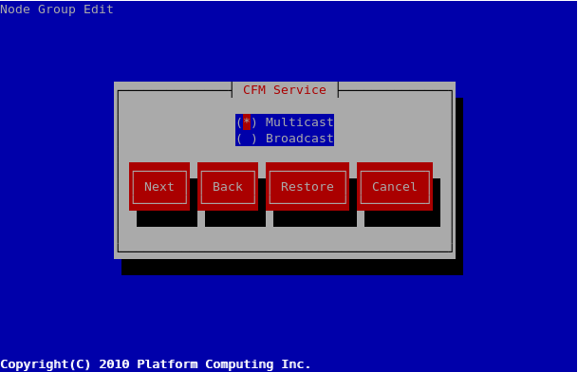

Screen Details:
- Broadcasting is enabled by default.
- The user cannot enable both broadcasting and multicasting at the same time.
- The user cannot change the CFM broadcasting/multicasting option when the node group has one or more nodes in it.

kusu-net-tool CLI changes

A new “cfm” sub-command is added to the kusu-net-tool CLI:

usage: kusu-net-tool cfm <action> [options]

options:
-h, --help show this help message and exit

actions:

info Display current CFM settings
set <broadcast|multicast> Change CFM to send messages using broadcasting
or multicasting

Use Cases

Use Case: Create a hierarchical cluster

Summary
This use case shows how to create a cluster using a 2 network tier + NFS Diskless layout.

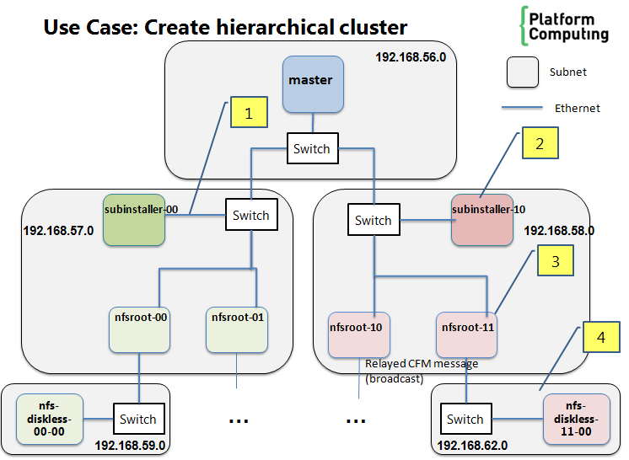

When the cluster is built, it will consist of the following hosts:
Host | Tier | Type | Node Group | Parent Installer | Network Configuration
 |  |  |  |  | eth0 | eth1 | Default gateway
master | 1 | Installer Node | installerNG | N/A | 192.168.56.0 /24
subinstaller-00 | 2 | Sub-installer Node | subinstallerNG | master | 192.168.57.0 /24 |  | 192.168.57.1
subinstaller-10 | 2 | Sub-installer Node | subinstallerNG | master | 192.168.58.0 /24 |  | 192.168.58.1
nfsroot-00 | 3 | NFS Root Server | nfsrootNG | subinstaller-00 | 192.168.57.0/24 | 192.168.59.0/24 | 192.168.57.1
nfsroot-01 | 3 | NFS Root Server | nfsrootNG | subinstaller-00 | 192.168.57.0/24 | 192.168.60.0/24 | 192.168.57.1
nfsroot-10 | 3 | NFS Root Server | nfsrootNG | subinstaller-01 | 192.168.58.0/24 | 192.168.61.0/24 | 192.168.58.1
nfsroot-11 | 3 | NFS Root Server | nfsrootNG | subinstaller-01 | 192.168.58.0/24 | 192.168.62.0/24 | 192.168.58.1
nfs-diskless-00-00 | 4 | NFS Diskless Node | nfsdisklessNG | nfsroot-00 | 192.168.59.0/24
nfs-diskless-01-00 | 4 | NFS Diskless Node | nfsdisklessNG | nfsroot-01 | 192.168.60.0/24
nfs-diskless-10-00 | 4 | NFS Diskless Node | nfsdisklessNG | nfsroot-10 | 192.168.61.0/24
nfs-diskless-11-00 | 4 | NFS Diskless Node | nfsdisklessNG | nfsroot-11 | 192.168.62.0/24

Furthermore, the CFM is configured as follows:
- Installer Node sends CFM messages using multicasting.
- Sub-installer Nodes send CFM messages using multicasting.
- NFS Root Servers send CFM messages using broadcasting.

We assume the “master” is already provisioned, and user is logged into it as “root” user. We also assume the Kusu cluster has:
- These 4 node groups already created:
- installerNG (for configuring installer node)
- subinstallerNG (to provision sub-installer nodes)
- nfsrootNG (to provision NFS root servers)
- nfsdisklessNG (to provision NFS diskless nodes)
- These networks already created:
- eth0-192.168.56.0-24

Steps
- Configure CFM on installer, subinstaller and NFS Root Servers.
  - For installer:
    - Run “kusu-net-tool cfm set multicast”
  - For subinstaller:
    - Run “kusu-ngedit”, edit “subinstallerNG”
    - Go to “CFM service” screen and select “Multicasting”
    - Save node group changes.
  - For NFS Root Server:
    - Run “kusu-ngedit”, edit “nfsrootNG”
    - Go to “CFM service” screen and select “Broadcasting”
    - Save node group changes.

- Create the Networks
  - Create the networks for 192.168.57.0/24 to 192.168.62.0/24 for eth0
# kusu-netedit –a –n 192.168.57.0 –s 255.255.255.0 –i eth0 –g
192.168.57.1 –x “-eth0” –y –N 6 –t 192.168.57.2 –e test

The auto-generated network names are:
    - eth0-192.168.57.0-24
    - eth0-192.168.58.0-24
    - eth0-192.168.59.0-24
    - eth0-192.168.60.0-24
    - eth0-192.168.61.0-24
    - eth0-192.168.62.0-24

  - Create the networks for 192.168.59.0/24 to 192.168.62.0/24 for eth1
# kusu-netedit –a –n 192.168.59.0 –s 255.255.255.0 –i eth1 –g 192.168.59.1 –x “-eth1” –y –N 4 –t 192.168.59.2 –e test

The auto-generated network names are:
    - eth1-192.168.59.0-24
    - eth1-192.168.60.0-24
    - eth1-192.168.61.0-24
    - eth1-192.168.62.0-24

Note: to add bonded networks, you would run the kusu-netedit commands above with these changes:
- Instead of “eth0” and “eth1”, use “bond0” and “bond1”
- Specify bonded slaves using “-S” option
- Specify bonded options using “-B” option

- Add Sub-installer Nodes
  - Create a MAC address file (mac.txt) containing the MAC addresses and networks for sub-installer nodes:
00:11:22:33:11:00,,subinstaller-00,,,,eth0-192.168.57.0-24
00:11:22:33:11:01,,subinstaller-01,,,,eth0-192.168.58.0-24

  - Import the sub-installer nodes:
# kusu-addhost –f mac.txt –n subinstallerNG –j eth0

- Add NFS Root Servers
  - Create a MAC address file (mac.txt) containing the MAC addresses and networks for NFS Root servers:
00:11:22:33:22:00,,nfsroot-00,,,,eth0-192.168.57.0-24;eth1-192.168.59.0-24,subinstaller-00
00:11:22:33:22:01,,nfsroot-01,,,,eth0-192.168.57.0-24;eth1-192.168.60.0-24,subinstaller-00
00:11:22:33:22:01,,nfsroot-10,,,,eth0-192.168.58.0-24;eth1-192.168.61.0-24,subinstaller-01
00:11:22:33:22:01,,nfsroot-11,,,,eth0-192.168.58.0-24;eth1-192.168.62.0-24,subinstaller-01

  - Import the sub-installer nodes:
# kusu-addhost –f mac.txt –n nfsrootNG –j eth0

- Add NFS Diskless Nodes
  - Create a MAC address file (mac.txt) containing the MAC addresses and networks for NFS Diskless Nodes:
00:11:22:33:33:00,,nfsdiskless-00-00,,,,eth0-192.168.59.0-24,nfsroot-00
00:11:22:33:33:01,,nfsdiskless-01-00,,,,eth0-192.168.60.0-24,nfsroot-01
00:11:22:33:33:02,,nfsdiskless-10-00,,,,eth0-192.168.61.0-24,nfsroot-10
00:11:22:33:33:03,,nfsdiskless-11-00,,,,eth0-192.168.62.0-24,nfsroot-11

  - Import the sub-installer nodes:
# kusu-addhost –f mac.txt –n nfsdisklessNG –j eth0

- Provision Sub-installer Nodes
  - Power on the Sub-installer Nodes
  - Wait until the Sub-Installers are provisioned by checking their provision state:
# kusu-nodestate –n subinstallerNG

- Provision NFS Root Servers
  - Power on the NFS Root Servers
  - Wait until the NFS Root Servers are provisioned by checking their provision state:
# kusu-nodestate –n nfsrootNG

- Provision NFS Diskless Nodes
  - Power on the NFS Diskless Nodes
  - Wait until the NFS Diskless Nodes are provisioned by checking their provision state:
# kusu-nodestate –n nfsdisklessNG

Expected Result
- After all steps are completed, all nodes in the table above are provisioned. The kusu-nodestate command shows the provision state of these nodes as “Installed”.

- The kusu-cluster command shows the following:

# kusu-cluster –l
Installer Node: master

Summary
=======
Num of Installers: 1
Num of Sub-installers: 6
Num of Compute Nodes: 4

Total Num of Nodes
(Installers + Sub-installers + Compute Nodes): 11

Details
=======
TIER NODES NODEGROUPS
1 1 installerNG
2 2 subinstallerNG
3 4 nfsrootNG
4 4 nfsdisklessNG

# kusu-cluster –g

INSTALLER NODE GROUP NODES
master subinstallerNG 2
subinstaller-00 nfsrootNG 2
subinstaller-01 nfsrootNG 2
nfsroot-00 nfsdisklessNG 1
nfsroot-01 nfsdisklessNG 1
nfsroot-10 nfsdisklessNG 1
nfsroot-11 nfsdisklessNG 1

# kusu-cluster –l -a
NODE INSTALLER NODE GROUP PACKAGE GROUP
master - installerNG -
subinstaller-00 master subinstallerNG -
subinstaller-10 master subinstallerNG -
nfsroot-00 subinstaller-00 nfsrootNG -
nfsroot-01 subinstaller-00 nfsrootNG -
nfsroot-10 subinstaller-01 nfsrootNG -
nfsroot-11 subinstaller-01 nfsrootNG -
nfs-diskless-00-00 nfsroot-00 nfsdisklessNG -
nfs-diskless-01-00 nfsroot-01 nfsdisklessNG -
nfs-diskless-10-00 nfsroot-10 nfsdisklessNG -
nfs-diskless-11-00 nfsroot-11 nfsdisklessNG -

Appendix A – Sub-Installer Node Group Configuration

Node Group Property | Default Value
Name | subinstaller-<OS type>  e.g. subinstaller-rhel-5.5-x86_64
Name format | subinstaller-#NNN
Repository | Same as Installer Node
Install Type | Package-Based
Kernel | Same as Installer Node
Initrd | Same as Installer Node
Kernel Params | Same as Installer Node
Components | component-base-subinstaller  component-base-node  OS Kit (e.g., rhel-5.5-x86_64)  Note: all of these components are mandatory (must be selected) for sub-installer node groups
Networks | Same as Installer Node
Optional Packages | None
NFS Configuration | None
Mount Points | None
Custom Scripts | None
Partition Schema | Same as Installer Node

Copy, edit and delete operations are supported on the Sub-Installer Node Group.
The edit operation allows the user to change all of the properties above.

Appendix B – Components

Component | Installer Node | Sub-Installer Node | Compute Node
component-base-node | X | X | X
component-base-installer | X
component-base-subinstaller * |  | X
rhel5 component (from OS kit) | X | X | X

* New sub-installer component added for this project

Appendix C – Services

Service | Installer Node | Sub-Installer Node | Compute Node
DHCP | X | X
TFTP (via xinetd) | X | X *
HTTP | X | X
Cfmd | X | X | X
Ntpd | X | X | X
Rsyslogd | X | X | X

* Only if DHCP server is enabled on sub-installer node (see section 3.3)

Appendix D – Configuration Files

File | Installer Node | Sub-Installer Node | Compute Node
/etc/hosts | Contains all hosts in cluster | Contains all hosts in cluster | Contains all hosts in cluster
/etc/ssh/ssh_config | Contains all hosts in cluster | Contains all hosts in cluster | Contains all hosts in cluster
/etc/ntp.conf | Configure Installer node as both NTP client and server  (1) NTP client connects to corporate NTP server  (2) NTP server handles requests from nodes managed by Installer Node | Configure Sub-Installer as both NTP client and server  (1) NTP client connects to parent installer  (2) NTP server handles requests from nodes managed by Sub-Installer | Configure Sub-Installer as NTP client only  (1) NTP client connects to parent installer
/etc/resolv.conf | Resolve hostnames using local DNS server. Any requests not handled by local DNS server is forwarded to corporate DNS server. | Resolve hostnames using Parent Installer’s DNS server. | Resolve hostnames using Parent Installer’s DNS server.
/etc/rsyslog.conf | Does not forward any syslog messages. | Forwards its own syslog messages to installer node, but does not forward syslog messages received from its compute nodes. | Forwards its own syslog messages to Parent installer.
/etc/sysconfig/network | Default gateway is set to value entered during installation. | Default gateway is set to first interface with a gateway defined. | Default gateway is set to first interface with a gateway defined.
/etc/yum.repos.d/kusu-*.repo | Points to Yum repo on Installer node. | Points to Yum repo on Parent Installer . | Points to Yum repo on Parent Installer .

Appendix E – How CFM works in a hierarchical cluster

In a hierarchical cluster, CFM messages are sent differently than in a flat cluster. Below are the details.

 | CFM Communication
Node Type | If Broadcasting is used… | If Multicasting is used…
Installer Node | - Installer node broadcasts CFM messages to all of the nodes it manages directly.  - These nodes can include sub-installer nodes, or compute nodes | - Installer node sends multicasts CFM messages to all of the nodes it manages directly.  - These nodes can include sub-installer nodes, or compute nodes.  - All of the nodes managed by installer node belong to the same multicast group having multicast IP address of 239.0.0.1.
Sub-Installer Node | - Subinstaller node broadcasts CFM messages to all of the nodes it manages directly.  - These nodes can include other sub-installer nodes, or compute nodes. | - Subinstaller node sends multicasts CFM messages to all of the nodes it manages directly.  - These nodes can include other sub-installer nodes, or compute nodes.  - All of the nodes managed by subinstaller node belong to the same multicast group having multicast IP address.  - The multicast IP is determined by incremented by 1 from 239.0.0.1. e.g., First sub-installer added to cluster gets 239.0.0.2, the next one gets 239.0.0.3, etc…

Appendix F – Error Messages and Conditions

New Errors displayed by kusu-netedit command

Operation | Error Condition | Error Message
Add Multiple Networks (using –a and –N options) | Number of networks specified with “-N” option is <= 0. | The number of networks specified must be greater than zero.
Add Multiple Networks (using –a and –N options) | Some of the networks cannot be created because they exceed the IP address boundary. * | Some of the networks cannot be created because they exceed the IP address boundary.
Add Multiple Networks (using –a and –N options) | Some of the networks cannot be created because they already exist. * | Some of the networks cannot be created because they already exist. These networks are: “[list of network names]”
Update Multiple Networks (using –C option) | Some of the networks cannot be updated because the bonding slaves/options cannot be applied to them. ** | Some of the networks cannot be updated because the bonding slaves/options cannot be applied to them. These networks are: “[list of network names]”
Delete Multiple Networks (using –D option) | Some of the networks cannot be deleted because they are currently in –use. *** | Some of the networks cannot be deleted because they are currently in-use. These networks are: “[list of network names]”
* For this case, kusu-netedit CLI will display the error but will continue to create other networks.
** For this case, kusu-netedit CLI will display the error but will continue to update other networks.
*** For this case, kusu-netedit CLI will display the error but will continue to delete other networks.

New Errors displayed by kusu-addhost command:

Errors displayed when adding node using PXE listener
Error Condition | Error Message
List of networks specified with “-N” option contains some bad networks. | The specified network list contains some networks which are not valid: “[list of network names]”.
List of networks specified with “-N” option contains some duplicate networks. | The specified network list contains some duplicate networks: “[list of network names]”.
List of networks specified with “-N” option contains some networks with the same device name. | The specified network list contains some networks with the same device name: “[list of network names]”.
List of networks specified with “-N” option does not contain any provisioning networks. | The specified network list must contain at least one provisioning network.
User attempts to add a node under installer node on a different network using –N option, while CFM broadcasting is enabled on installer node . | Nodes cannot be added under an installer node on a different network while CFM broadcasting is enabled on the installer node.
User attempts to add a node under sub-installer node on a different network using –N option, while CFM broadcasting is enabled on sub-installer node. | Nodes cannot be added under a sub-installer node on a different network while CFM broadcasting is enabled on the sub-installer node.
Sub-installer node specified with “-S” option is not valid. | The sub-installer node “[subinstaller name]” is not valid.
Sub-installer node specified with “-S” option is not running. | The sub-installer node “[subinstaller name]” must be running.
The node group for sub-installer (as specified with “-S” option) is the same as the node group selected by user (using “-n” option, or selected from TUI). | The selected node group “[node group]” must be different from the node group for sub-installer “[subinstaller name]”.
The node provisioning interface specified with “-j” option does not match a device name of one of the provisioning networks specified with “-N” option. | The node provisioning interface “[device name]” does not match a device name of one of the provisioning networks in the specified network list.

Errors displayed when adding node using MAC address file:
Error Condition | Error Message
A node in the file has a list of networks containing some bad networks.* | Node “[MAC address]” cannot be added because its network list contains some networks which are not valid: “[list of network names]”.
A node in the file has a list of networks containing some duplicate networks. * | Node “[MAC address]” cannot be added because its network list contains some duplicate networks: “[list of network names]”.
A node in the file has a list of networks containing some networks with the same device name. * | Node “[MAC address]” cannot be added because its network list contains some networks with the same device name.: “[list of network names]”.
A node in the file has a list of networks which does not contain any provisioning networks. * | Node “[MAC address]” cannot be added because The specified network list for node with MAC address “[MAC address]” must contain at least one provisioning network.
A node in the file is being added under  the installer node on a different network, while CFM broadcasting is enabled on installer node . * | Node “[MAC address]” cannot be added under an installer node on a different network while CFM broadcasting is enabled on the installer node.
A node in the file is being added under a sub-installer node on a different network, while CFM broadcasting is enabled on the sub-installer node. * | Node “[MAC address]” cannot be added under a sub-installer node on a different network while CFM broadcasting is enabled on the sub-installer node.
A node in the file has a bad sub-installer node. * | Node “[MAC address]” cannot be added because its sub-installer node “[subinstaller name]” is not valid.
A node in the file has a sub-installer which has the same node group as the selected node group (specified using “-n” option) * | Node “[MAC address]” cannot be added because the selected node group is the same as its sub-installer’s node group.
A node in the file has a network list which doesn’t have any networks with a device name matching the selected node provisioning interface (specified using “-j” option) * | Node “[MAC address]” cannot be added because none of the networks in its network list has a device name that matches the specified node provisioning interface “[device name]”.
* For this case, kusu-addhost CLI will display the error but will continue to add other nodes.

New Errors displayed by kusu-cluster command:

List Nodes  (using –l option) | Execute Command Operation  (using -x option) | List Node Groups (using –g option) | Error Condition | Error Message
X | X |  | Node list specified with  “-m” option contains some bad nodes. * | The following nodes are not valid and are ignored: “[list of bad nodes]”.
X | X | X | Subinstaller list specified with “-s” option contains some bad nodes. * | The following sub-installer nodes are not valid and are ignored: “[list of bad nodes]”.
X | X |  | Node group specified with “-n” option is not valid. | The node group “[node group name]” is not valid.
X | X |  | Package group specified with “-p” option is not valid. | The package group “[package group name]” is not valid.
X | X |  | Package group specified with “-p” is not valid for specified node group. | The package group “[package group name]” is not valid for the specified node group “[node group name]”.
X |  |  | Network specified with “-N” option is not valid. | The network “[network name]” is not valid.
* For this case, kusu-cluster CLI will display the error, and will continue to run, ignoring the bad nodes.

New Errors displayed by kusu-cfmsync command:

Update Operation  (using -f, -p, -u options) | Reinstall Operation  (using –r option) | Error Condition | Error Message
X | X | Node list specified with  “-m” option contains some bad nodes. * | The following nodes are not valid and are ignored: “[list of bad nodes]”.
X |  | Node group type specified with “-t” option is not valid. | The node group type “[node group type]” is not valid.
X | X | Subinstaller list specified with “-s” option contains some bad nodes. * | The following sub-installer nodes are not valid and are ignored: “[list of bad nodes]”.
X | X | Node group specified with “-n” option is not valid. | The node group “[node group name]” is not valid.
X | X | Package group specified with “-P” option is not valid. | The package group “[package group name]” is not valid.
X | X | Package group specified with “-P” is not valid for specified node group. | The package group “[package group name]” is not valid for the specified node group “[node group name]”.
* For this case, kusu-cfmsync CLI will display the error, and will continue to run, ignoring the bad nodes.

New Errors displayed by kusu-ngedit command:

Error Condition | Error Message
User tries to change installer NG to use CFM broadcasting while the current installer node is managing nodes that are on different networks. | CFM broadcasting cannot be enabled for this node group because the installer node is currently managing nodes that are on different networks.
User tries to change sub-installer NG to use CFM broadcasting while the current sub-installer nodes are managing nodes that are on different networks. | CFM broadcasting cannot be enabled for this node group because the existing sub-installer nodes are currently managing nodes that are on different networks.

Appendix G – Subinstaller questionaire

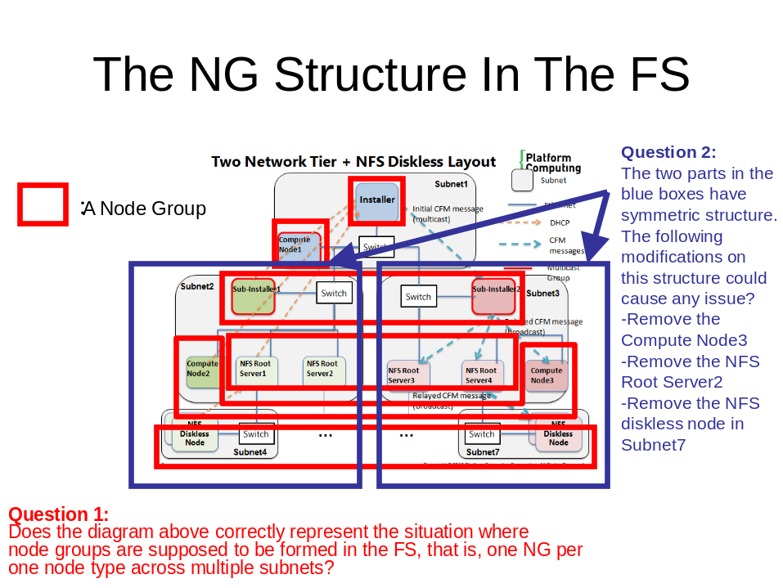

Answers from Platform:
Question 1:
=======
- The diagram above shows 5 possible node groups. Each node group corresponds to a node type.
- Installer NG = {Installer}
- Compute NG = {Compute Node1, Compute Node2, Compute Node3}
- Subinstaller NG = {Sub-Installer1, Sub-Installer2}
- NFS Root Server NG = {NFS Root Server1, NFS Root Server2, NFS Root Server3, NFS Root Server 4}
- NFS Diskless NG = {NFS Diskless Node, …}
Question 2:
=======
- Removing “Compute Node3” from “Compute NG” should not cause any problems.
- Removing “NFS Root Server 2” from “NFS Root Server NG”
  - Is allowed if “NFS Root Server 2” is not managing any NFS Diskless nodes
  - Is not allowed if “NFS Root Server 2” is managing one or more NFS Diskless nodes
  - Removing “NFS Diskless Node” in Subnet7 should not cause any problems.

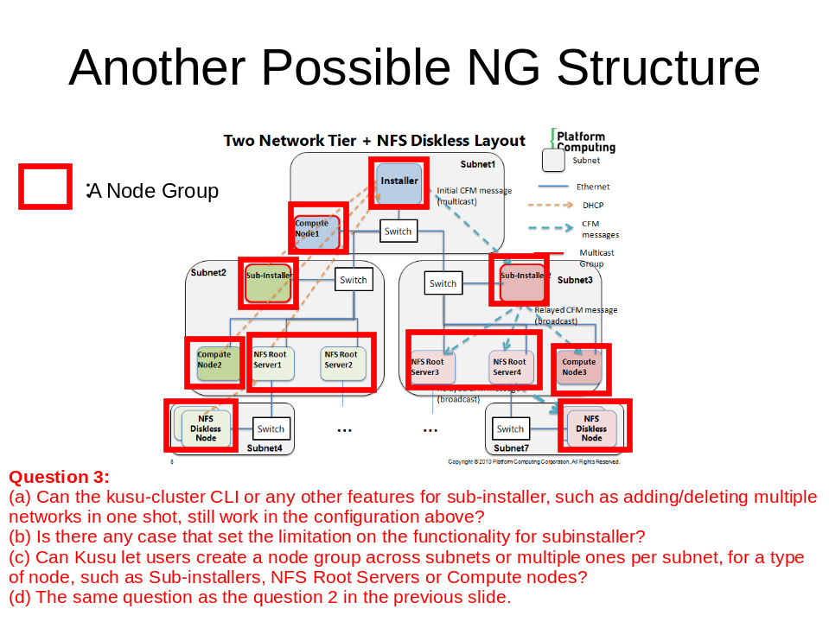

Answers from Platform:
Question 3:
=======
- Yes. All sub-installer features would still work if you created node groups based on the diagram above.
- No.
- Yes. Nodes in the same node group will have the same node type, but can be connected to different subnet. For example, you can use a single Sub-installer node group to provision a subinstaller on one subnet (say 192.168.56.0/24 ), and use the same node group to provision a subinstaller on a different subnet (say 192.168.57.0/24).
- The answer is the same as Question 2 on previous slide.

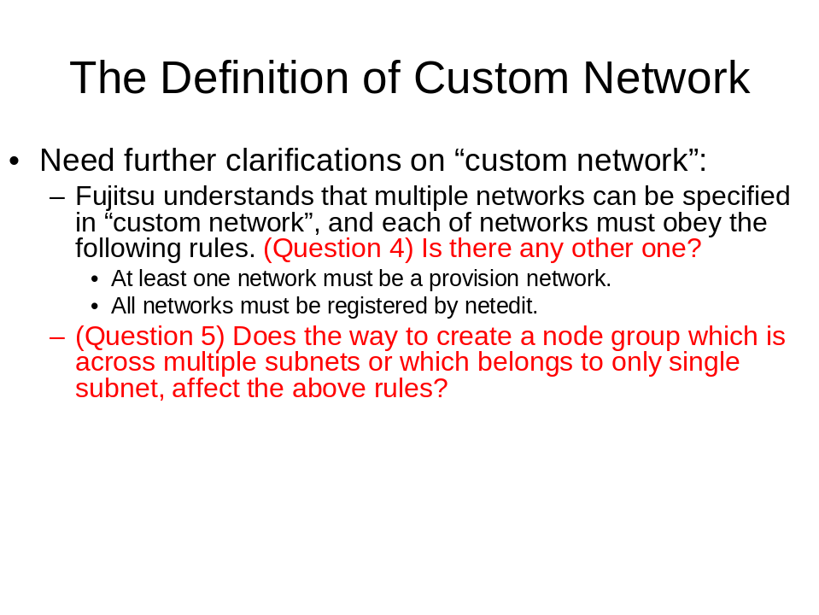

Answers from Platform:
Question 4:
=======
Some more rules:
- The custom networks list must not contain multiple networks with the same device name
e.g., eth0-192.168.56.0-24, and eth0-192.168.57.0.24
- The custom network does not need to be associated with the target node group.
Question 5:
=======
- No. When assigning custom networks to hosts using kusu-addhost, the target node group’s network configuration is not considered when enforcing the above rules.

