AI USAGE RECORD
AI-assisted work and learning evidence | Records 01–04
Project / module: Symbolic AI and Software – Stage 2 mini-lecture (SY4: expert systems) Team / student: DanD Disciples – Talgat
Use one record for each significant AI activity. Insert a readable screenshot of the key interaction, then briefly record how you checked the output and what you used, changed, or rejected. Keep the full evidence in your project and personal logs as required.
AI USE RECORD 01  Date: 07.11.2026 Person(s): Talgat  AI tool / model: Claude (Anthropic), Opus 5.5 – Claude desktop app  Purpose: Choose our mini-lecture topic for Symbolic AI and Software (8 min)  Key prompt / output / follow-up: Which free topic fits best? AI suggested SY4 + a rough 8-minute plan  How did you verify the result? Checked sign-up sheet (SY1, SY2, SY5 taken; SY4 free) and the prof’s brief  Decision: accepted / revised / rejected, and why? Accepted – fits informative / engaging / inspiring  Outcome / project impact: Topic proposal SY4 (expert systems) + first lecture outline  My contribution / what I learned: An 8-min talk needs one big idea, not a whole chapter  Sources checked / attribution: Course sign-up sheet; prof’s mini-lecture instructions | AI USE RECORD 02  Date: 07.11.2026 Person(s): Talgat  AI tool / model: Claude (Anthropic), Opus 5.5 – Claude desktop app  Purpose: Beginner-level contrast for the lecture intro  Key prompt / output / follow-up: 3 sentences: hand-written rules vs. learning patterns from examples  How did you verify the result? Compared with lecture notes and Russell & Norvig ch. 1 definitions  Decision: accepted / revised / rejected, and why? Revised – kept the idea, reworded in our own words  Outcome / project impact: Intro slide “Rules vs. Examples”  My contribution / what I learned: Symbolic AI explains itself but is brittle; ML is flexible but opaque  Sources checked / attribution: Course lecture notes; Russell & Norvig, AIMA (4th ed.)
  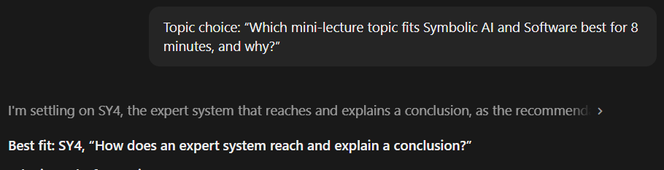
  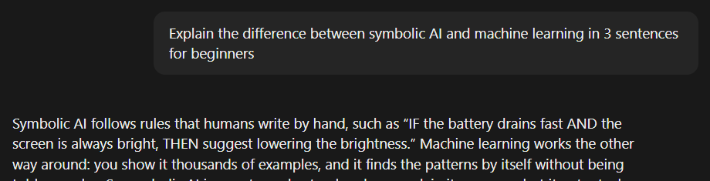
AI USE RECORD 03  Date: 07.11.2026 Person(s): Talgat  AI tool / model: Claude (Anthropic), Opus 5.5 – Claude desktop app  Purpose: Understand how an expert system reaches a conclusion  Key prompt / output / follow-up: Asked for a tiny example; got a 3-rule battery case (forward chaining)  How did you verify the result? Traced the 3 rules by hand: each new fact follows from the rule before  Decision: accepted / revised / rejected, and why? Accepted – correct and simple enough for classmates  Outcome / project impact: Base example for the “rules fire” diagram slide  My contribution / what I learned: A rule fires only when ALL of its IF parts are in the facts  Sources checked / attribution: Course lecture notes on expert systems | AI USE RECORD 04  Date: 07.11.2026 Person(s): Talgat  AI tool / model: Claude (Anthropic), Opus 5.5 – Claude desktop app  Purpose: Clarify forward vs. backward chaining  Key prompt / output / follow-up: One example shown both ways (game → CPU overload → overheating)  How did you verify the result? Re-did both directions on paper; compared with textbook definitions  Decision: accepted / revised / rejected, and why? Accepted – kept the comparison table  Outcome / project impact: Comparison slide + backup explanation for Q&A  My contribution / what I learned: Forward = data-driven; backward = goal-driven (like MYCIN)  Sources checked / attribution: Russell & Norvig, AIMA – forward / backward chaining
  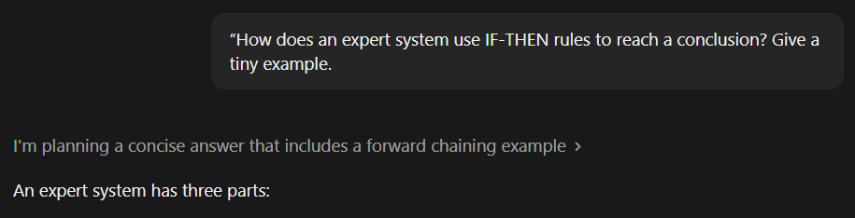
  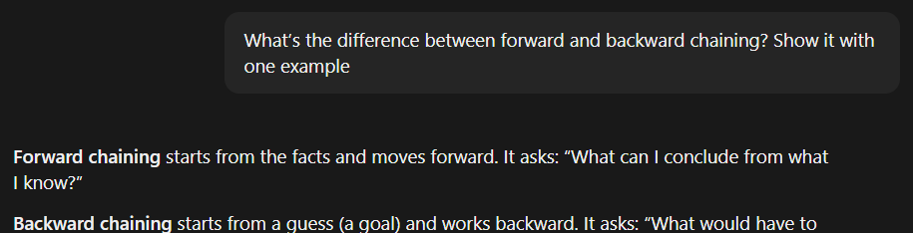

AI USAGE RECORD
AI-assisted work and learning evidence | Records 05–08
Project / module: Symbolic AI and Software – Stage 2 mini-lecture (SY4: expert systems) Team / student: DanD Disciples – Talgat
Use one record for each significant AI activity. Insert a readable screenshot of the key interaction, then briefly record how you checked the output and what you used, changed, or rejected. Keep the full evidence in your project and personal logs as required.
AI USE RECORD 05  Date: 07.11.2026 Person(s): Talgat  AI tool / model: Claude (Anthropic), Opus 5.5 – Claude desktop app  Purpose: Link the “Software” half of our topic to symbolic AI  Key prompt / output / follow-up: How do the OS and apps relate to expert systems? Got a layer stack  How did you verify the result? Checked each layer’s role against our OS / software chapter notes  Decision: accepted / revised / rejected, and why? Revised – simplified to 3 layers for the slide  Outcome / project impact: Software-link slide (OS → app → expert system)  My contribution / what I learned: An expert system is an app that relies on OS services  Sources checked / attribution: Course notes: operating systems and application software | AI USE RECORD 06  Date: 07.11.2026 Person(s): Talgat  AI tool / model: Claude (Anthropic), Opus 5.5 – Claude desktop app  Purpose: Find an opening hook (rule: cut to the chase)  Key prompt / output / follow-up: 3 hooks: “beat the machine”, mystery story, “explain yourself”  How did you verify the result? Timed each aloud (< 1 min); flagged the MYCIN claim in hook 1  Decision: accepted / revised / rejected, and why? Hook 2 accepted; hook 3 rejected (claim too vague)  Outcome / project impact: Lecture opens with the Dandroid battery mystery  My contribution / what I learned: A good hook opens a question that the ending answers  Sources checked / attribution: Prof’s three presentation rules (instruction sheet)
  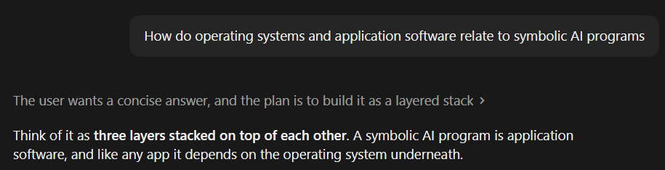
  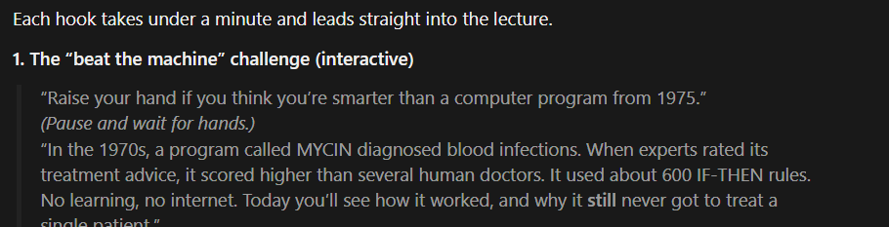
AI USE RECORD 07  Date: 07.11.2026 Person(s): Talgat  AI tool / model: Claude (Anthropic), Opus 5.5 – Claude desktop app  Purpose: Interactive part of the lecture (rule: show, don’t tell)  Key prompt / output / follow-up: 2-min demo: 6 rule cards, class predicts which rule fires next  How did you verify the result? Walked through it as a team; checked R1 and R6 cannot fire  Decision: accepted / revised / rejected, and why? Revised – cut to 5 rules if it runs over 2 min  Outcome / project impact: Live “Phone Doctor” demo in the middle of the lecture  My contribution / what I learned: Trap rules teach “ALL conditions must match” best  Sources checked / attribution: Own rehearsal; course notes on inference engines | AI USE RECORD 08  Date: 07.11.2026 Person(s): Talgat  AI tool / model: Claude (Anthropic), Opus 5.5 – Claude desktop app  Purpose: Explain the twist ending (rule: save the best for last)  Key prompt / output / follow-up: What is brittleness? Got causes + MYCIN, XCON, “measles car”  How did you verify the result? MYCIN / XCON checked in textbook; “measles car” = anecdote only  Decision: accepted / revised / rejected, and why? Revised – anecdote not presented as fact  Outcome / project impact: Finale: system goes silent → why hybrid AI exists  My contribution / what I learned: Rules cannot cover the unexpected – no common sense  Sources checked / attribution: Russell & Norvig, AIMA; Lenat (anecdote, not cited as fact)
  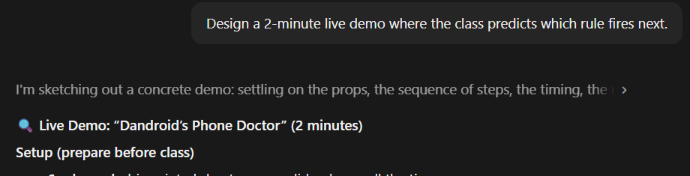
  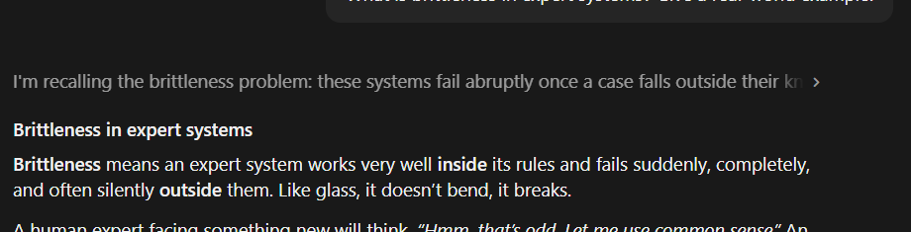

AI USAGE RECORD
AI-assisted work and learning evidence | Records 09–10 and log cross-references
Project / module: Symbolic AI and Software – Stage 2 mini-lecture (SY4: expert systems) Team / student: DanD Disciples – Talgat
Use one record for each significant AI activity. Insert a readable screenshot of the key interaction, then briefly record how you checked the output and what you used, changed, or rejected. Keep the full evidence in your project and personal logs as required.
 | AI USE RECORD 09  Date: 07.11.2026 Person(s): Talgat  AI tool / model: Claude (Anthropic), Opus 5.5 – Claude desktop app  Purpose: Fact-check MYCIN before using it in the hook and the finale  Important prompt / output / follow-up: “Was MYCIN real, what did it do, why wasn’t it used?” → Stanford, 1970s, ~600 rules, antibiotic advice; not used for legal, speed and trust reasons  Verification and decision (accepted / revised / rejected, and why): Checked key facts (Stanford, Shortliffe, 1979 JAMA evaluation) against the sources below. Accepted – only facts we could confirm go on the slides  Outcome, project impact, and personal contribution / learning: MYCIN is our real-world example in the hook and the finale. I learned that a system can perform well and still not be used, for practical and legal reasons  External source(s) checked / attribution: Shortliffe (1976); Yu et al. (1979) JAMA 242(12); Buchanan & Shortliffe (1984)
  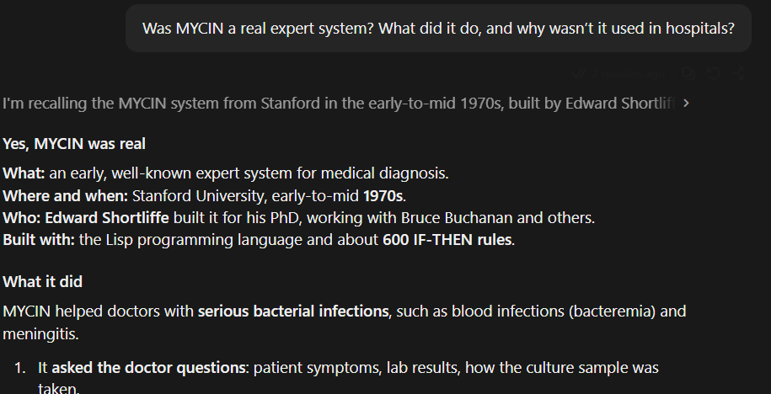

 | AI USE RECORD 10  Date: 07.11.2026 Person(s): Talgat  AI tool / model: Claude (Anthropic), Opus 5.5 – Claude desktop app  Purpose: Quality-check our own Test Bank questions on expert systems  Important prompt / output / follow-up: Checked 3 questions (forward chaining T/F, inference-engine MCQ, weakness MCQ) for correct answers and beginner wording  Verification and decision (accepted / revised / rejected, and why): Compared with our Answer Key and lecture notes. Answers accepted as correct; revised Q2 distractors (keyboard / printer too easy) and Q3 option D wording  Outcome, project impact, and personal contribution / learning: Wording fixes go into Test Bank V2. I learned that a good wrong option must be believable  External source(s) checked / attribution: Our Test Bank V1 and Answer Key; course lecture notes
  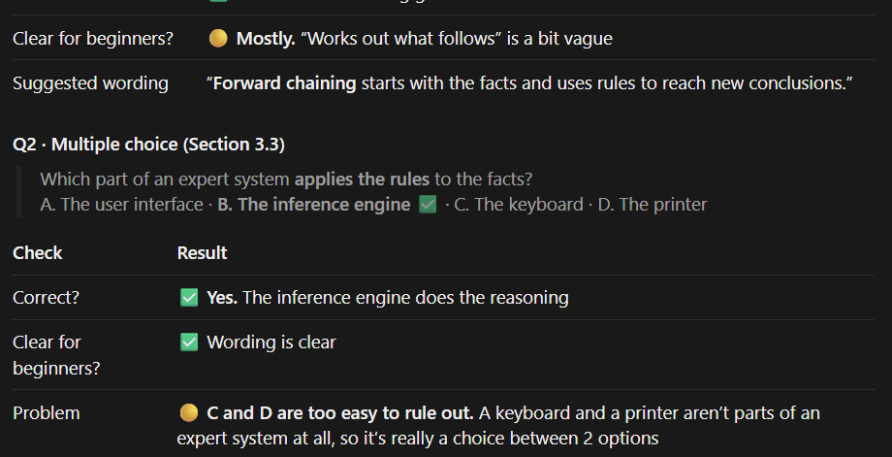

PROJECT AND PERSONAL LOG CROSS-REFERENCES
Project log: relevant task / entry / date  GitHub project log – Topics 13 & 14 (Talgat), 07.11.2026 | Personal log: my own contribution / entry / date  Researched Topics 13 & 14; lecture hook, demo and fact checks – 07.11.2026
Sources actually checked and cited (where used)  Russell & Norvig AIMA; Shortliffe 1976; Yu et al. 1979; Buchanan & Shortliffe 1984 | Any important AI output rejected or still needing follow-up  Hook 3 rejected; “measles car” kept as anecdote; Test Bank V2 fixes to apply
Reminder: Record significant AI use as it happens. Verify important claims and test generated examples, code, calculations, and answers. A screenshot or polished result alone is not enough; your own judgment, contribution, learning, and source attribution must be clear. Do not fabricate prompts, outputs, or verification.

