**Map Application for People with Disabilities Using Smart Devices**

**By Soo Jin Lee.**

<Manual>

1. Save ‘gestures.file’ and ‘OCG_App for the disabled_by SooJin.apk’ in internal storage of your phone. 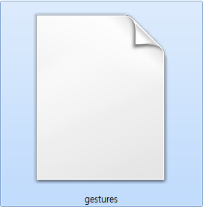 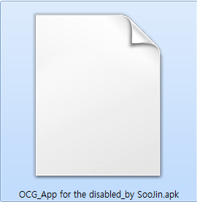
2. Install this application!!!!!

<You want to register self–gestures>

1. Click ‘ADD GESTURE’ button

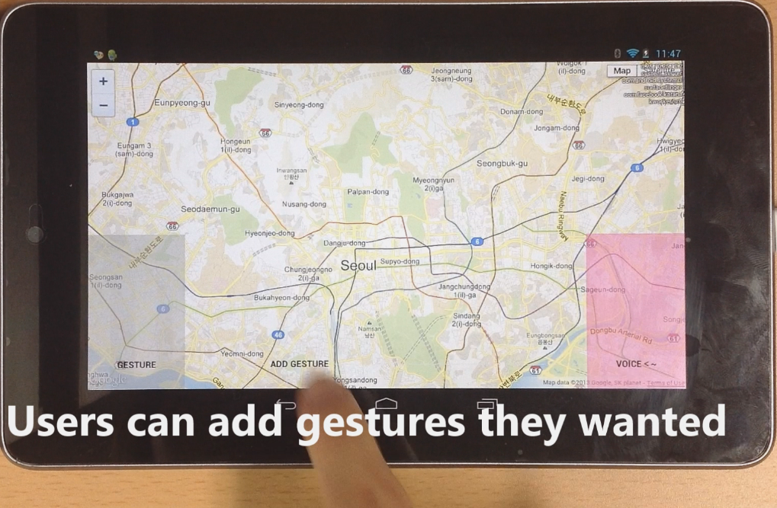

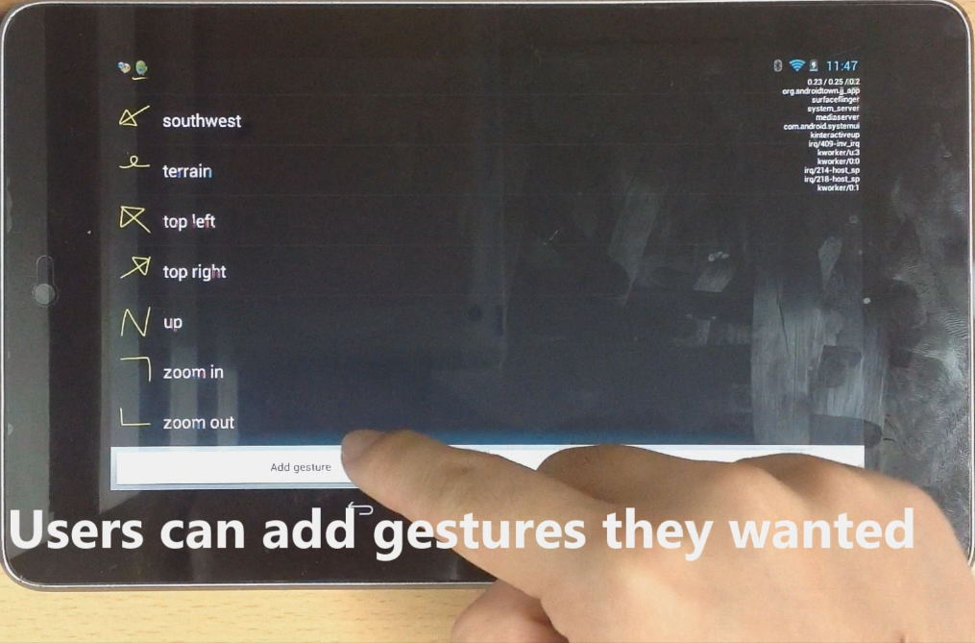

1. Register your gesture!

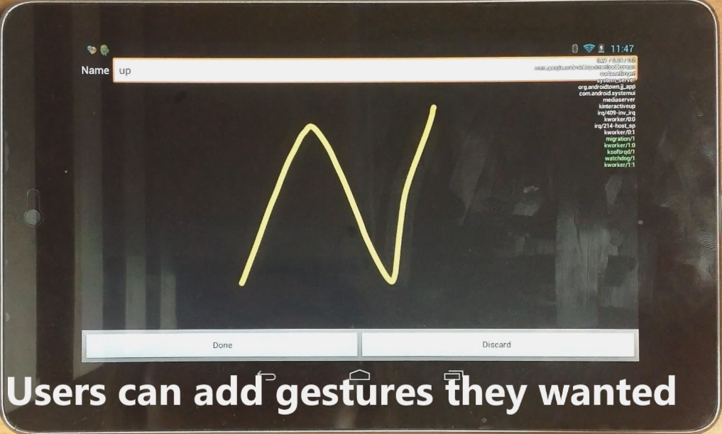

★★★★★

* Gesture Name must be named in list of function’s name that I made.

Table 1 . List of Function's name

|  |  |  |  |  |  |
| --- | --- | --- | --- | --- | --- |
| up | right | left | down | top | bottom |
| northeast | northwest | NW | southwest | southeast |  |
| roadmap | satellite | hybrid | terrain |  | |
| zoom out | zoom in | very zoom in | | very zoom out | |
| seoul | deagu | busan | pusan |  | |
| library for the disabled | | remove library | |  | |

For example,

