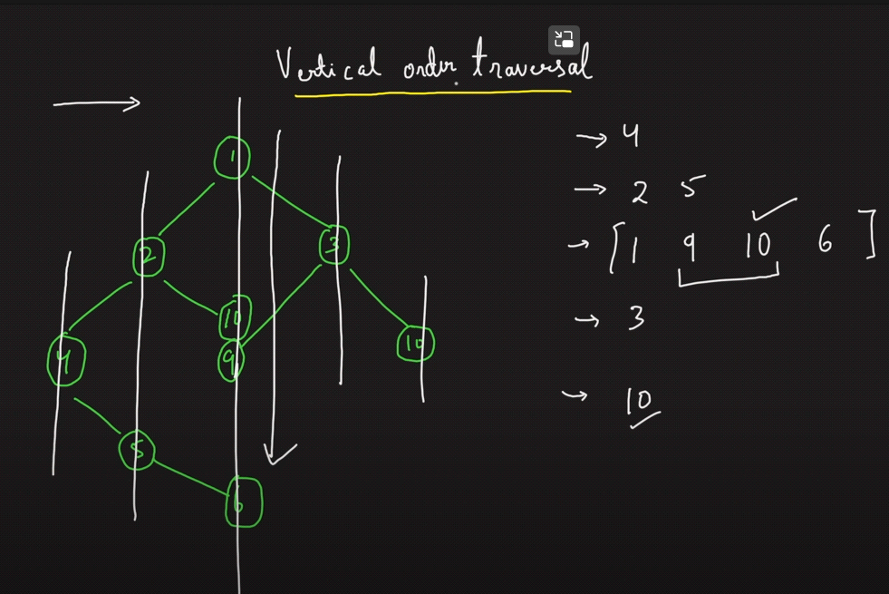

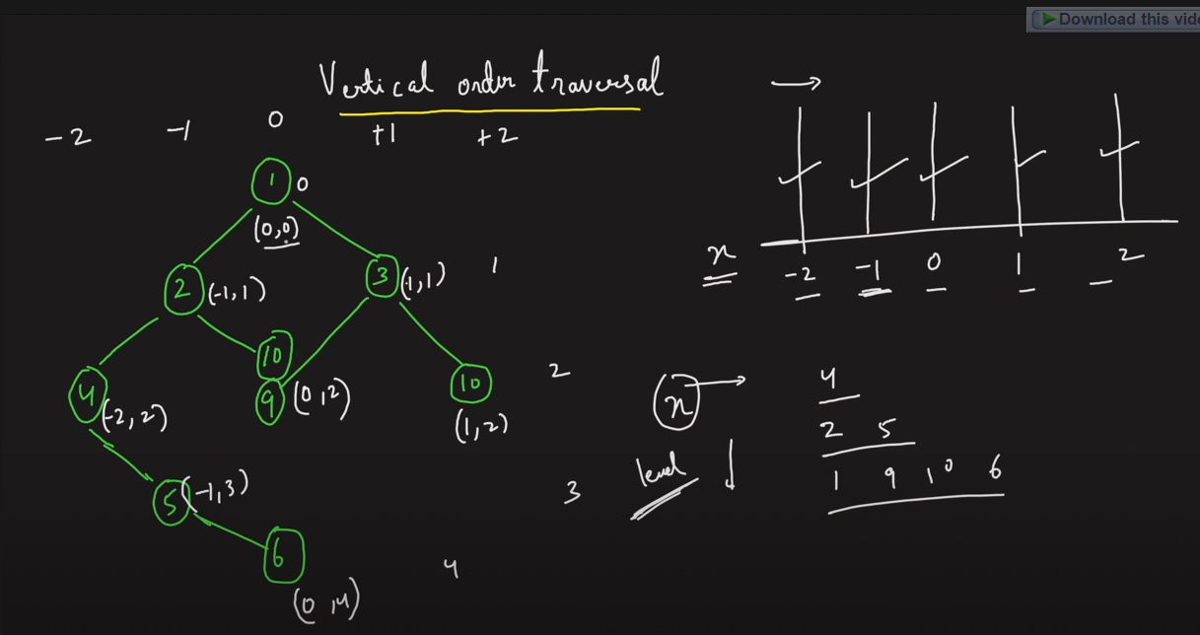

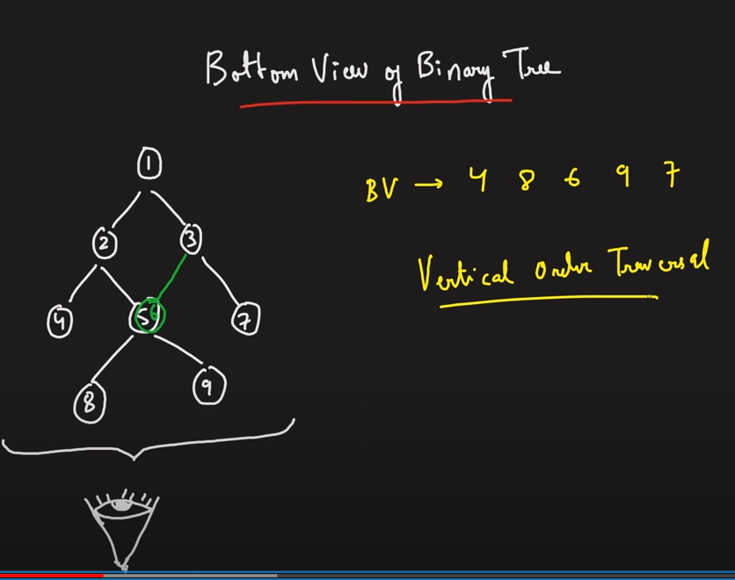

In above case, 5&6 coincide, in this case take the right value which comes later in level order.

Code for bottom view is same as top view except that in this case, we don’t check while pushing a key into map whether it exists or not, we just push it, overwriting the older value.