Doctor Appointment System : A mini-project

About: In this project we tried to create an affordable record management system for appointments taken at a doctor’s clinic.

Primary reason for this project and objecive: Idea for this mini project came from the current pandemic situation when we saw that evem in the villages, the appointments at clinics were being made over phone calls. This inspired us to create an application with a minimalistic GUI that can help rural clinic workers store and edit appointment data of various patients without having to spend a lot on professional tools.
Scope: This program is just a prototype but with a few enhancements, this program can literally make the appointment system faster and cheaper plus more efficient.
Working methodology & summary: This program has been completely written in C++. It utilises concepts of defining and calling various C++ functions,array manipulation, complex if-else and for structures with file manipulation. The code is relatively simple and the UI is fairly intuitive so that a layman can use the application without much issues. Our program is somewhat robust as the data once stored remains saved even after the program has been closed.
We’ve used fstream library to stream text from a file(our primary database file), we have used two primary functions bookAppointment() and existingAppointment() to help book and show empty slots respectively using the main() driver function. Using an object “read” created out of ifstream class, we access “appointment.dat” text file which contains our bookings. So using the read object we open the text file and iterate through each line of the document using getline(). If a record is found for a particular time slot, our program specifies that the slot is not availiable. If the slot is availiable then our program creates the appointment. If the appointment is selected over a pre booked slot, it is overwritten. Now we used ofstream class and made an object “out” to write the data in the .dat file.
Our program is looped so that it doesn’t close automatically after showing/writing data. It’ll close only when the user chooses to close it.
Hardware and Software used: We wrote this program on Vim text editor on a Ubuntu 20.04 OS. Compiler was g++. We shared our work with each other through github and through whatsapp, that way we all contributed to the project.
As for the user, this program can be run by old processors too. It requires minimal space to operate and is simplistic.
Limitations: Since it is a mini project, so it has bugs and limitations. Our program is not made for high number of patients. We are only storing patient’s name here. The program doesn’t allow for flexible appointments of times less than 1 hour. The data is not encrypted.

Features
- This project manages doctor appointment
- The record is maintained even if application is closed
- Compiled on g++(Ubuntu)
Source Code

#include <iostream>
#include <string>
#include <fstream>
#include <cstring>

using namespace std;

int bookAppointment()
{
system("clear");

cout<<"\n ----- Book Your Appointment ---- \n";
cout<<"\n ----- Availbale slots ---- \n";

//check if record already exist..
ifstream read;
read.open("appointment.dat");

int hoursbook = 8;

int arr[13] = {0,0,0,0,0,0,0,0,0,0,0,0,0};
int recordFound =0;

if(read)
{
string line;
char key = 'A';
int i = 9;

while(getline(read, line)) {
char temp = line[0];
int index = (temp - 65);
arr[index]=1;
recordFound = 1;
}
if(recordFound == 1)
{
cout<<"\n Appointment Summary by hours:";
char key = 'A';
int hours = 9;
for(int i = 0; i<=12; i++)
{
if(i == 0){
if(arr[i] == 0)
cout<<"\n "<<key<<"-> 0"<<hours<<" - Available";
else
cout<<"\n "<<key<<"-> 0"<<hours<<" - Booked";
}

else
{
if(arr[i] == 0)
cout<<"\n "<<key<<"->"<<hours<<" - Available";
else
cout<<"\n "<<key<<"->"<<hours<<" - Booked";
}
hours++; key++;
}

}

read.close();
}
if(recordFound == 0){
cout<<"\n Appointment Available for following hours :";
char key = 'A';
for(int i = 9; i<=21; i++)
{
if(i==9)
cout<<"\n "<<key<<" -> 0"<<i<<" - Available";
else
cout<<"\n "<<key<<" -> "<<i<<" - Available";
key++;
}

}

char choice;
cout<<"\n\n Input your choice : ";
cin>>choice;

if( !(choice >= 'A' && choice <='Z'))
{
cout<<"\n Error : Invalid Selection";
cout<<"\n Please selction correct value from menu A- Z";
cout<<"\n Press any key to continue";
getchar();getchar();
system("clear");
bookAppointment();
}

int index = (choice-65 );
int isBooked = 1;
if(arr[index] == 0)
isBooked = 0;

if(isBooked ==1)
{
cout<<"\n Error : Appointment is already booked for this Hour";
cout<<"\n Please select different time !!";
cout<<"\n Press any key to continue!!";
getchar();getchar();
system("clear");
bookAppointment();
}

string name;
cout<<"\n Enter your first name:";
cin>>name;

ofstream out;
out.open("appointment.dat", ios::app);

if(out){
out<<choice<<":"<<name.c_str()<<"\n";
out.close();
cout<<"\n Appointment booked for Hours : "<< (choice-65) + 9 <<" successfully !!";
}
else
{
cout<<"\n Error while saving booking";
}

cout<<"\n Please any key to continue..";
getchar(); getchar();
return 0;
}

int existingAppointment()
{
system("clear");
cout<<"\n ----- Appointments Summary ---- \n";
//check if record already exist..
ifstream read;
read.open("appointment.dat");

int hoursbook = 8;

int arr[13] = {0,0,0,0,0,0,0,0,0,0,0,0,0};
int recordFound =0;

if(read)
{
string line;
char key = 'A';
int i = 9;

while(getline(read, line)) {
char temp = line[0];
int index = (temp - 65);
arr[index]=1;
recordFound = 1;
}
if(recordFound == 1)
{
cout<<"\n Appointment Summary by hours:";
char key = 'A';
int hours = 9;
for(int i = 0; i<=12; i++)
{
if(arr[i] == 0)
cout<<"\n "<<key<<"->"<<hours<<" - Available";
else
cout<<"\n "<<key<<"->"<<hours<<" - Booked";
hours++; key++;
}

}

read.close();
}
else
{
char key = 'A';
for(int i = 9; i<=21; i++)
{
if(i==9)
cout<<"\n "<<key<<" -> 0"<<i<<" - Available";
else
cout<<"\n "<<key<<" -> "<<i<<" - Available";
key++;
}
}

cout<<"\n Please any key to continue..";
getchar(); getchar();
return 0;
}

int main() {
while(1)
{
system("clear");
cout<<"\t\t\tDoctor Appointment System\n";
cout<<"----------------------------------------\n\n";

cout<<"1. Book Appointment\n";
cout<<"2. Check Existing Appointment\n";
cout<<"0. Exit\n";
int choice;

cout<<"\n Enter you choice: ";
cin>>choice;

switch(choice)
{
case 1: bookAppointment(); break;
case 2: existingAppointment(); break;
case 0:
while(1)
{
system("clear");
cout<<"\n Are you sure, you want to exit? y | n \n";
char ex;
cin>>ex;
if(ex == 'y' || ex == 'Y')
exit(0);
else if(ex == 'n' || ex == 'N')
{
break;
}
else{
cout<<"\n Invalid choice !!!";
getchar();
}
} break;

default: cout<<"\n Invalid choice. Enter again ";
getchar();

}
}
return 0;
}

Output:

Note that for simplicity of code we have used the 24 hour time format and also each appointed time is of 1 hour.
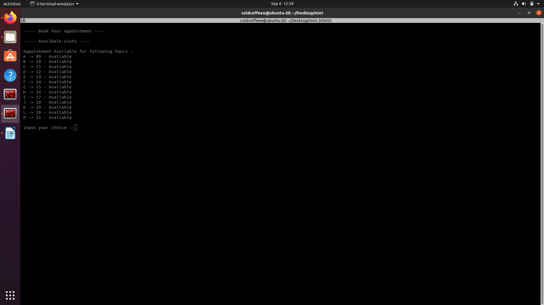

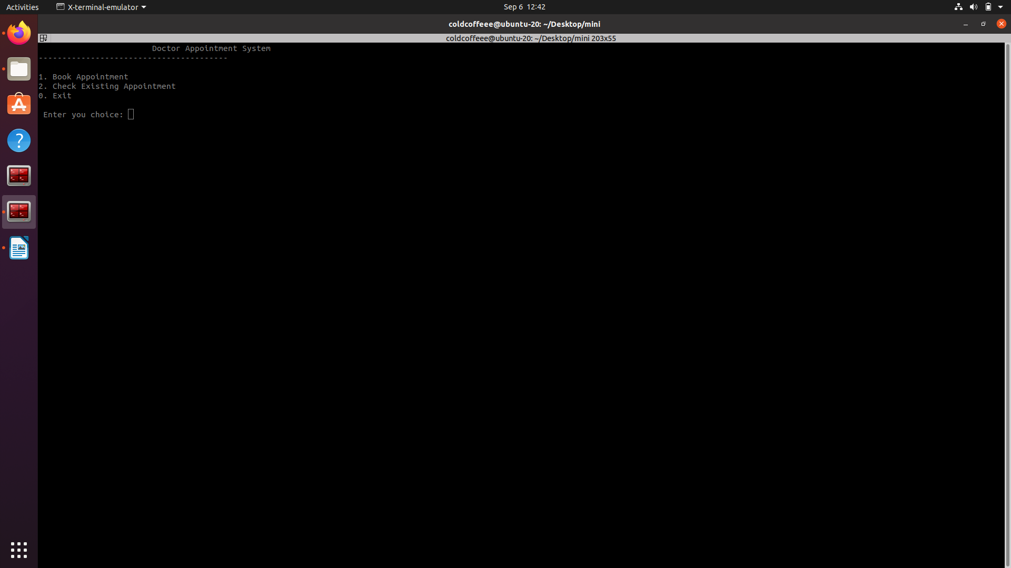
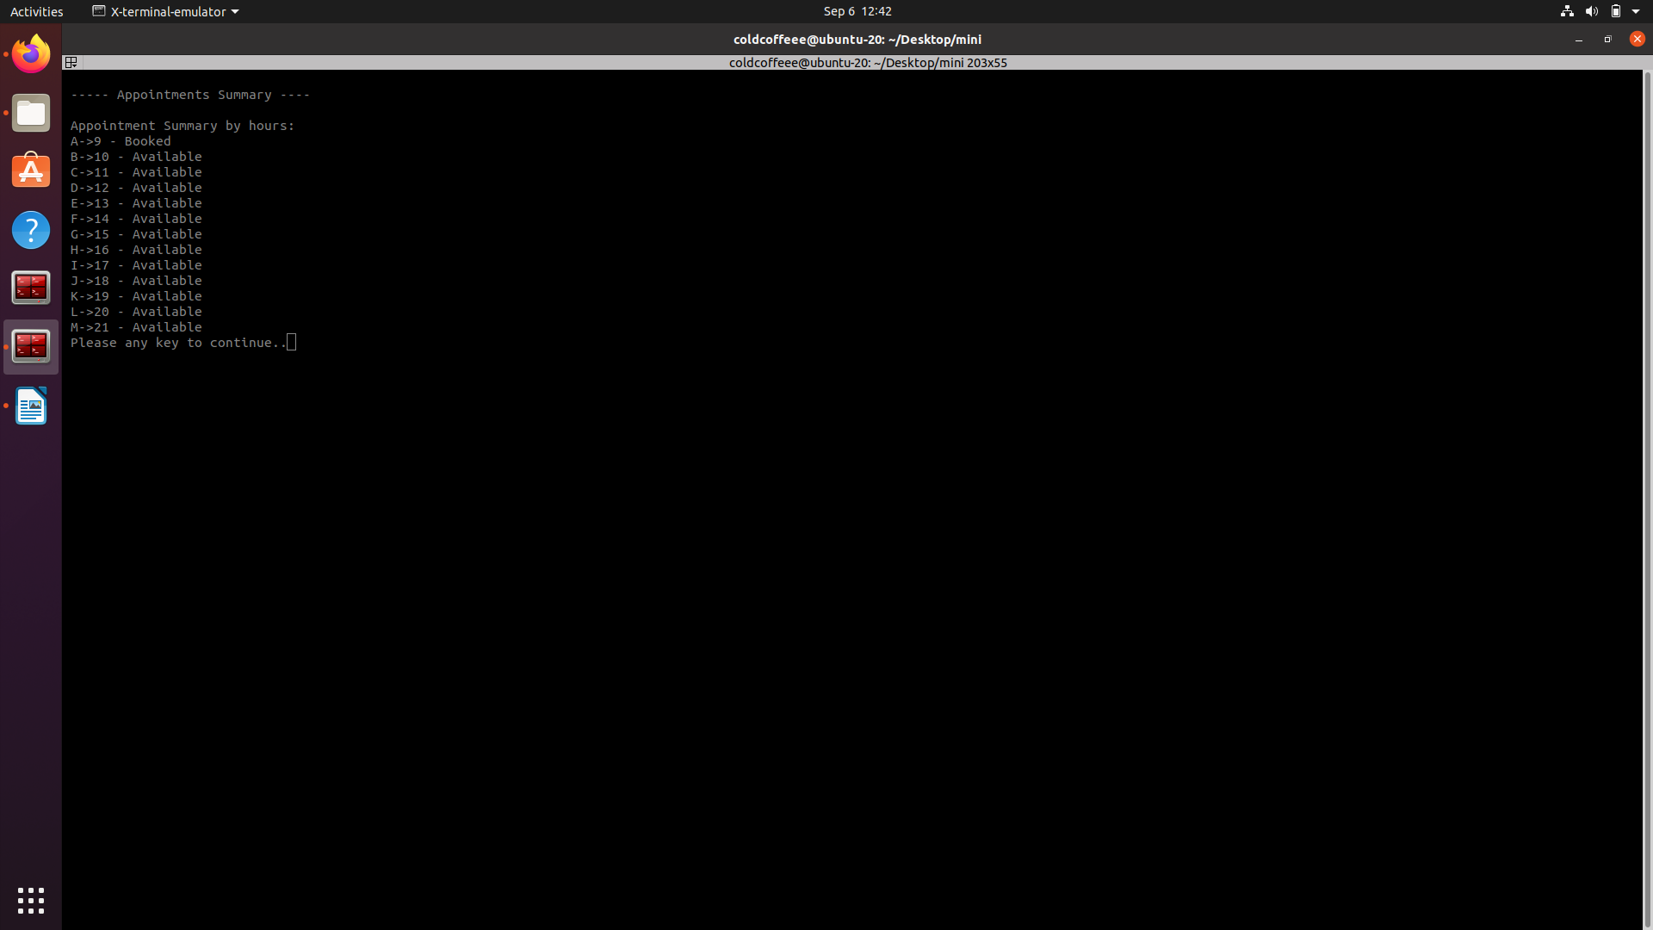
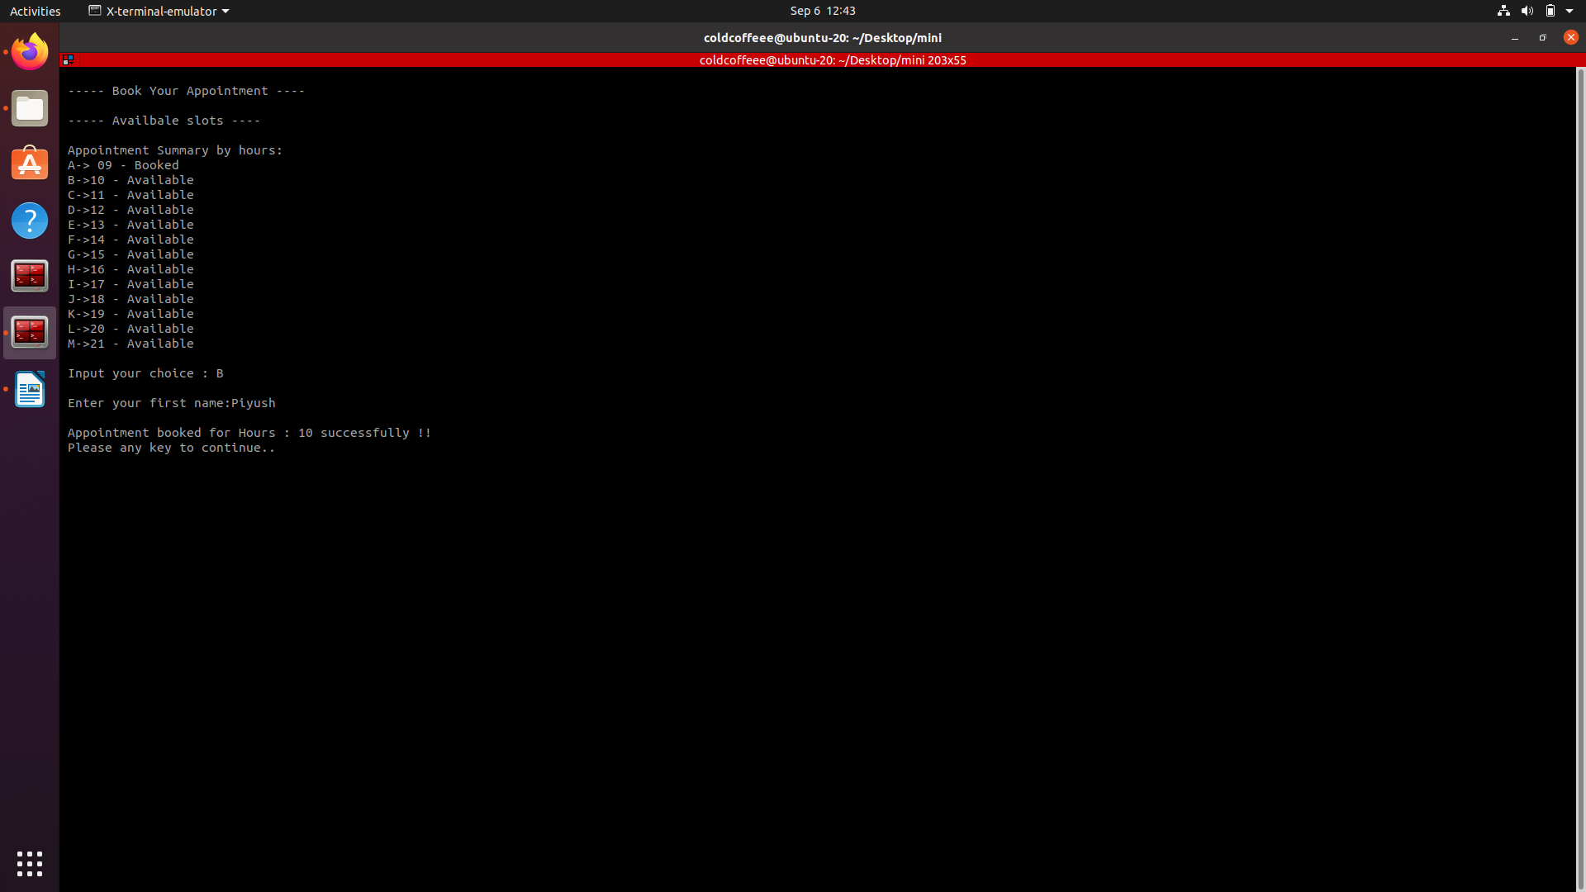

Conclusion:

This project gave us knowledge about a small practical implementation of C++. Our program can handle small data entries easily. We also learned to present our project as a team. We learned about team work. There is, however, a lot to learn and a long way ahead. So we are on a continuous path of learning as well as helping the society from our knowledge.
We would like to thank our professors who gave us this mini-project to work on and in a way learn to care about society.

