Bergen County Academies
6th Annual Joe Holbrook Memorial
Math Competition
Sponsored by BCA Math Team Booster Club
Individual Competitions for grade 4th through 8th
Prizes for top finishers in each grade level
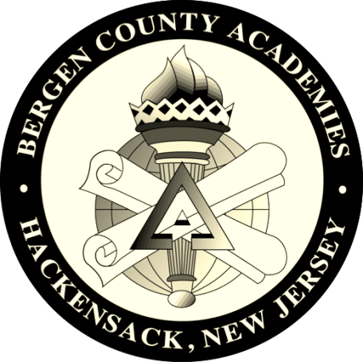
SUNDAY, OCTOBER 15, 2017
10:00AM TO 3:00 PM
Please arrive no later than 9:30 AM
Bergen County Academies
200 Hackensack Avenue
Hackensack, NJ 07601
$30 Online Registration Fee (seats are limited)
Students should bring lunch or snack
For Registration & more information visit
Holbrook.bergen.org

