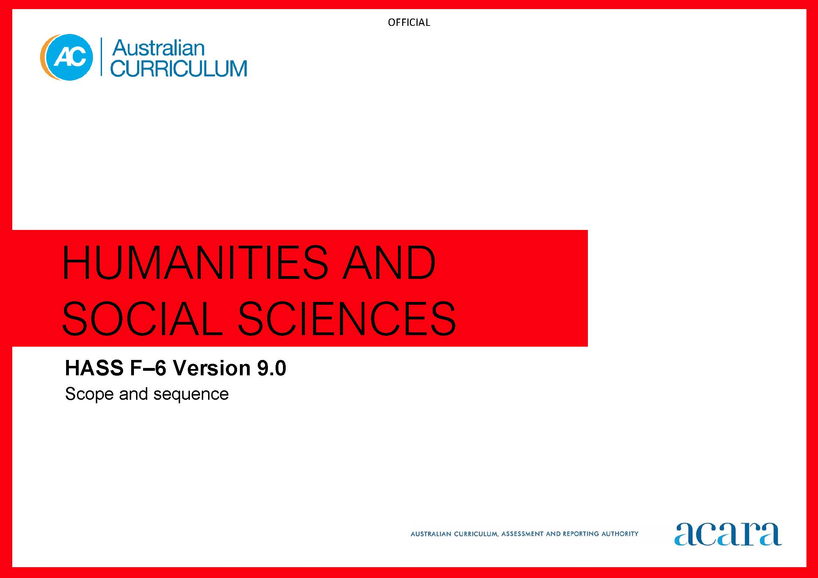

Copyright and Terms of Use Statement
© Australian Curriculum, Assessment and Reporting Authority 2022
The material published in this work is subject to copyright pursuant to the Copyright Act 1968 (Cth) and is owned by the Australian Curriculum, Assessment and Reporting Authority (ACARA) (except to the extent that copyright is held by another party, as indicated).
The viewing, downloading, displaying, printing, reproducing (such as by making photocopies) and distributing of these materials is permitted only to the extent permitted by, and is subject to the conditions imposed by, the terms and conditions of using the ACARA website (see, especially, clauses 2, 3 and 4 of those terms and conditions). The terms and conditions can be viewed at https://www.acara.edu.au/contact-us/copyright

Foundation
Achievement standard
By the end of Foundation, students identify significant people and events in their own lives, and how significant events are celebrated or commemorated. Students recognise the features of familiar places, why some places are special to people and the ways they can care for them.
Students pose questions, and sort and record information from observations and provided sources. They share a perspective and draw conclusions. Students use sources and terms to share observations about places and the past.

Content descriptions
Strand: Knowledge and understanding
Sub-strand: History
the people in their family, where they were born and raised, and how they are related to each other
AC9HSFK01
the celebrations and commemorations of significant events shared with their families and others
AC9HSFK02
Sub-strand: Geography
the features of familiar places they belong to, why some places are special and how places can be looked after
AC9HSFK03
the importance of Country/Place to First Nations Australians and the Country/Place on which the school is located
AC9HSFK04

Strand: Skills
Sub-strand: Questioning and researching
pose questions about familiar objects, people, places and events
AC9HSFS01
sort and record information including pictorial timelines and locations on pictorial maps or models
AC9HSFS02
Sub-strand: Interpreting, analysing and evaluating
share a perspective on information, such as stories about significant events and special places
AC9HSFS03
Sub-strand: Concluding and decision making
draw conclusions in response to questions
AC9HSFS04
Sub-strand: Communicating
share narratives and observations, using sources and terms about the past and places
AC9HSFS05

Year 1 | Year 2
Achievement standard
By the end of Year 1, students identify continuity and change in family structures, roles and significant aspects of daily life. They identify the location and nature of the natural, managed and constructed features of local places, the ways places change, and how they can be cared for by people.  Students develop questions and collect, sort and record information and data from observations and provided sources. They interpret information and discuss perspectives. They draw conclusions and make proposals. Students share narratives and observations about people, places and the past, drawing on sources and incorporating subject-specific terms. | By the end of Year 2, students identify the significance of a local person, group, place and/or building. They identify the effects of changes in technologies on people’s lives. Students identify that places can be spatially represented in different geographical divisions. They identify how people and places are interconnected both at local and broader scales.  Students develop questions, and collect, sort and record related information and data from observations and provided sources. They interpret information and data, and identify and discuss perspectives. Students use interpretations to draw conclusions and make proposals. Students use sources, and subject-specific terms to present narratives and observations about the past, people and places at different scales.

Content descriptions
Strand: Knowledge and understanding
Sub-strand: History
differences in family structures and roles today, and how these have changed or remained the same over time  AC9HS1K01 | a local individual, group, place or building and the reasons for their importance, including social, cultural or spiritual significance  AC9HS2K01
continuity and change between aspects of their daily lives and their parents’ and grandparents’ childhoods  AC9HS1K02 | how technological developments changed people’s lives at home, and the ways they worked, travelled and communicated  AC9HS2K02
Sub-strand: Geography
the natural, managed and constructed features of local places, and their location  AC9HS1K03 | how places can be spatially represented in geographical divisions from local to regional to state/territory, and how people and places are interconnected across those scales  AC9HS2K03
how places change and how they can be cared for by different groups including First Nations Australians  AC9HS1K04 | the interconnections of First Nations Australians to a local Country/Place  AC9HS2K04

Strand: Skills
Sub-strand: Questioning and researching
develop questions about objects, people, places and events in the past and present
AC9HS1S01 AC9HS2S01
collect, sort and record information and data from observations and from provided sources, including unscaled timelines and labelled maps or models
AC9HS1S02 AC9HS2S02
Sub-strand: Interpreting, analysing and evaluating
interpret information and data from observations and provided sources, including the comparison of objects from the past and present
AC9HS1S03 AC9HS2S03
discuss perspectives related to objects, people, places and events
AC9HS1S04 AC9HS2S04
Sub-strand: Concluding and decision-making
draw conclusions and make proposals
AC9HS1S05 AC9HS2S05
Sub-strand: Communicating
develop narratives and share observations using sources, and subject-specific terms
AC9HS1S06 AC9HS2S06

Year 3 |  | Year 4
Achievement standard
By the end of Year 3, students describe the causes, effects and contributions of people to change. They identify the significance of events, symbols and emblems to Australia’s identity and diversity. They describe the representation of places within and near Australia. They identify the similarities, differences and connections of people to places across those scales. Students describe the importance of rules and people’s contributions to communities.  Students develop questions and locate, collect and record information and data from different sources. They interpret information and data in different formats. They analyse information and data to identify perspectives and they draw conclusions. They propose actions or responses. Students use ideas from sources, and subject-specific terms to present descriptions and explanations | By the end of Year 4, students describe the diversity of experiences of people in Australia prior to and following 1788. They describe the events and causes of the establishment of the first British colony in Australia. They describe the effects of colonisation on people and environments. Students describe the importance of environments, and sustainable allocation and management of resources. They describe the importance and role of local government, community members and laws, and the cultural and social factors that shape identity.  Students develop questions and locate, collect and record information and data from a range of sources and formats. They interpret and analyse information and data to identify perspectives, and draw conclusions. Students propose considered actions or responses. Students use ideas from sources and relevant subject-specific terms to present descriptions and explanations.

Content descriptions
Strand: Knowledge and understanding
Sub-strand: History
causes and effects of changes to the local community, and how people who may be from diverse backgrounds have contributed to these changes  AC9HS3K01 | the diversity of First Nations Australians, their social organisation and their continuous connection to Country/Place  AC9HS4K01
significant events, symbols and emblems that are important to Australia’s identity and diversity, and how they are celebrated, commemorated or recognised in Australia, including Australia Day, Anzac Day, NAIDOC Week, National Sorry Day, Easter, Christmas, and other religious and cultural festivals  AC9HS3K02 | the causes of the establishment of the first British colony in Australia in 1788  AC9HS4K02
the experiences of individuals and groups, including military and civilian officials, and convicts involved in the establishment of the first British colony
AC9HS4K03
the effects of contact with other people on First Nations Australians and their Countries/Places following the arrival of the First Fleet and how this was viewed by First Nations Australians as an invasion
AC9HS4K04
Sub-strand: Geography
the representation of contemporary Australia as states and territories, and as the Countries/Places of First Nations Australians prior to colonisation, and the locations of Australia’s neighbouring regions and countries  AC9HS3K03 | the importance of environments, including natural vegetation and water sources, to people and animals in Australia and on another continent  AC9HS4K05
the ways First Nations Australians in different parts of Australia are interconnected with Country/Place  AC9HS3K04 | sustainable use and management of renewable and non-renewable resources, including the custodial responsibility First Nations Australians have for Country/Place  AC9HS4K06
the similarities and differences between places in Australia and neighbouring countries in terms of their natural, managed and constructed features
AC9HS3K05
Sub-strand: Civics and Citizenship
who makes rules, why rules are important in the school and/or the local community, and the consequences of rules not being followed  AC9HS3K06 | the differences between “rules” and “laws”, why laws are important and how they affect the lives of people  AC9HS4K07
why people participate within communities and how students can actively participate and contribute to communities  AC9HS3K07 | the roles of local government and how members of the community use and contribute to local services  AC9HS4K08
diversity of cultural, religious and/or social groups to which they and others in the community belong, and their importance to identity
AC9HS4K09

Strand: Skills
Sub-strand: Questioning and researching
develop questions to guide investigations about people, events, places and issues
AC9HS3S01 AC9HS4S01
locate, collect and record information and data from a range of sources, including annotated timelines and maps
AC9HS3S02 AC9HS4S02
Sub-strand: Interpreting, analysing and evaluating
interpret information and data displayed in different formats
AC9HS3S03 AC9HS4S03
analyse information and data, and identify perspectives
AC9HS3S04 AC9HS4S04
Sub-strand: Concluding and decision-making
draw conclusions based on analysis of information
AC9HS3S05 AC9HS4S05
propose actions or responses to an issue or challenge that consider possible effects of actions
AC9HS3S06 AC9HS4S06
Sub-strand: Communicating
present descriptions and explanations, using ideas in sources and relevant subject-specific terms
AC9HS3S07 AC9HS4S07

Year 5 |  | Year 6
Achievement standard
By the end of Year 5, students explain the causes of the establishment of the British colonies in Australia after 1800. They explain the roles of significant individuals or groups in the development of an Australian colony and the impact of those developments. They explain the influence of people on the characteristics of places and in the management of spaces. Students explain the key values and features of Australia’s democracy and how people achieve civic goals. They explain the nature of resources, and how they meet needs and wants.  Students develop questions and locate, collect and organise information and data from primary and secondary sources. They evaluate sources to determine origin and perspectives. Students evaluate information and data to identify and describe patterns or trends. They suggest conclusions based on evidence. Students consider criteria in proposing actions or responses. Students select ideas and findings from sources and use relevant terms and conventions, to present descriptions and explanations. | By the end of Year 6, students explain the roles of significant people, events and ideas that led to Australian Federation, democracy and citizenship. They explain the causes and effects of migration to Australia since Federation. They explain the geographical diversity of places and the effects of interconnections with other countries. Students explain the key institutions, roles and responsibilities of Australia’s levels of government, and democratic values and beliefs. They explain influences on consumers and strategies for informed consumer and financial choices.  Students develop questions, and locate, collect and organise information and data from a range of primary and secondary sources. They evaluate sources to determine origin, purpose and perspectives. Students evaluate a range of information and data formats to identify and describe patterns, trends or inferred relationships. They evaluate evidence to draw conclusions. Students propose actions or responses and use criteria to assess the possible effects. Students select and organise ideas and findings from sources, and use a range of relevant terms and conventions, to present descriptions and explanations.

Content descriptions
Strand: Knowledge and understanding
Sub-strand: History
the economic, political and social causes of the establishment of British colonies in Australia after 1800  AC9HS5K01 | significant individuals, events and ideas that led to Australia’s Federation, including the Constitution and democratic system of government  AC9HS6K01
the impact of the development of British colonies in Australia on the lives of First Nations Australians, the colonists and convicts, and on the natural environment  AC9HS5K02 | changes in Australia’s political system and to Australian citizenship after Federation and throughout the 20th century that impacted on First Nations Australians, migrants, women and children  AC9HS6K02
the role of a significant individual or group, including First Nations Australians and those who migrated to Australia, in the development or events in an Australian colony  AC9HS5K03 | the motivation of people migrating to Australia since Federation and throughout the 20th century, their stories and effects on Australian society, including migrants from the Asia region  AC9HS6K03
Sub-strand: Geography
the influence of people, including First Nations Australians and people in other countries, on the characteristics of a place  AC9HS5K04 | the geographical diversity and location of places in the Asia region, and its location in relation to Australia  AC9HS6K04
the management of Australian environments, including managing severe weather events such as bushfires, floods, droughts or cyclones, and their consequences  AC9HS5K05 | Australia’s interconnections with other countries and how these change people and places  AC9HS6K05
Sub-strand: Civics and Citizenship
the key values and features of Australia’s democracy, including elections, and the roles and responsibilities of elected representatives  AC9HS5K06 | the key institutions of Australia’s system of government, how it is based on the Westminster system, and the key values and beliefs of Western democracies  AC9HS6K06
how citizens (members of communities) with shared beliefs and values work together to achieve a civic goal  AC9HS5K07 | the roles and responsibilities of the 3 levels of government in Australia  AC9HS6K07
Sub-strand: Economics and Business
types of resources, including natural, human and capital, and how they satisfy needs and wants  AC9HS5K08 | influences on consumer choices and strategies that can be used to help make informed personal consumer and financial choices  AC9HS6K08

Strand: Skills
Sub-strand: Questioning and researching
develop questions to investigate people, events, developments, places and systems
AC9HS5S01 AC9HS6S01
locate, collect and organise information and data from primary and secondary sources in a range of formats
AC9HS5S02 AC9HS6S02
Sub-strand: Interpreting, analysing and evaluating
evaluate information and data in a range of formats to identify and describe patterns and trends, or to infer relationships
AC9HS5S03 AC9HS6S03
evaluate primary and secondary sources to determine origin, purpose and perspectives
AC9HS5S04 AC9HS6S04
Sub-strand: Concluding and decision-making
develop evidence-based conclusions
AC9HS5S05 AC9HS6S05
propose actions or responses to issues or challenges and use criteria to assess the possible effects
AC9HS5S06 AC9HS6S06
Sub-strand: Communicating
present descriptions and explanations, drawing ideas, findings and viewpoints from sources, and using relevant terms and conventions
AC9HS5S07 AC9HS6S07

