**MOVIE TICKET BOOKING SYSTEM**

Our project basically manages the ticket booking process of a theater, providing an interface to the user to book movie tickets in a more easy way. The project proceeds through a sequence of well-designed forms provided with validations to ensure consistency, reliability and most importantly correctness of information fed into the database

**SOLUTION DESIGN**

We used tkinter toolkit for GUI. we Incorporated some widgets which better the result screen , so that the user can use the application with no confusion. The overall architecture can be thought of having ​two ​main parts :

* The user side
* The admin side

**The user side :**

This portion of the application is exclusively for the user who uses the app for booking the tickets.This portion consists of the following windows

1. Home Screen

This is the page the user will see when he opens the application or (runs main.py).

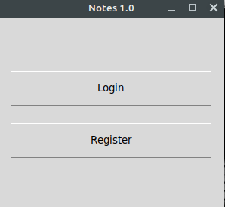

If he is using the application for the first time he can click on Register and register himself. Else he can Login using his Credentials and move forward

1. Register Screen

This page is for users who are using the app for the first time . Here users can register using his/her email id and password . Then an email will be sent to his email id , which confirms his/her registration.

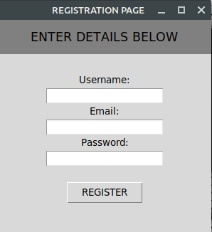

1. Login Screen

Users who have already registered before can straightaway login using their username,password and start booking.

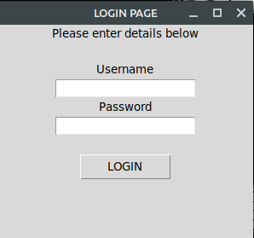

1. Now Showing Screen

This screen is shown after the login/registration process . It shows a list of the movies currently being shown at the theatre. The user has to select one among and click confirm.On clicking confirm a poster of that movie will pop up . On clicking on that poster you will be taken to the seat selection Screen where you can select the seats you want to book.

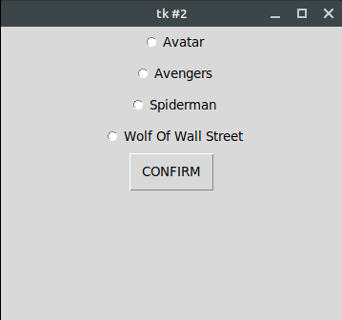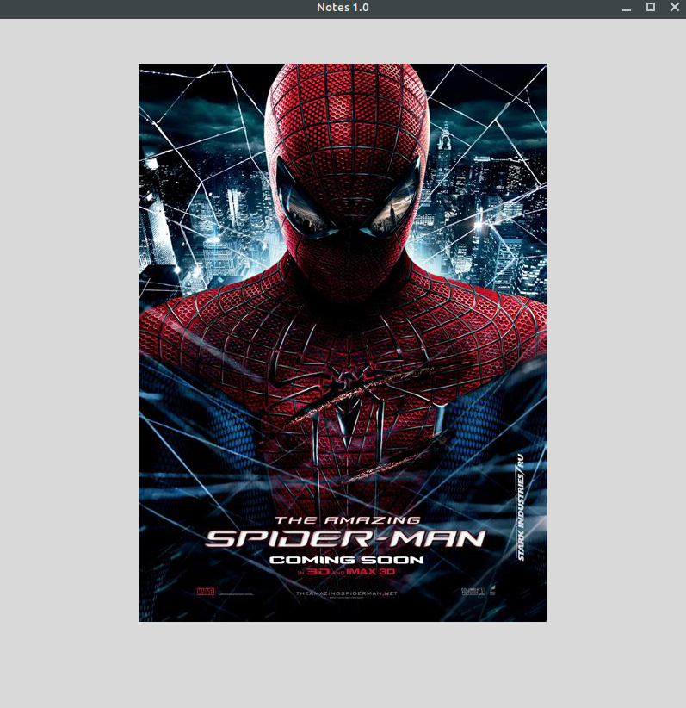

1. Seat Selection Screen

On this screen there is a grid of seats just like the one in a theater . User will have to select the seats of his choice from the available seats . On clicking confirm the seats will be booked and the session code or receipt code will be sent to you via mail.

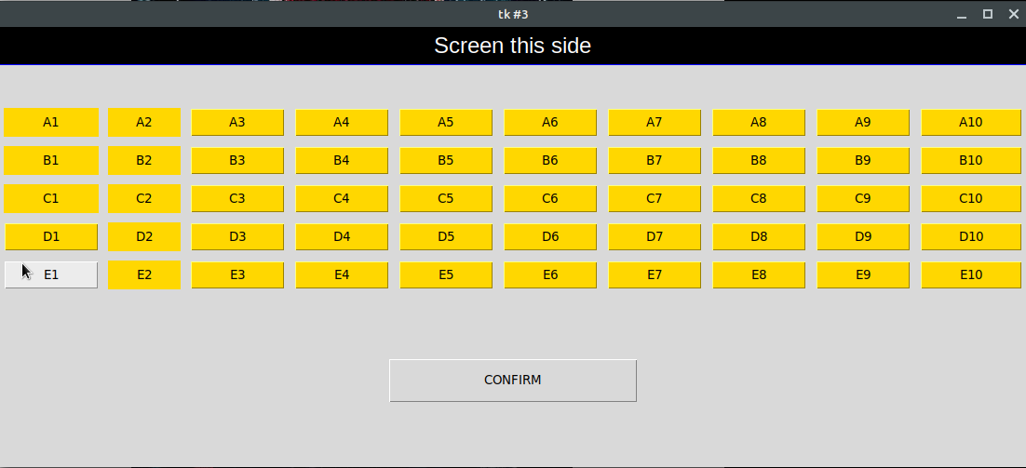

As you can see in the above image , the seats which have been booked already are displayed differently as labels and the available seats are displayed as buttons which can be clicked.

**The admin side :**

This portion is for the admin or the owner of the theatre or the booking counter at the theatre . Now the receipt code which the user has been allotted will be entered in the window and the booking will be confirmed and he will be allowed entry in the theater.

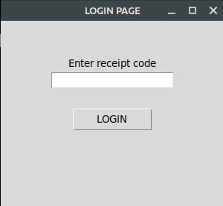

**IMPLEMENTATION PLAN**

We have used PYTHON language and specifically Tkinter toolkit for the GUI package. We have used sqlite3 for the database management of the users . And we have used MS Excel ( via openpyxl module ) to maintain a record of booked seats .