**IMED 120 Celebration of Knowledge (Open-Book)**

1. Explain what **Github Desktop** and **P5.JS** are:

Github is a powerful collaboration and project management tool for computer program. It’s designed to let people share coding projects with others and help manage those projects while allowing others to also contribute to the source code. P5.JS is a library that allows artists, designers, educators, and beginners to build computational projects in the browser. It is used for art, data visualization, and websites.

1. Explain to your family what **Media Computation** is, using only 3 sentences, and write it down below:

Media Computation is learning how to design and write basic programs using a programming language. In my course, I learned how to create various browser projects like a fully functional calculator that can calculate your tip percentage, a playable piano that allows users to press the piano keys to make a sound, and a paint program that allows users to draw on the browser canvas. Media computation allows you to visualize problems

1. Could you explain what the below code would do?

By creating variables for colors, you can easily refer to a color by typing the variable name rather than using a RBG color code/number. For example in the code given, “let outside = color(153, 51, 0);”, the color that the user wants the outside to be is (153, 51, 0), a brown color. So the user makes a variable with that specific color number to refer back to in their code in later usage.

1. Can you fix the bugs for the below code?

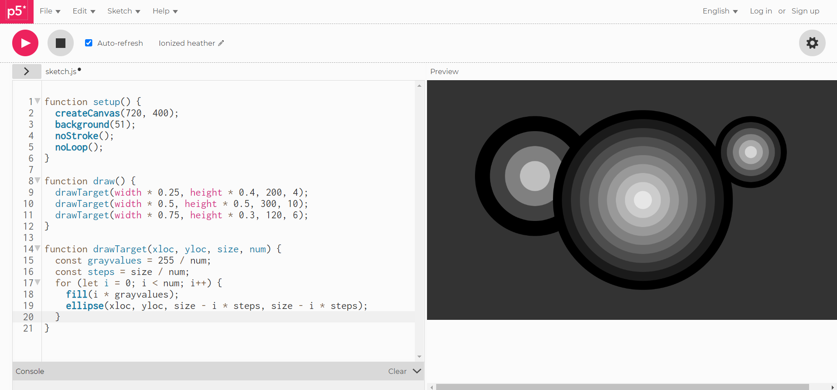

This is the correct code but I put into p5js editor to debug.

Line 4 – Missing end parenthesis “)” for noStroke();

Line 12 – Missing end bracket “}” for “function draw() {“

Line 21 – Missing end bracket “}” for “function drawTarget”

1. Write down at least one more thing you would like to learn about programming that we have not covered in the class.

I kinda wanted to learn more about the music player project that we did. I want to learn how to make a real music player that allows the user to control the duration of the song. The user can drag the circle across the line and the song will play at that point in the song. The music playlist was a fun project for me.

*If that wasn’t the appropriate answer to the question, then my other answer is that I want to learn how to make a website using p5js.*