- 题目要求
用Three.js装载、显示场景模型，能实现一定的漫游。

- 运行结果截图
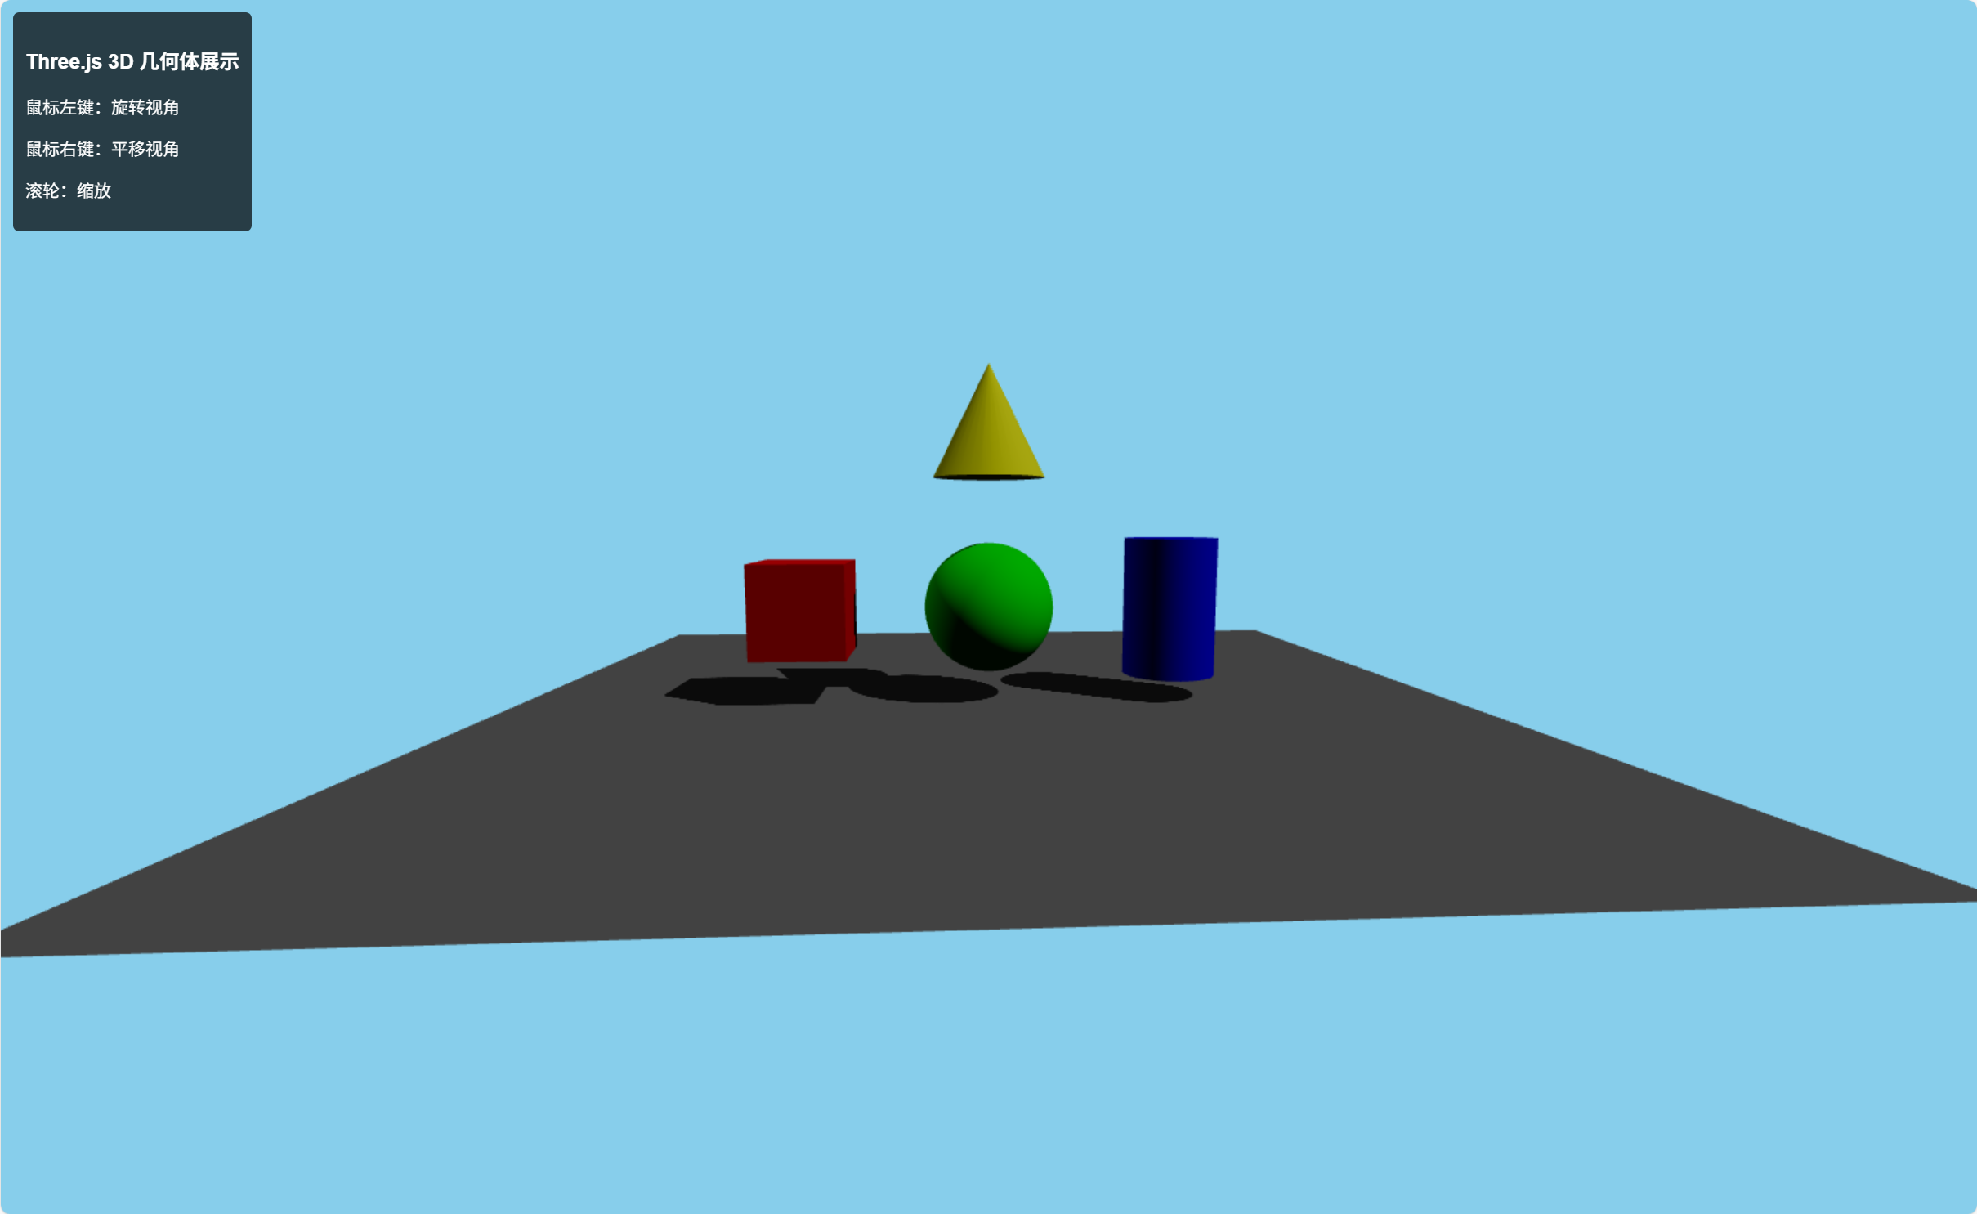
图表 1初始场景展示
内容描述：包含蓝色背景、红色立方体、绿色球体、蓝色圆柱、黄色圆锥，以及灰色地面。

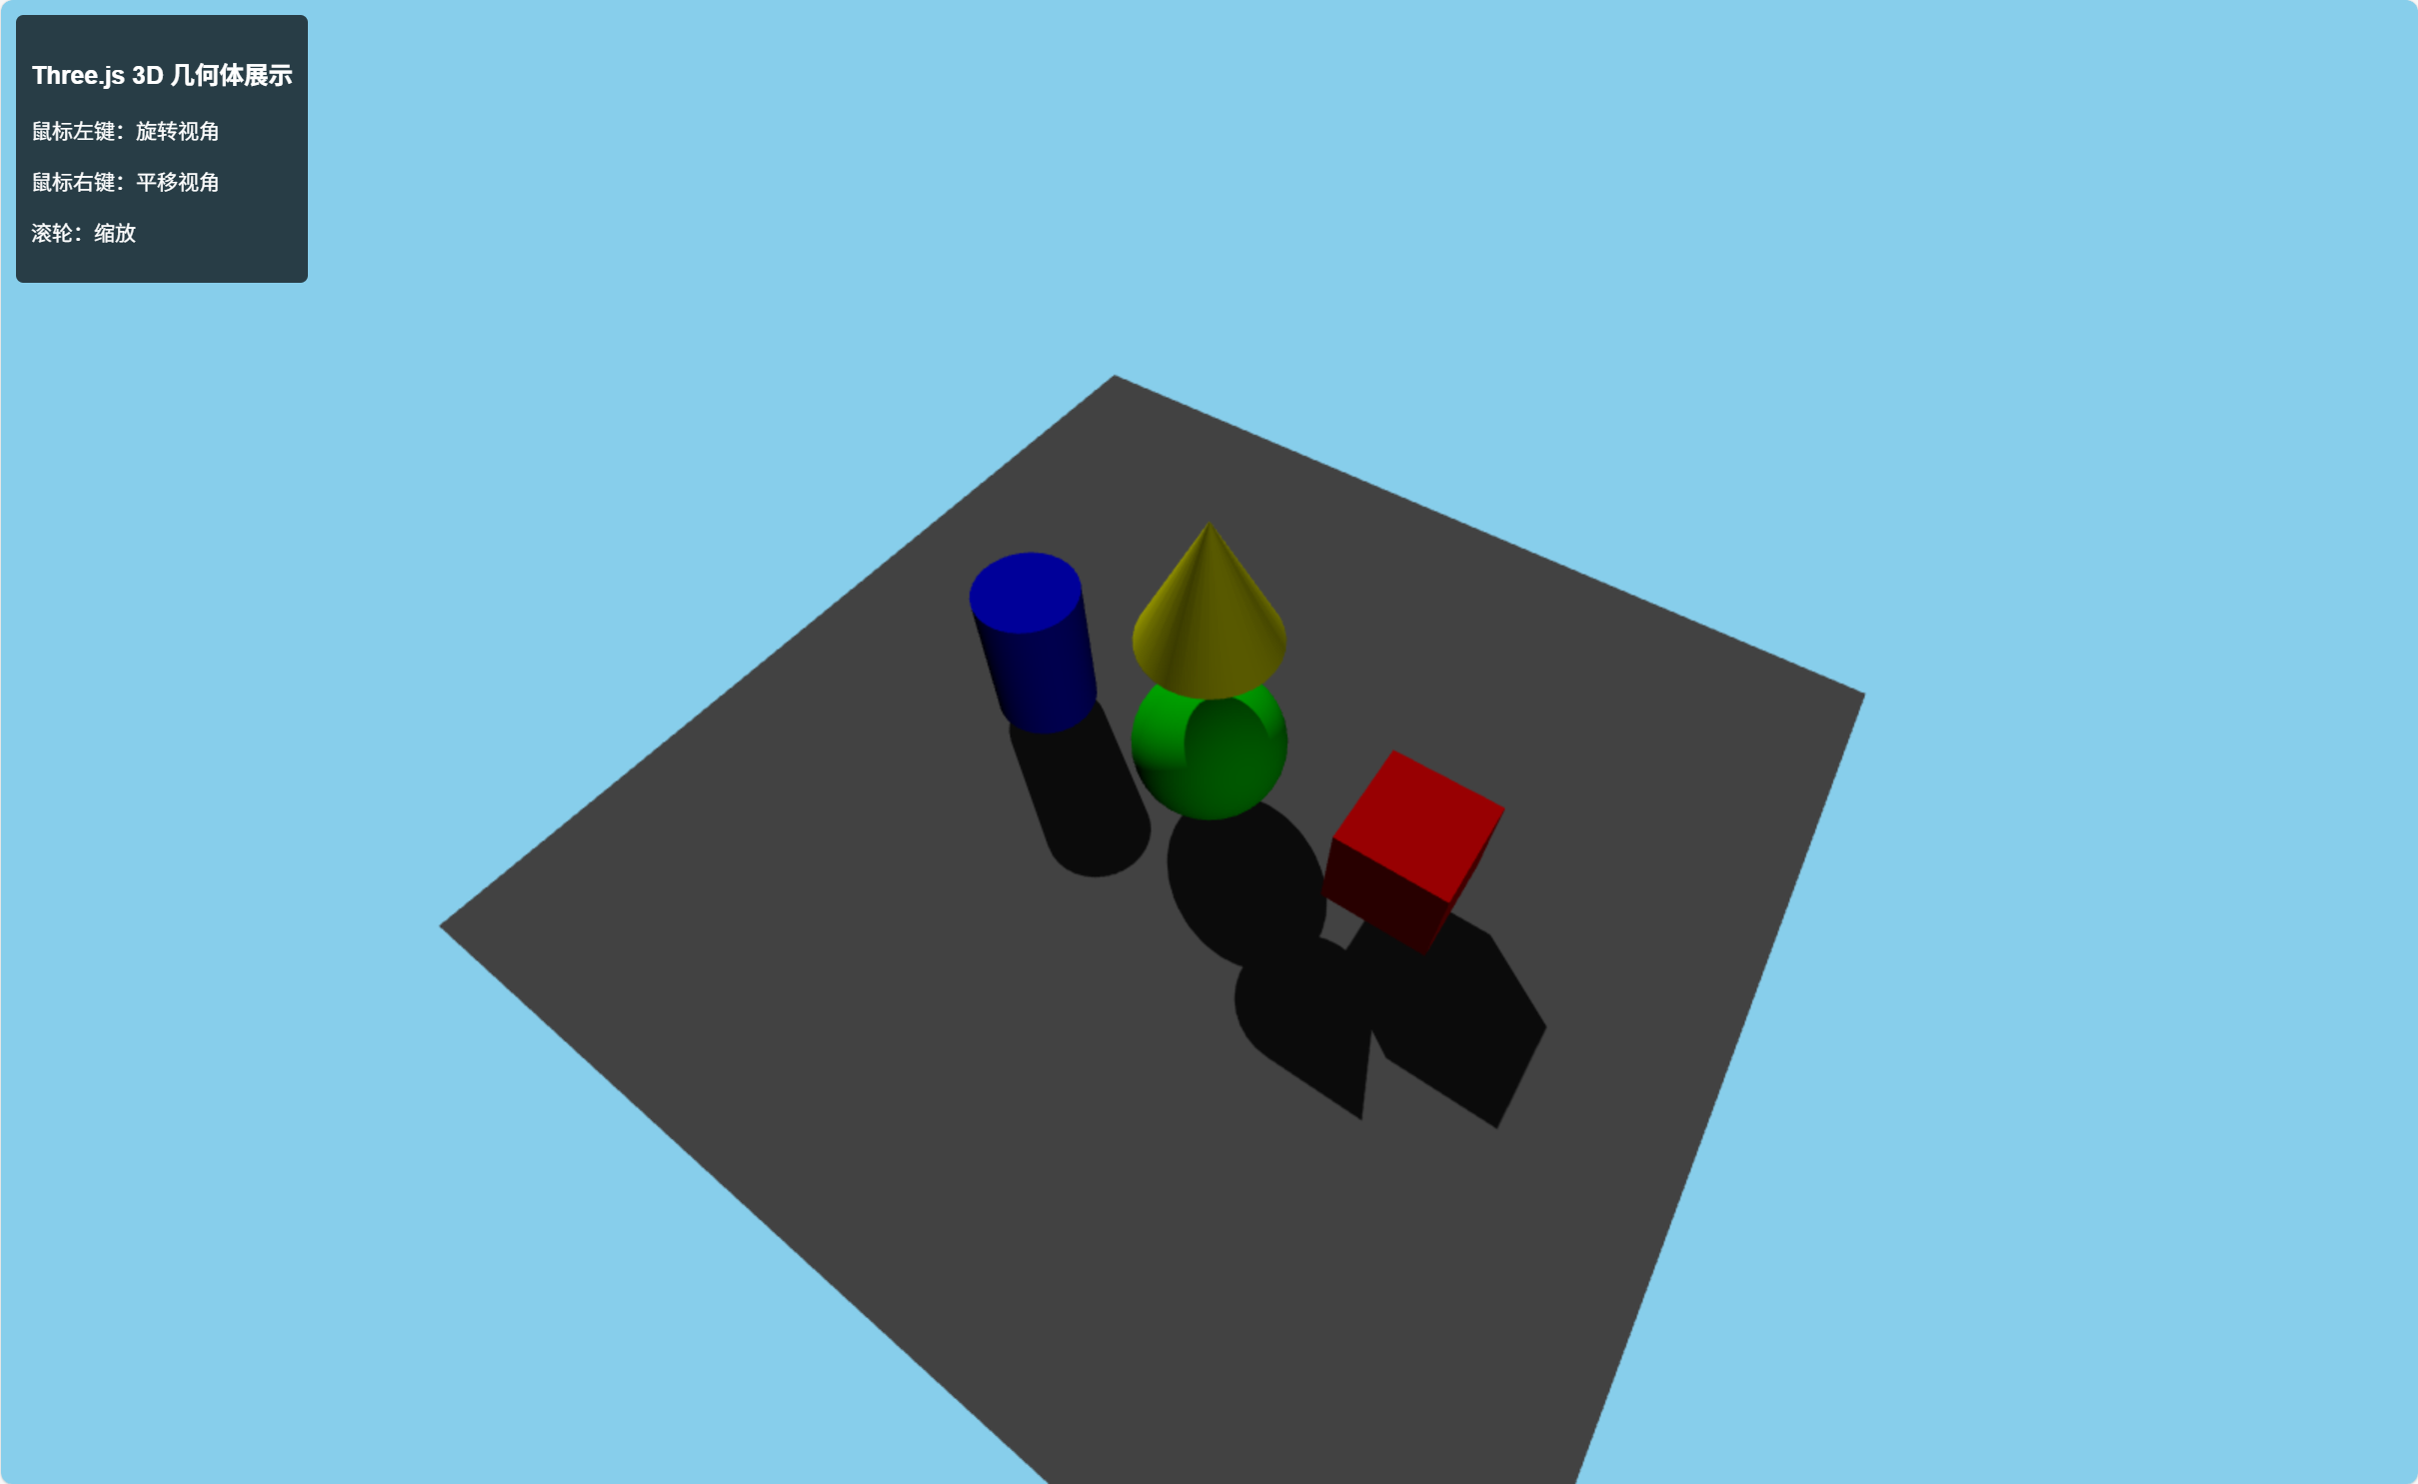
图表 2旋转视角效果
操作：按住鼠标左键拖动，改变观察角度。

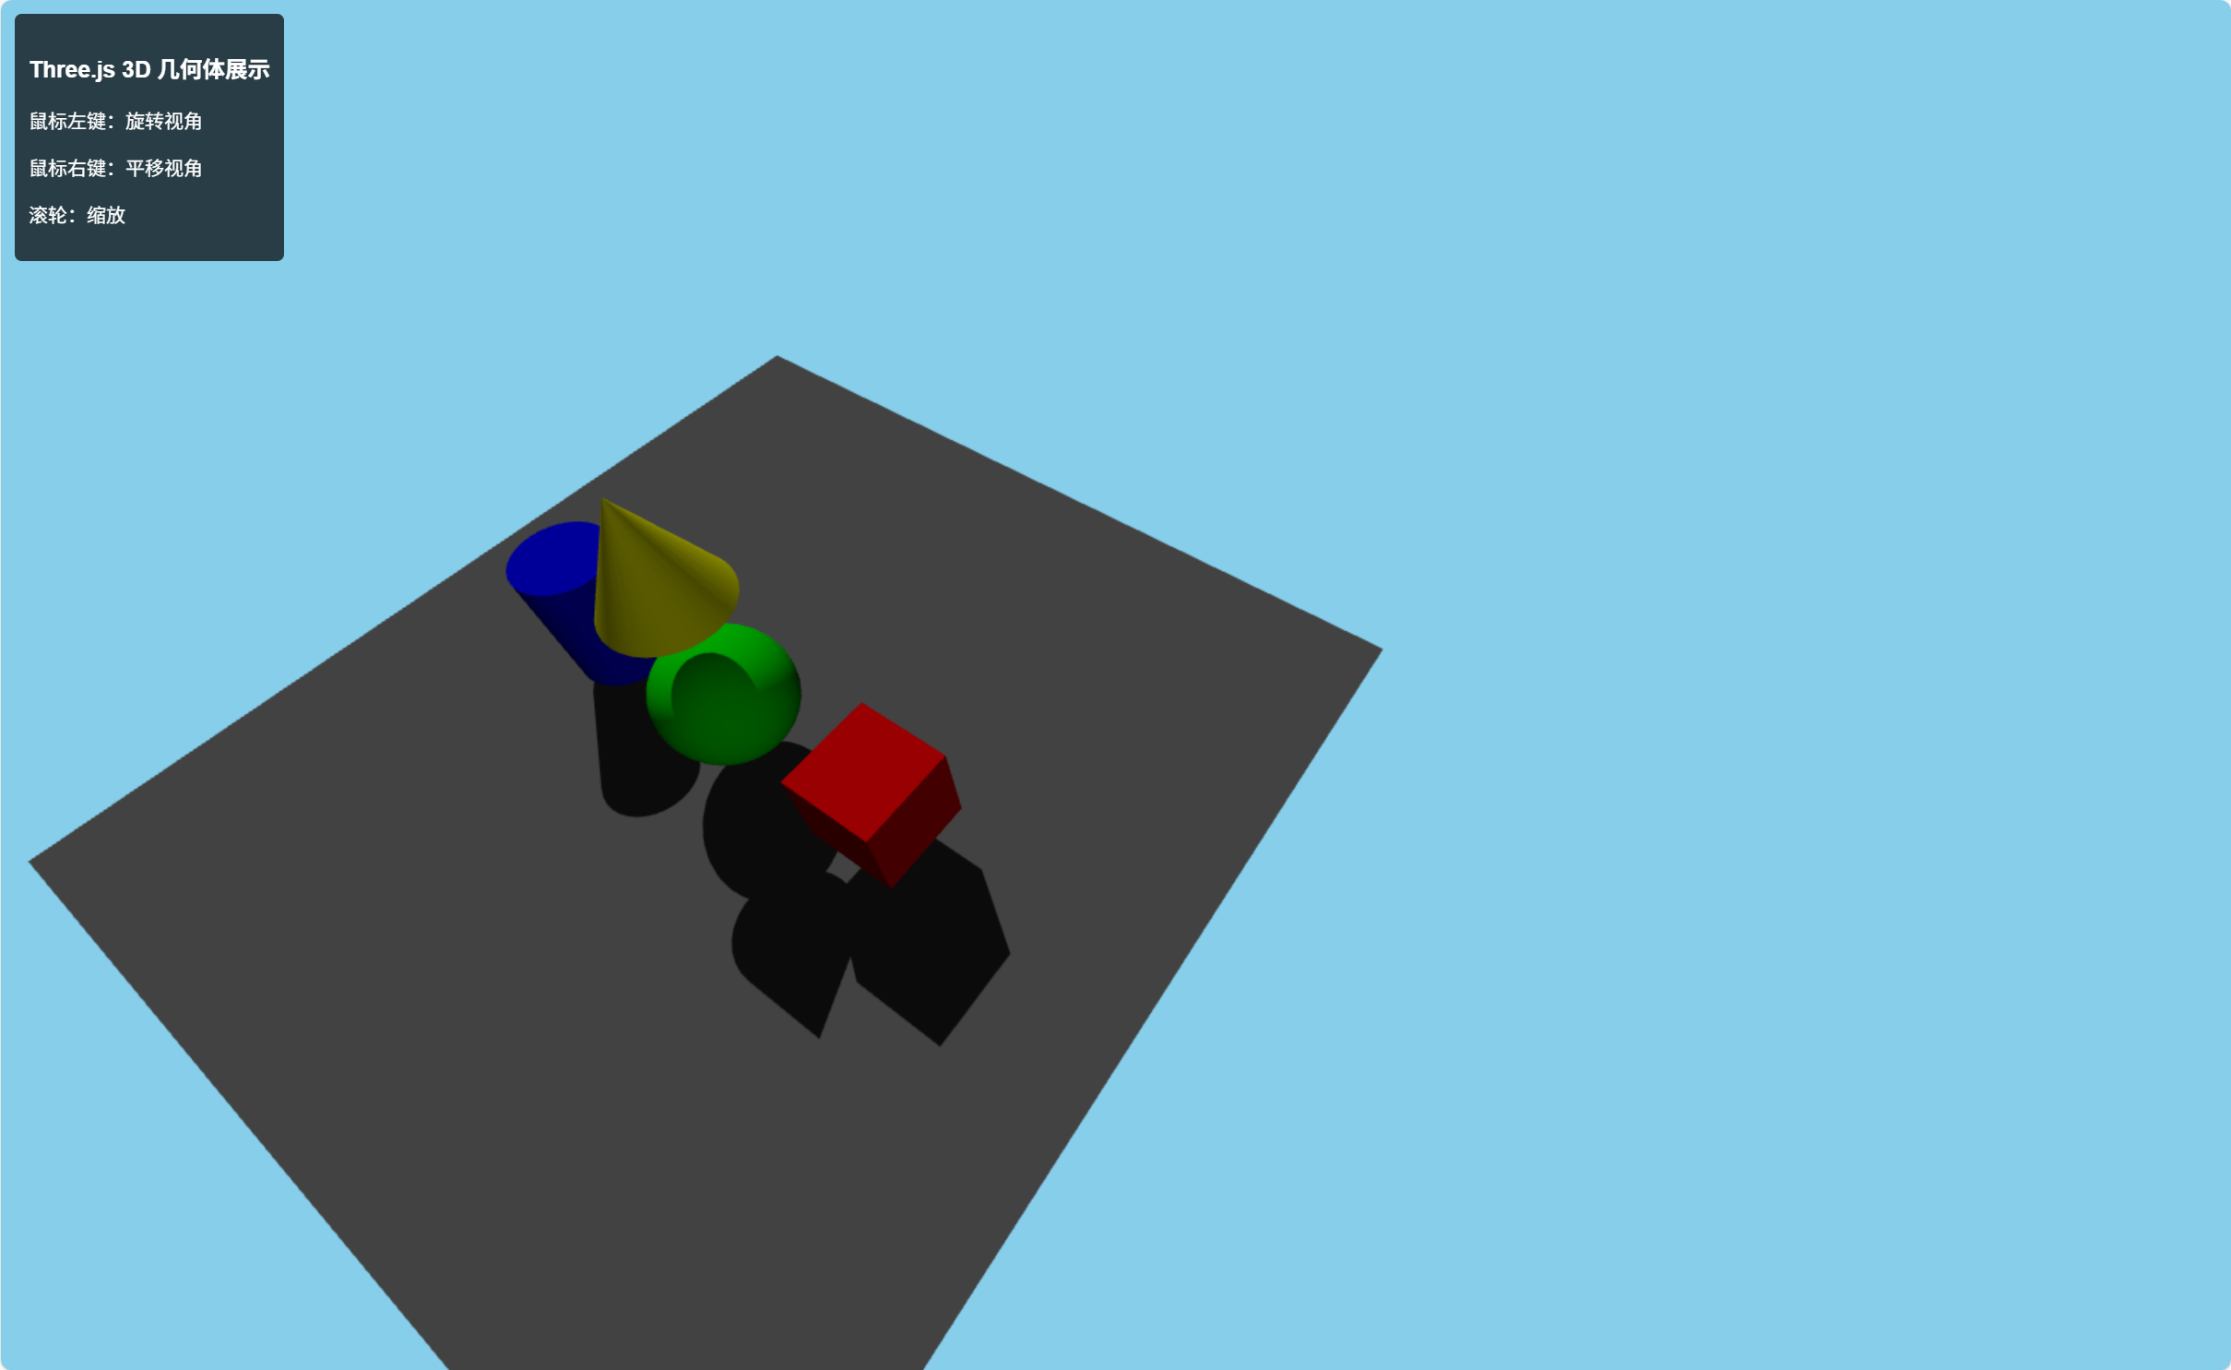
图表 3平移视角效果
操作：按住鼠标右键拖动，观察摄像机平移效果。
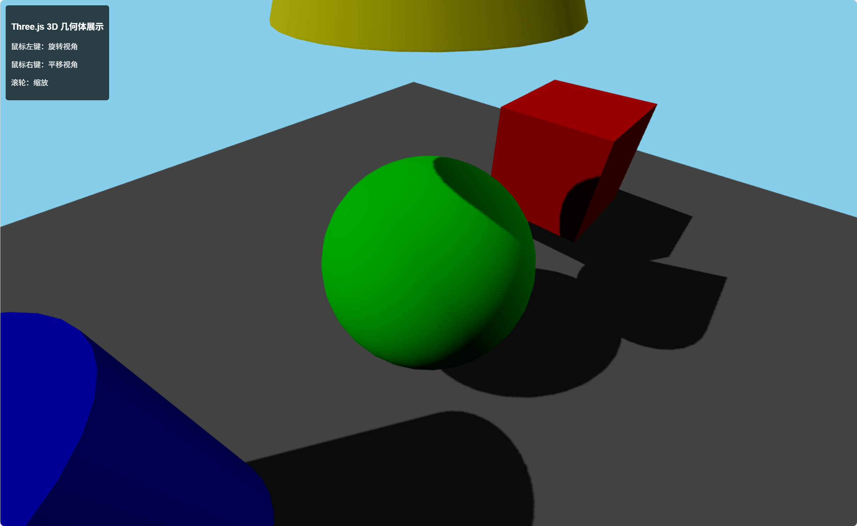
图表4缩放效果
操作：使用鼠标滚轮缩放镜头，展示远景与近景对比。

- 实现代码
HTML文件：index.html
<!DOCTYPE html>
<html lang="zh-CN">
<head>
<meta charset="UTF-8" />
<meta name="viewport" content="width=device-width, initial-scale=1.0"/>
<title>Three.js 几何体展示</title>
<style>
body {
margin: 0;
padding: 0;
background-color: #000;
font-family: Arial, sans-serif;
overflow: hidden;
}
#container {
width: 100vw;
height: 100vh;
}
#info {
position: absolute;
top: 10px;
left: 10px;
color: white;
background: rgba(0, 0, 0, 0.7);
padding: 10px;
border-radius: 5px;
font-size: 14px;
z-index: 100;
}
</style>
</head>
<body>
<div id="container"></div>
<div id="info">
<h3>Three.js 3D 几何体展示</h3>
<p>鼠标左键：旋转视角</p>
<p>鼠标右键：平移视角</p>
<p>滚轮：缩放</p>
</div>
<script src="https://unpkg.com/three@0.158.0/build/three.min.js"></script>
<script>
let scene, camera, renderer;
let model = null;
window.addEventListener('load', function() {
setTimeout(init, 50);
});
function init() {
scene = new THREE.Scene();
scene.background = new THREE.Color(0x87CEEB);
camera = new THREE.PerspectiveCamera(75, window.innerWidth / window.innerHeight, 0.1, 1000);
camera.position.set(5, 5, 5);
renderer = new THREE.WebGLRenderer({ antialias: true });
renderer.setSize(window.innerWidth, window.innerHeight);
renderer.shadowMap.enabled = true;
renderer.shadowMap.type = THREE.PCFSoftShadowMap;
renderer.toneMapping = THREE.ACESFilmicToneMapping;
renderer.toneMappingExposure = 1;
const container = document.getElementById('container');
container.appendChild(renderer.domElement);
setupMouseControls();
setupLighting();
createTestGeometry();
window.addEventListener('resize', onWindowResize);
animate();
}
function createTestGeometry() {
const geometries = [
{ geo: new THREE.BoxGeometry(1, 1, 1), color: 0xff0000, pos: [-2, 0, 0] },
{ geo: new THREE.SphereGeometry(0.7, 32, 32), color: 0x00ff00, pos: [0, 0, 0] },
{ geo: new THREE.CylinderGeometry(0.5, 0.5, 1.5, 32), color: 0x0000ff, pos: [2, 0, 0] },
{ geo: new THREE.ConeGeometry(0.6, 1.2, 32), color: 0xffff00, pos: [0, 2, 0] }
];
geometries.forEach(item => {
const material = new THREE.MeshLambertMaterial({ color: item.color });
const mesh = new THREE.Mesh(item.geo, material);
mesh.position.set(item.pos[0], item.pos[1], item.pos[2]);
mesh.castShadow = true;
mesh.receiveShadow = true;
scene.add(mesh);
});
const groundGeometry = new THREE.PlaneGeometry(10, 10);
const groundMaterial = new THREE.MeshLambertMaterial({ color: 0x888888 });
const ground = new THREE.Mesh(groundGeometry, groundMaterial);
ground.rotation.x = -Math.PI / 2;
ground.position.y = -1;
ground.receiveShadow = true;
scene.add(ground);
camera.position.set(5, 5, 5);
camera.lookAt(0, 0, 0);
}
function setupLighting() {
const ambientLight = new THREE.AmbientLight(0x404040, 0.6);
scene.add(ambientLight);
const directionalLight = new THREE.DirectionalLight(0xffffff, 1.0);
directionalLight.position.set(15, 20, 10);
directionalLight.castShadow = true;
directionalLight.shadow.mapSize.width = 2048;
directionalLight.shadow.mapSize.height = 2048;
scene.add(directionalLight);
const fillLight = new THREE.DirectionalLight(0xffffff, 0.3);
fillLight.position.set(-10, 5, -5);
scene.add(fillLight);
}
function onWindowResize() {
camera.aspect = window.innerWidth / window.innerHeight;
camera.updateProjectionMatrix();
renderer.setSize(window.innerWidth, window.innerHeight);
}
function setupMouseControls() {
const container = document.getElementById('container');
let isLeftMouseDown = false;
let isRightMouseDown = false;
let mouseX = 0, mouseY = 0;
container.addEventListener('mousedown', function(event) {
if (event.button === 0) isLeftMouseDown = true;
else if (event.button === 2) isRightMouseDown = true;
mouseX = event.clientX;
mouseY = event.clientY;
});
container.addEventListener('mouseup', function(event) {
if (event.button === 0) isLeftMouseDown = false;
else if (event.button === 2) isRightMouseDown = false;
});
container.addEventListener('mousemove', function(event) {
if (isLeftMouseDown) {
const deltaX = event.clientX - mouseX;
const deltaY = event.clientY - mouseY;
const spherical = new THREE.Spherical();
spherical.setFromVector3(camera.position);
spherical.theta -= deltaX * 0.01;
spherical.phi += deltaY * 0.01;
spherical.phi = Math.max(0.1, Math.min(Math.PI - 0.1, spherical.phi));
camera.position.setFromSpherical(spherical);
camera.lookAt(0, 0, 0);
mouseX = event.clientX;
mouseY = event.clientY;
} else if (isRightMouseDown) {
const deltaX = event.clientX - mouseX;
const deltaY = event.clientY - mouseY;
const right = new THREE.Vector3();
right.crossVectors(camera.up, camera.getWorldDirection(new THREE.Vector3())).normalize();
const up = camera.up.clone();
const moveSpeed = 0.01;
camera.position.addScaledVector(right, -deltaX * moveSpeed);
camera.position.addScaledVector(up, deltaY * moveSpeed);
mouseX = event.clientX;
mouseY = event.clientY;
}
});
container.addEventListener('wheel', function(event) {
const scale = event.deltaY > 0 ? 1.1 : 0.9;
camera.position.multiplyScalar(scale);
event.preventDefault();
});
container.addEventListener('contextmenu', function(event) {
event.preventDefault();
});
}
function animate() {
requestAnimationFrame(animate);
renderer.render(scene, camera);
}
</script>
</body>
</html>

四、结果说明
该程序成功使用 Three.js 构建了一个可交互的三维场景，实现了基本漫游功能。可以通过鼠标旋转、平移和缩放视角自由观察模型，场景中光照柔和、阴影自然，能够直观展示多种几何体模型的空间关系。

