Change default access port 3389 to other (3489 for example)

**VM**--**Run command**--**SetRDPort**

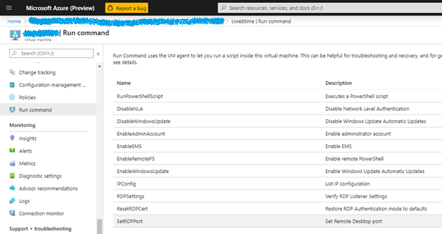

Input New port number and click "Run"

Machine generated alternative text:
RunCommandScript
5RD；；00
．Scriptexecution[0m0已
Details
Setsthe0斷30toruserspecifiedportn」m「formo怛Desktop《onnectio的．Enables力wrulefo「inbo」nd彐e巧tothe些也
丷Script
Parameters
RDPPORT《
Output
GetRW：3389
Setting甲PortNuÖerto3489

Script to run:

|  |
| --- |
| param($RDPPort=3389)  $TSPath = 'HKLM:\SYSTEM\CurrentControlSet\Control\Terminal Server'  $RDPTCPpath = $TSPath + '\Winstations\RDP-Tcp'  Set-ItemProperty -Path $TSPath -name 'fDenyTSConnections' -Value 0  # RDP port  $portNumber = (Get-ItemProperty -Path $RDPTCPpath -Name 'PortNumber').PortNumber  Write-Host Get RDP PortNumber: $portNumber  if (!($portNumber -eq $RDPPort))  {    Write-Host Setting RDP PortNumber to $RDPPort    Set-ItemProperty -Path $RDPTCPpath -name 'PortNumber' -Value $RDPPort    Restart-Service TermService -force  }  #Setup firewall rules  if ($RDPPort -eq 3389)  {    netsh advfirewall firewall set rule group="remote desktop" new Enable=Yes  }  else  {    $systemroot = get-content env:systemroot    netsh advfirewall firewall add rule name="Remote Desktop - Custom Port" `  dir=in program=$systemroot\system32\svchost.exe service=termservice action=allow `  protocol=TCP localport=$RDPPort enable=yes  } |

Then **VM**—**Netwroking**—Select the line to control RDP access in **Inbound port rules**

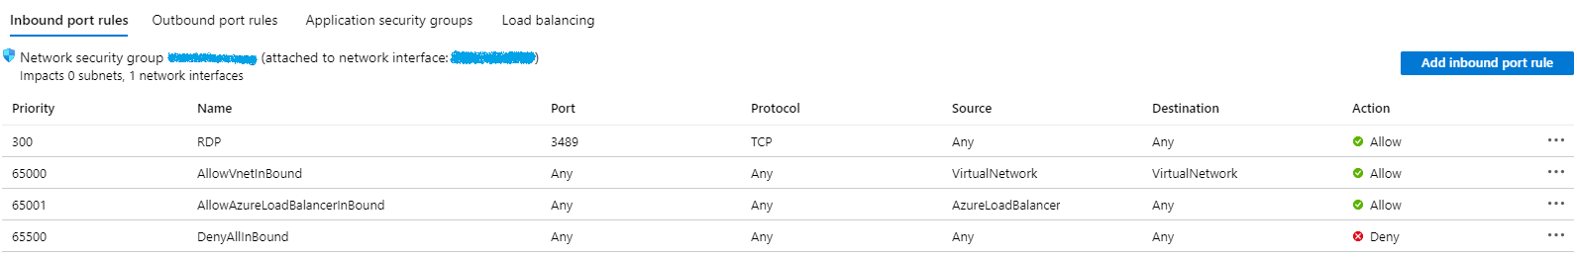

And change the Destination port ranges number to the new one(3489 in this example)

