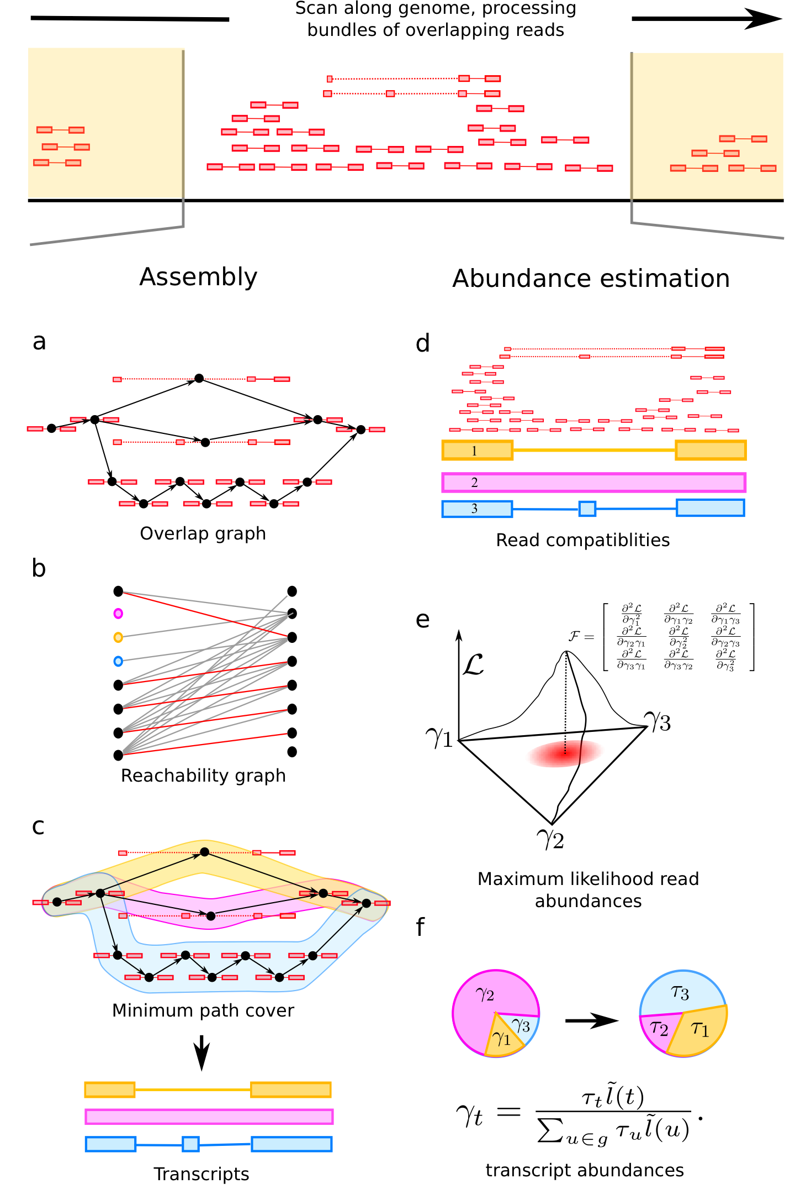
Figure 1 An overview of Cufflinks. The algorithm assembles read alignments by loci (a-b), and then estimates the abundances of the assembled transcripts (d-e). To assemble, Cufflinks (a) stores the pairwise compatibilities between overlapping alignments in a directed acyclic graph, (b) extends compatibilities to non-overlapping alignments by following paths between pairs, and uses the resulting bipartite graph to (c) build a minimum path cover of the overlap graph via Dilworth’s theorem. Each element of the cover corresponds to one of a minimal set of transcripts. To estimate their abundances, Cufflinks (d) calculates the probability of observing each fragment according to a model of RNA-Seq. These probabilities are used as constants in a linear statistical model with a unique maximum likelihood, which Cufflinks (e) finds using a numerical algorithm. The parameters of this model correspond to the fraction of fragments in the experiment that originate from each transcript. (f) Cufflinks converts these fractions into the relative abundances for each transcript.
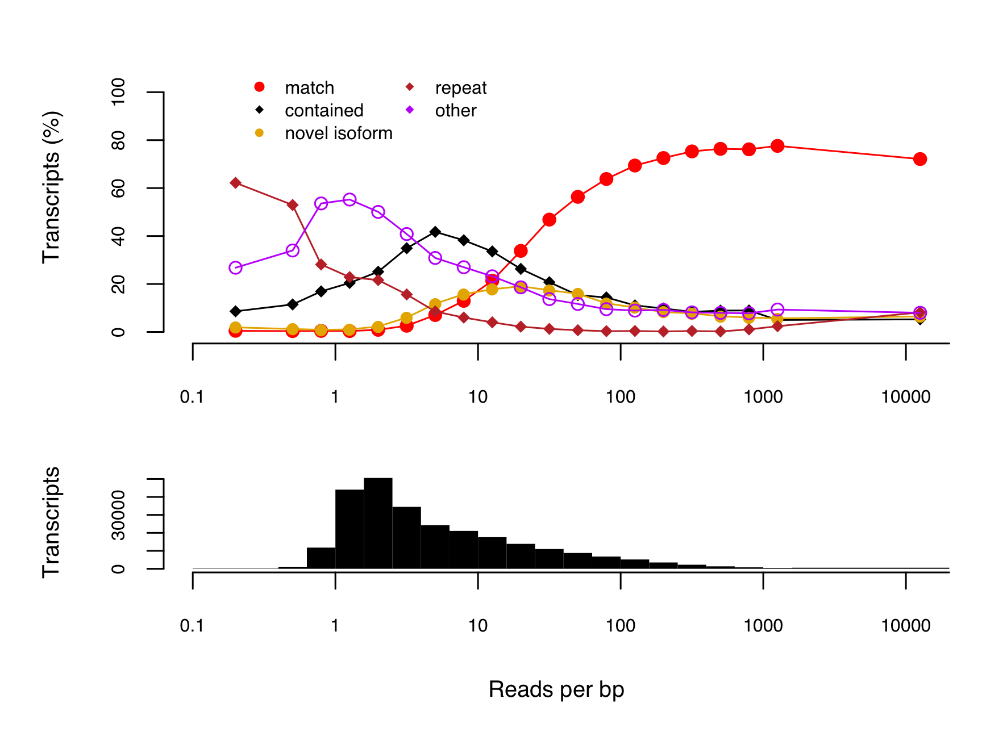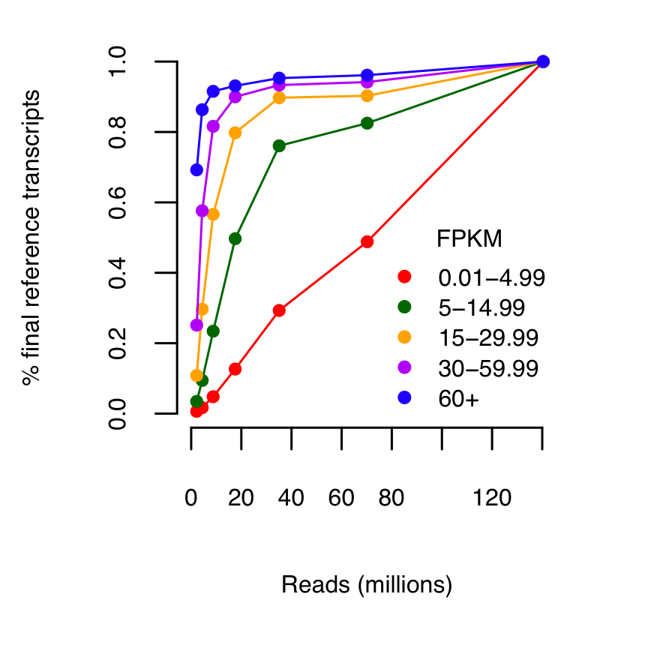
Figure 2 (a) Categorization of Cufflinks transcripts by estimated depth of read coverage. (b) Transcript recovery as a function of depth of sequencing

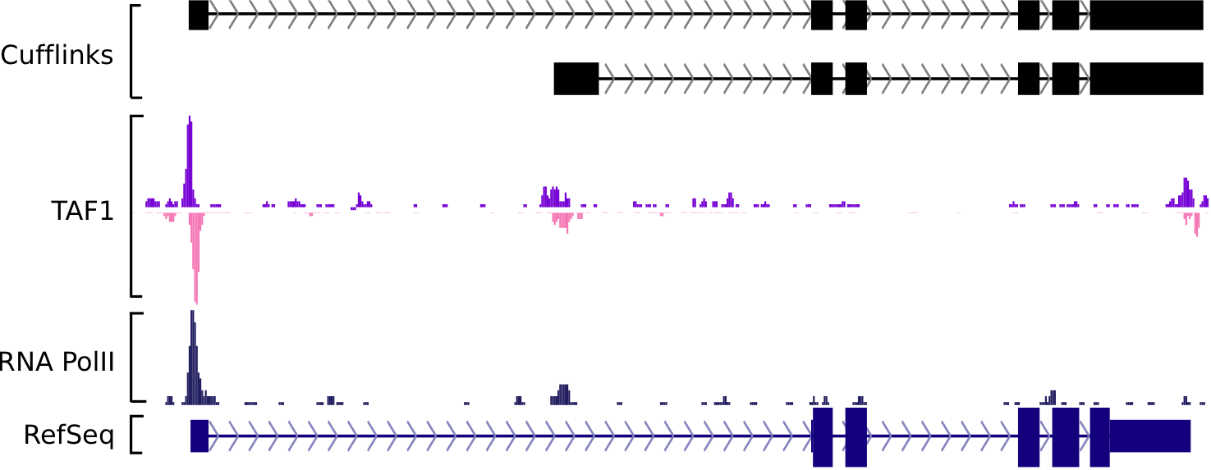

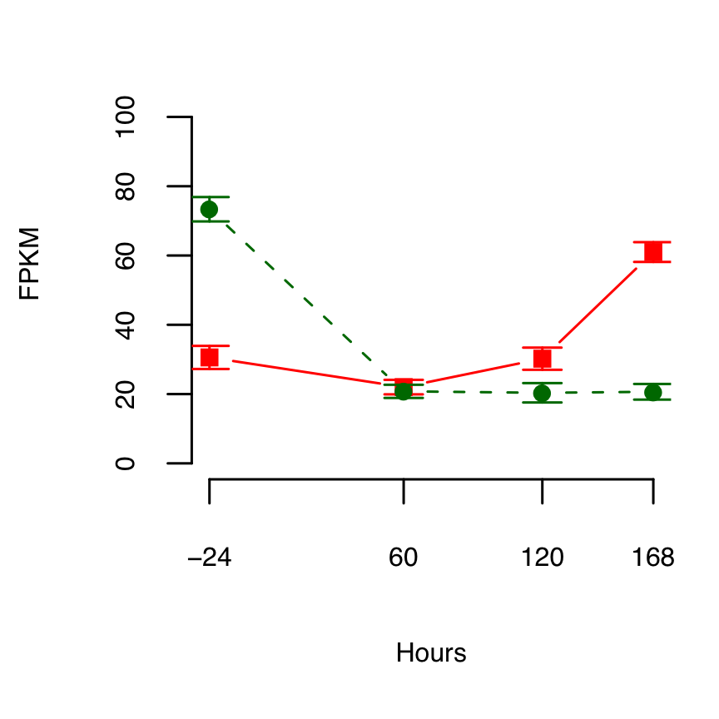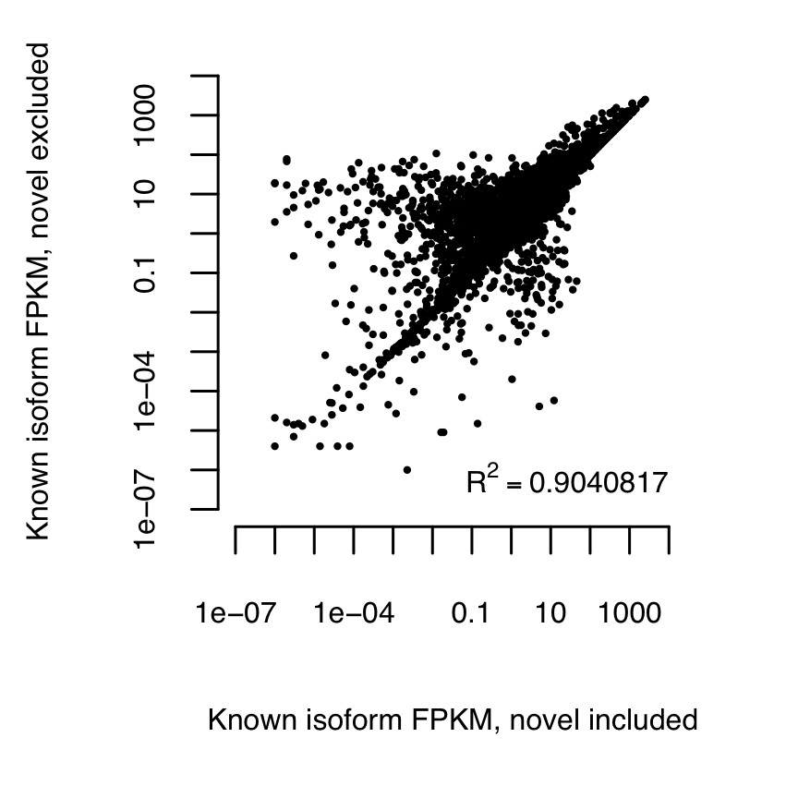
Figure 3 Excluding isoforms discovered by Cufflinks from the software’s transcript abundance estimation impacts the abundance estimates of known isoforms, in some cases by orders of magnitude. . Four-and-a-half-LIM domains 3 (Fhl3) inhibits myogenesis by binding MyoD and attenuating its transcriptional activity. The C2C12 transcriptome contains a novel isoform which is dominant during proliferation. The known isoform is preferred at time points following differentiation.
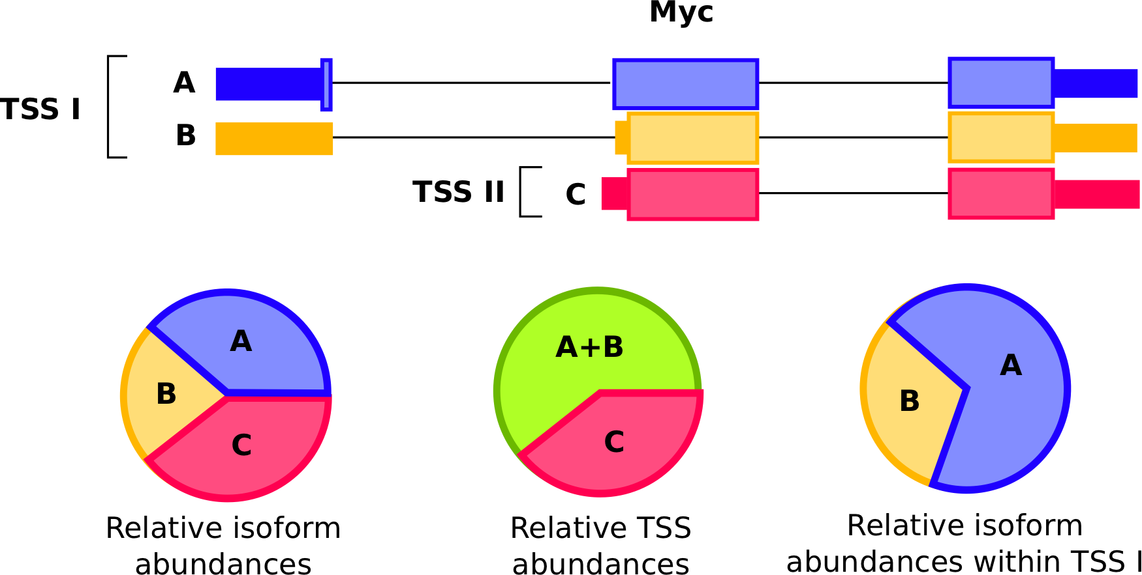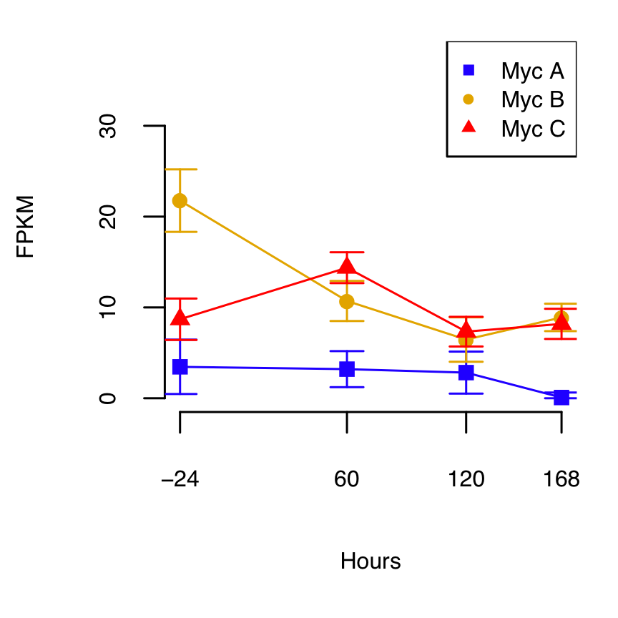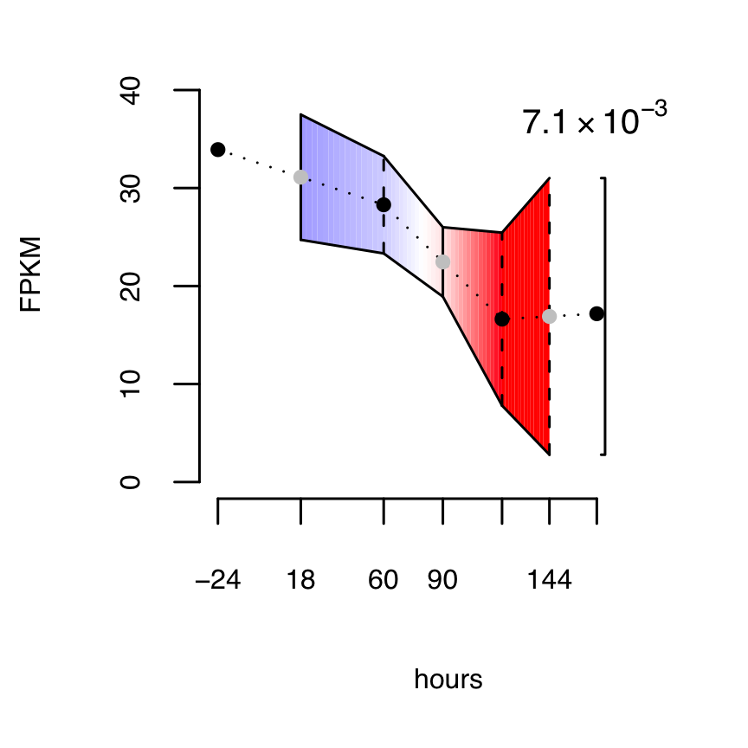 Figure 4 Distinction of transcriptional and post-transcriptional regulatory effects on overall transcript output. (a) When abundances of isoforms A, B, and C of Myc are grouped by TSS, changes in the relative abundances of the TSS groups indicate transcriptional regulation, where post-transcriptional effects are seen in changes in levels of isoforms of a single group. (b) Myc isoforms are being downregulated as the timecourse proceeds. Changes in relative abundances suggest that transcriptional effects immediately following differentiation at 0 hours give way to post-transcriptional effects later in the time course, as isoform A is eliminated.
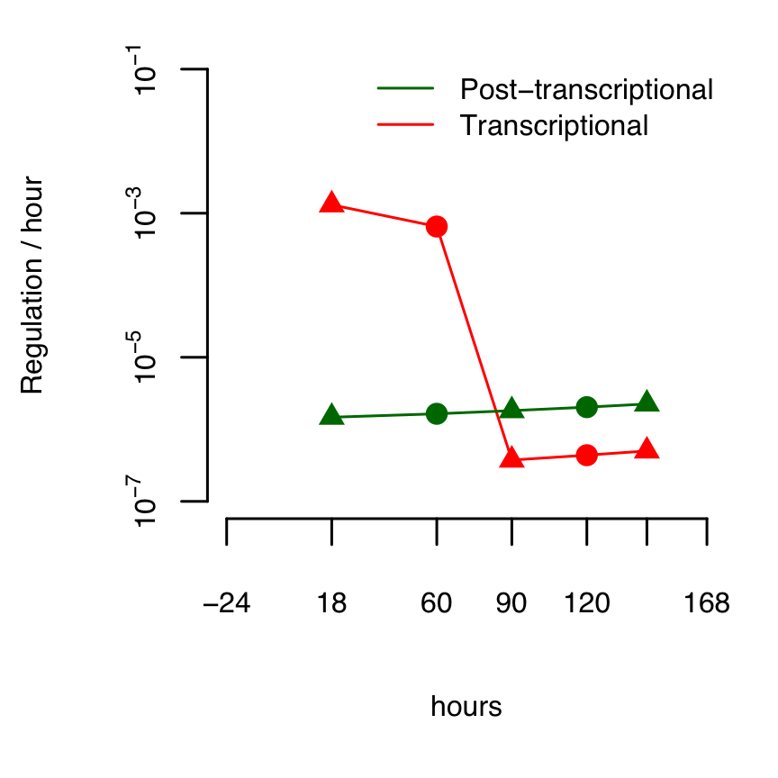
Figure 5 Averaging the rates regulation over the C2C12 transcriptome reveals a relatively stable rate of post-transcriptional regulation, contrasted with dramatically higher rate of post-transcriptional regulation immediately following differentiation.
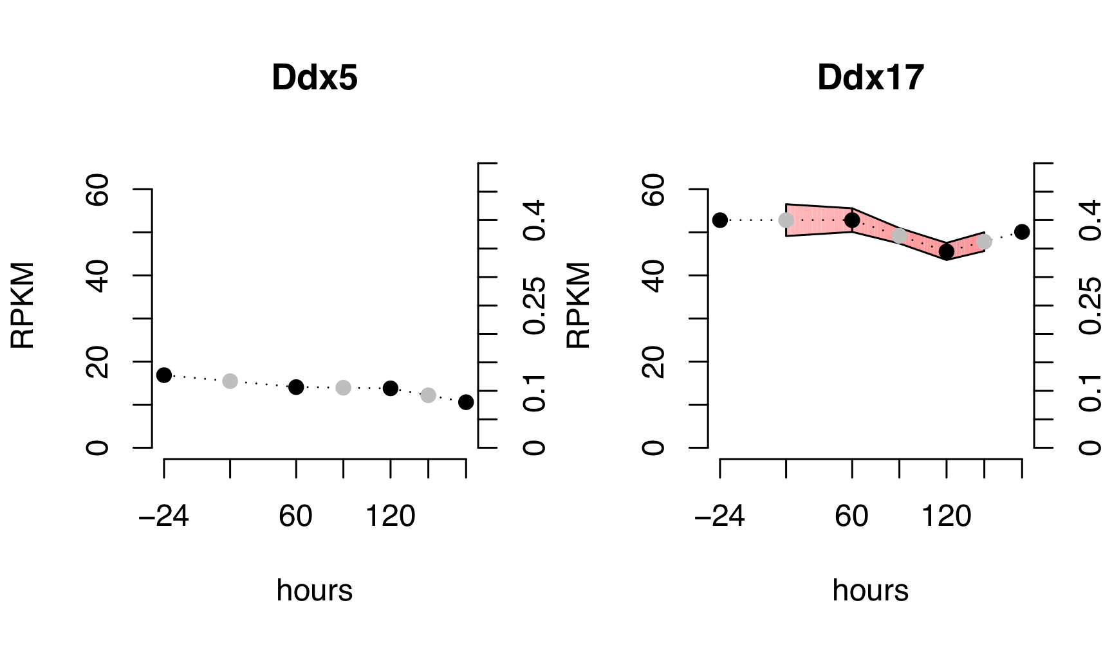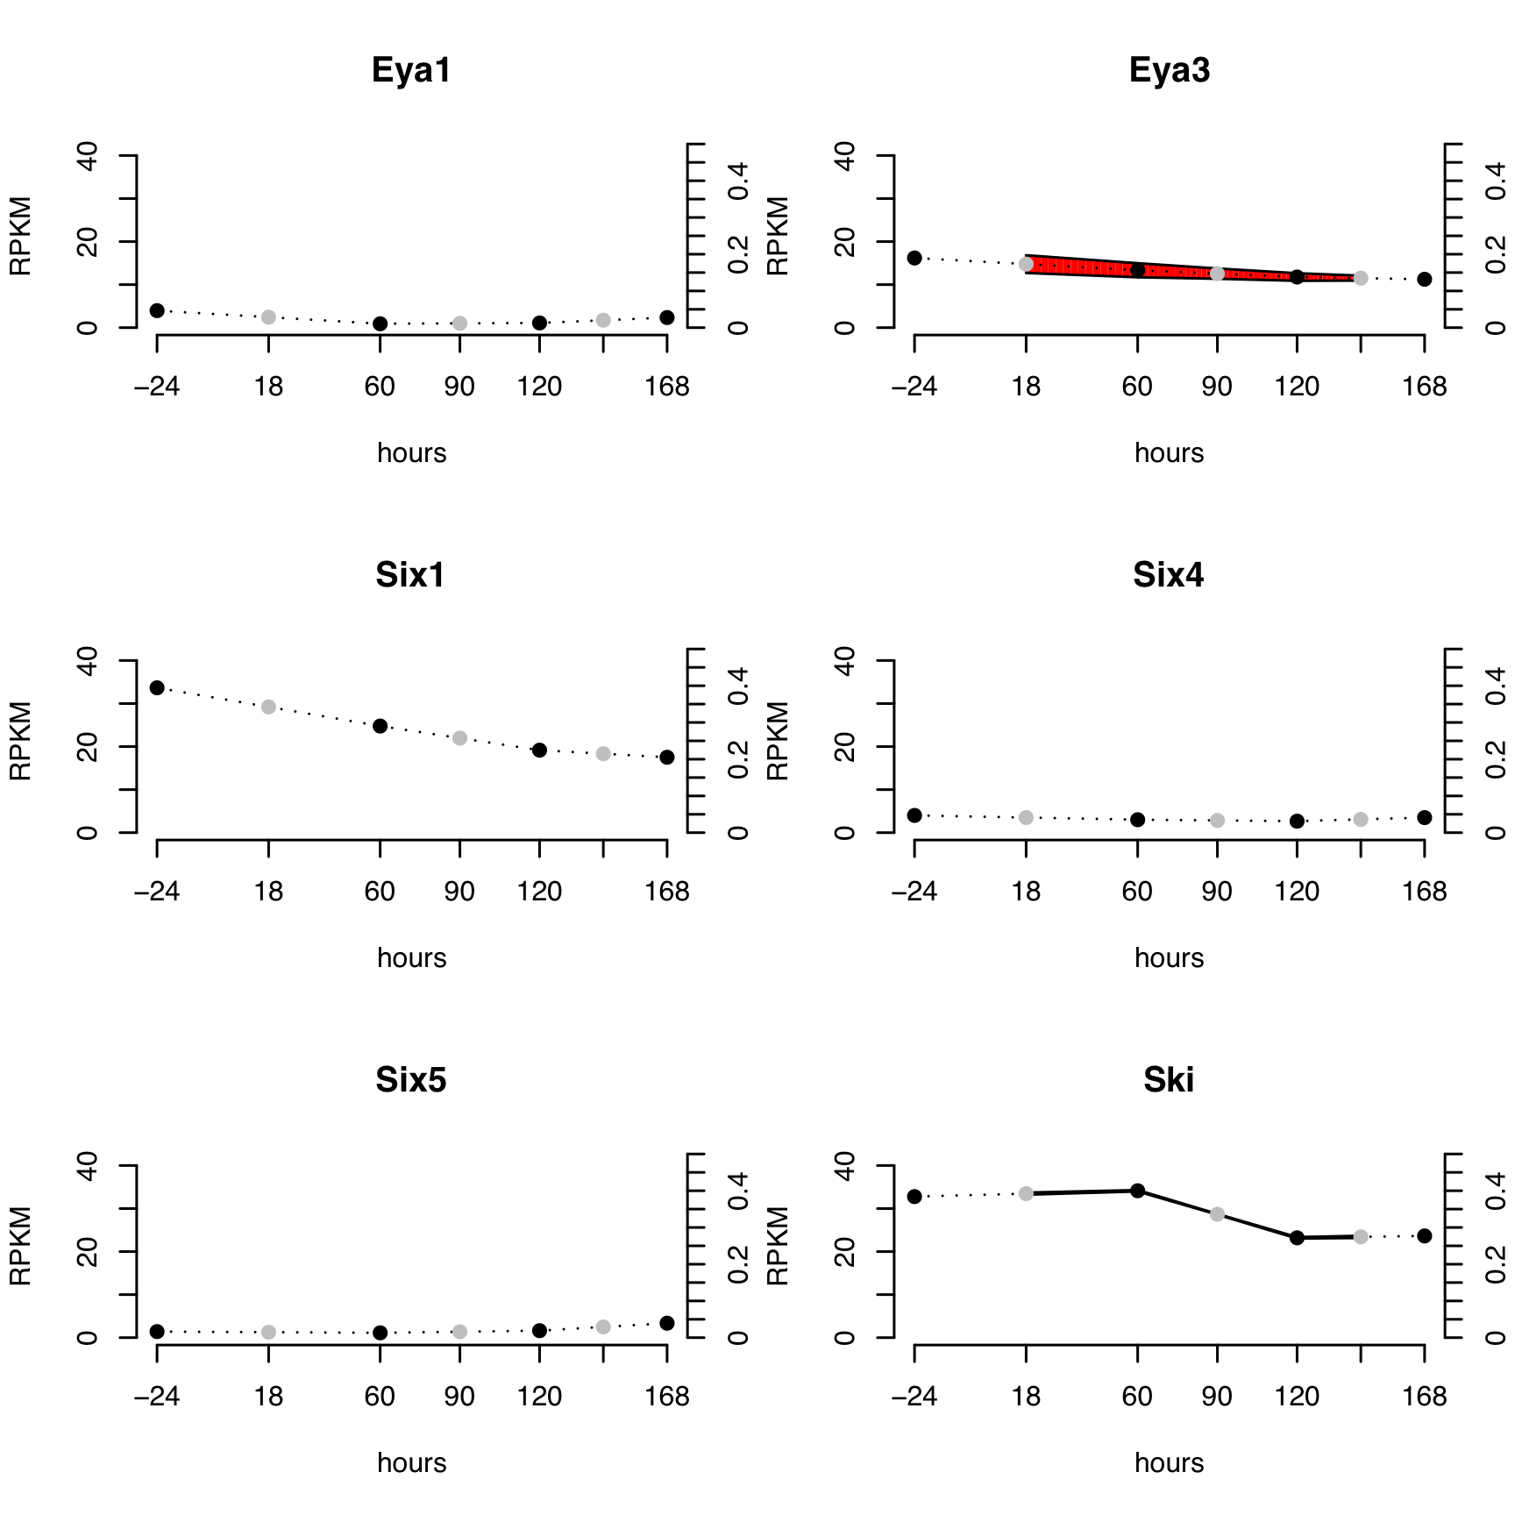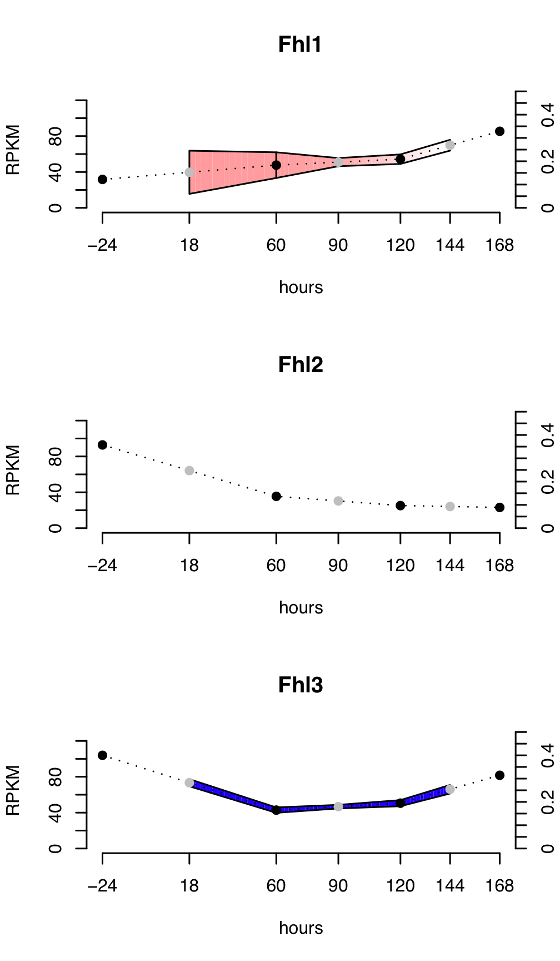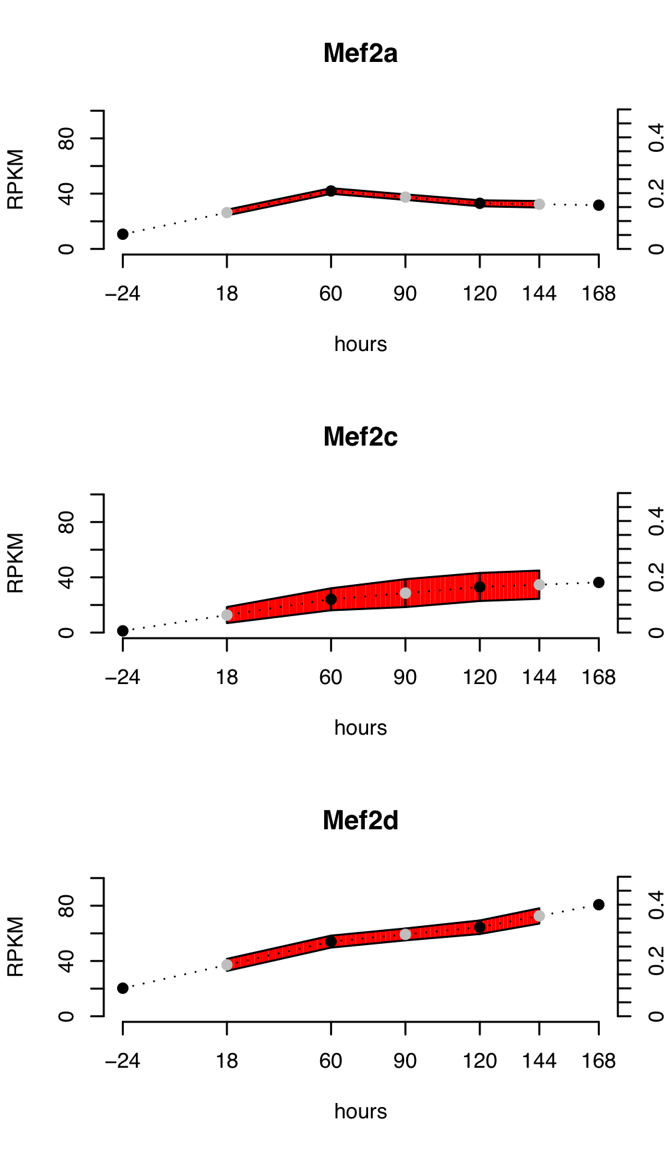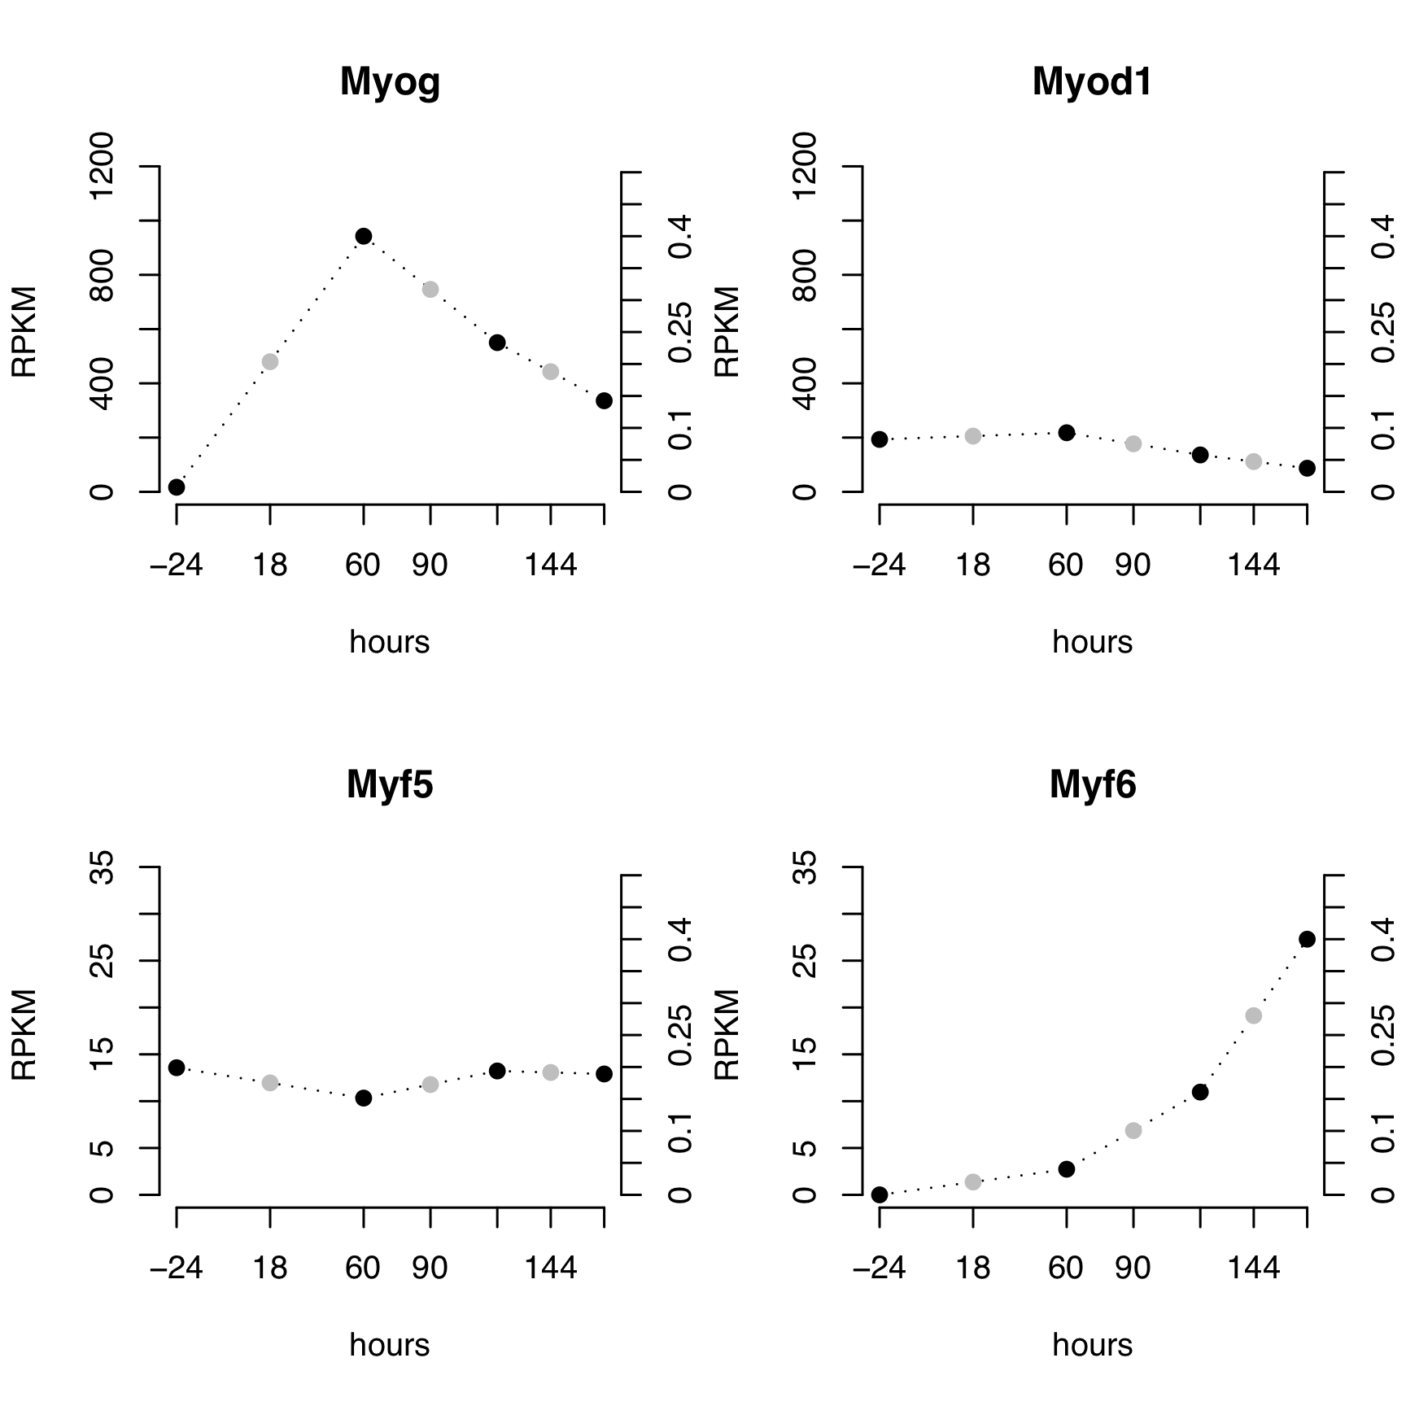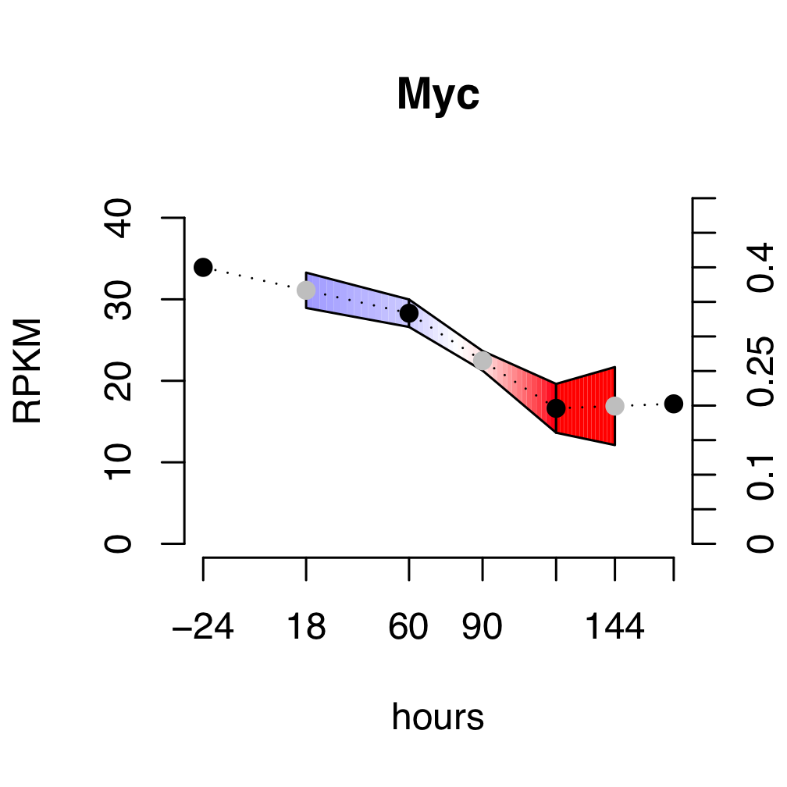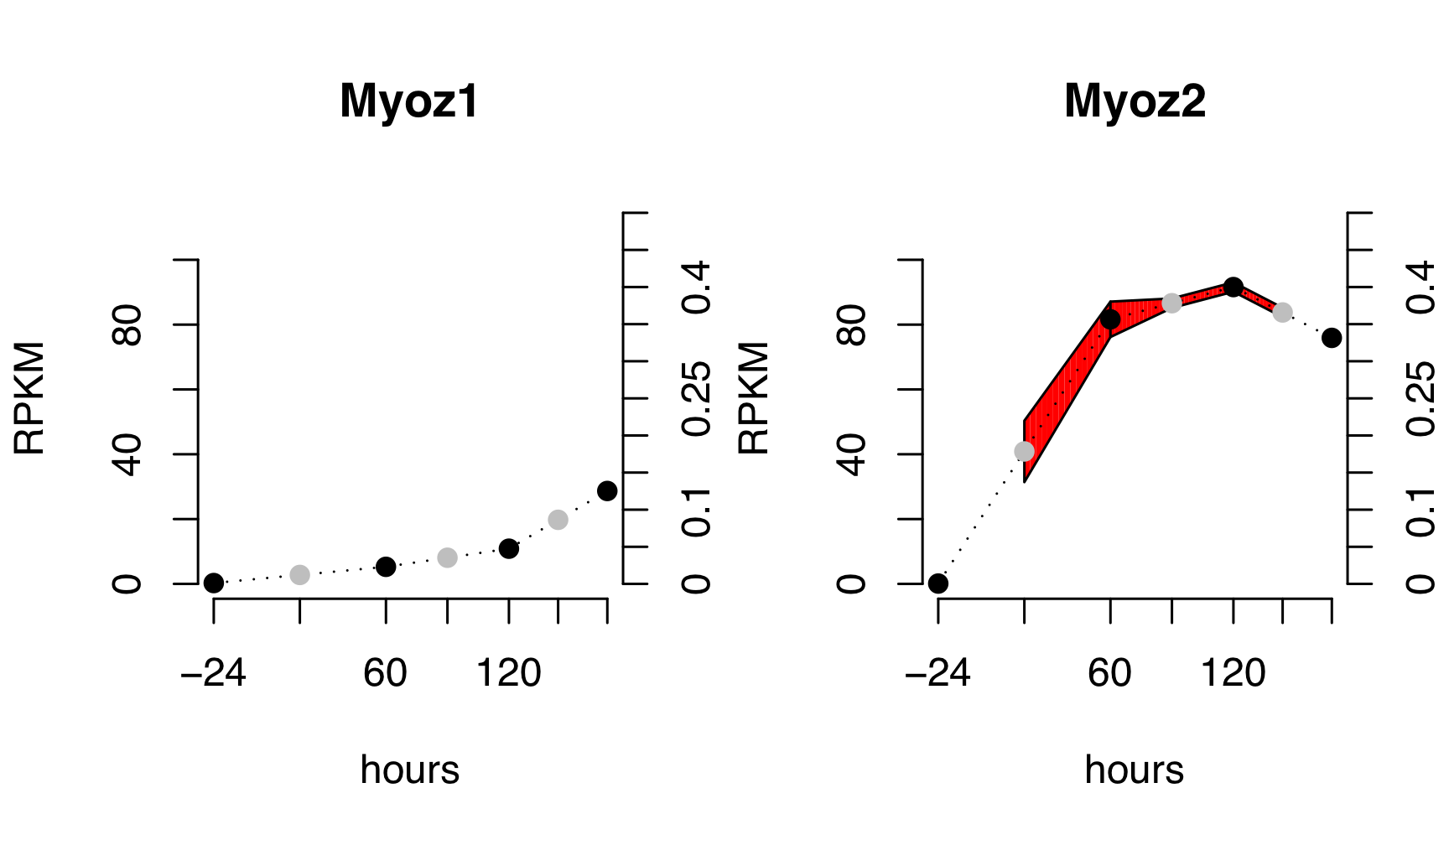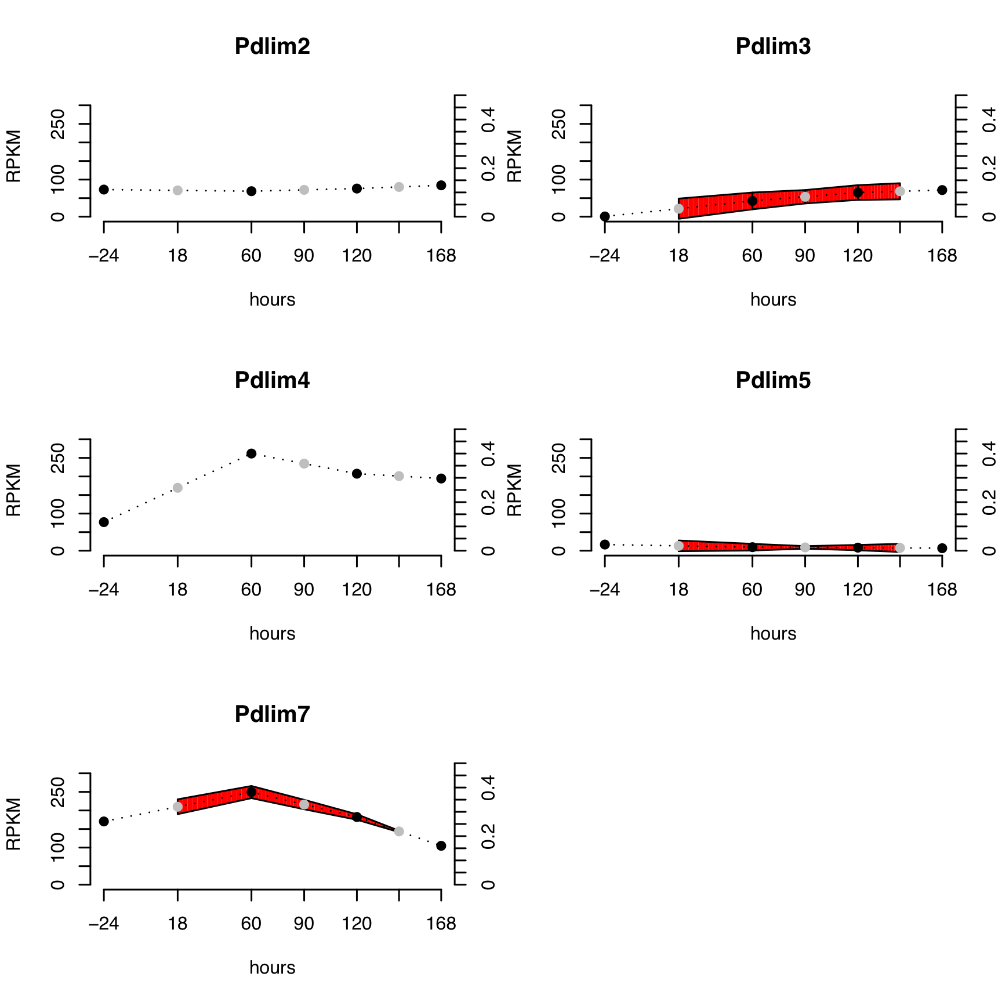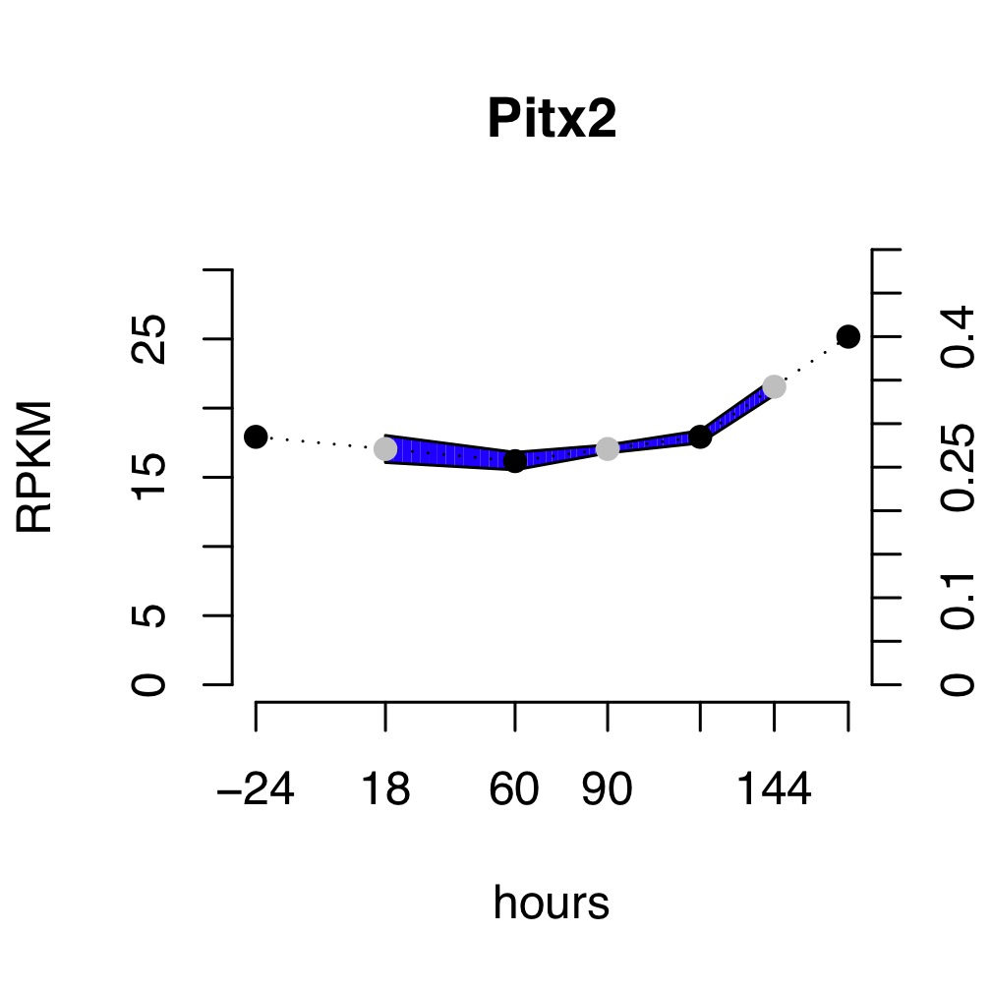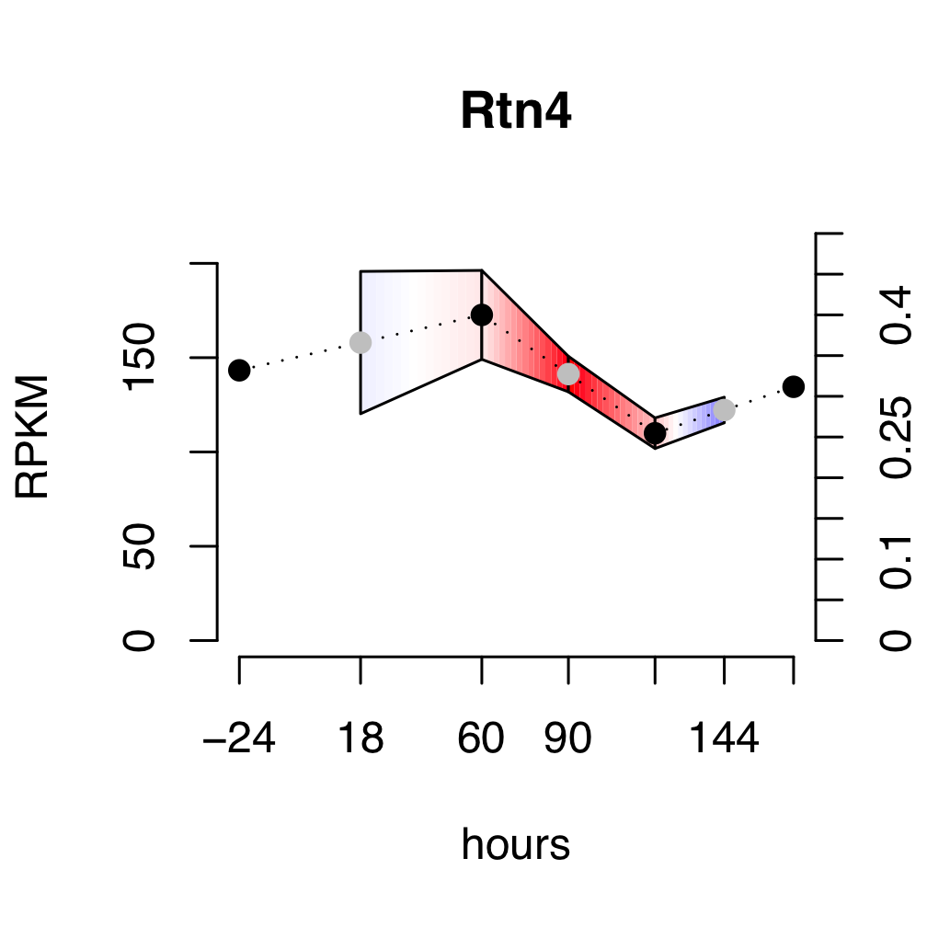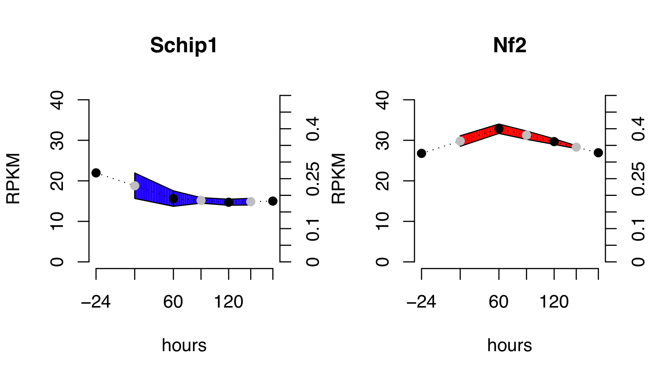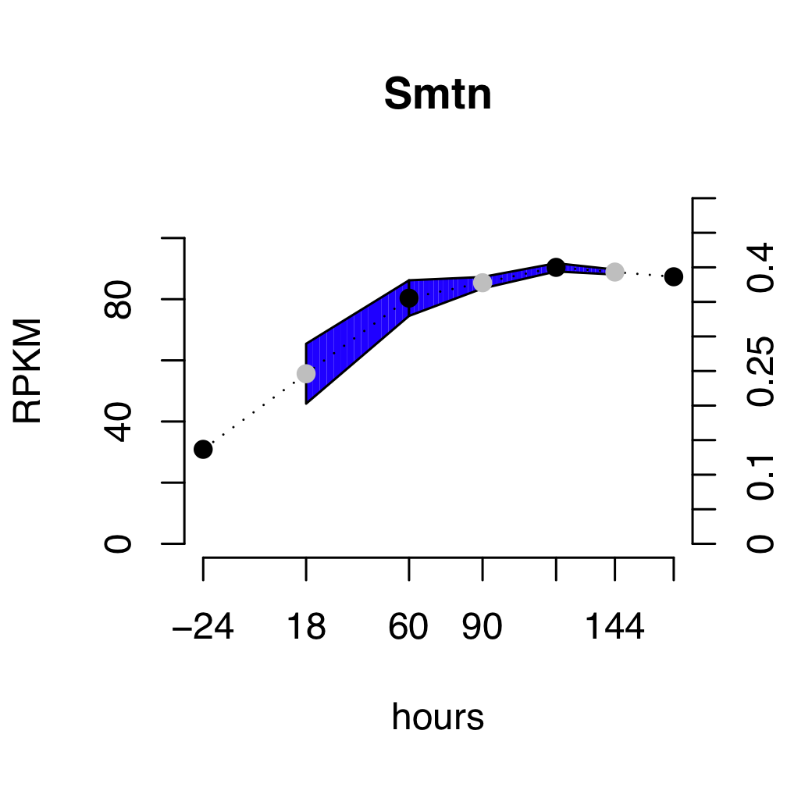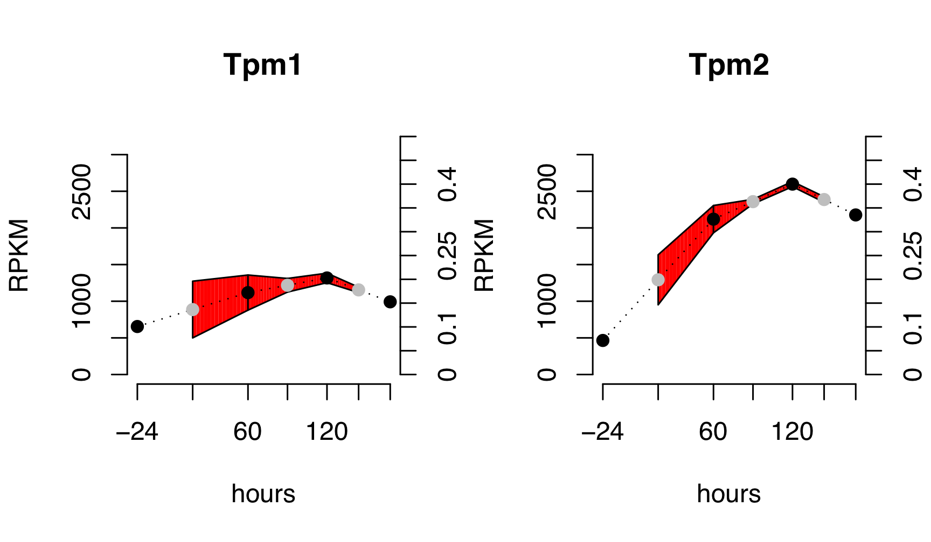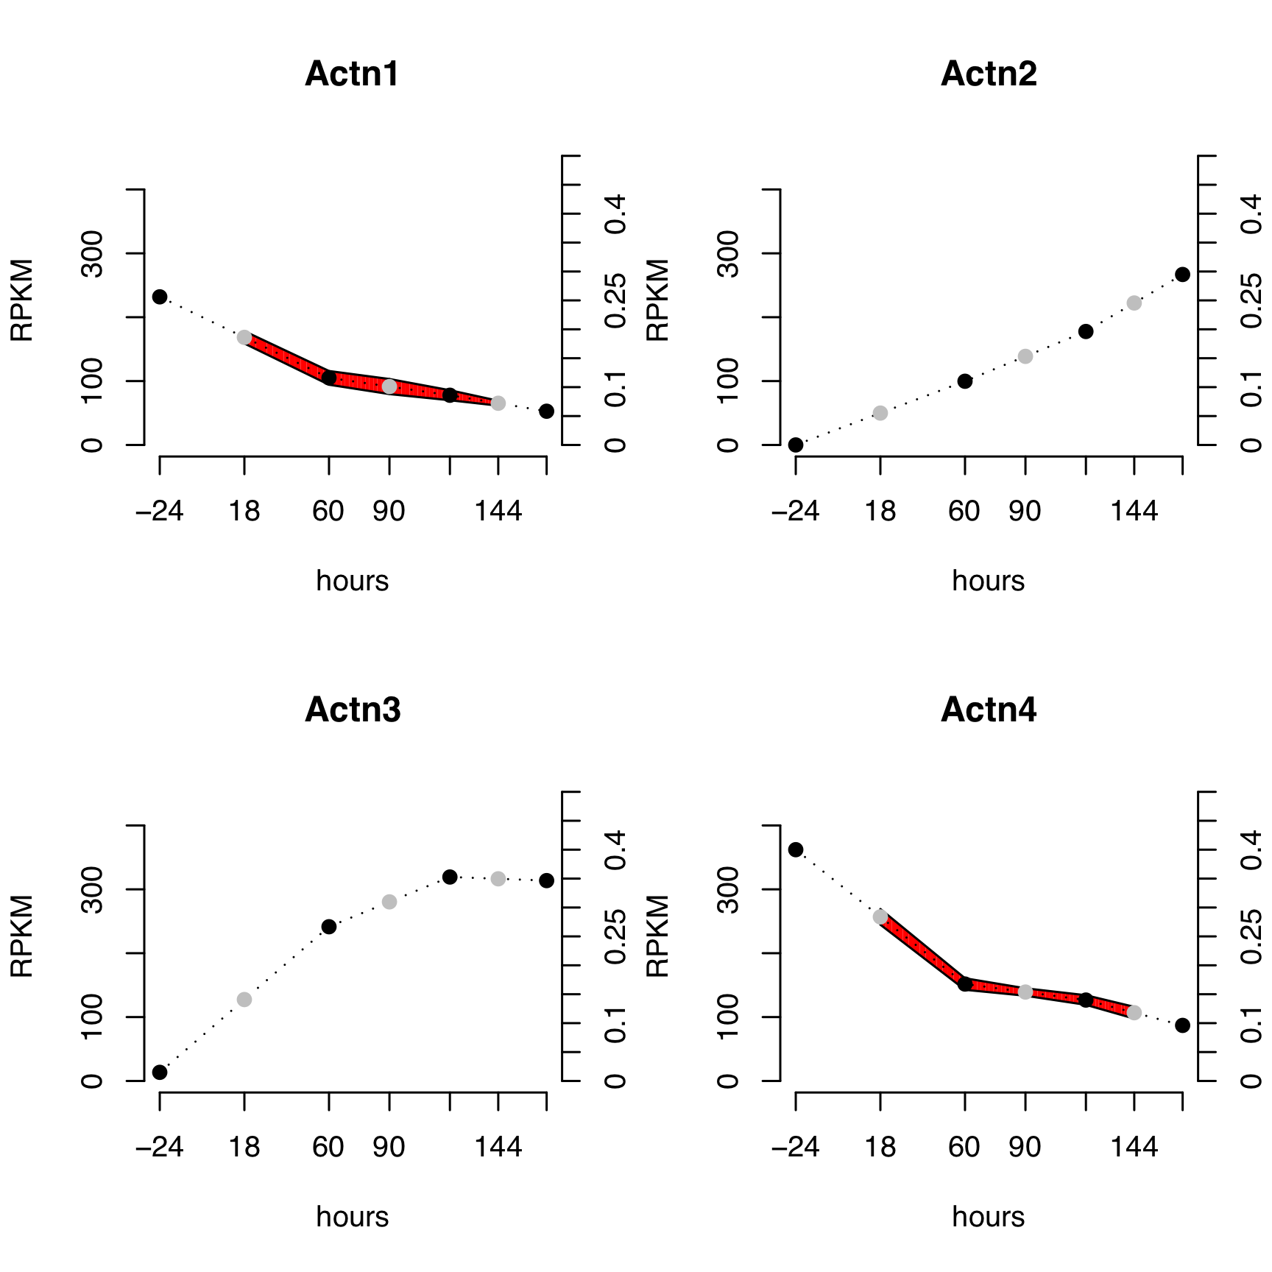
Supplemental Figures and Tables
Category | Transcripts (%) | Assembled reads (%)
Match to known isoform | 16.1 | 77.3
Contained in known isoform | 25.0 | 5.2
Novel isoform of known gene | 8.1 | 13.2
Repeat | 14.1 | 0.6
Intronic | 15.9 | 0.9
Polymerase run-on | 4.2 | 0.3
Intergenic | 11.7 | 0.8
Other artifacts | 4.9 | 1.7
Table 1 Cufflinks transfrags by category

Supplemental Figure 1 Cufflinks quantitation accuracy when provided with a perfect assembly. Simulated reads were aligned ab initio with TopHat and the alignments were provided to Cufflinks along with the structures of the transcripts in the simulated sample.

Supplemental Figure 2 Assessing accuracy of Cufflinks abundance estimates with a simulated RNA-Seq experiment. Black points indicate full-length UCSC transcripts in the sample reconstructed by the software. Red points indicate partial reconstructions. Cufflinks produced full-length matches across most of the dynamic range of expression.

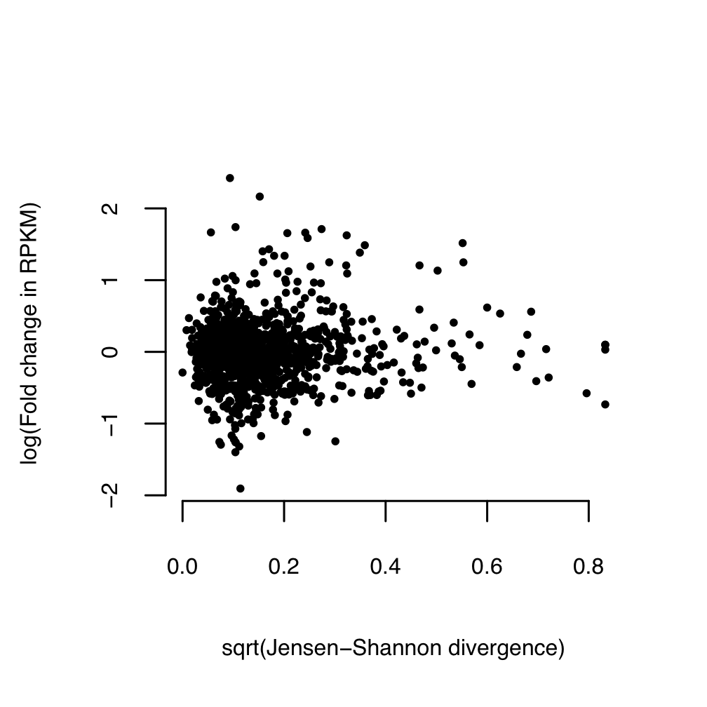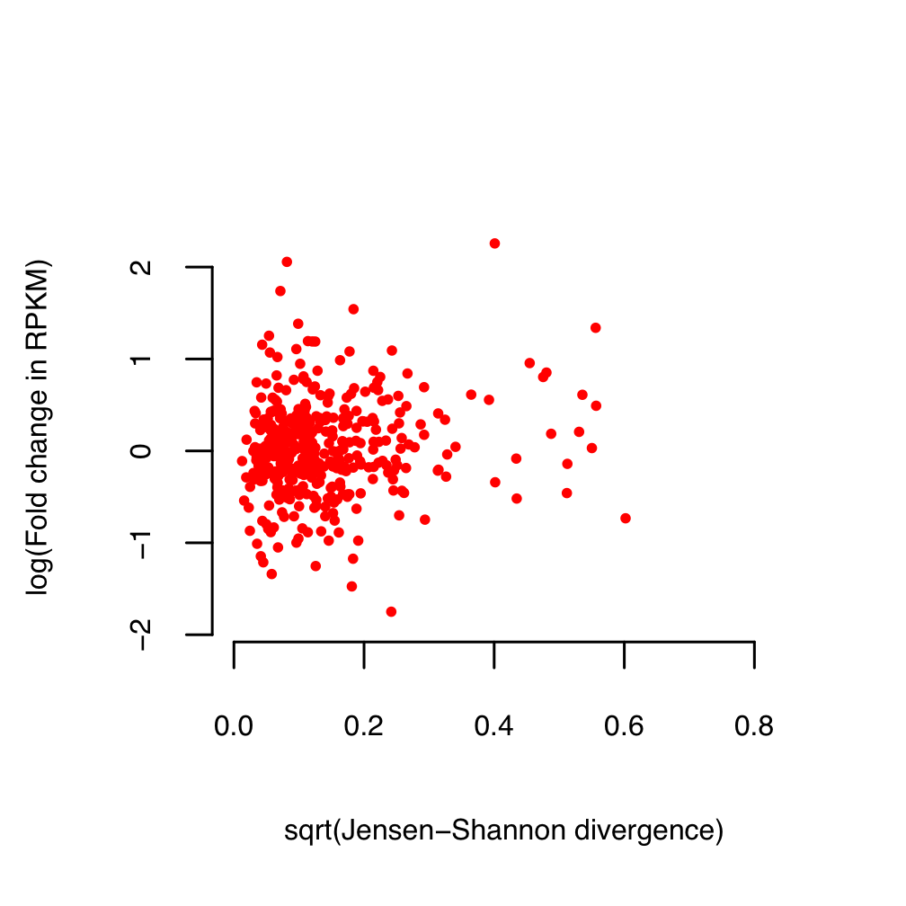
Genes undergoing differential splicing or TSS preference over the between sequential time points often display little to no gene-level expression changes.

Sample | Reads | Total alignments | Spliced alignments | Multiread alignments | Consensus alignments | Transfrags
0 hours | 84,369,078 | 66,541,668 | 10,754,363 | 7,694,141 | 37,278,036 | 58,008
60 hours | 140,384,062 | 103,681,081 | 19,194,697 | 9,982,807 | 64,348286 | 69,716
120 hours | 82,138,212 | 47,431,271 | 9,015,806 | 7,933,431 | 29,442,063 | 55,241
168 hours | 123,575,666 | 89,162,512 | 17,449,848 | 10,661,904 | 56,982,303 | 63,664
Total | 430,467,018 | 306,816,532 | 56,414,714 | 36,272,283 | 188,050,688 | 246,629
Table 2 Sequencing, mapping, and assembly stats
Genes | 11,895
Transcripts | 17,423
Multi-isoform TSS groups | 3,286
Mean transcripts/TSS group | 2.78
Mean transcripts/gene | 1.46
Table 3 Grouping statistics for the C2C12 “consensus” transcript set.
# genes with differential: | -24 to 60 | 60 to 120 | 120 to 168 | Any time point
splicing | 429 | 233 | 165 | 629
TSS use | 171 | 58 | 67 | 212
CDS output | 153 | 74 | 60 | 211
Table 4 Summary of transcriptome-wide differential splicing, promoter use, and CDS abundance.

