**Notes on Tensor Flow**

**(Intellipaat Video on Tensorflow applied to Neural Networks):**

video url:[**https://www.youtube.com/watch?v=5pG9HYdFd8M&ab_channel=Intellipaat**](https://www.youtube.com/watch?v=5pG9HYdFd8M&ab_channel=Intellipaat)

**Activation Functions** take linear data and convert it into nonlinear data in many cases in order to do things like attempt to draw a decision boundary between two classes.

* The ReLU activation function is the most common activation function
* It is most commonly used in the hidden layers

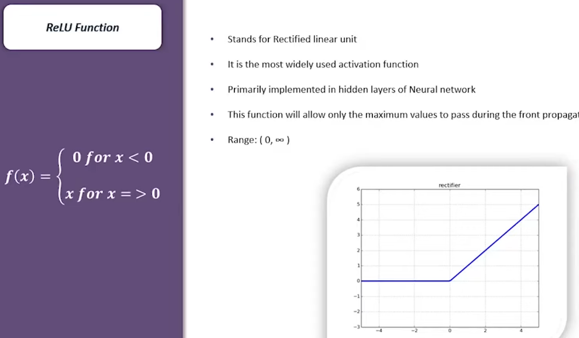

* The Softmax activation function is another popular function and it is ideally used in the output layer of classification networks

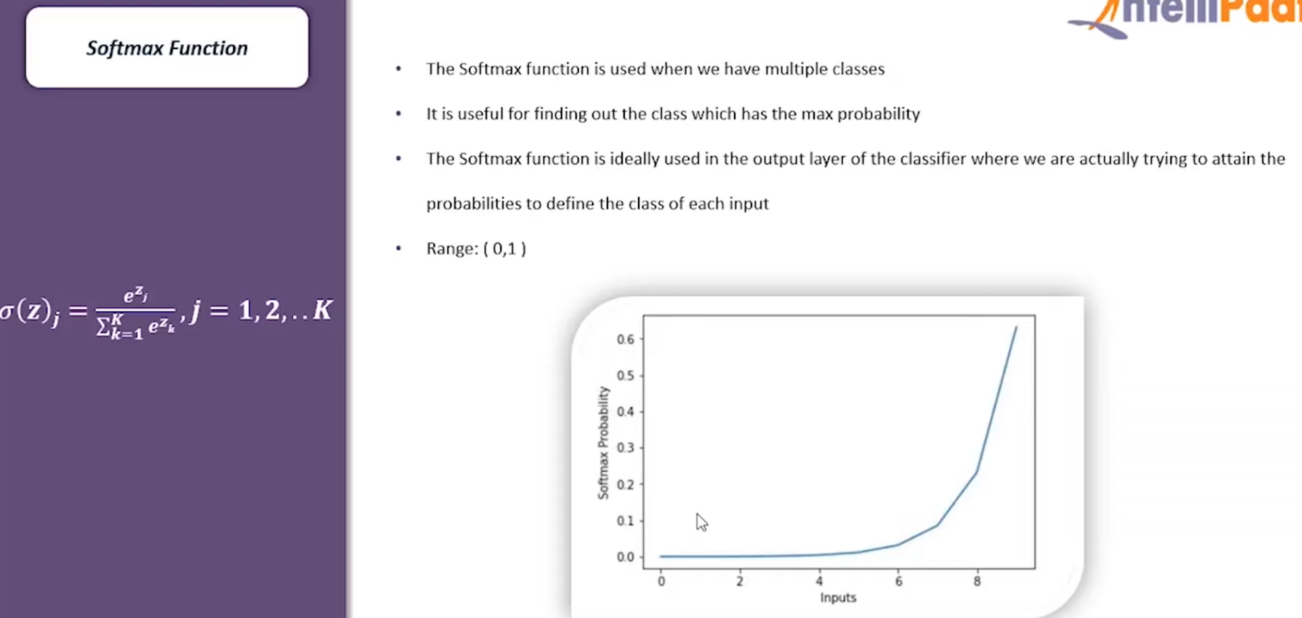

Illustration of a **“back-propagation”** process

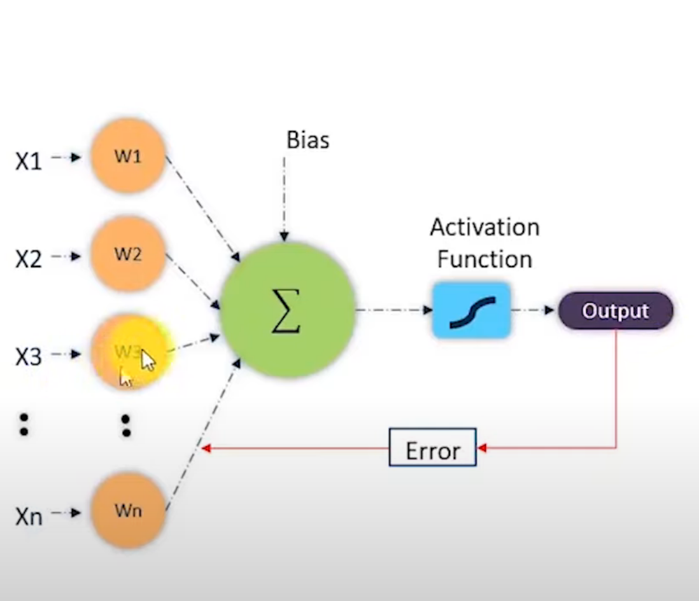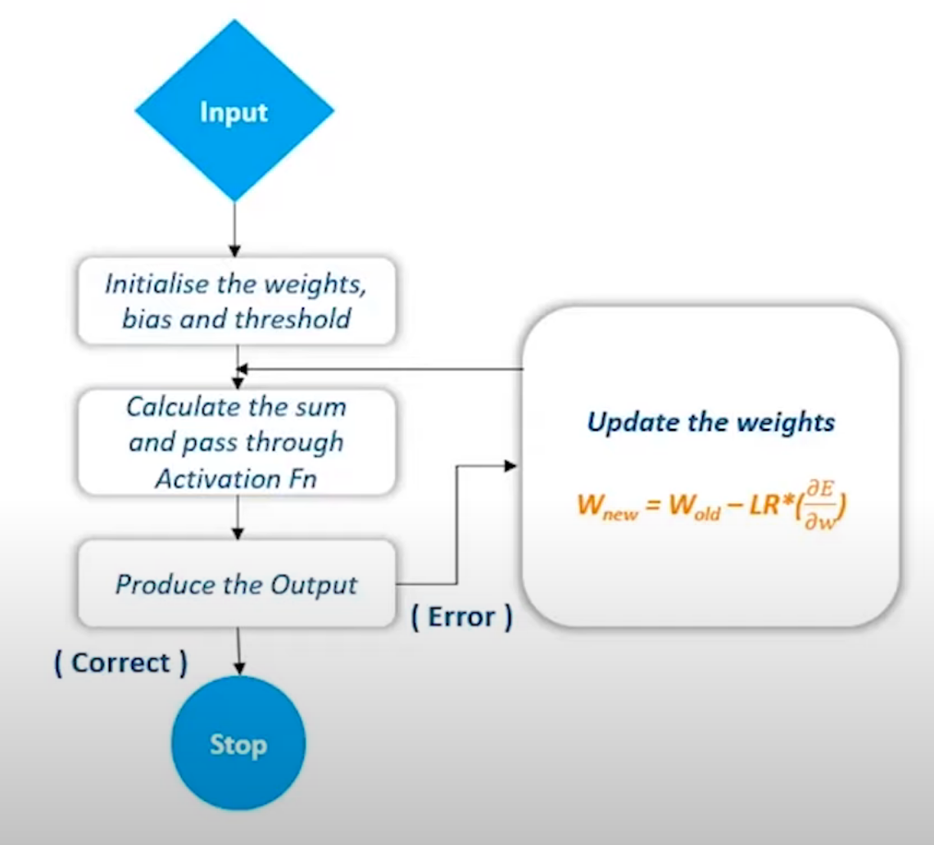

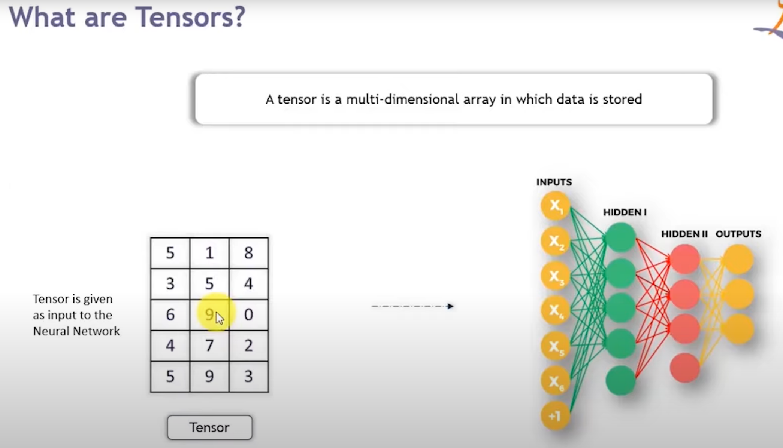

**Important Notes:**

* After about 40 minutes into this video it started becoming redundant and irrelevant so I skipped from about 0:45 → 2:55 minutes
* Also, the version of tensorflow he is using is very outdate v1.x versus mine which is v2.7
* After that I abandoned this video

**Video2: TensorFlow 2.0 Complete Course – Python Neural Networks:**

video url: <https://www.youtube.com/watch?v=tPYj3fFJGjk&t=23715s&ab_channel=freeCodeCamp.org>

Types of Tensors:

* Variable (mutable)
* Constant (immutable)
* Placeholder (immutable)
* SparseTensor (immutable)

Although his video is very good quality you are skipping from 1:01 --> 2:46 because you want to go straight to the neural networks if possible. He calls this *Module 4*

* His notes for module 4 are at:
* [https://colab.research.google.com/drive/1m2cg3D1x3j5vrFc-Cu0gMvc48gWyCOuG#forceEdit=true&sandboxMode=true](https://colab.research.google.com/drive/1m2cg3D1x3j5vrFc-Cu0gMvc48gWyCOuG" \l "forceEdit=true&sandboxMode=true)

You stopped at 3:43 where it transitions to Module 5