**Differential Sea Lice Loads on Pacific Salmon Species**

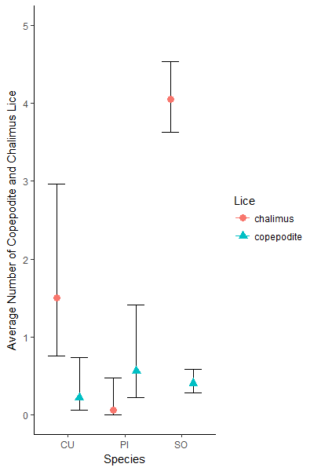

**Figure 1:** Here we show the relative abundance of chalimus staged lice versus copepodite staged lice for the three species of salmon. It is clear that while copepodite numbers are relatively stable between ~0.25 - ~0.75 across all three salmon species, there is a significant difference between the chalimus abundance, with sockeye showing significantly higher counts than the other two. *NOTE*: it is important to recall that sockeye make up more than ¾ of the fish that have data for chalimus/copepodite counts.

**Table 1:** A summary of some important result values from our null and alternate models for both chalimus and copepodite lice.

|  |  |  |  |  |
| --- | --- | --- | --- | --- |
| **Model** | **Fixed Effect** | **Negative Log Likelihood** | **AIC value** | **Delta-AIC value** |
| **Chalimus Null** | -- | -814.806 | 1635.6 | 0.0 |
| **Chalimus Alternate** | Salmon Species | -787.394 | 1584.8 | 50.8 |
| **Copepodite Null** | -- | -321.102 | 648.2 | 0.0 |
| **Copepodite Alternate** | Salmon Species | -320.075 | 650.1 | 1.9 |

**Table 2:** A summary of the coefficients and standard errors from the two alternate models run for both chalimus-stage and copepodite-stagelice. The coefficient values here were reverse transformed, along with +/- two standard errors to plot the points and error bars for Fig. 1.

|  |  |  |  |  |  |  |
| --- | --- | --- | --- | --- | --- | --- |
| **Output** | **Chum Coefficient** | **Chum Standard Error** | **Pink Coefficient** | **Pink**  **Standard Error** | **Sockeye Coefficient** | **Sockeye Standard Error** |
| **Chalimus Model** | 0.408 | 0.340 | -2.799 | 1.033 | 1.400 | 0.111 |
| **Copepodite Model** | -1.494 | 0.593 | -0.569 | 0.458 | -0.895 | 0.182 |

**Added Covariates of Pre-adult & Adult stage models**

The below are the results of adding additional variables into our existing models for *C. clemensi*  & *L. salmonis.* Year (2015 – 2018), and the fork length of the individual fish were added to the model as fixed effects, such that salmon species, year, and fork length were the fixed effects of the model, while collection number remained a random effect. This analysis was performed only on the portion of the data that had fork length measurements, as all fish missing this measurement were excluded for the purposes of this analysis. The formula for the model is as follows:

*all.leps ~ spp + year + fork.length - 1 + (1|collection)*

With the family being specified as ‘negative binomial’ and the zero-inflation term set to false. This model was run for both ‘all.leps’ and ‘all.cal’, representing measurements for both for *C. clemensi*  & *L. salmonis.*

**Table 3:** A summary of some important result values from our null and alternate models for both *C. clemensi*  & *L. salmonis* lice species with added covariates from the initial models.

|  |  |  |  |  |
| --- | --- | --- | --- | --- |
| **Model** | **Fixed Effect** | **Negative Log Likelihood** | **AIC value** | **Delta-AIC value** |
| ***C. clemensi*  Null** | -- | -935.136 | 1876.3 | 0.0 |
| ***C. clemensi*  Alternate** | Salmon Species | -919.534 | 1857.1 | 19.2 |
| ***L. salmonis*****Null** | -- | -334.275 | 674.5 | 0.0 |
| ***L. salmonis*****Alternate** | Salmon Species | -298.099 | 614.2 | 60.4 |

**Table 4:** A summary of the coefficients and standard errors from the two alternate models run for both *C. clemensi*  & *L. salmonis* lice species.

|  |  |  |  |
| --- | --- | --- | --- |
| **Output** | **Coefficient** | **Standard Error** | **Significance** |
| ***L. salmonis* Chum** | 0.2925 | 1.4383 | 0.839 |
| ***C. clemensi*  Chum** | -1.4823 | 0.6760 | 0.028 |
| ***L. salmonis* Pink** | 1.1187 | 1.4312 | 0.434 |
| ***C. clemensi*  Pink** | -0.8779 | 0.6572 | 0.182 |
| ***L. salmonis* Sockeye** | -1.5174 | 1.3732 | 0.269 |
| ***C. clemensi*  Sockeye** | -0.9154 | 0.6290 | 0.146 |
| ***L. salmonis* 2016** | -0.7260 | 0.3576 | 0.042 |
| ***C. clemensi*  2016** | -0.6478 | 0.1955 | 0.001 |
| ***L. salmonis* 2017** | -2.9020 | 1.1372 | 0.011 |
| ***C. clemensi*  2017** | -0.9501 | 0.3367 | 0.005 |
| ***L. salmonis* 2018** | -8.0512 | 283.24 | 0.977 |
| ***C. clemensi*  2018** | -11.330 | 350.36 | 0.974 |
| ***L. salmonis* Fork Length** | -0.0184 | 0.0116 | 0.112 |
| ***C. clemensi*  Fork Length** | 0.0046 | 0.0053 | 0.379 |

**Table 5:** A summary of some important result values from our null and alternate models for both *C. clemensi*  & *L. salmonis* lice species with added covariates from the initial models.

|  |  |  |  |  |
| --- | --- | --- | --- | --- |
| **Model** | **Fixed Effect** | **Negative Log Likelihood** | **AIC value** | **Delta-AIC value** |
| ***C. clemensi*  Null** | -- | -935.136 | 1876.3 | 0.0 |
| ***C. clemensi*  Alternate** | Salmon Species | -919.534 | 1857.1 | 19.2 |
| ***L. salmonis*****Null** | -- | -334.275 | 674.5 | 0.0 |
| ***L. salmonis*****Alternate** | Salmon Species | -298.099 | 614.2 | 60.4 |