**EEB499 Proposal**

**Cole Brookson**

**Introduction:**

Pacific salmon make up some of the most important fisheries in Canada, not only with respect to their economic importance but also from a cultural and historical perspective (Cooke et al. 2004. Eliason et al. 2011; FAO 2015). Yet despite the importance placed on them, these fisheries have seen significant declines in recent decades. Indeed, the Fraser River sockeye salmon (*Oncorhynchus nerka*) in particular have seen large population declines, resulting in a federal judicial inquiry by the Canadian government into the causes of this decline (Cohen 2012). While there are likely multiple reasons behind this decline, the current consensus is that multiple intertwined factors impact the survival and growth of these populations (Peterman et al. 2010). It has been posited that threats specific to these fish during their juvenile life stage might be most important when considering what factors impact the number of fish that return as adults and are subsequently available to fisheries and predators that rely on them (Godwin et al. 2017). Fraser River sockeye in British Columbia begin their lives in freshwater environments where they were spawned, and subsequently migrate out to the marine environment, where they traverse up through the Strait of Georgia, Johnstone Strait and the Discovery Islands, and then out through Queen Charlotte Sound to the open ocean. When the juveniles leave their freshwater spawning areas, they encounter a whole host of stressors including a lack of sufficient food, as well as numerous parasites and pathogens (Hunt et al. 2018).

The Hakai Juvenile Salmon Marine Survival Program was set up in 2015 and is centred around the Fraser River sockeye salmon, as well as two other species of pacific salmon, the pink salmon (*Oncorhynchus gorbuscha*), and the chum salmon (*Oncorhynchus keta*). The goal of the program is to quantitatively answer questions regarding juvenile salmon condition, relevant threats to their survival, and ultimately the mortality rates of juvenile salmon during their migration from natal spawning grounds to the open ocean (Hunt et al. 2018). One of the important factors affecting juvenile salmon survival, and a focus of this program is quantifying the levels of parasitism on juvenile salmon by two species of sea lice, *Caligus clemensi* a generalist parasite infecting multiple fish species, and *Lepeophtheirus salmonis,* a salmon specialist (Johnson & Albright 1991)*.* These ectoparasitic copepods are native to the region, and feed on the soft tissues and musculature of numerous species of marine fishes (Costello 1993; Krkosek 2009). Unable to survive in freshwater environments (Bricknell et al. 2006), sea lice naturally infect juvenile pink, chum, and sockeye salmon once they move into marine environments, likely host-switching from sympatric subadult coho and chinook salmon (Krkosek 2009). Typically, adult pink, chum, and sockeye are still residing offshore during this spring/early summer period as the juvenile salmon migrate northwards up the coast. The juveniles become sympatric with their in-migrating adult conspecifics at the northern end of their coastal migration towards the end of summer, when the juveniles are typically 10-100 times larger than when they first emerged into the marine environment, and have developed scales (Krkosek et al. 2007b). The juveniles are now prepared to deal with the increased infection pressure that will come with adult salmon who have been harbouring significant parasite loads out at sea (Nagasawa 2001). However, with the addition of fish farms along the western coast of mainland British Columbia and the eastern coast of Vancouver island, this whole dynamic has changed. These farms, which hold large numbers of Atlantic salmon, can act as refugia for both species of lice, thereby eliminating the spatio-temporal allopatry between adult and juvenile salmon and vastly increasing the infection pressure on the juvenile salmon during their northern migration, likely contributing significantly to population decline (Krkosek et al. 2005; Krkosek et al. 2007a; Krkosek et al. 2007b; Costello 2009; Price et al. 2011).

While evidence suggests that population-level declines are directly related to increased infection pressure from these parasites, there are still many unknowns surrounding the host-pathogen dynamics in this system (Hunt et al. 2018). Indeed, there is little known about the patterns of infection across the different species of fish and lice. Questions still remain as to whether or not different species of salmon show higher infection loads of *C. clemensi* vs. *L. salmonis* as well as what environmental and life history traits affect parasite loads in these focal salmon species. While some previous work has suggested that sockeye juveniles are infected primarily by *C. clemensi* (Price et al. 2011; Godwin et al. 2015), estimates for pink and chum salmon do not exist, and information regarding what other factors affect parasite load for these three species is still relatively sparse. The present study will attempt to shed some light on the relationships between pink, chum, and sockeye juvenile salmon and their sea lice parasites using data from the Hakai Juvenile Salmon Marine Survival program, collected between 2015 and 2018. Specifically, the goals of this study are to determine the parasite loads of both *C. clemensi* and *L. salmonis* on pink, chum, and sockeye salmon, and to determine what factors contribute to the differences in infection across the different salmon species.

**Methods:**

In order to obtain data on species-specific lice abundances, juvenile salmon were sampled at entry points to the Discovery Islands, and exit points from Johnstone Strait to Queen Charlotte Sound during the months of May to July, from 2015 to 2018 (Fig. 1). Purse seine nets were deployed from small research vessels to capture samples of heterospecific schools comprised of juvenile pink, chum and sockeye salmon, often with a few sub-adult coho and chinook salmon as well. Some individuals were euthanized and retained for laboratory analysis, while the majority of captured fish underwent examination using a hand lens on the boat and then were released. Information regarding fish body size, as well as number, life stage, and species of any sea lice present were recorded, along with relevant environmental data. Fish that were sacrificed for lab testing were also examined for lice and the number, species, and life stage of each louse was recorded. This resulted in a dataset of over 1,800 individual fish, collected at eight different sites, across 52 individual collections. A collection represents a unique sampling site/date combination, where at least five individuals of pink, chum, and sockeye juvenile salmon were sampled.

To address our research questions, we plan to fit a series of generalized linear mixed effects models to our data, with salmon species, sampling year, fish fork length, and site region (Johnstone Strait vs. Discovery Islands) as fixed effects, along with collection number as a random effect. These models will be run separately for *C. clemensi* and *L. salmonis,* so as to gain a better idea of what is driving the abundance of the two lice species in our study system. Both *C. clemensi* and *L. salmonis* have the same life cycle, consisting of nauplii, copepodite, chalimus, and motile life stages (Johnson & Albright 1991), but due to the differing morphology during these life stages, only motile lice were easily identifiable by species on each and every fish, and as such, only motile data were retained for the purposes of the present models. Initially, analyses were run with only salmon species as a fixed effect and collection as a random effect to determine the lice species-specific parasite load on the three different species of pacific salmon. We used generalized linear mixed effects models (GLMMs) in the glmmABMD package to draw our conclusions. The models employed a negative binomial error for the response distribution, as well as a log link function. The GLMMs were written such that the number of lice per fish was treated as the response variable, and species of salmon were fixed effects. The results of the models were used to plot Figure 4, with the points representing the reverse transformed coefficients of the salmon species effects from our GLMMs, along with +/- 2 standard errors to form a 95% confidence interval, represented by the error bars. Four models were run, one alternate and one null model for each lice species.

**Preliminary Results:**

Our initial results indicate that there is in fact species-level differences between the three species of juvenile salmon, with regards to sea lice loads. The average number of lice per individual fish varied from more than 4 lice per fish in some collections, to less than 0.5 in other collections (Fig. 2). Each collection showed at least some lice present, though not each collection showed lice on each species of salmon. When looking separately at the two lice species, it is clear that not only is *C. clemensi* present at many more collections than *L. salmonis* but it is also generally present at higher numbers (Fig. 3). Additionally, the highest numbers of lice per collection for *C. clemensi* were just under three lice per fish, while for *L. salmonis*, the highest average number of lice per fish was just under 2.5 fish. It is also clear that there are very few *L. salmonis* lice present on sockeye salmon, compared to pink and even chum salmon.

The results of our initial analyses show that *C. clemensi* is present at higher per fish averages across the whole dataset (Tables 1 & 2, Fig. 4), with the highest frequencies being shown on pink and sockeye salmon. *L. salmonis* lice were present at lower numbers on each of the three salmon species, but were highest on pink salmon. These initial results are contrary to previous field observations which indicated that sockeye salmon exhibit the highest levels of *C. clemensi*, however they do confirm field observations that suggested pink salmon carry the highest levels of *L. salmonis.*

While these initial results begin to show some insights with regards to the main questions of this study, future model sets with more covariates will allow us to more accurately determine what is driving the frequency of lice infections on our focal salmon species. Next steps include finalizing full model sets with all relevant covariates, developing figures showing relative lice abundances with different predictor variables included for the different salmon species, and then further analyzing the dataset to pull out any other relevant information, potentially related to life stage, or additional environmental variables not yet accounted for.

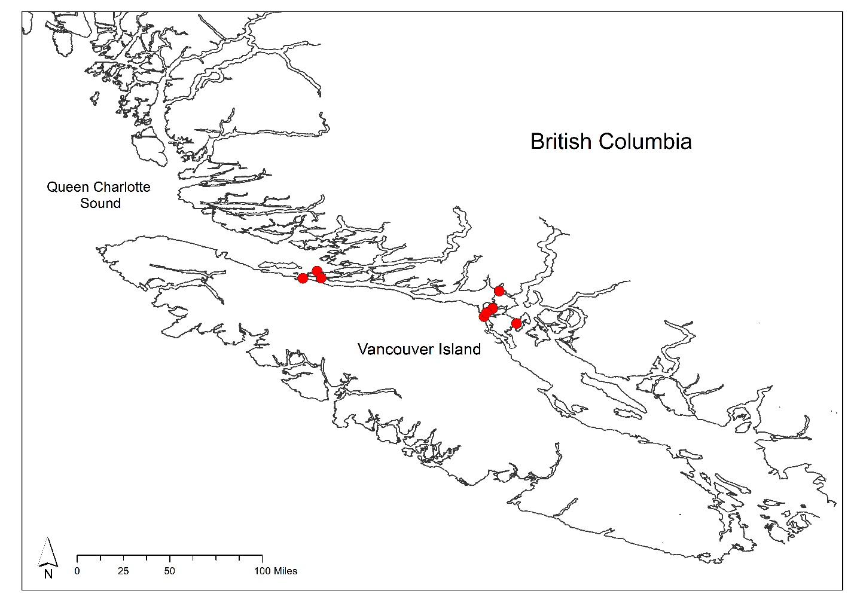

**Figure 1:** A site map of the study region showing the 8 sampling sites in two groupings in the Discovery Islands to the south-east, and Johnstone Strait to the northwest.

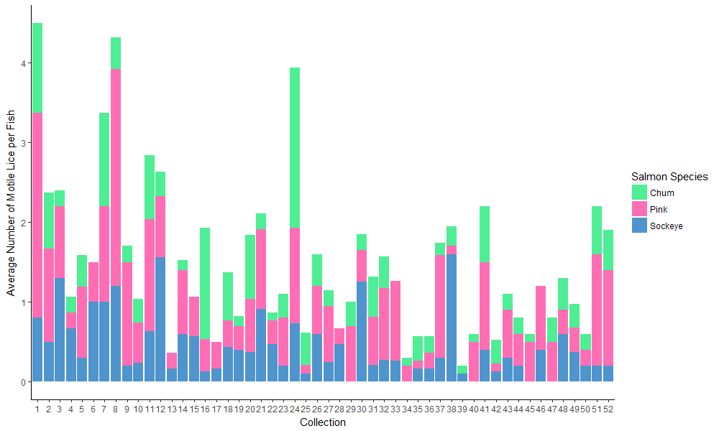

**Figure 2:** Here we see the average number of lice per fish (both lice species as well as individuals at unidentified stages combined), for each collection across the data. The colours in each collection represent the species of salmon.

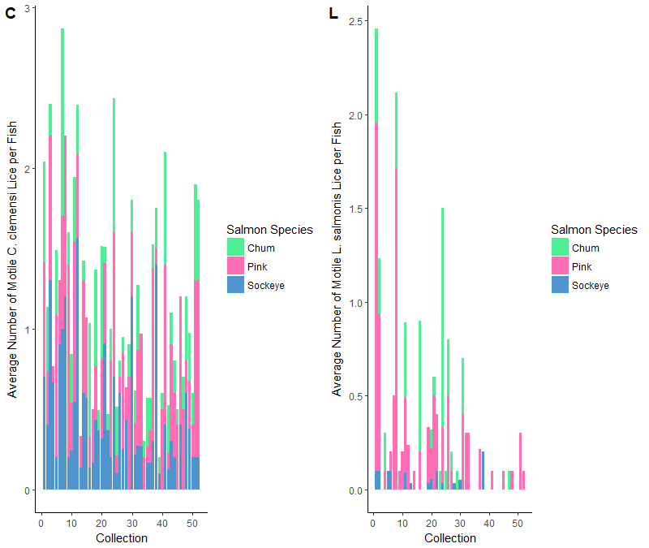

**Figure 3:** Here we see the average number of lice per fish in each collection, divided into two plots to separate by louse species, and divided by colour to separate by fish species. ‘C’ shows the average number of *C. clemensi*  per fish, with colour dividing per species. Visually it is clear that sockeye and pinks typically have higher average numbers of *C. clemensi.* ‘L’ shows the average number of *L. salmonis* per fish, with colour dividing per species. Visually, pink salmon seem to have higher average numbers of *L. salmonis*.

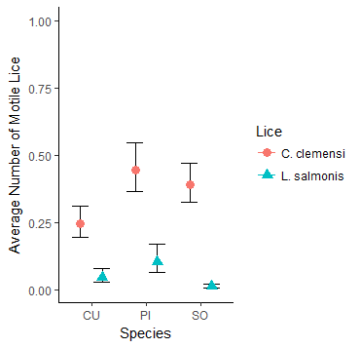

**Figure 4:** Here we show the estimated average number of lice per fish across all collections, separated by the louse species. This confirms the visual estimate from the above plots that *C. clemensi* can be found with the highest frequency on sockeye salmon and pink salmon, and that *L. salmonis* can be found with the highest frequency on pink salmon.

**Table 1:** A summary of some important result values from our null and alternate models for both *C. clemensi* and *L. salmonis* lice.

|  |  |  |  |  |
| --- | --- | --- | --- | --- |
| **Model** | **Fixed Effect** | **Negative Log Likelihood** | **AIC value** | **Delta-AIC value** |
| ***C. clemensi* Null** | -- | -1509.74 | 3025.5 | 0.0 |
| ***C. clemensi* Alternate** | Salmon Species | -1497.33 | 3004.7 | 20.8 |
| ***L. salmonis* Null** | -- | -461.325 | 928.6 | 0.0 |
| ***L. salmonis* Alternate** | Salmon Species | -427.833 | 865.7 | 63.0 |

**Table 2:** A summary of the coefficients and standard errors from the two alternate models run for both *C. clemensi* and *L. salmonis* lice. The coefficient values here were reverse transformed, along with +/- two standard errors to plot the points and error bars for Fig. 3.

|  |  |  |  |  |  |  |
| --- | --- | --- | --- | --- | --- | --- |
| **Output** | **Chum Coefficient** | **Chum Standard Error** | **Pink Coefficient** | **Pink**  **Standard Error** | **Sockeye Coefficient** | **Sockeye Standard Error** |
| ***C. clemensi* Model** | -1.4080 | 0.1192 | -0.8103 | 0.1011 | -0.9425 | 0.0917 |
| ***L. salmonis* Model** | -3.101 | 0.279 | -2.273 | 0.242 | -4.555 | 0.339 |

**References:**

Briknell, I.R., Dalesman, S.J., O’Shea, B., Pert, C.C., and Mordue Luntz, A.J. 2006. Effect of environmental salinity on sea lice Lepeoptheirus salmonis settlement success. Dis. Aquat. Organ. **71**: 201–212.

Cohen, B.I. 2012. Cohen Commission of inquiry into the decline of Sockeye Salmon in the Fraser River - Final Report. The Uncertain future of Fraser River sockeye. Available from http://www.npafc.org [accessed 02 December 2018].

Cooke, S.J., Hinch, S.G., Farrell, A.P., Lapointe, M.F., Jones, S.R.M., Macdonald, S.J., Patterson, D.A., Healey, M.C., and Van Der Kraak, G. 2004. Abnormal migration timing and high en route mortality of Sockeye Salmon in the Fraser river, British Columbia. Fisheries **29**(2): 23–32.. doi:10.1577/1548-8446(2004)29[22:AMTAHE]2.0.CO;2.

Costello, M.J. 1993. Review of methods to control sea lice (Caligidae: Crustacea) infestations on salmon (Salmo salar) farms. Available from https://books.google.ca/books [accessed 03 December 2018].

Costello, M.J. 2006. How sea lice from salmon farms may cause wild salmonid declines in Europe and North America and be a threat to fishes elsewhere. Trends Parasitol. **22**(10): 475–483. doi:10.1016/j.pt.2006.08.006.

Costello, M.J. 2009. How sea lice from salmon farms may cause wild salmonid declines in Europe and North America and be a threat to fishes elsewhere. Proc. R. Soc. B Biol. Sci. **276**(1672): 3385–3394. doi:10.1098/rspb.2009.0771.

Eliason, E.J., Clark, T.D., Hague, M.J., Hanson, L.M., Gallagher, Z.S., Jeffries, K.M., Gale, M.K., Patterson, D.A., Hinch, S.G., and Farrell, A.P. 2011. Differences in Thermal Tolerance Among Sockeye Salmon Populations. Science. **332**(6025): 109–112. doi:10.1126/science.1198767.

FAO. 2017. Global capture production 1950–2013. *In* of the United Nations, Fisheries and Aquaculture Information and Statistics Branch. doi:10.1111/jfb.13325.

Godwin, S.C., Dill, L.M., Krkošek, M., Price, M.H.H., and Reynolds, J.D. 2017. Reduced growth in wild juvenile sockeye salmon Oncorhynchus nerka infected with sea lice. J. Fish Biol. **91**(1): 41–57. doi:10.1111/jfb.13325.

Godwin, S.C., Dill, L.M., Reynolds, J.D., and Krkošek, M. 2015. Sea lice, sockeye salmon, and foraging competition: lousy fish are lousy competitors. Can. J. Fish. Aquat. Sci. **72**(7): 1113–1120. doi:10.1139/cjfas-2014-0284.

Hunt, B.P.V., Johnson, B.T., Godwin, S.C., Krkošek, M., Pakhomov, E.A., and Rogers, L.A. 2018. The Hakai Institute Juvenile Salmon Program : Early Life History Drivers of Marine Survival in Sockeye, Pink and Chum Salmon in British Columbia. Available from http://www.npafc.org [accessed 11 December 2018].

Krkošek, M., Ford, J.S., Morton, A., Lele, S., Myers, R.A., and Lewis, M.A. 2007a. Declining Wild Salmon Populations in Relation to Parasites from Farm Salmon. Science (80-. ). **40**: 1772–1775. doi:10.1126/science.1149887.

Krkošek, M., Gottesfeld, A., Proctor, B., Rolston, D., Carr-Harris, C., and Lewis, M.A. 2007b. Effects of host migration, diversity and aquaculture on sea lice threats to Pacific salmon populations. Proc. R. Soc. B Biol. Sci. **274**(1629): 3141–3149. doi:10.1098/rspb.2007.1122.

Krkošek, M. 2010. Sea lice and salmon in Pacific Canada: Ecology and policy. Front. Eco. Environ. **8**(4). 201-209. doi:10.1890/080097.

Nagasawa, K. 2001. Annual changes in the population size of the salmon louse Lepeophtheirus salmonis (Copepoda: Caligidae) on high-seas Pacific Salmon (Oncorhynchus spp.), and relationship to host abundance. Hydrobiologia.**453.** 411–416. doi:10.1023/A:1013154403992.

Price, M.H.H., Proboszcz, S.L., Routledge, R.D., Gottesfeld, A.S., Orr, C., and Reynolds, J.D. 2011. Sea louse infection of juvenile sockeye salmon in relation to marine salmon farms on Canada’s west coast. PLoS One **6**(2): e16851. doi:10.1371/journal.pone.0016851.